GO Implement User Workflow Document

Contents

1.User Log In 1

2. Hierarchy 2

3.Skills Summary 3

4.Edit Skills 4

5.Reset user settings 5

# 1.User Log In

Case 1(First Time user Log in)

As a User , when he access url <https://in-goimplement.ingrnet.com> Login Screen will appear;

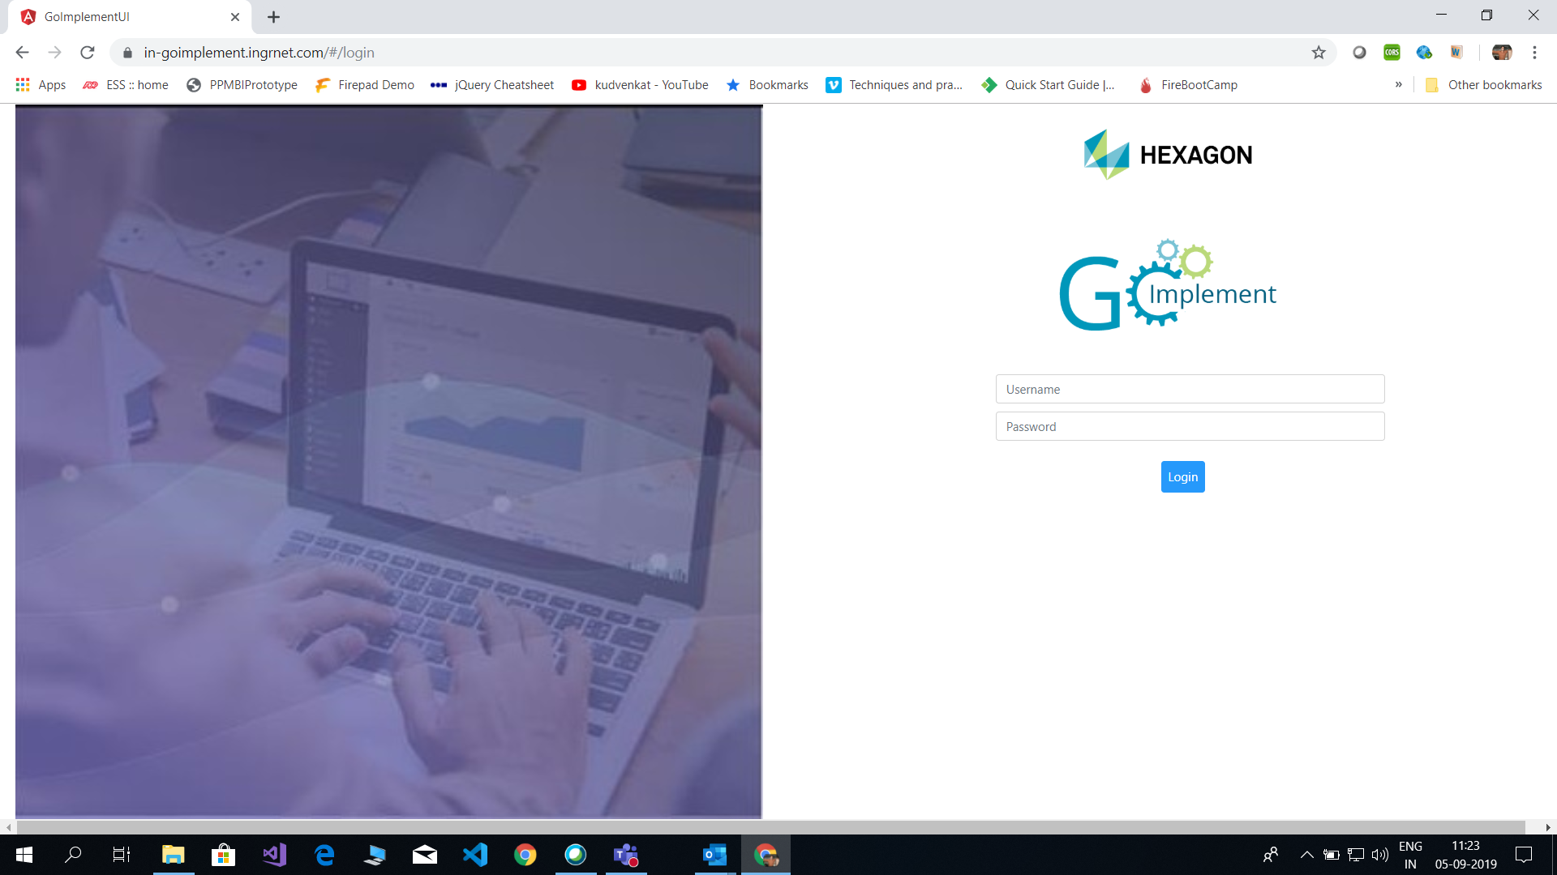

User can log in to the system with his domain credentials (Domain Short Name (XXXX) and Domain Password) and click Login Button.

Case 2(second time/next time user Log in):

After First time onwards user need not to provide credentials again (single sign on enabled) and user will be landed to summary skills page where he can manage the respective user skills.

# 2. Hierarchy

Case 1(include as services Resource):

with valid Credentials User should get Login successful message and Resource Hierarchy Screen will appear.

* system directly lands you in my organization / team hierarchy page from LDAP (Active Directory)
* By default, all employees who are directly reporting to you are selected i.e., they are services resources.
* How many resources and which resources are processed on clicking OK (Green) button

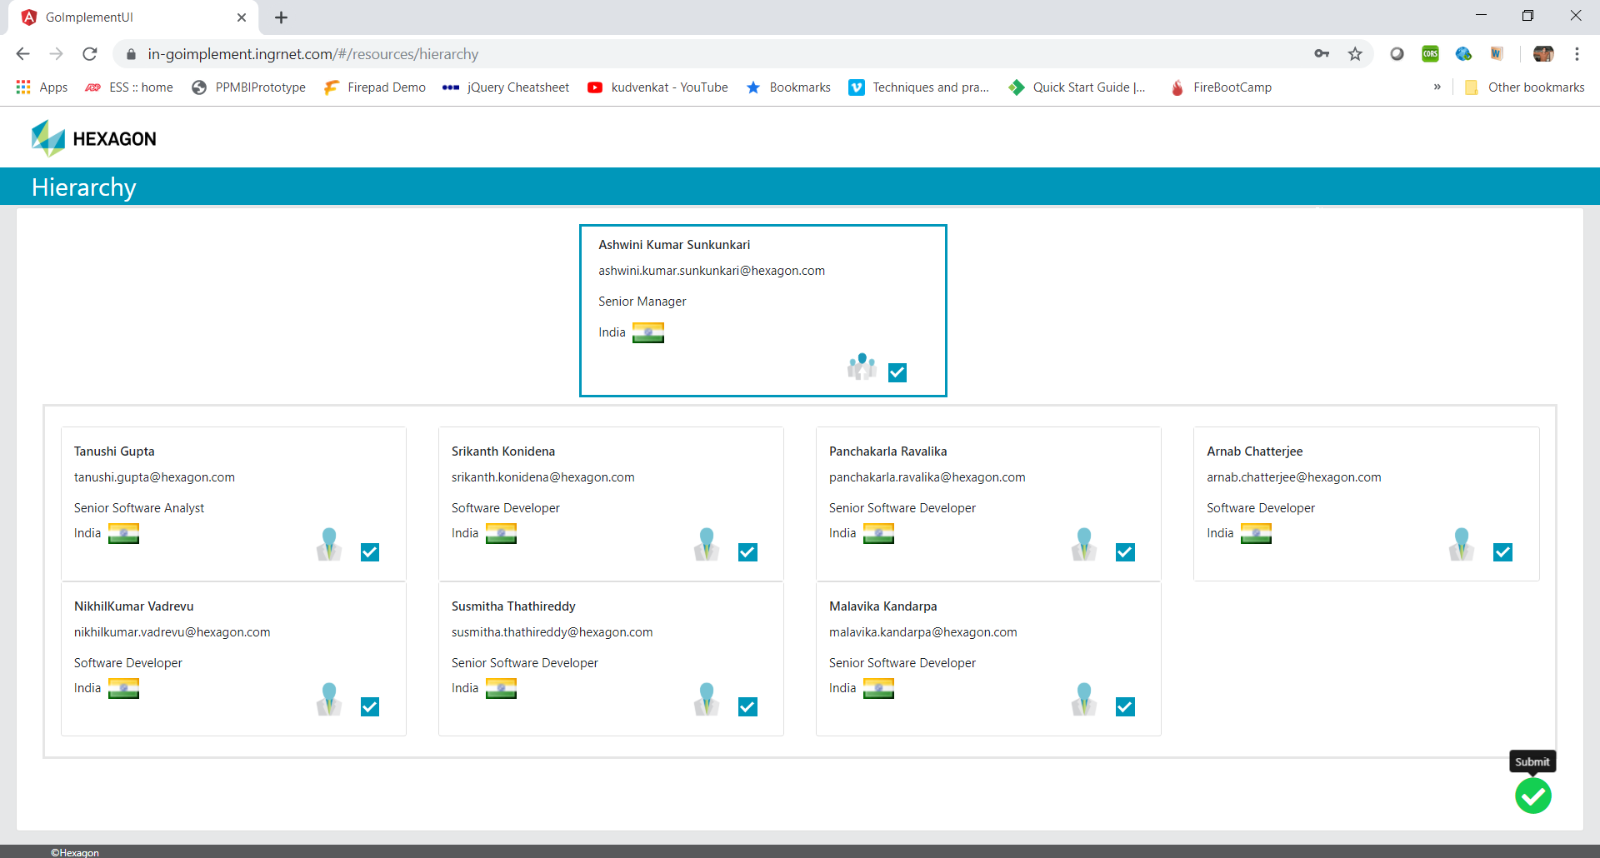

By default, user should see all his Resources Checked and if he clicks submit (Green Button) Resources Added successfully message should displayed and Skills summary Screen will appear.

Case 2(Exclude/make non service Resource):

* When you uncheck an employee in the hierarchy, the employee name is added in the excluded resources list on the left-hand side
* At any point of time you can include any of the excluded employees list back into services list by clicking arrow button on employee card on left side ”Excluded employees” list.
* Upon clicking OK button (green button on the bottom right side),
* From this view the user can make a non-service as service resource and vice versa

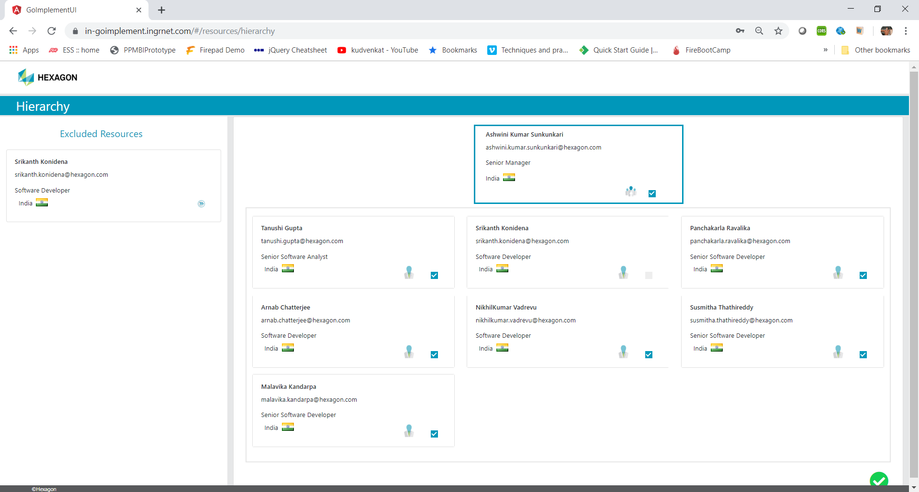

# 3.Skills Summary

After successfully adding Resources, Skills Summary screen will appear.

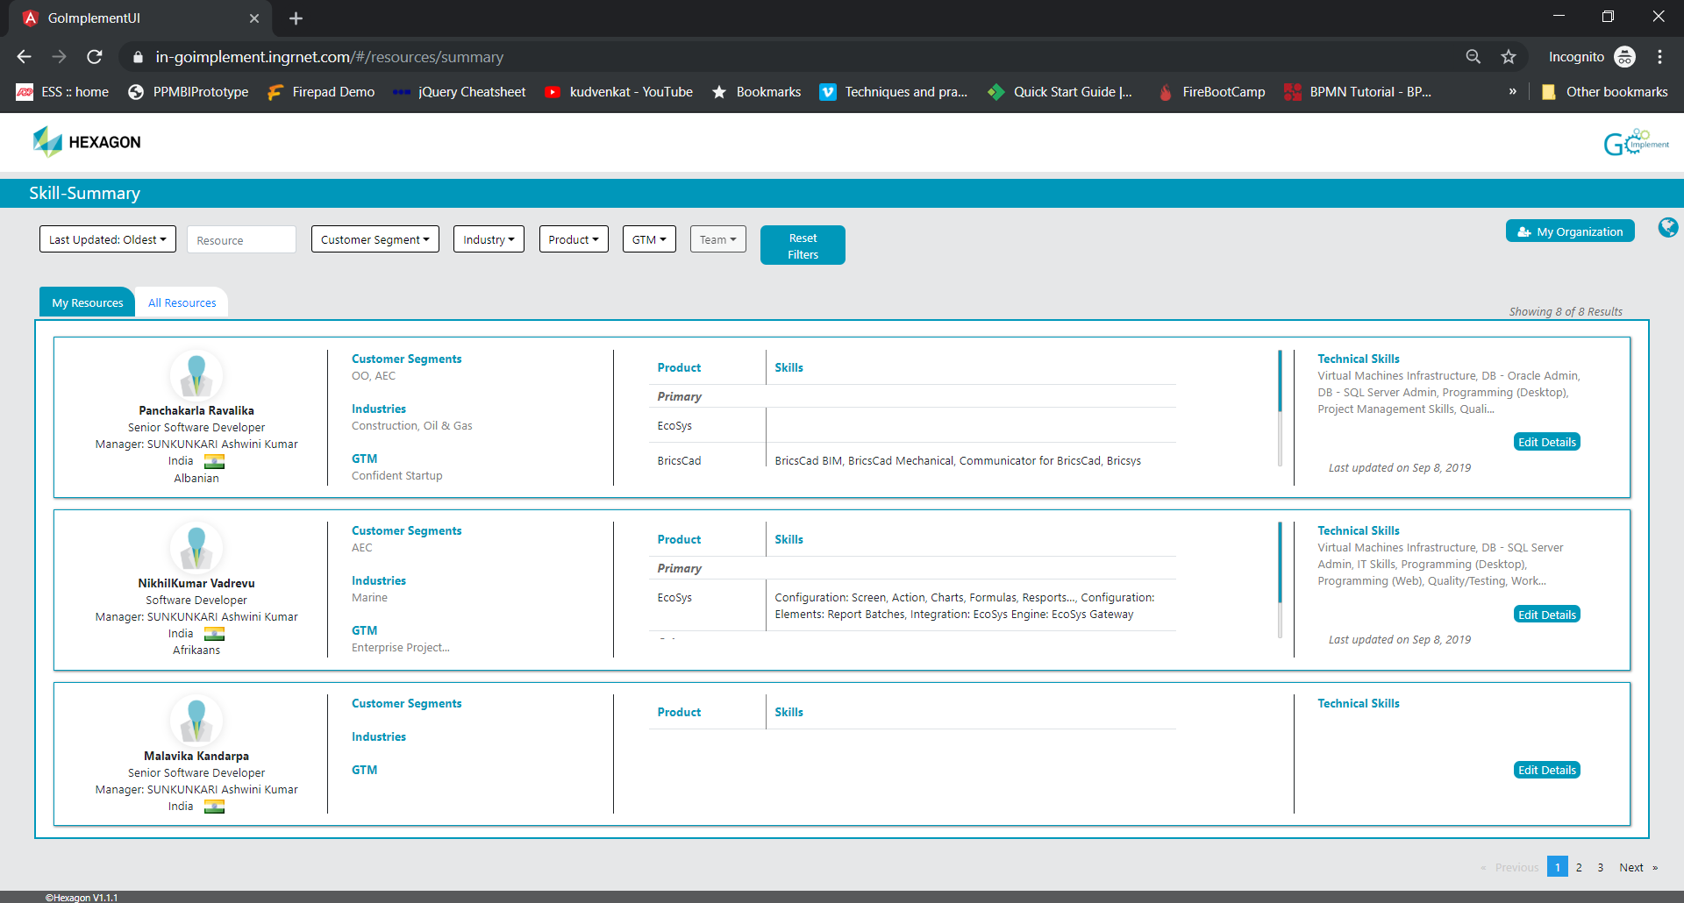

Here user able to see resources reporting to himself in My Resources section and able to see all the resources in All Resources section.

Filters:

Use should be able to filter the Resources based

* Last update
* First Name
* Last Name
* Customer segment,
* Industry
* Product
* GTM Categories
* Teams.

# 4.Edit Skills

From Skills summary screen, user can select a resource to update respective skills by clicking the Edit Button then user will be navigated to Update skills Screen

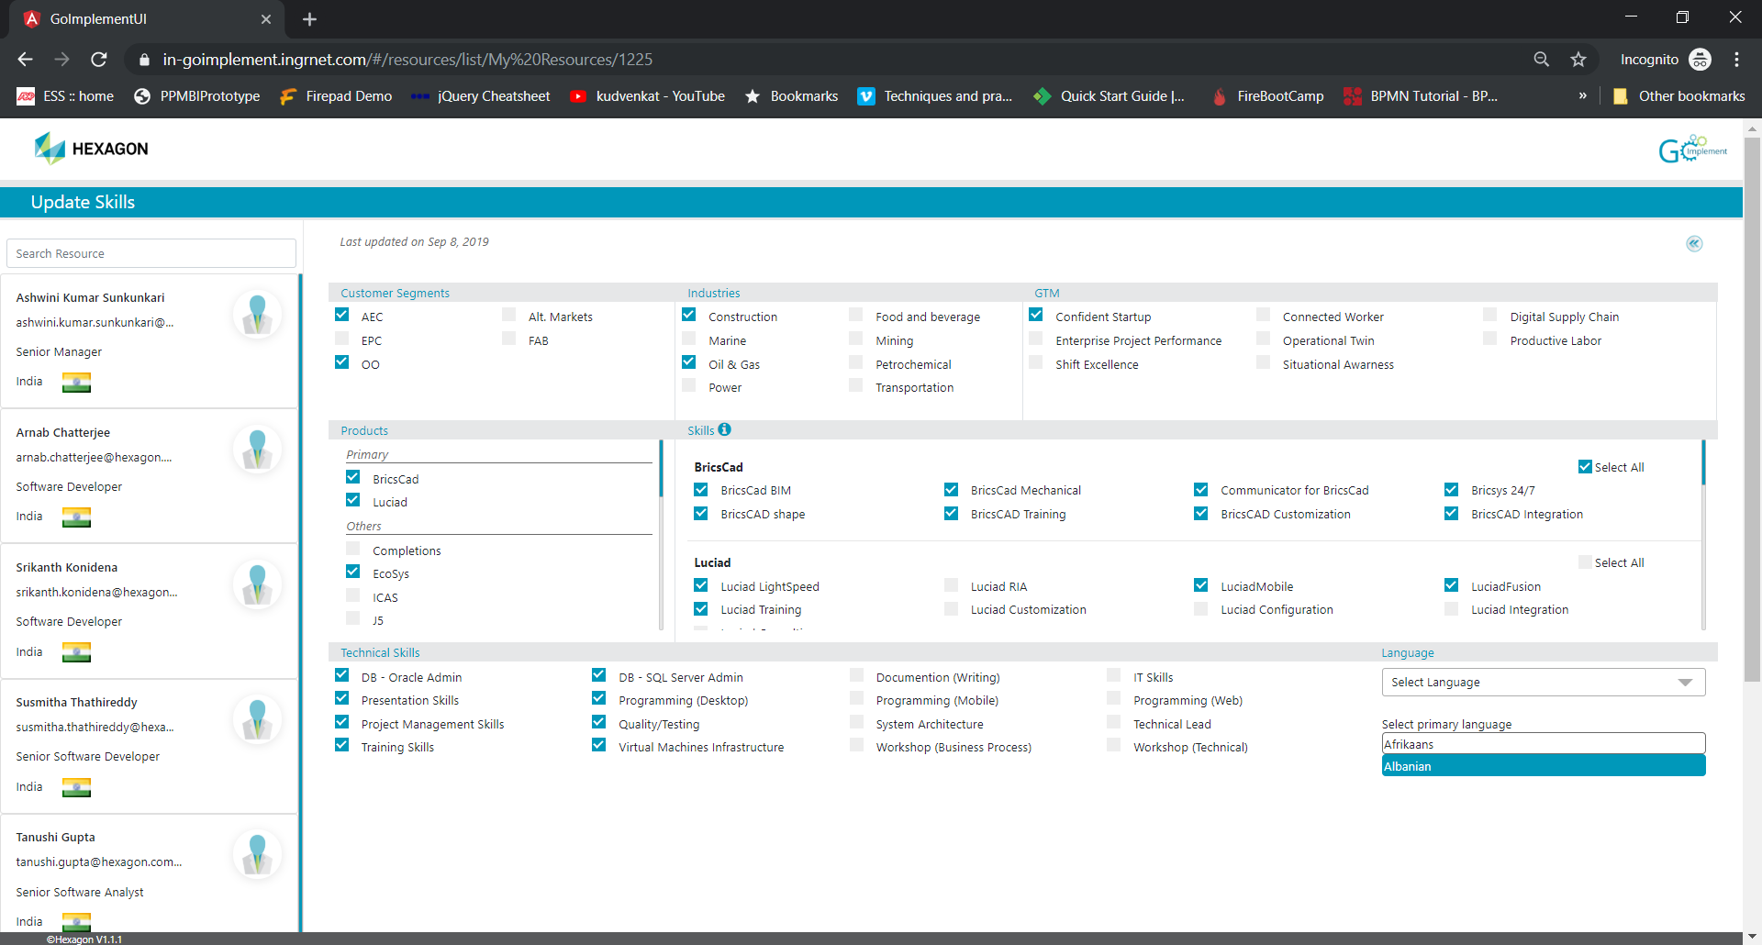

Here user can update below skills;

* Customer segment,
* Industry
* GTM Categories
* Product & Skills
* Technical Skills
* Languages

Validations:

* After updating the skills user should make(select) at least one product as primary skill
* How ever user can select multiple products as primary skill
* User must select one language as primary

# 5.Reset user settings

In order to incorporate application updates, you need to reset the application settings/cache by clicking the Hexagon label (highlighted with Green box)in page footer section and user will be redirected to Login page again.

