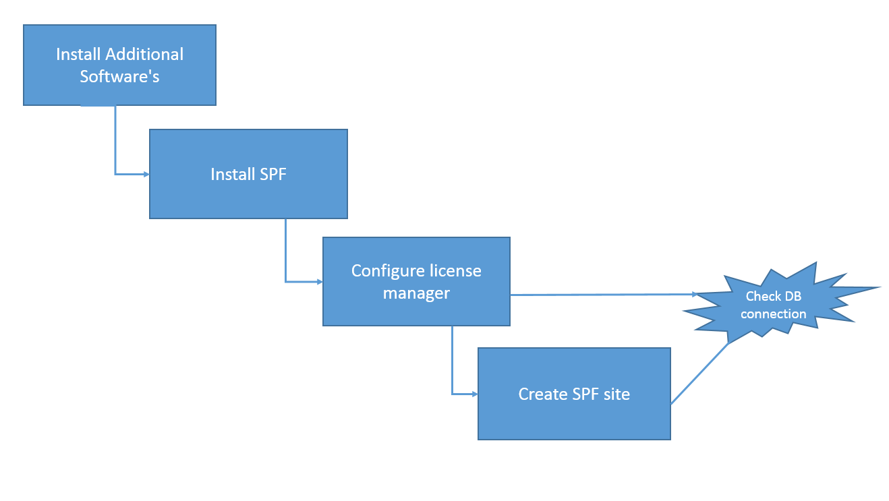

The following steps demonstrates the simple installation of SPF

**A) Steps to install SPF**

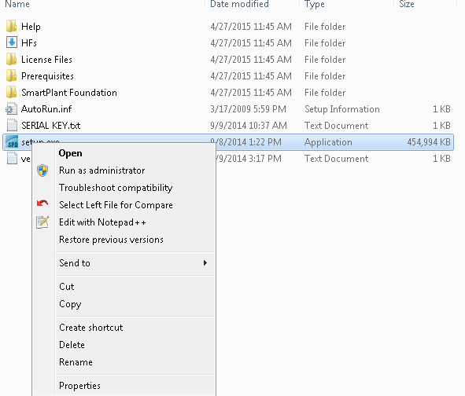

* Before installing the SPF, please check the required additional software’s

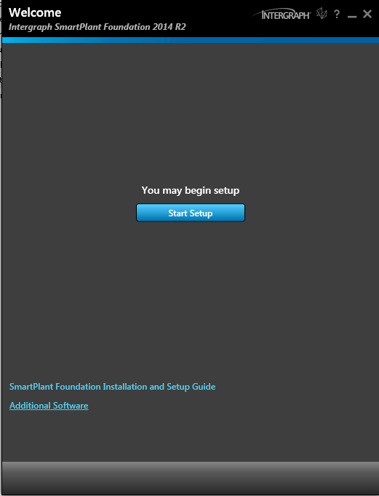

* Make sure install the necessary software’s before installing SPF
* For integration environment the following are necessary
  + SmartPalnt Client.Net and Schema Component.Net setup
  + SmartPlant Client Setup
  + Schema Component setup

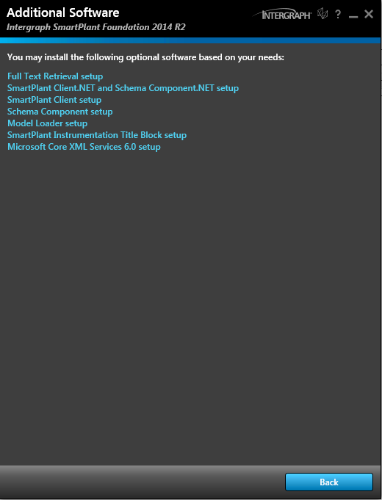

* Enter the serial Number, User Name and company name. Also select the features to install the SPF.
* If you are not sure of license type the select both FlexLM and License Manager under the **‘Select Features to install’.**

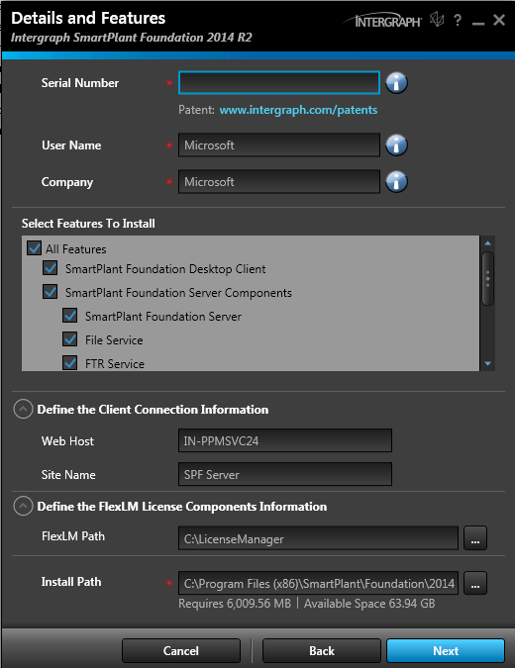

* Accept the license

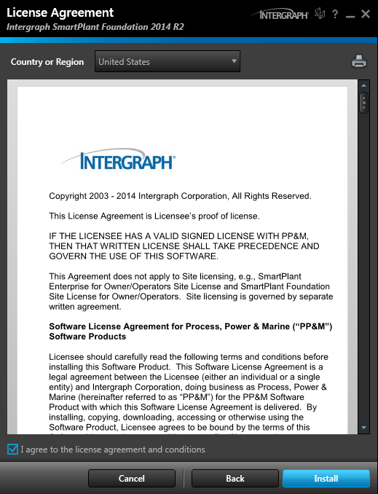

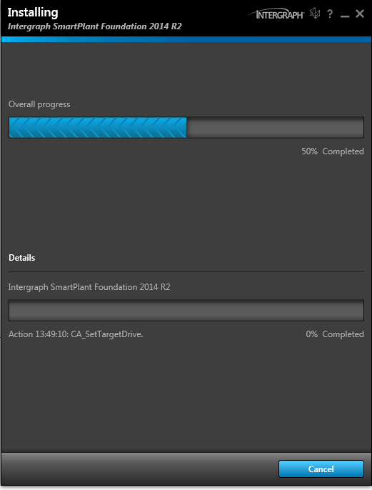

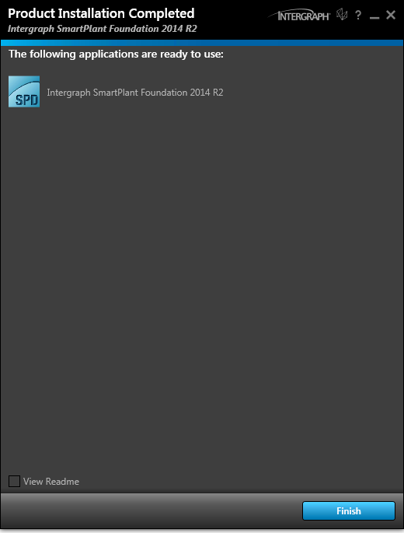

This will finish the SPF setup and after that configuring license manager, creating SPF site and launching it

**B) Configuring new site**

* Open the server manager and set the server manager path to the server. Click OK/Yes to continue the server manager setup/configuring.

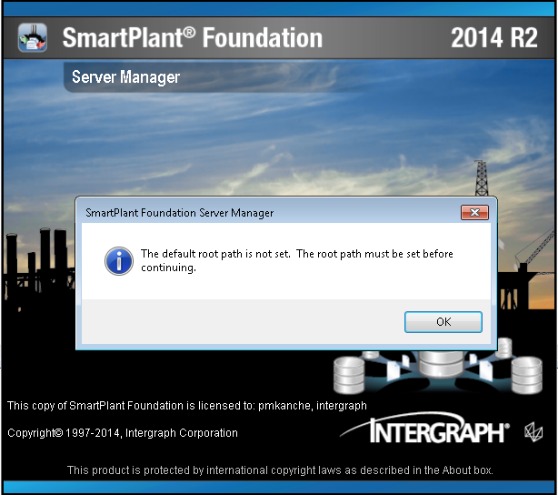

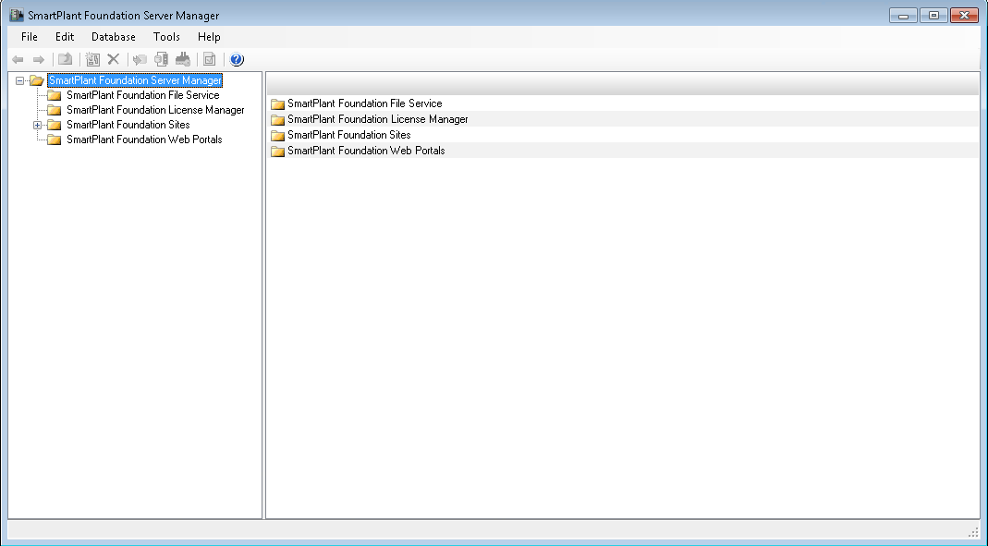

* Create a license manager before creating SPF site. Click ‘New’

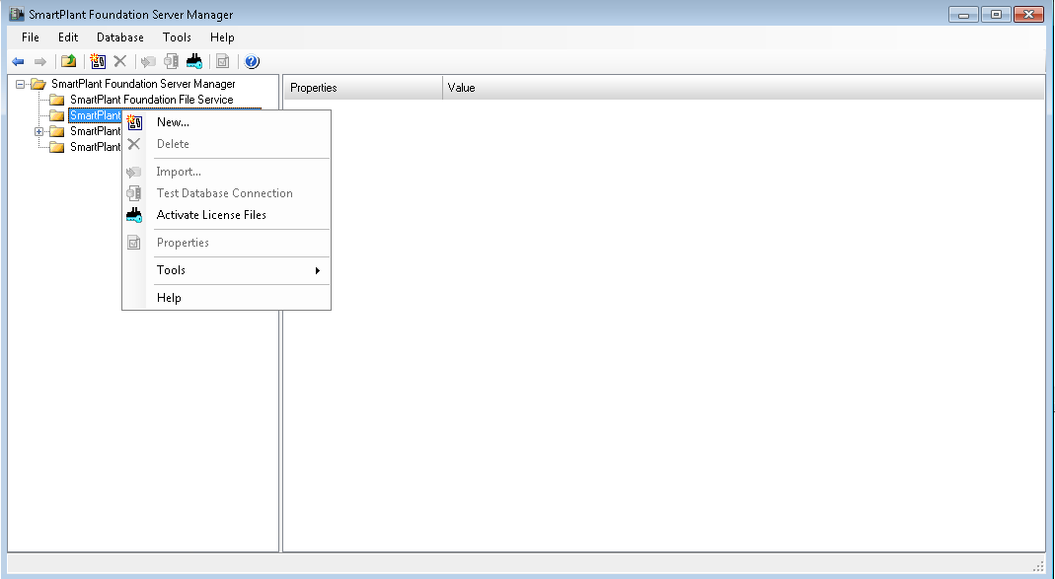

* Select the type of license

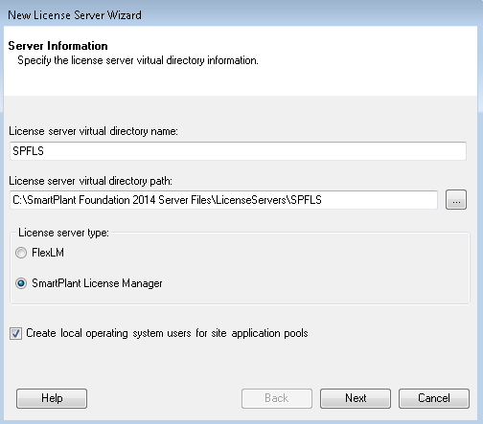

* Enter the credentials based on the data base used.

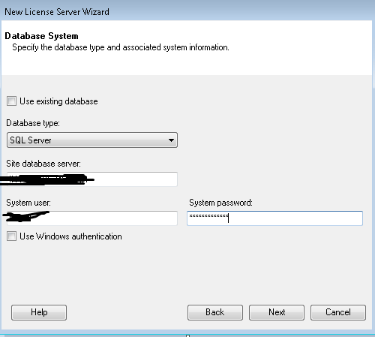

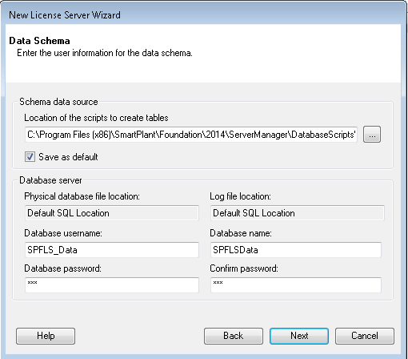

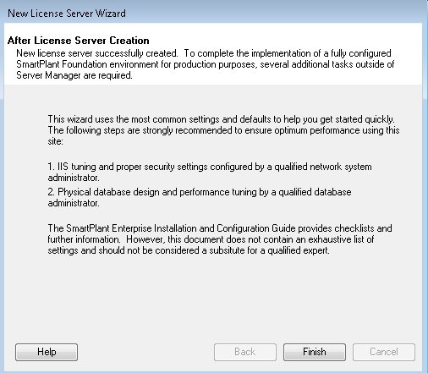

* Once the license manager was created then check the connection (this will not work for FlexLM)

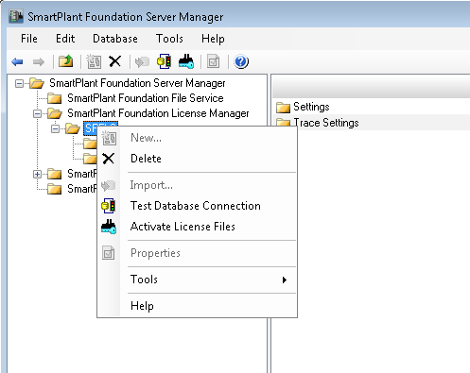

* Connection should be successful

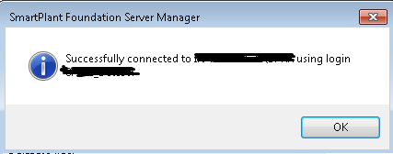

**c)Prepare SPF Site**

* Click “New” for creating new SPF site

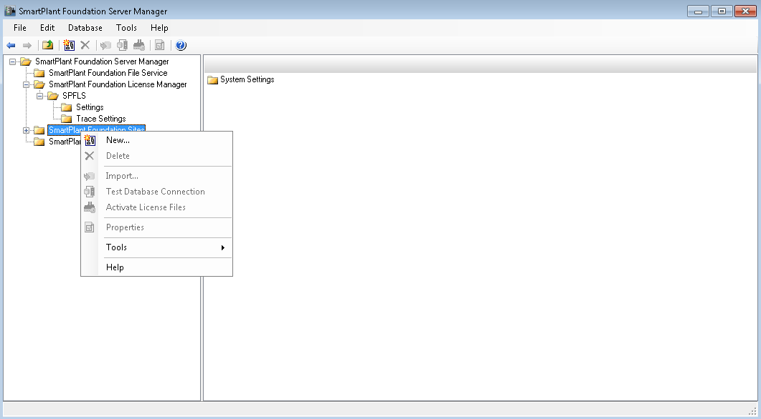

Please follow the this doc for creating SPF site for SQL DB in server manager(Please find it from the attachements)



* Once the SPF site was created then check the connection with the database

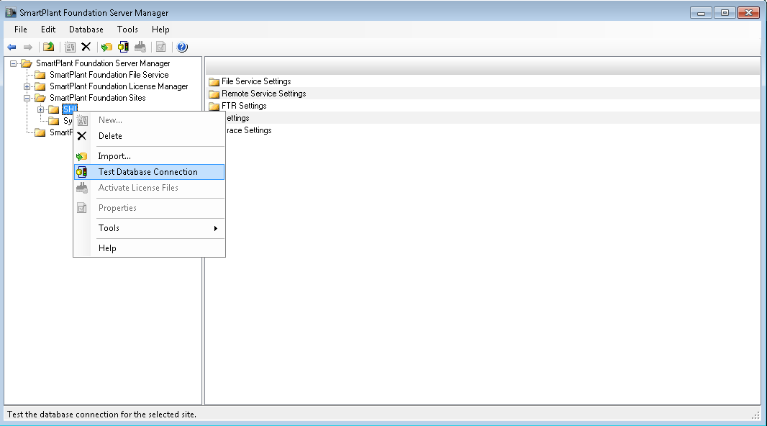

* You should be able to connect the DB successfully

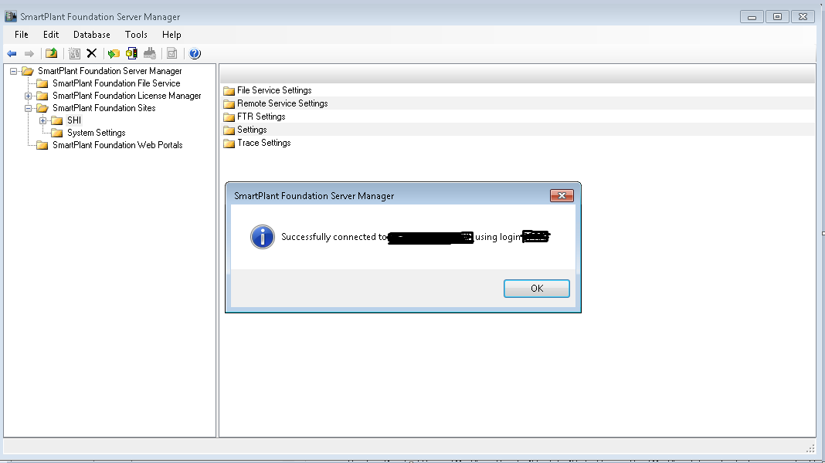

* Then launch the SPF with the newly created site
* Try to connect the new connected site with username as ‘superuser’.
* Select the new site create in the server manager under ”Server” drop down
* Later create separate logins for separate users

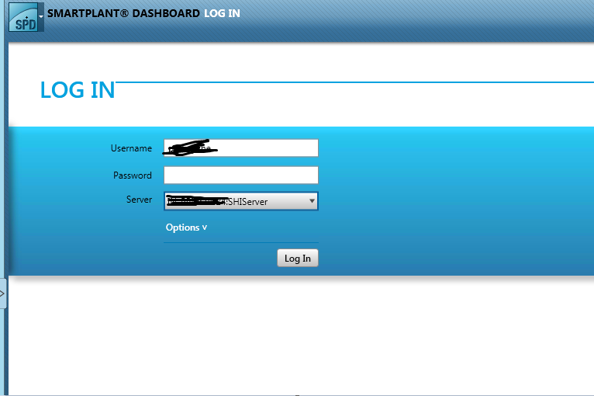

* Click the SmartPlant Foundation Client

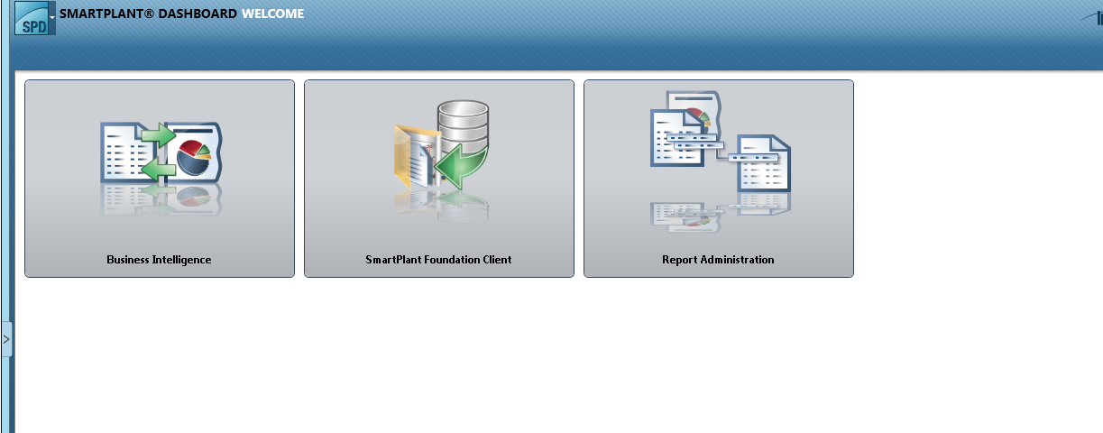

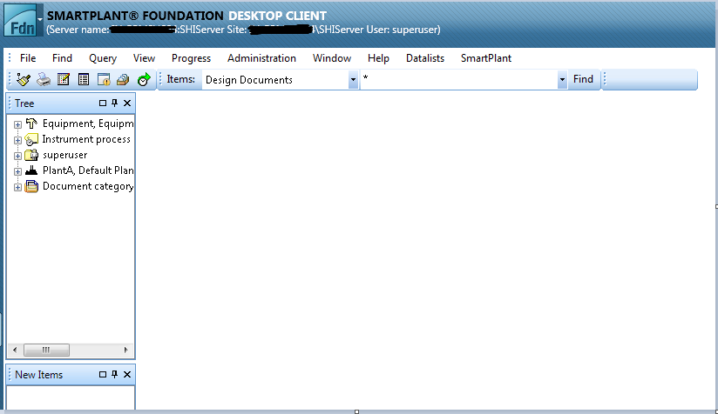

That finishes the setup ☺

**Simple Troubleshooting:**   
Open ‘inetmgr’

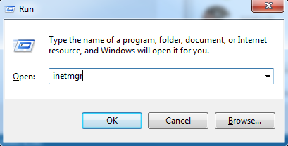

Click OK

This opens the IIS manager

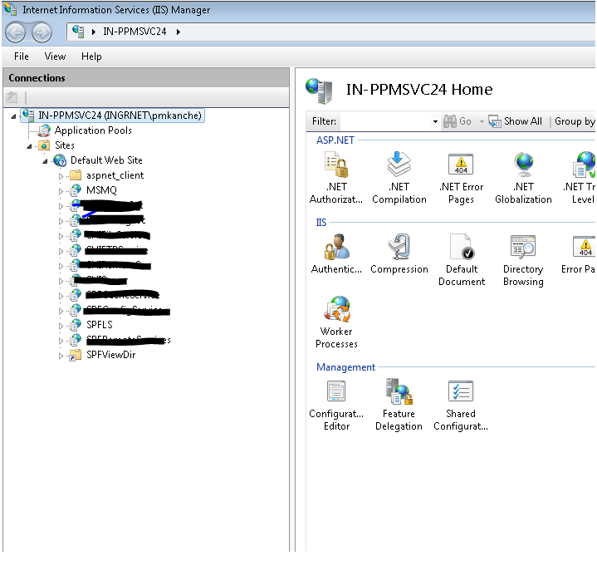

Double click on ‘Directory Browsing’ and ‘Enable’ the feature for SPFLS

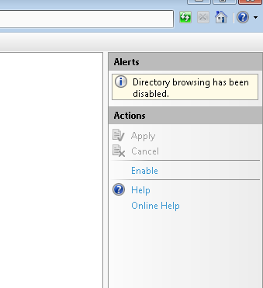

Then browse to SPFLS to check the actual error in case of any license issues

Right click on SPFLS🡪Manage Application🡪Browse

This shows the proper license error message

Similarly we can check the issues in server.

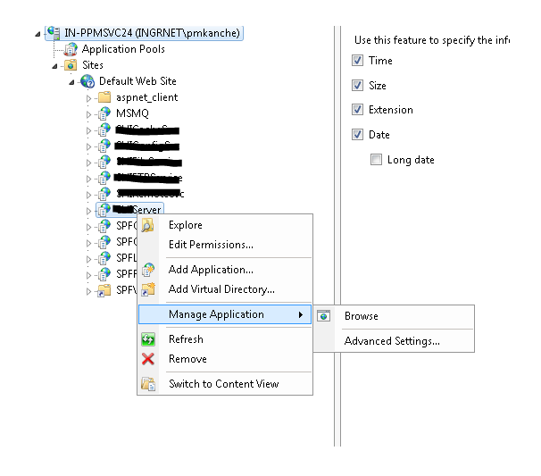

The following page appears if we browse to the server

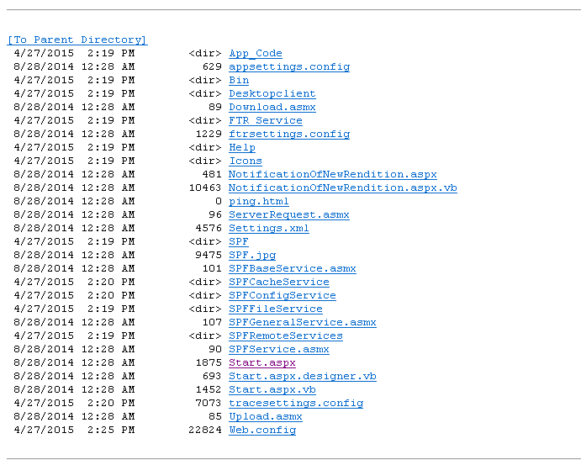

Click on Start.aspx, if everything working fine then the following page appers

