**Problem Statement: eCommerce Web Application**

Develop a web based, distributed application using Springboot and Microservices architecture.

eCommerce application with two different roles, Seller and Buyer.

Seller can perform below operations

1. add new products to inventory
2. update product stock numbers, price
3. view product details

Below are sample wire frames of Seller Use Case

1. List all products along with View, Delete Buttons

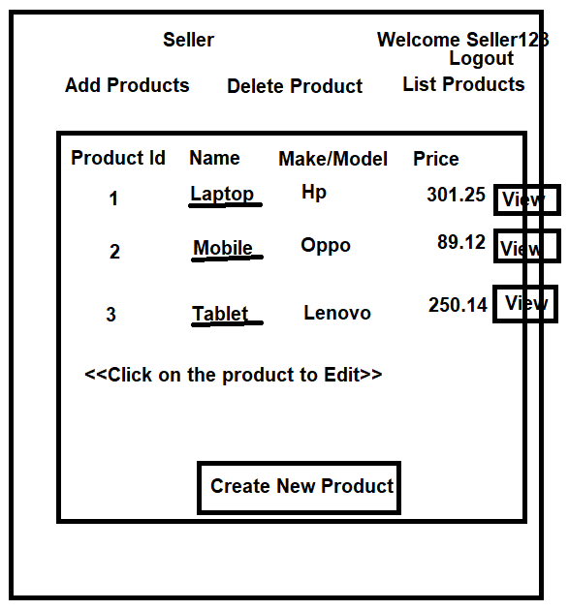

1. Create a New Product(uploading Product Image is optional)

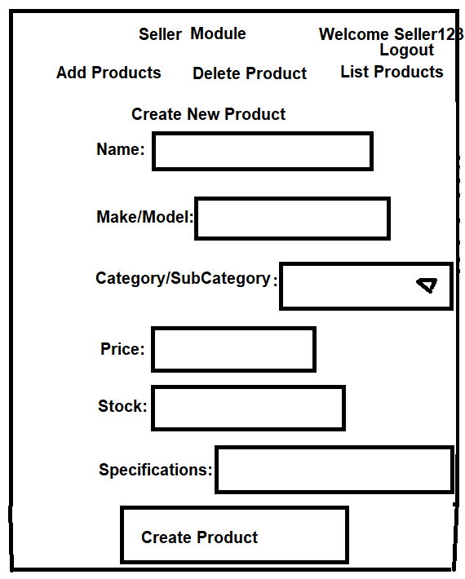

1. Delete option may be provided along with Listing Products or separate Form to specify Product Id, to be deleted.

Buyer can perform below operations

1. search for product based on search string such as product name/make/model, price range, etc…
2. select a Product, specify quantity
3. Buy product
4. After product is bought, update product stock details
5. view purchase History of specific Buyer.
6. Add/delete products to/from shopping cart, check out shopping cart. This requirement is optional.
7. Search Products

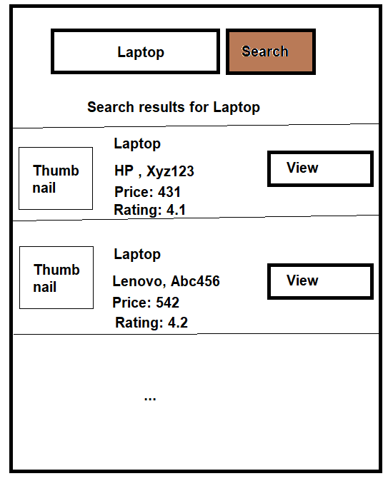

1. View Product

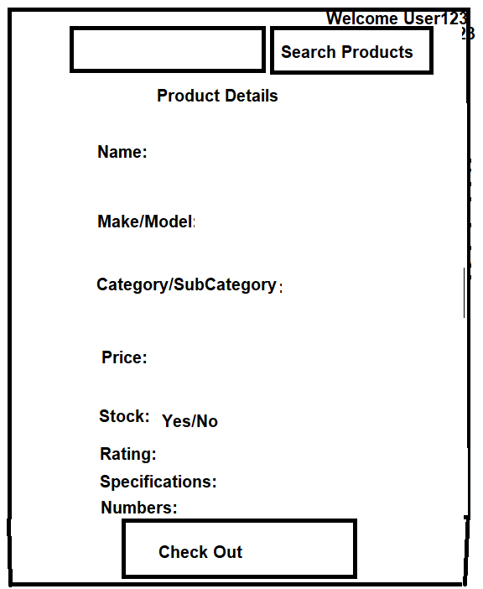

1. Checkout Product

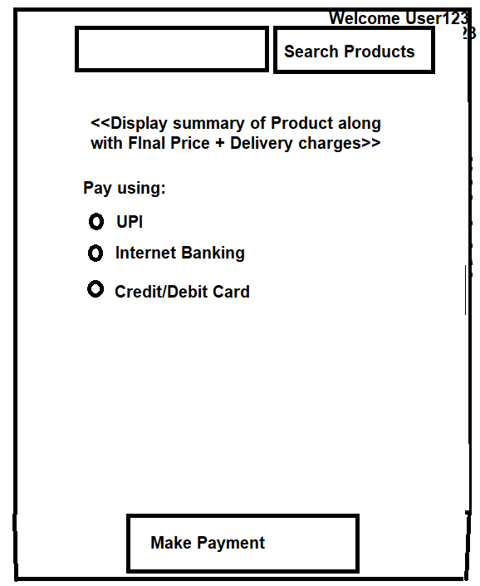

Purchase History of Seller/Buyer can be shown UI

Consider using the DB Tables sellers, buyers, products, purchase_history, you can assume the columns/fields based on the scenario.

**Please see that below best coding practices are applied to the Project:**

1. Use Java 8 and other advanced features
2. Layering and folder structure(with Proper Packages/Sub Packages) - Controller, Service, Repository, Entity classes
3. Use interfaces for loose coupling
4. Proper Exception Handling and create Custom Exceptions
5. Exception Wrapping
6. Close Connections
7. Proper Table Schema with required Foreign key relationships,
8. Validations - use regex

**Deliverables:**

1. Compiled Backend(Java /Spring Boot source code) and Front End(React) on Github
2. Output Screenshots(atleast 3 to 4) of Back end and Front end

Single React app which consumes below REST APIs

/seller/addproduct -- POST

/seller/listproducts -- GET

/seller/viewproduct -- GET

/seller/updateproduct -- PUT

/buyer/search -- GET

/buyer/product/<product_id> -- GET

/buyer/checkout -- POST

