Database System Engineering and Distributed Backend Development(25CS1302E)
Practical Week-1

Name : Venkata Sai Krishna
Roll No. : 2520030027
SEC : 7

Step 1 : Database Setup
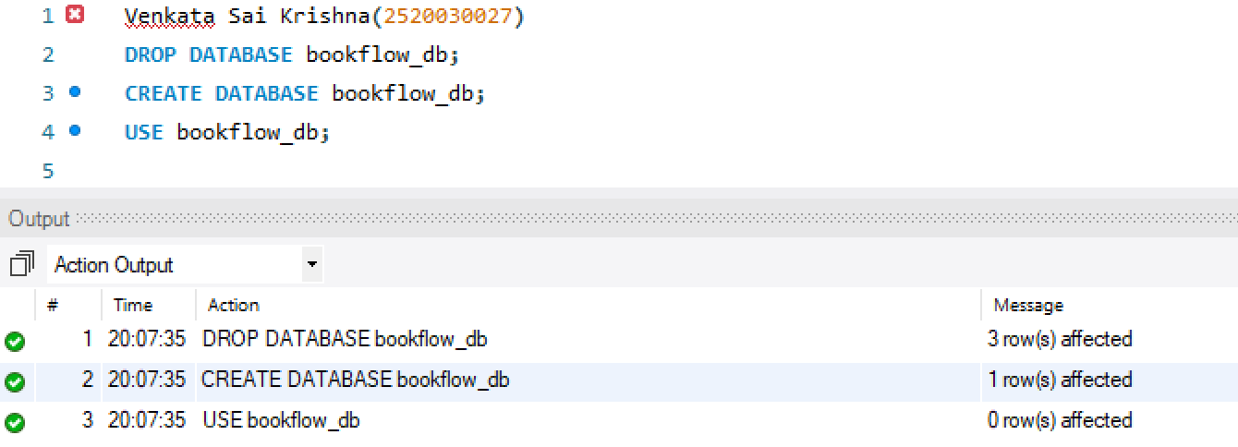

Step 2 : Table Creation
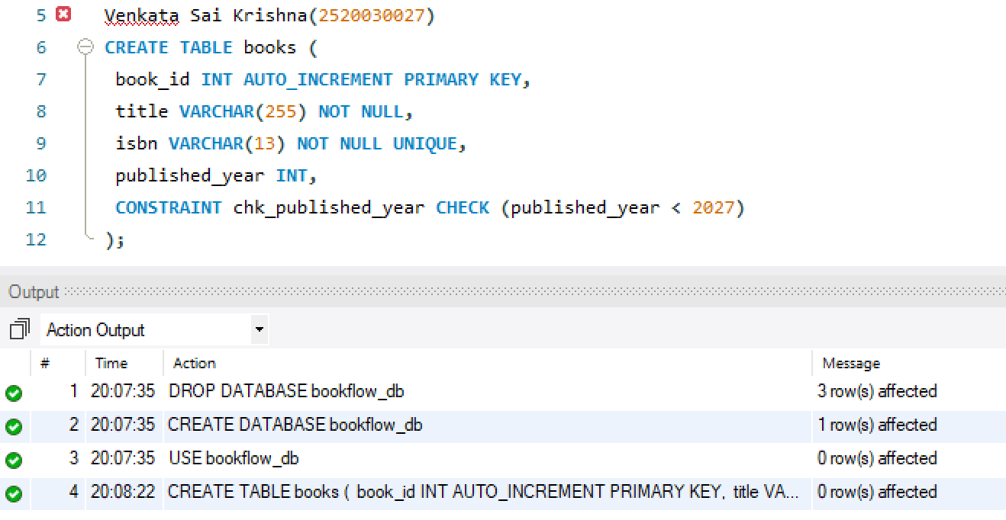
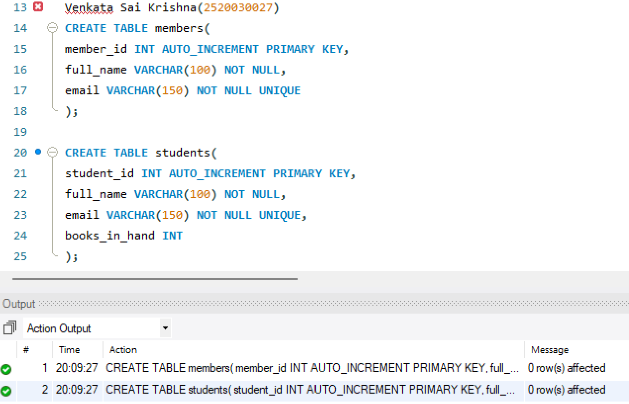
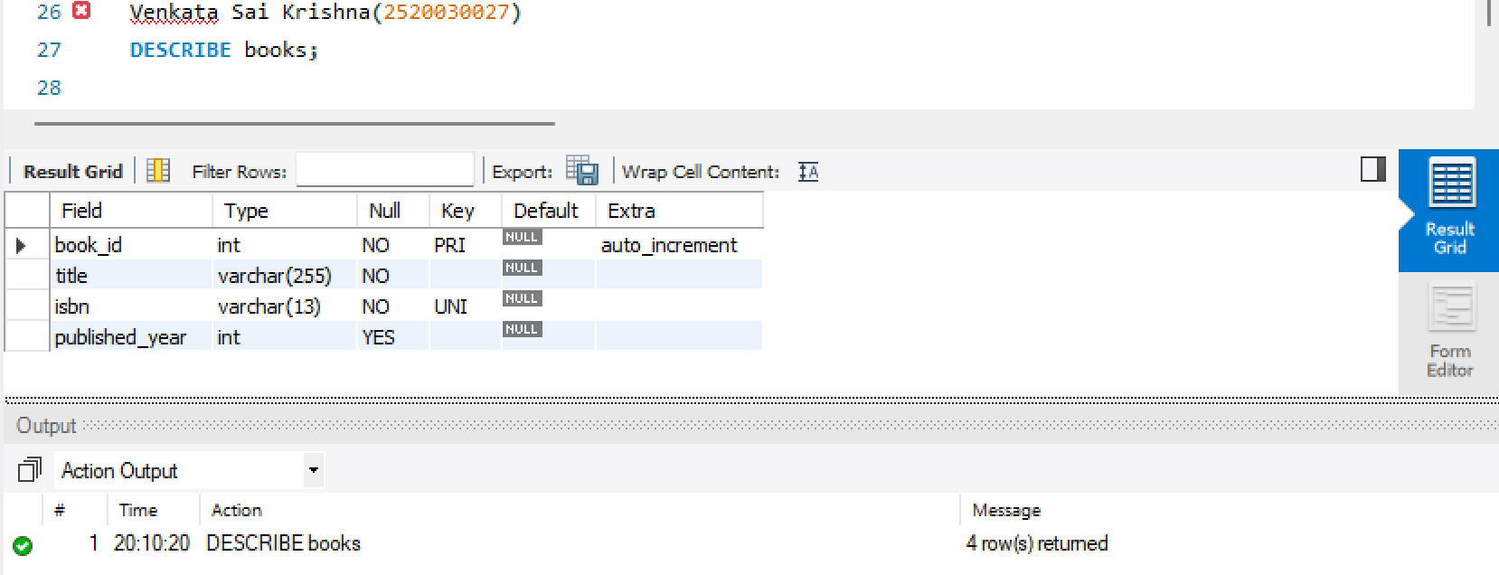

Step 3 : Initial Seeding
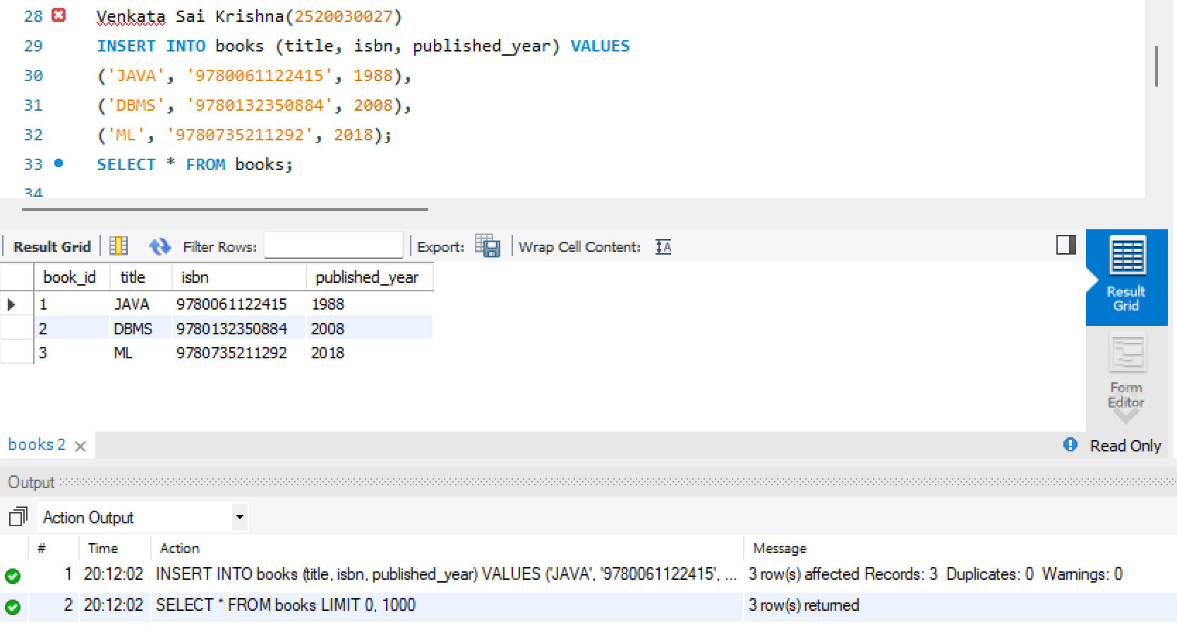
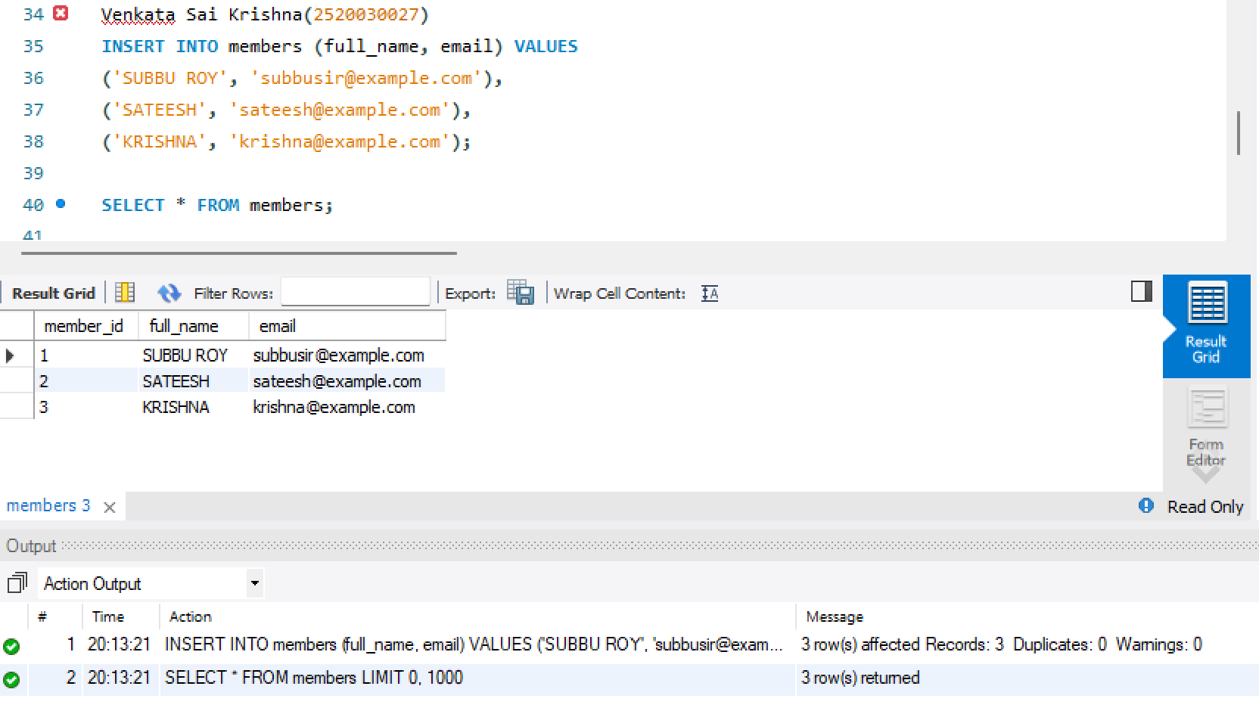

Step 4 : Constraint Tests
