#### **Random Quote Generator**

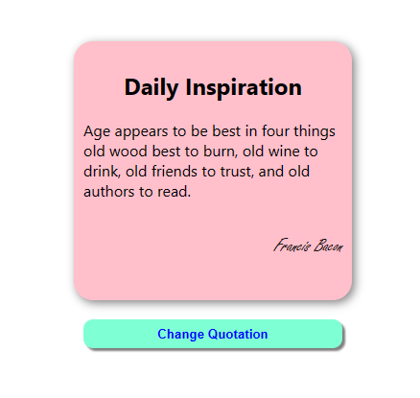

#### Props

* **btnTxt**: The text to be displayed on the button for generating a new quote.
* **heading**: The heading or title for the quote display.

#### State

* **quoteText**: Holds the text of the current quote.
* **author**: Holds the author of the current quote.
* **quote**: Represents the index of the current quote in the fetched data. The default value is 0.

#### useEffect Hook

The **useEffect** hook is used to fetch data from the "<https://quote-garden.onrender.com/api/v3/quotes>" API when the component mounts or when the **quote** state changes.

* It makes an asynchronous call to the API using the **fetch** function.
* Upon a successful response, it extracts the quote text and author from the API response and updates the state variables **quoteText** and **author**.
* If there's an error during the API call, it logs an error message to the console.
* The **useEffect** hook is dependent on the **quote** state, meaning it will re-run whenever the **quote** state changes.

#### fetchApi Function

* **fetchApi**: An asynchronous function responsible for fetching data from the API.
* It constructs the API URL, sends a request using **fetch**, and then processes the response as JSON.
* It updates the state variables **quoteText** and **author** based on the data from the API.

#### increment Function

* **increment**: A function that increments the **quote** state by 1.
* If the current value of **quote** is greater than or equal to 10, it resets **quote** to 0. Otherwise, it increments **quote** by 1.

#### Render

* The component renders a **div** with the class name "main" containing two child elements.
* The first child contains a heading (**h2**), the current quote text (**p**), and the author (**p**).
* The second child is a button with an **onClick** handler that triggers the **increment** function.