**Student Registration Form**

* Login Page
  + When you submit blank form error is shown

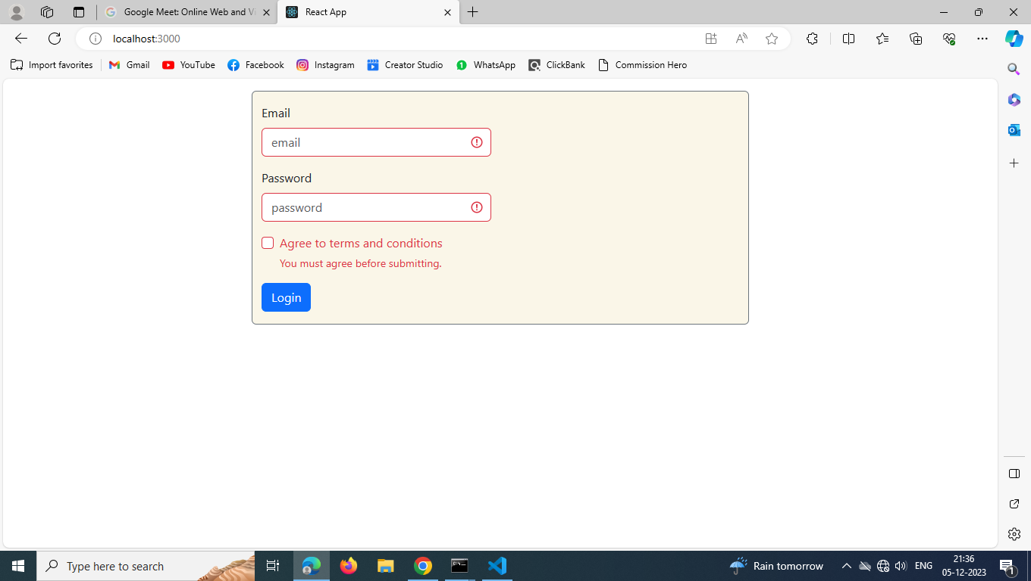

* Popup is shown when enter incorrect password or Email

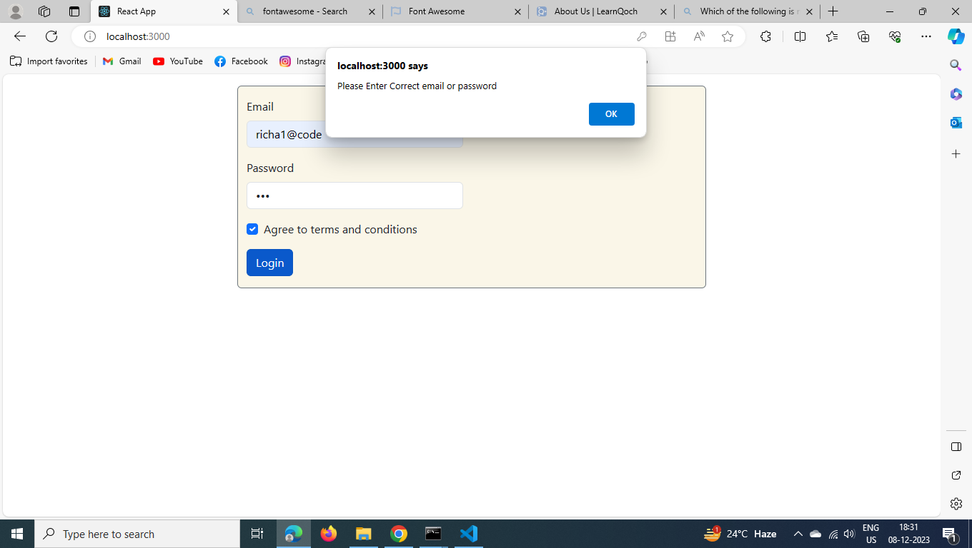

* When you Login successfully redirect to registration page and login credentials are stored in local storage.

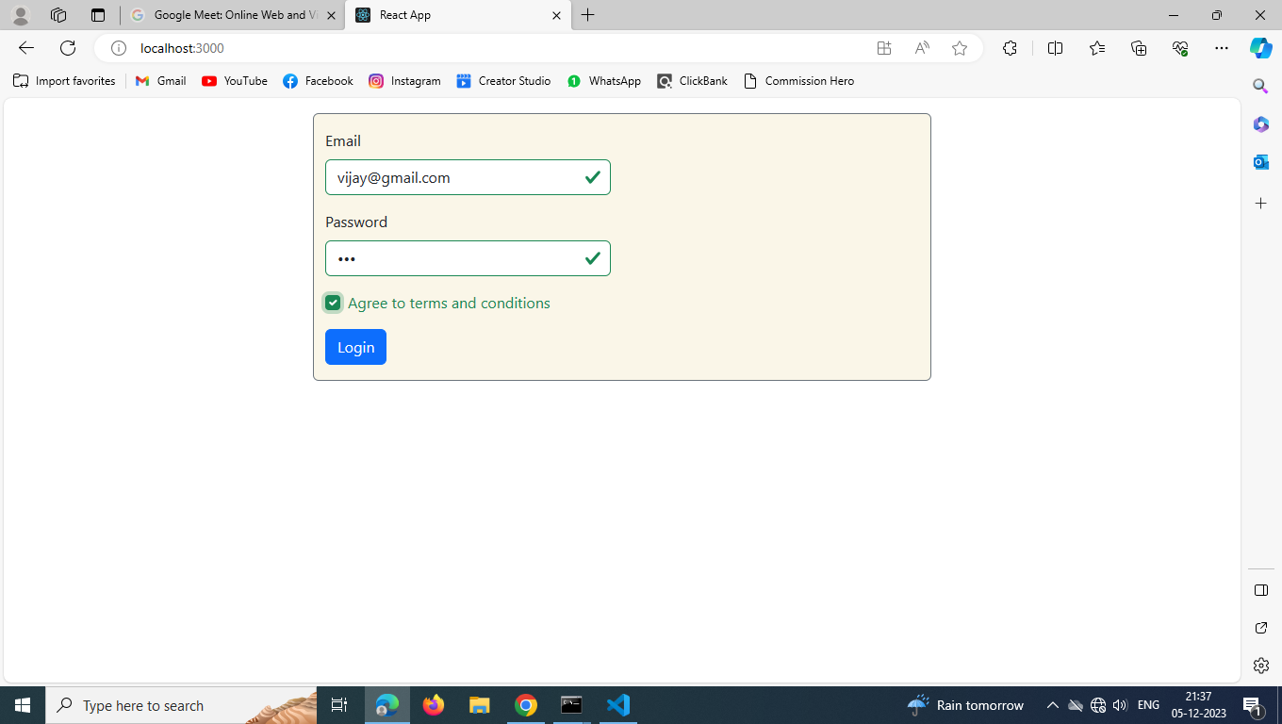

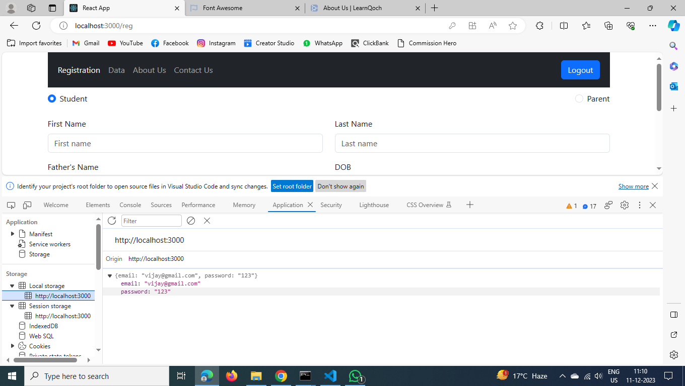

* Registration Page: when you are submitting blank form error and toaster is shown.

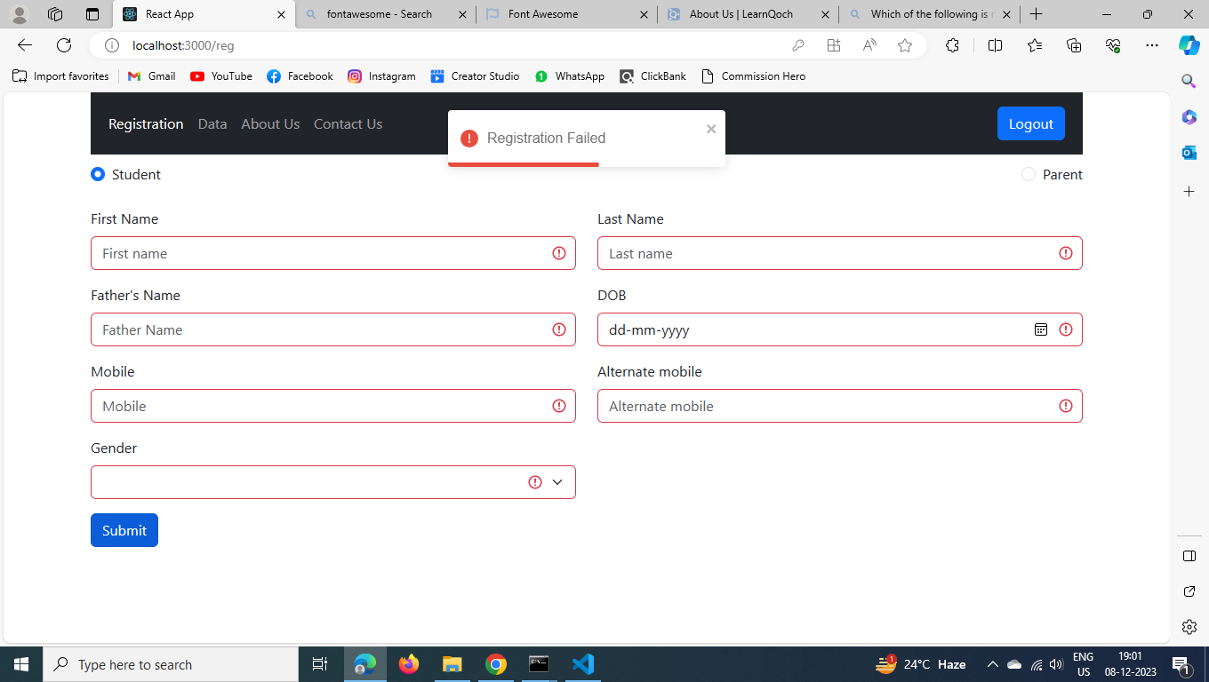

* When form is successfully submitted, and data is stored in Api

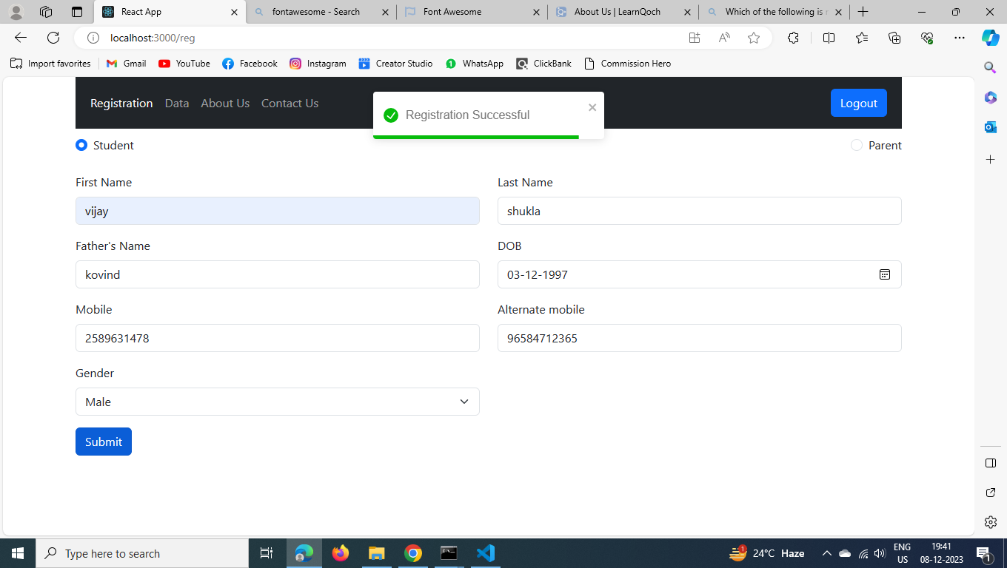

* Data is fetched from Api and shown here

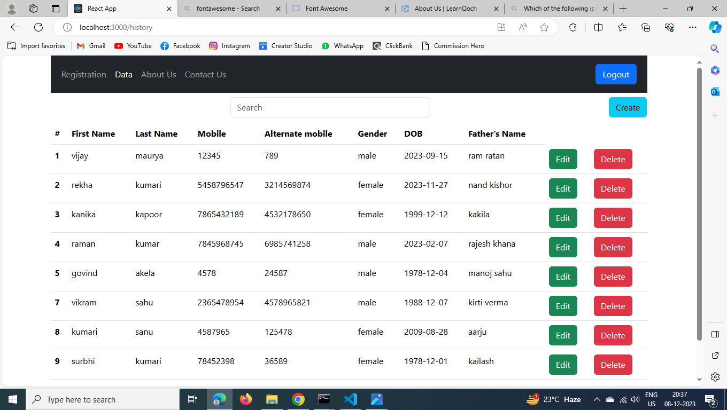

* Search: Enter the name of the user and search for specific data for it.
* Pagination will also be shown when data is more than 10 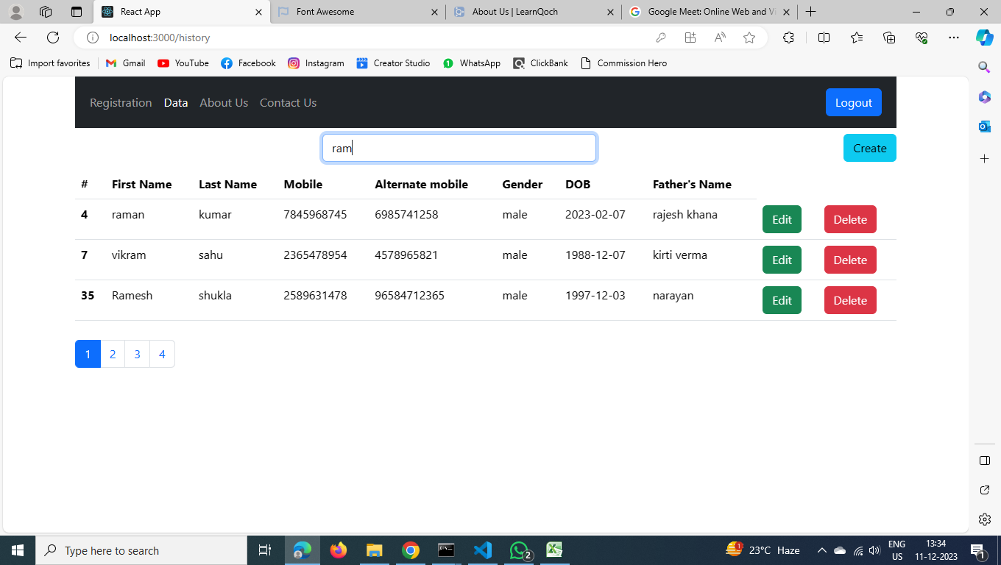
* When clicked the delete button data is removed from database. See id 35

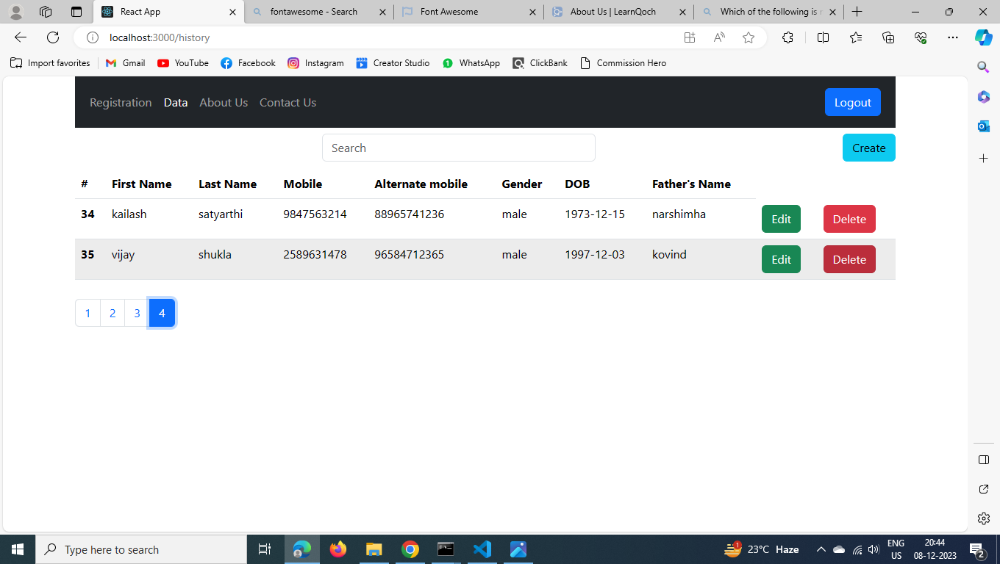

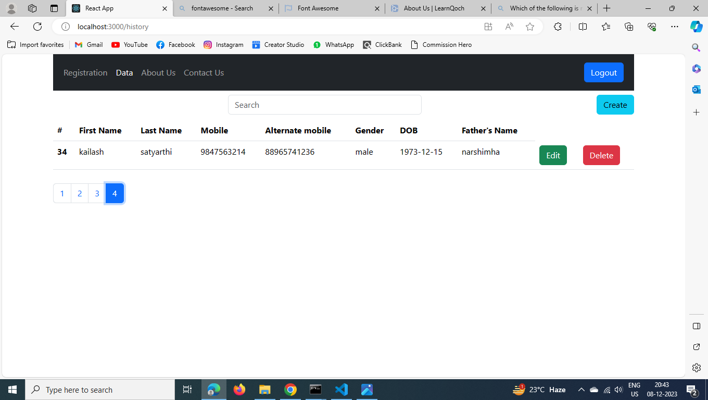

* Update: When clicked the update button update information is shown where we can change our information and save it.

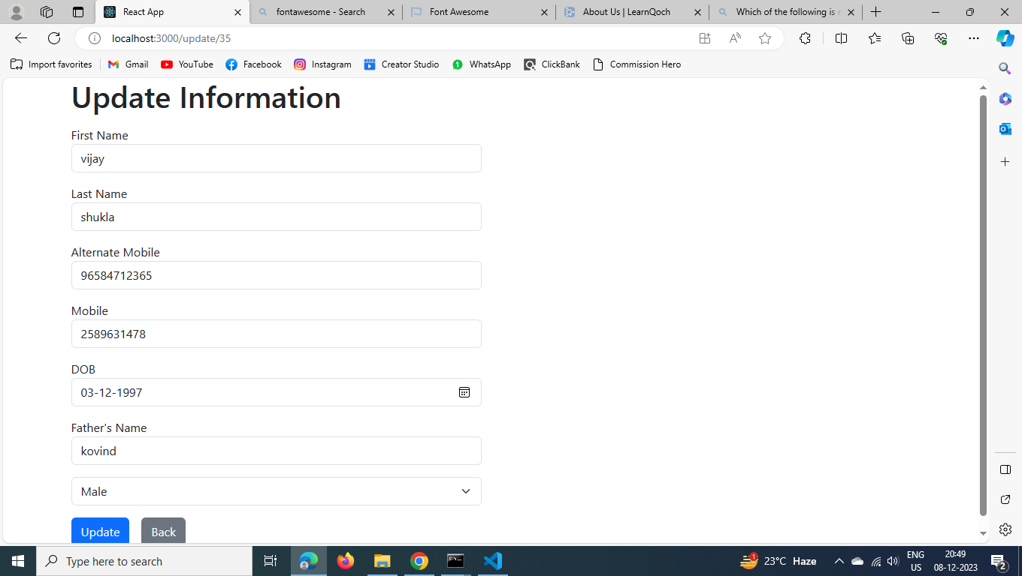

See here updated data (id 35)

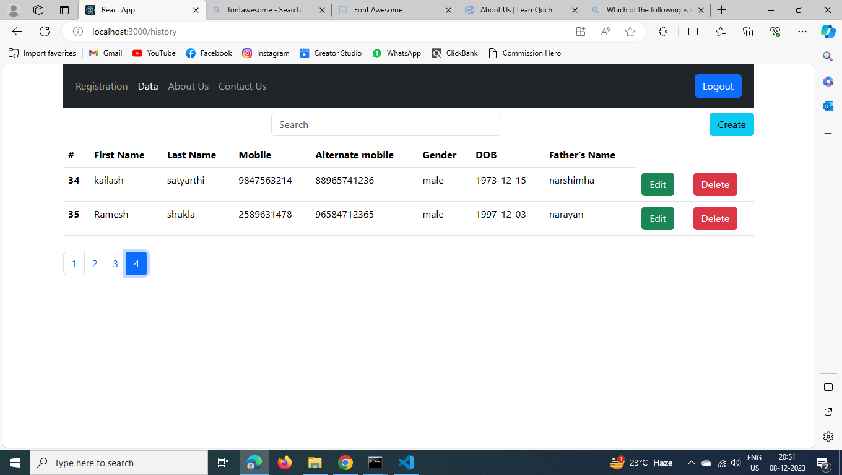

About Us

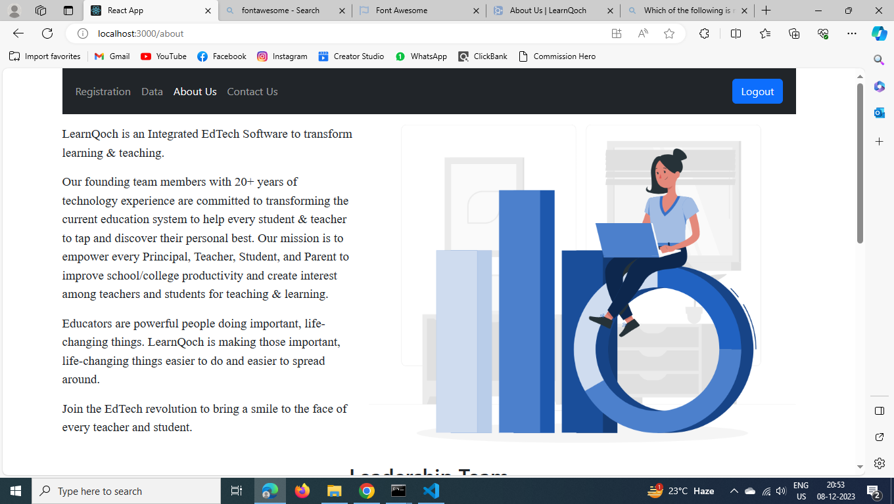

Contact Us

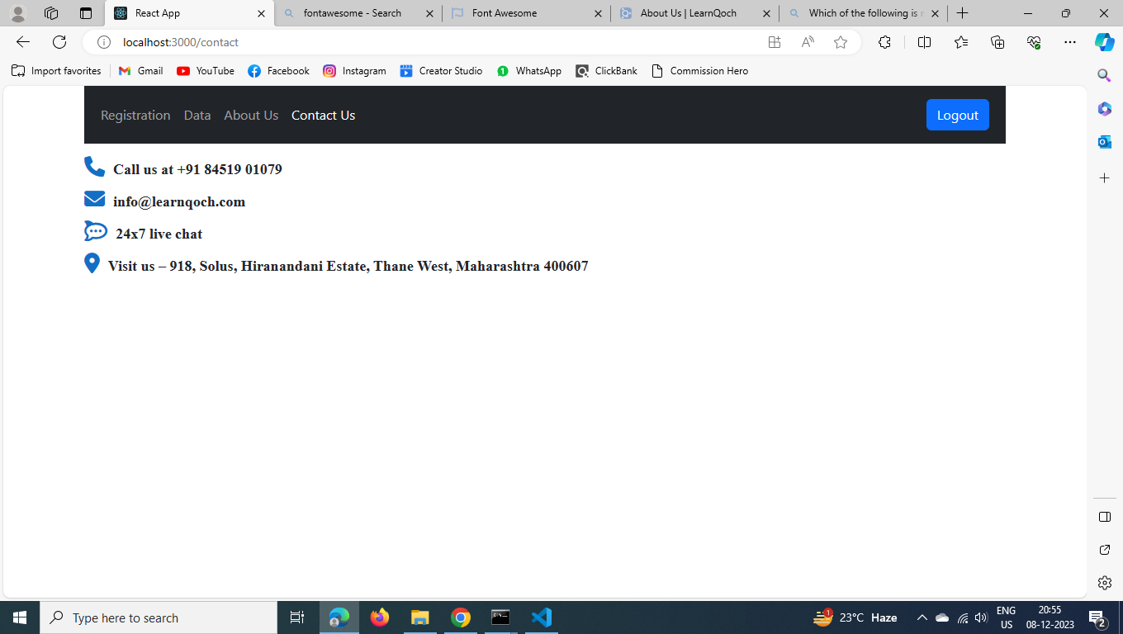

Logout: when clicked the logout button redirect into login page and login credentials which were stored will be removed.

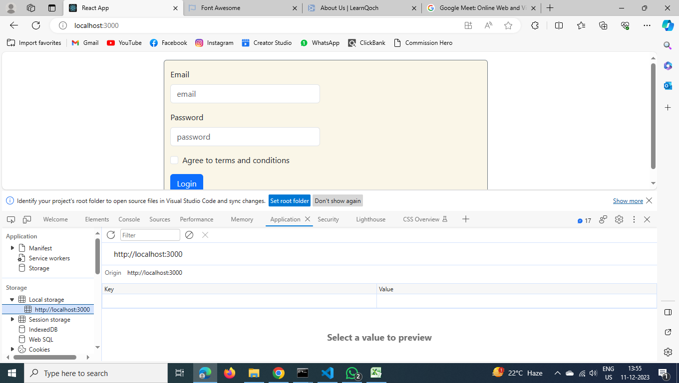

Data stored in Api

