Question Paper Set 2
Class XII – Reproduction (Reproduction in plants, human reproduction, reproductive health)
Time: 60 minutes | Max Marks: 32

Section A: Multiple Choice Questions (8 x 1m)
- Which part of the pollen grain is characterized by the presence of 'Sporopollenin'? (a) Intine (b) Germ pore (c) Exine (d) Generative cell
- In a 7-celled, 8-nucleate embryo sac, the 'Central Cell' is: (a) Haploid (b) Diploid (c) Triploid (d) Binucleate
- The transformation of round spermatids into mobile spermatozoa is known as: (a) Spermatogenesis (b) Spermiogenesis (c) Spermiation (d) Insemination
- At what stage of embryonic development does the human embryo get implanted into the uterine wall? (a) Zygote (b) Morula (c) Blastocyst (d) Gastrula
- Which of the following IUDs is hormone-releasing? (a) Multiload 375 (b) Lippes Loop (c) LNG-20 (d) Cu7
- Cleistogamous flowers have an advantage because: (a) They exhibit high genetic variability (b) They do not depend on pollinators for seed setting (c) They attract diverse insect species (d) They prevent self-pollination
- The signals for parturition originate from: (a) Placenta only (b) Fully developed foetus only (c) Both placenta and fully developed foetus (d) Maternal pituitary gland
- 'Amniocentesis' is a technique used to determine: (a) The sex of the foetus (b) Genetic abnormalities (c) Maturity of the foetal heart (d) Both a and b

Section B: Short Answer Questions (4 x 2m)
- What is Apomixis? Mention one way it is beneficial to farmers.
- Define 'Capacitation'. Where does it occur in the female reproductive tract?
- Differentiate between Vasectomy and Tubectomy. Why are they considered terminal methods of contraception?
- Name the three accessory glands of the male reproductive system. What is their collective secretion called?

Section C: Long Answer Questions (3 x 4m)
- Draw a neat, labeled diagram of a human sperm. Explain the function of the Acrosome and the Middle Piece.
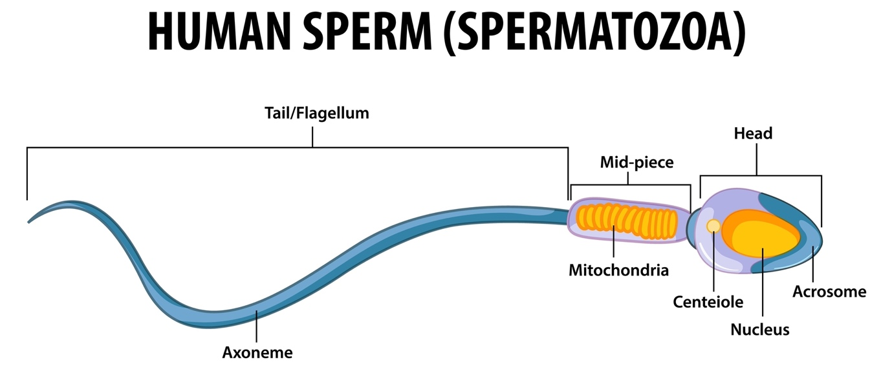
Shutterstock
Explore
- Describe the process of Double Fertilization in Angiosperms. Why is it called "Double" fertilization?
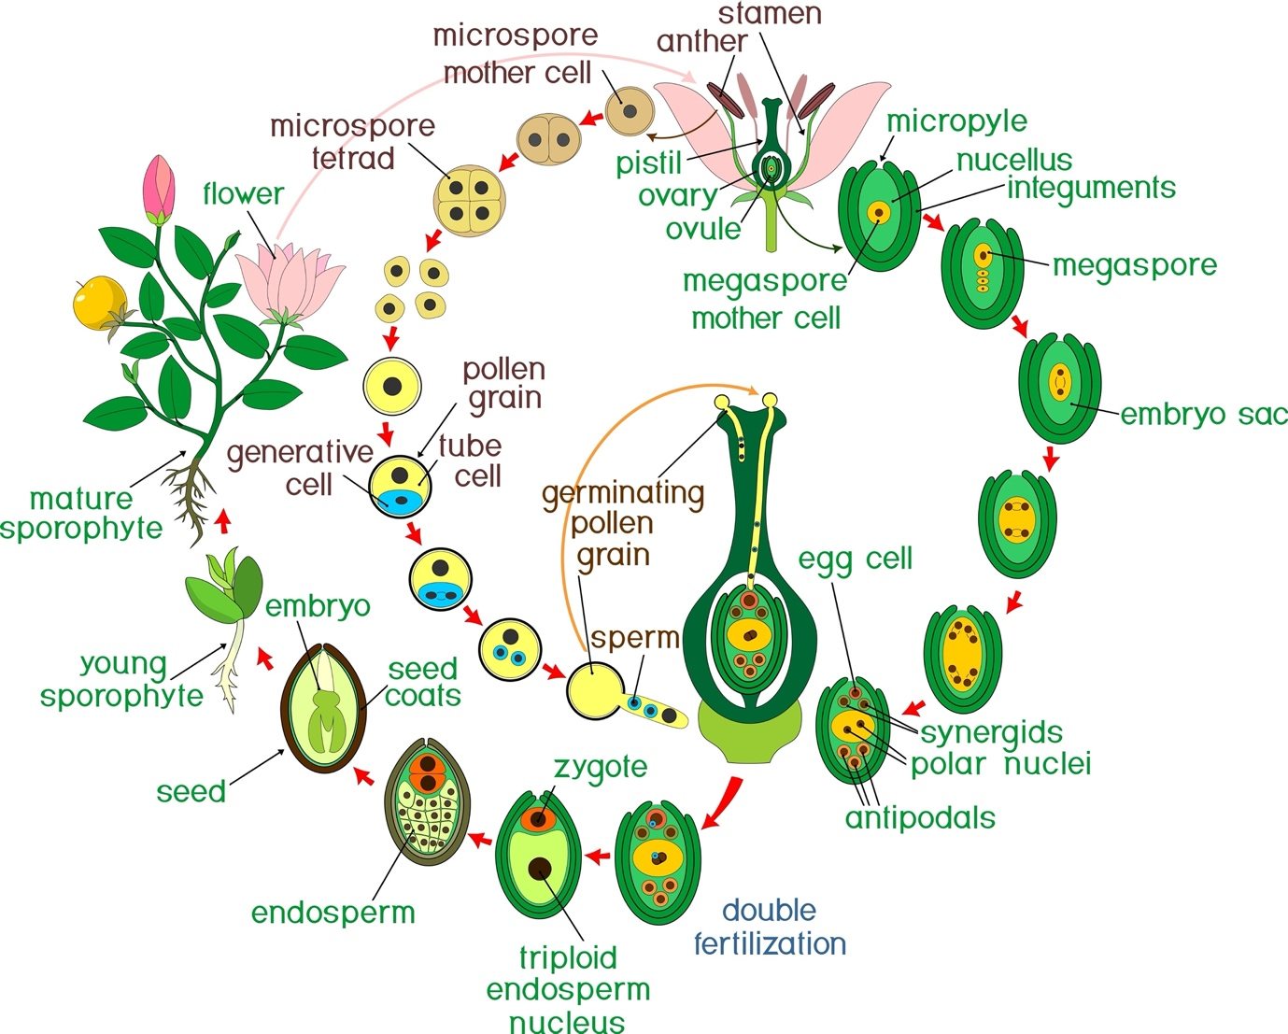
Shutterstock
- Discuss the various Assisted Reproductive Technologies (ART) available for couples suffering from male infertility factors (e.g., low sperm count). Focus on ICSI and IUI.

Section D: Case Study Question (1 x 5m)
- Case Study: Agricultural Innovation A scientist is working on a variety of hybrid maize that produces extremely high yields. However, he observes that when farmers use the seeds from their harvest to plant the next year's crop, the yield drops significantly and the plants show diverse characteristics.
(i) Why do the hybrid characters "segregate" in the second generation? (1m) (ii) How can "Apomixis" solve this problem for the farmers? (2m) (iii) If a seed is formed through apomixis from a diploid nucellar cell, what will be its ploidy? (1m) (iv) Name one common fruit where polyembryony is frequently observed. (1m)

