Section A: 40 MCQs (1 Mark each)
Focus: High-difficulty, conceptual triggers.
- If the diploid number of a flowering plant is 36, what would be the chromosome number in its endosperm?
  - (a) 18 (b) 36 (c) 54 (d) 72
  - Answer: (c) 54
  - Reasoning: Endosperm is triploid (); if , then , so .
- Sporopollenin, the most resistant organic material, is absent in which part of the pollen grain?
  - (a) Exine (b) Germ pore (c) Intine (d) Vegetative cell
  - Answer: (b) Germ pore
  - Reasoning: The germ pore is where the exine is absent to allow the pollen tube to emerge during germination.
- In a functional megaspore of an angiosperm, how many mitotic divisions are required to form a mature embryo sac?
  - (a) 2 (b) 3 (c) 4 (d) 8
  - Answer: (b) 3
  - Reasoning: One nucleus divides into 2, then 4, and finally 8 nuclei via three sequential mitotic divisions.
- Identify the correct sequence of sperm transport in the male reproductive system:
  - (a) Testis → Epididymis → Vasa efferentia → Vas deferens
  - (b) Seminiferous tubules → Rete testis → Vasa efferentia → Epididymis
  - (c) Vas deferens → Epididymis → Rete testis → Vasa efferentia
  - (d) Rete testis → Epididymis → Vas deferens → Vasa efferentia
  - Answer: (b)
  - Reasoning: This follows the anatomical path from the site of production (tubules) to the maturation site (epididymis).
- A surge in which hormone triggers ovulation in humans?
  - (a) FSH (b) Estrogen (c) LH (d) Progesterone
  - Answer: (c) LH
  - Reasoning: The "LH Surge" causes the mature Graafian follicle to rupture and release the secondary oocyte.
- The "Saheli" oral contraceptive pill is unique because it is:
  - (a) Steroidal and daily (b) Non-steroidal and weekly (c) Steroidal and weekly (d) Non-steroidal and daily
  - Answer: (b) Non-steroidal and weekly
  - Reasoning: It contains Centchroman, which blocks estrogen receptors in the uterus rather than adding hormones.
- What is the ploidy level of the cells of the nucellus, MMC, and the functional megaspore respectively?
  - (a) 2n, 2n, n (b) n, 2n, n (c) 2n, n, n (d) n, n, n
  - Answer: (a) 2n, 2n, n
  - Reasoning: Nucellus and MMC are sporophytic (2n) tissues, while megaspores are the result of meiosis (n).
- Cleavage in a human zygote is described as:
  - (a) Holoblastic and equal (b) Meroblastic (c) Holoblastic and unequal (d) Superficial
  - Answer: (c) Holoblastic and unequal
  - Reasoning: The whole zygote divides (holoblastic), but the resulting blastomeres are not perfectly equal in size.
- The medical termination of pregnancy (MTP) is considered safe up to how many weeks?
  - (a) 8 weeks (b) 12 weeks (c) 18 weeks (d) 24 weeks
  - Answer: (b) 12 weeks
  - Reasoning: MTP is safest during the first trimester; the risk to the mother increases significantly in the second trimester.
- The 'Filiform apparatus' is a characteristic feature of:
  - (a) Egg (b) Synergid (c) Antipodal (d) Zygote
  - Answer: (b) Synergid
  - Reasoning: These finger-like projections guide the pollen tube to enter the embryo sac.
- Spermiogenesis is the transformation of:
  - (a) Spermatids into Spermatozoa (b) Spermatogonia into Spermatids
  - (c) Primary spermatocytes into Secondary (d) Sperms into Semen
  - Answer: (a) Spermatids into Spermatozoa
  - Reasoning: This is the morphological differentiation of round spermatids into mobile, tailed sperm cells.
- Which hormone is secreted only during pregnancy in humans?
  - (a) Estrogen (b) hCG (c) Progesterone (d) LH
  - Answer: (b) hCG
  - Reasoning: Human Chorionic Gonadotropin is produced by the placenta only after implantation.
- What prevents polyspermy in humans?
  - (a) Acrosomal reaction (b) Zona reaction (c) Capacitation (d) Implantation
  - Answer: (b) Zona reaction
  - Reasoning: Once a sperm touches the oocyte membrane, the Zona Pellucida hardens to block other sperm.
- If an angiospermic male plant is diploid (2n) and the female plant is tetraploid (4n), the ploidy of the endosperm will be:
  - (a) 3n (b) 4n (c) 5n (d) 6n
  - Answer: (c) 5n
  - Reasoning: Endosperm = 2 polar nuclei (2n + 2n) + 1 male gamete (n) = 5n.
- Apomixis is a form of reproduction that:
  - (a) Mimics sexual reproduction (b) Is a type of sexual reproduction (c) Involves syngamy (d) Produces identical twins
  - Answer: (a)
  - Reasoning: It produces seeds without fertilization, essentially being asexual reproduction mimicking sexual results.
- Identify the 'False Fruit' from the following list:
  - (a) Apple (b) Strawberry (c) Cashew (d) All of these
  - Answer: (d) All of these
  - Reasoning: In all three, parts other than the ovary (like the thalamus or pedicel) contribute to fruit formation.
- Which of the following is NOT a copper-releasing IUD?
  - (a) CuT (b) Cu7 (c) Multiload 375 (d) LNG-20
  - Answer: (d) LNG-20
  - Reasoning: LNG-20 is a hormone-releasing IUD; the others release copper ions.
- The 'Saheli' contraceptive pill acts by:
  - (a) Preventing ovulation (b) Blocking estrogen receptors in the uterus (c) Killing sperms (d) Thickening cervical mucus
  - Answer: (b)
  - Reasoning: It prevents the endometrium from becoming receptive to the blastocyst by blocking estrogen action.
- Morpula is a developmental stage:
  - (a) Between zygote and blastocyst (b) Between blastocyst and gastrula (c) After implantation (d) Before fertilization
  - Answer: (a)
  - Reasoning: The morula is a solid ball of 8–16 blastomeres that forms before the hollow blastocyst.
- The part of the fallopian tube closest to the ovary is:
  - (a) Isthmus (b) Ampulla (c) Infundibulum (d) Cervix
  - Answer: (c) Infundibulum
  - Reasoning: The infundibulum possesses fimbriae that help collect the ovum after ovulation.
- In 'GIFT', what is transferred into the fallopian tube?
  - (a) Zygote (b) Embryo (c) Ovum (d) Sperm
  - Answer: (c) Ovum
  - Reasoning: Gamete Intra-Fallopian Transfer involves transferring an egg into a woman who cannot produce one but can provide a suitable environment.
- What is the function of the tapetum?
  - (a) Dehiscence (b) Nutrition to pollen (c) Protection (d) Photosynthesis
  - Answer: (b)
  - Reasoning: Cells of the tapetum possess dense cytoplasm and generally have more than one nucleus to nourish microspores.
- Apomixis is a form of:
  - (a) Asexual reproduction mimicking sexual (b) Sexual reproduction mimicking asexual (c) Parthenogenesis (d) None of these
  - Answer: (a)
  - Reasoning: It produces seeds without fertilization, but uses the seed-dispersal mechanism of sexual plants.
- The secondary oocyte completes its second meiotic division only:
  - (a) During ovulation (b) During menstruation (c) At the time of fertilization (d) After implantation
  - Answer: (c)
  - Reasoning: The entry of the sperm triggers the completion of Meiosis II, resulting in an ootid and a second polar body.
- The signal for parturition originates from:
  - (a) Fully developed foetus only (b) Placenta only (c) Both foetus and placenta (d) Pituitary gland only
  - Answer: (c)
  - Reasoning: The "Foetal Ejection Reflex" is triggered by combined signals from the mature foetus and the placenta.
- Test-tube baby program uses which of the following techniques?
  - (a) ZIFT (b) GIFT (c) ICSI (d) IUI
  - Answer: (a) ZIFT
  - Reasoning: ZIFT (Zygote Intra-Fallopian Transfer) is a common method where fertilization happens in the lab.
- In a 7-celled, 8-nucleate embryo sac, the central cell is:
  - (a) Haploid (b) Diploid (c) Triploid (d) Binucleate
  - Answer: (d) Binucleate
  - Reasoning: The large central cell contains two polar nuclei that have not yet fused into a secondary nucleus.
- Non-albuminous seeds are produced in:
  - (a) Wheat (b) Pea (c) Castor (d) Maize
  - Answer: (b) Pea
  - Reasoning: In peas, the endosperm is completely consumed by the developing embryo before the seed matures.
- The surgical method of sterilization in males is:
  - (a) Tubectomy (b) Vasectomy (c) MTP (d) IUD
  - Answer: (b) Vasectomy
  - Reasoning: A small part of the vas deferens is removed or tied up to block sperm transport.
- What prevents the backflow of semen into the bladder during ejaculation?
  - (a) Prostate gland (b) Internal urethral sphincter (c) External urethral sphincter (d) Epididymis
  - Answer: (b)
  - Reasoning: This muscle contracts to ensure semen exits through the urethra and not into the bladder.
- Which of the following is an example of an albuminous seed?
  - (a) Groundnut (b) Wheat (c) Bean (d) Pea
  - Answer: (b) Wheat
  - Reasoning: Cereals like wheat and maize retain part of the endosperm in the mature seed.
- The middle piece of the sperm contains:
  - (a) Nucleus (b) Mitochondria (c) Centriole (d) Acrosome
  - Answer: (b) Mitochondria
  - Reasoning: These "powerhouses" provide the energy (ATP) for the tail movement and sperm motility.
- Relaxin is produced by the:
  - (a) Ovary (b) Pituitary (c) Adrenal (d) Thyroid
  - Answer: (a) Ovary
  - Reasoning: In the later phase of pregnancy, the ovary (specifically the corpus luteum) secretes relaxin to soften pelvic ligaments.
- Syphilis is caused by:
  - (a) Treponema pallidum (b) Neisseria gonorrhoeae (c) HIV (d) Herpes virus
  - Answer: (a)
  - Reasoning: It is a bacterial STI that can be treated with antibiotics if detected early.
- The first sign of a growing foetus may be noticed by:
  - (a) Movement (b) Appearance of hair (c) Listening to heart sound (d) Formation of limbs
  - Answer: (c) Listening to heart sound
  - Reasoning: After one month of pregnancy, the embryo's heart is formed and can be heard via stethoscope.
- What structure guides the entry of the pollen tube into the synergid?
  - (a) Antipodals (b) Central cell (c) Filiform apparatus (d) Micropyle
  - Answer: (c)
  - Reasoning: The filiform apparatus secretes chemicals that direct the pollen tube growth.
- Cleistogamous flowers are strictly autogamous because:
  - (a) They remain closed (b) They are wind-pollinated (c) They lack anthers (d) They attract specific insects
  - Answer: (a)
  - Reasoning: Since the flower never opens, no foreign pollen can land on the stigma.
- The "Statutory ban" on amniocentesis is to check:
  - (a) Genetic disorders (b) Increasing population (c) Female foeticide (d) STIs
  - Answer: (c)
  - Reasoning: The ban targets the misuse of the test for sex determination.
- Which hormone level drops to trigger menstruation?
  - (a) LH (b) FSH (c) Progesterone (d) Estrogen
  - Answer: (c) Progesterone
  - Reasoning: The degeneration of the corpus luteum causes a drop in progesterone, leading to endometrial shedding.
- The process of delivery of the foetus is called:
  - (a) Gestation (b) Lactation (c) Parturition (d) Implantation
  - Answer: (c)
  - Reasoning: Parturition is the clinical term for childbirth induced by a complex neuroendocrine mechanism.

Section B: 30 Questions (2 Marks each)
Focus: Precision and Terminology.
- Differentiate between Perisperm and Endosperm with an example for each.
  - Key Point: Perisperm is the persistent nucellus (2n) (e.g., Black Pepper). Endosperm is triploid (3n) food storage tissue (e.g., Maize).
- Why is the tapetum a crucial layer in the microsporangium?
  - Key Point: It provides nutrition to developing pollen and secretes the exine precursor (Sporopollenin).
- Explain why "Geitonogamy" is genetically autogamy but functionally cross-pollination.
  - Key Point: Genetically autogamy because pollen comes from the same plant; functionally cross-pollinated because it requires a pollinator.
- Define 'Colostrum'. Why is it recommended for a newborn baby?
  - Key Point: Yellowish milk produced early; rich in IgA antibodies for passive immunity.
- How do Cu-releasing IUDs act as a contraceptive?
  - Key Point: Cu ions suppress sperm motility and their fertilizing capacity.
- What is the difference between ZIFT and GIFT?
  - Key Point: ZIFT transfers a zygote into the tube; GIFT transfers an unfertilized ovum (gamete) into the tube.
- Mention two advantages of Apomixis in the agriculture industry.
  - Key Point: Hybrid seeds don't segregate traits; farmers don't need to buy expensive hybrid seeds every year.
- Why do the testes in human males descend into the scrotum?
  - Key Point: To maintain a temperature 2-2.5°C lower than the body, essential for spermatogenesis.
- Differentiate between 'Menarche' and 'Menopause'.
  - Key Point: Menarche is the beginning of the menstrual cycle at puberty; Menopause is its permanent cessation around age 50.
- Explain the term "Double Fertilization".
  - Key Point: The occurrence of two fusions—Syngamy (Egg + Sperm) and Triple Fusion (Polar nuclei + Sperm).
- What is the role of Oxytocin during parturition?
  - It causes strong uterine contractions (labour pains) and works on a positive feedback loop with the pituitary.
- Define Spermiogenesis and Spermiation.
  - Spermiogenesis: Transformation of spermatids into spermatozoa. Spermiation: Release of mature sperms from seminiferous tubules.
- Why is the second half of the menstrual cycle called the "Luteal phase"?
  - Because the ruptured Graafian follicle transforms into the Corpus Luteum, which secretes progesterone.
- How does the "Acrosomal reaction" help in fertilization?
  - Enzymes in the acrosome dissolve the egg's protective layers (Corona radiata and Zona pellucida) for sperm entry.
- What are 'reproduction-related' problems targeted by RCH programs?
  - Awareness of STIs, maternal/infant health, contraception, and postnatal care.
- Suggest two reasons for the population explosion in India.
  - Rapid decline in death rate and maternal mortality rate (MMR); increase in the number of people in reproductive age.
- Differentiate between Vasectomy and Tubectomy.
  - Vasectomy: Blocking the vas deferens in males. Tubectomy: Blocking the fallopian tubes in females.
- How do IUDs prevent pregnancy? Mention two ways.
  - Increasing phagocytosis of sperms and suppressing sperm motility/fertilizing capacity.
- What is the legal age for marriage for boys and girls in India? Why was it raised?
  - 18 for girls, 21 for boys; raised to ensure emotional/physical maturity and population control.
- Define Lactational Amenorrhea. Is it a reliable method?
  - Absence of menstruation during intense breastfeeding. It is natural but only effective for up to 6 months post-childbirth.
- What is the difference between ZIFT and IUT?
  - ZIFT is for embryos up to 8 blastomeres (Fallopian tube); IUT is for embryos beyond 8 blastomeres (Uterus).
- Name two STIs that are not completely curable.
  - Hepatitis-B, Genital Herpes, and HIV infections.
- Why is 'Saheli' preferred by women over traditional oral pills?
  - It is a non-steroidal, "once-a-week" pill with very few side effects.
- Explain the term 'In vitro fertilization'.
  - Fertilization occurring outside the body in conditions similar to the body (test-tube baby procedure).
- What is the difference between Perisperm and Endosperm?
  - Perisperm: Diploid nucellus remnant. Endosperm: Triploid nutritive tissue.
- How does a synergid guide the pollen tube?
  - Through the filiform apparatus which provides chemical signals (chemotropism).
- Mention the function of the Leydig cells.
  - They synthesize and secrete testicular hormones called androgens (testosterone).
- What is the composition of the seminal plasma?
  - Rich in fructose, calcium, and certain enzymes; provided by accessory glands.
- Define Parthenocarpy. Give one example.
  - Development of fruit without fertilization; e.g., Banana.
- What are the 'emergency contraceptives' and when should they be used?
  - Progestogens or IUDs used within 72 hours of unprotected intercourse to prevent pregnancy.

Section C: 15 Questions (4 Marks each)
Focus: Diagrams and Processes.
- Draw a neat labeled diagram of a mature Anatropous Ovule.
  - Key Points: Micropyle, Chalaza, Integuments, Nucellus, Embryo sac.
- Describe the hormonal regulation of the Menstrual Cycle.
  - Key Points: FSH (follicle growth), LH (ovulation), Estrogen (endometrium repair), Progesterone (maintenance).
- Explain the process of Megasporogenesis until the formation of a 7-celled, 8-nucleate embryo sac.
  - Key Points: Meiosis of MMC, 3 degenerate, 1 functional megaspore, 3 mitoses.
- Outline the structure of a human sperm with a labeled diagram.
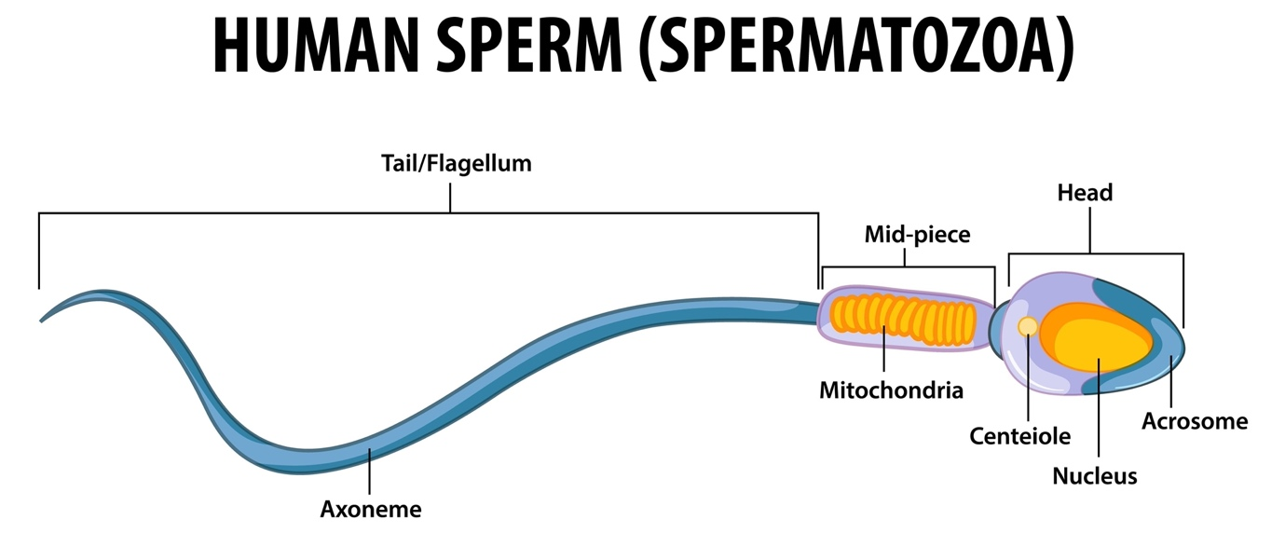
Shutterstock
Explore
- Key Points: Head (Acrosome/Nucleus), Middle piece (Mitochondria), Tail.
- What are the various Assisted Reproductive Technologies (ART)? Explain any two in detail.
  - Key Points: IVF, ZIFT, GIFT, ICSI, IUI. Detail the procedure and the specific infertility cases they solve.
- Describe the process of Oogenesis with the help of a flow chart.
  - Key Stages: Multiplication phase (mitosis in foetal life), Growth phase, Maturation phase (Meiosis I and II).
- Draw a neat labeled diagram of the human male reproductive system.
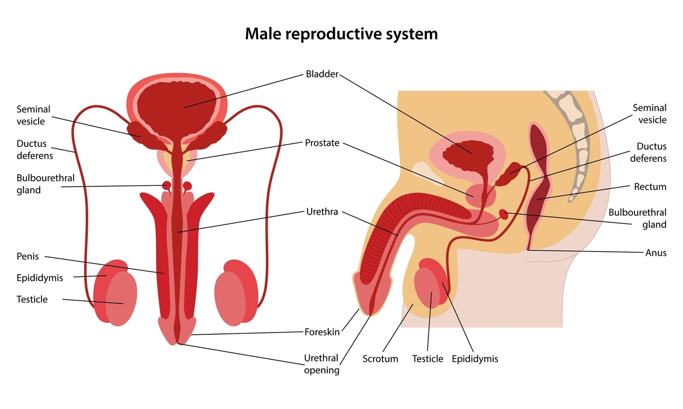
Shutterstock
- Key Labels: Testis, Epididymis, Vas deferens, Prostate gland, Seminal vesicles, Urethra.
- Describe the stages of human embryonic development from zygote to implantation.
  - Key Stages: Cleavage (2, 4, 8, 16 cells), Morula, Blastocyst formation, Trophoblast attachment to Endometrium.
- Explain the mechanism of parturition and lactation.
  - Key Points: Neuroendocrine mechanism, Foetal ejection reflex, Oxytocin role, Prolactin/Colostrum importance.
- Discuss the social and legal aspects of Medical Termination of Pregnancy (MTP) in India.
  - Key Points: Legalized in 1971, used for contraceptive failure or health risks, strictly restricted to prevent sex determination.
- Explain the development of a Dicot embryo with suitable diagrams.
  - Stages: Zygote → Proembryo → Globular → Heart-shaped → Mature embryo.
- What is Polyembryony? How is it significant in commercial horticulture?
  - Key Points: Presence of more than one embryo in a seed (e.g., Citrus). Allows for clonal propagation and virus-free plants.
- Describe the various methods of contraception. Classify them into natural, barrier, and surgical.
  - Key Points: Periodic abstinence (Natural), Condoms/Diaphragms (Barrier), Vasectomy (Surgical).
- What is Double Fertilization? Explain Triple Fusion and Syngamy. Why is this process unique to Angiosperms?
  - Key Points: Syngamy (Egg+Sperm=Zygote), Triple Fusion (2 Polar Nuclei+Sperm=PEN). PEN develops into nutritive endosperm.
- What are the various Assisted Reproductive Technologies (ART) available for infertile couples? Explain any two.
  - Key Points: Detail IVF-ET and ICSI. Mention that they are used when natural conception or simple treatments fail.

Section D: 5 Case Studies (Total Questions per case: 3x1m, 3x2m)

Case Study 1: The IVF Journey
A 35-year-old woman is unable to conceive due to blocked fallopian tubes. Her husband's sperm count is normal. They opt for ART.
- Which specific ART technique is most suitable here? (1m)
  - Answer: IVF (In-vitro Fertilization).
- Where does fertilization take place in this method? (1m)
  - Answer: Outside the body in a laboratory setting.
- If the zygote is transferred at the 8-blastomere stage, what is the procedure called? (1m)
  - Answer: ZIFT (Zygote Intra-Fallopian Transfer).
- How does ZIFT differ from IUT? (2m)
  - Answer: ZIFT transfers to the fallopian tube (up to 8 cells); IUT transfers to the uterus (more than 8 cells).
- Why is the success rate of ART not 100%? (2m)
  - Answer: Success depends on factors like age, endometrial receptivity, and embryo quality.
- Suggest one ethical consideration regarding surrogacy as an alternative. (2m)
  - Answer: Rights of the surrogate mother vs. the intended parents; prevention of commercial exploitation.

Case Study 2: Pollination and Purity
A farmer wants to develop a pure-line variety of pea plants by preventing any chance of cross-pollination.
- Which floral modification ensures self-pollination in peas? (1m)
  - Answer: Cleistogamy (flowers remain closed).
- Identify the term for the removal of anthers to prevent selfing. (1m)
  - Answer: Emasculation.
- Why is bagging done after emasculation? (1m)
  - Answer: To prevent contamination by unwanted foreign pollen.
- Differentiate between Autogamy and Geitonogamy. (2m)
  - Answer: Autogamy is within the same flower; Geitonogamy is between two flowers of the same plant.
- Why does inbreeding depression occur? (2m)
  - Answer: Continuous self-pollination increases homozygosity and expresses lethal recessive traits.
- How can the farmer introduce new traits intentionally? (2m)
  - Answer: Through artificial hybridization by dusting desired pollen on the emasculated stigma.

Case Study 3: The Menstrual Cycle and Contraception
A 25-year-old woman tracks her menstrual cycle and finds it is consistently 28 days. She wishes to use the "Natural Method" of contraception known as Periodic Abstinence to avoid pregnancy without using chemicals or devices.
- During which days of her cycle is the "Fertile Window" most likely to occur? (1m)
  - Answer: Days 10 to 17.
  - Reasoning: Ovulation typically occurs on day 14; since sperm can survive for a few days and the ovum for 24 hours, this window is high-risk.
- Which hormone is at its peak level just 24 hours before ovulation? (1m)
  - Answer: LH (Luteinizing Hormone).
  - Reasoning: The "LH Surge" is the specific trigger that causes the Graafian follicle to rupture.
- If the cycle was 35 days instead of 28, would the fertile window change? (1m)
  - Answer: Yes, it would shift later.
  - Reasoning: The luteal phase is constant (14 days), so ovulation would occur around Day 21 ().
- Explain why Periodic Abstinence is often called the "Rhythm Method." (2m)
  - Answer: It relies on the rhythmic nature of the menstrual cycle and the predictability of ovulation.
  - Reasoning: It requires a regular cycle to accurately calculate the days when coitus should be avoided.
- What is a major limitation of relying solely on this natural method? (2m)
  - Answer: High failure rate and requirement for high cycle regularity.
  - Reasoning: Factors like stress or illness can delay ovulation, making the calculation inaccurate and leading to unintended pregnancy.
- How does this method differ from Lactational Amenorrhea? (2m)
  - Answer: Periodic abstinence is based on the calendar; Lactational Amenorrhea is based on the absence of ovulation due to breastfeeding.
  - Reasoning: One is a behavioral calculation, while the other is a physiological state (high Prolactin inhibiting GnRH).

Case Study 4: Seed Development and Agriculture
A group of students visited a farm where the farmer was growing "Hybrid Maize" and "Apomictic Citrus." The farmer explained that for Maize, he has to buy new seeds every year, but for Citrus, he uses the seeds from the previous harvest.
- Why can't the farmer use seeds from his hybrid maize harvest for the next year? (1m)
  - Answer: Because of the Law of Segregation.
  - Reasoning: Hybrid characters segregate in the progeny ( generation), and the desired hybrid vigor is lost.
- Define the term "Apomixis" as seen in the Citrus plants. (1m)
  - Answer: Production of seeds without fertilization.
  - Reasoning: It is a form of asexual reproduction that mimics the seed-production process of sexual reproduction.
- What is the ploidy of an embryo formed via "nucellar polyembryony"? (1m)
  - Answer: Diploid ().
  - Reasoning: These embryos develop directly from the diploid maternal nucellar cells, not from a haploid egg.
- Explain the commercial advantage of developing apomictic hybrid seeds. (2m)
  - Answer: It prevents the segregation of traits in hybrids.
  - Reasoning: Farmers can use the same seeds year after year, significantly reducing the cost of high-yield farming.
- What is "Polyembryony," and why is it common in Citrus? (2m)
  - Answer: The presence of more than one embryo in a single seed.
  - Reasoning: In Citrus, nucellar cells surrounding the embryo sac start dividing and protrude into the sac to form multiple embryos.
- Draw a labeled diagram of a typical monocot (maize) seed. (2m)
  - Key Labels: Scutellum, Coleoptile, Coleorhiza, Endosperm, Pericarp.
  - Reasoning: These specific parts distinguish the monocot structure from dicots like peas.

Case Study 5: Reproductive Health and STIs
A health camp was organized in a village to spread awareness about STIs (Sexually Transmitted Infections). A young man reported symptoms of itching, fluid discharge, and slight pain in the genital region.
- Based on the symptoms, which class of diseases might he be suffering from? (1m)
  - Answer: STIs (specifically bacterial or viral infections like Chlamydia or Gonorrhea).
  - Reasoning: Localized symptoms like discharge and itching are classic early signs of many genital tract infections.
- Why are STIs often called "Silent Killers" in females? (1m)
  - Answer: They are often asymptomatic in the early stages in women.
  - Reasoning: Lack of early symptoms leads to late detection and severe complications like PID.
- Name one STI that is caused by a virus and is non-curable. (1m)
  - Answer: AIDS (HIV) or Genital Herpes or Hepatitis-B.
  - Reasoning: Unlike bacterial STIs, these viral infections cannot be completely eliminated from the host's body.
- What is PID, and what are its long-term consequences? (2m)
  - Answer: Pelvic Inflammatory Disease.
  - Reasoning: It can lead to ectopic pregnancies, chronic pelvic pain, and permanent infertility due to scarring of fallopian tubes.
- Suggest two simple principles to prevent the contraction of STIs. (2m)
  - Answer: Use of barriers (condoms) and avoiding sex with multiple/unknown partners.
  - Reasoning: These methods reduce direct contact with infected bodily fluids and limit exposure to pathogens.
- Why is early detection of STIs considered a crucial part of the RCH program? (2m)
  - Answer: To prevent long-term health complications and further transmission.
  - Reasoning: Early treatment is usually simple (antibiotics), whereas late-stage complications can be life-threatening or cause permanent sterility.

