Question Paper Set 1 – Answer Keys
Class XII –Genetics and Evolution
Chapters: Principles of Inheritance, Molecular Basis, Evolution
Time: 60 minutes | Max Marks: 32

Section A: MCQs: Answer (1 Mark)
1(b), 2(c), 3(c), 4(b), 5(b), 6(c), 7(b), 8(c).

Section B: Short Answer (2 Marks)
- Test Cross: Crossing an individual with a homozygous recessive parent.
  - Significance: It helps determine the genotype of a dominant phenotype (whether it is or ).
- Homologous vs. Analogous:
  - Homologous: Same origin, different functions (e.g., Forelimbs of a human and a whale). Indicates divergent evolution.
  - Analogous: Different origin, same function (e.g., Wings of a butterfly and a bird). Indicates convergent evolution.
- DNA vs. RNA:
  - DNA: More stable due to the absence of 2'-OH group; contains Thymine.
  - RNA: Highly reactive/unstable due to 2'-OH group; contains Uracil.
- Adaptive Radiation: The process of evolution of different species in a given geographical area starting from a point.
  - Darwin’s Finches: From the original seed-eating feature, many other forms with altered beaks arose (insect-eating, etc.) to occupy different niches on the Galapagos Islands.

Section C: Long Answer (4 Marks)
- Hershey-Chase Experiment:
  - Phages grown on radioactive Phosphorus () labeled DNA; phages grown on radioactive Sulfur () labeled protein coat.
  - Bacteria infected with became radioactive, while those infected with did not.
  - Conclusion: DNA enters the bacteria and is the genetic material.
- DNA Replication Fork:
  - Helicase: Unwinds the DNA double helix.
  - DNA Polymerase: Adds nucleotides in direction.
  - Leading Strand: Continuous synthesis toward the fork.
  - Lagging Strand: Discontinuous synthesis (Okazaki fragments) away from the fork.
  - DNA Ligase: Joins the Okazaki fragments.
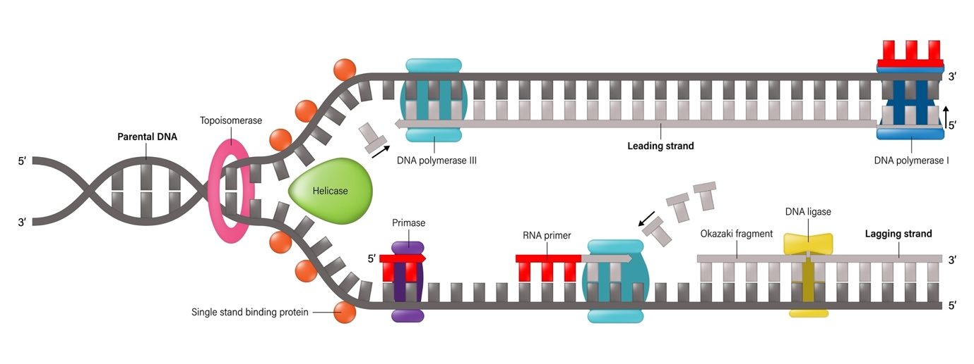
Shutterstock
- Law of Independent Assortment: When two pairs of traits are combined in a hybrid, segregation of one pair of characters is independent of the other pair.
  - Dihybrid Cross: results in ().
  - Phenotypic Ratio: (Round Yellow) : (Round Green) : (Wrinkled Yellow) : (Wrinkled Green).

Section D: Case Study (5 marks)
(i) Hemophilia. (ii) Only one X-chromosome. (iii) No, father gives Y to son. (iv) 50%.

