Question Paper Set 1
Class XII –Genetics and Evolution
Chapters: Principles of Inheritance, Molecular Basis, Evolution
Time: 60 minutes | Max Marks: 32

Section A: Multiple Choice Questions (8 x 1m)
- A cross between a tall plant (TT) and a short plant (tt) results in tall plants. The probability of getting a homozygous recessive plant in is: (a) 1/2 (b) 1/4 (c) 3/4 (d) 1/8
- If the sequence of the coding strand is -ATGCATGC-, the sequence of the mRNA will be: (a) -TACGTACG- (b) -AUGCUAGC- (c) -AUGCAUGC- (d) -UACGUACG-
- Which isotope was used by Hershey and Chase to specifically label the viral DNA? (a) (b) (c) (d)
- The "Start Codon" AUG codes for which amino acid? (a) Valine (b) Methionine (c) Glycine (d) Phenylalanine
- Analogous structures are a result of: (a) Divergent evolution (b) Convergent evolution (c) Genetic drift (d) Common ancestry
- In the Lac Operon, the repressor protein binds to the: (a) Promoter (b) Structural genes (c) Operator (d) Inducer
- The process of splicing in eukaryotes involves the removal of: (a) Exons (b) Introns (c) Capping (d) Tail
- Who proposed the "Theory of Mutation"? (a) Darwin (b) Lamarck (c) Hugo de Vries (d) Mendel

Section B: Short Answer Questions (4 x 2m)
- Define Test Cross and state its significance.
- Differentiate between Homologous and Analogous organs with one example each.
- List two differences between DNA and RNA as genetic material.
- What is Adaptive Radiation? Give the example of Darwin's Finches.

Section C: Long Answer Questions (3 x 4m)
- Describe the Hershey-Chase experiment to prove that DNA is the genetic material. Include a schematic diagram.
- Explain the process of DNA Replication at the replication fork. Mention the role of DNA Polymerase and Ligase.
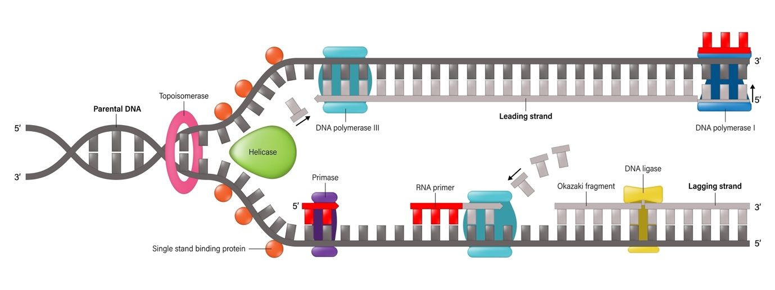
Shutterstock
- State Mendel's Law of Independent Assortment. Show the result of a dihybrid cross () using a Punnett square.

Section D: Case Study Question (1 x 5m)
- Case Study: The Royal Pedigree A pedigree shows several males in a family suffering from a blood-clotting disorder, while females are carriers. (i) Identify the genetic disorder. (1m) (ii) Why are males more prone to such X-linked recessive disorders? (1m) (iii) Can a father pass this disease directly to his son? Explain. (2m) (iv) What is the probability of a carrier female's son being affected? (1m)

