Question Paper Set 2 – Answer Keys
Class XII –Genetics and Evolution
Chapters: Principles of Inheritance, Molecular Basis, Evolution
Time: 60 minutes | Max Marks: 32

Section A: MCQs: Answer (1 Mark)

1(b), 2(b), 3(b), 4(b), 5(c), 6(b), 7(b), 8(b).

Section B: Short Answer (2 Marks)
- Central Dogma: Proposed by Crick; defines the flow of genetic information: .
- VNTRs (Variable Number of Tandem Repeats): Short nucleotide sequences that vary in number from person to person.
  - Utility: Since they are unique to individuals (except identical twins), they act as genetic markers in DNA fingerprinting.
- Dominance vs. Co-dominance:
  - Dominance: Only the dominant allele expresses in heterozygote (e.g., is Tall).
  - Co-dominance: Both alleles express fully in heterozygote (e.g., results in AB blood group).
- Founder Effect: When a small part of a population drifts/migrates to a new area, the limited gene pool of these "founders" determines the genetic makeup of the future population, potentially creating a new species.

Section C: Long Answer (4 Marks)
- tRNA (Clover Leaf Model):
  - Anticodon Loop: Has bases complementary to the mRNA codon.
  - Amino Acid Acceptor End: Binds to the specific amino acid.
  - DHU and loops: Help in ribosome and enzyme binding.
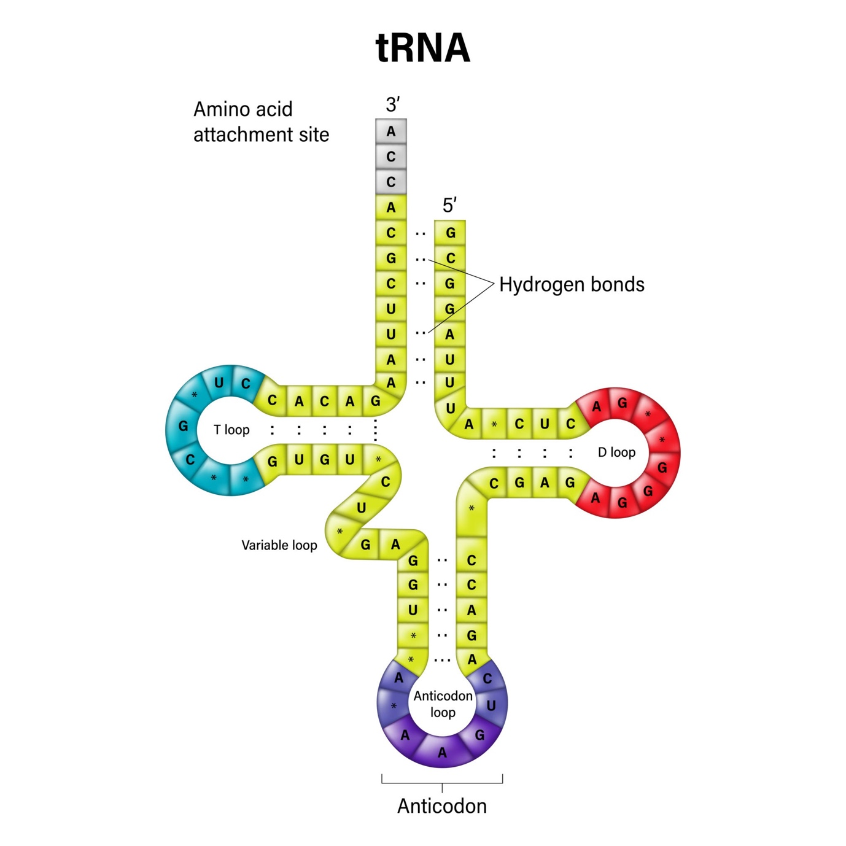
Getty Images
Explore
- Lac Operon (Lactose Present):
  - Lactose (Inducer) binds to the repressor protein.
  - The repressor becomes inactive and cannot bind to the Operator.
  - RNA Polymerase accesses the Promoter and transcribes structural genes ().
  - Enzymes (-galactosidase, etc.) are produced.
- Human Evolution Lineage:
  - Dryopithecus/Ramapithecus: Ape-like and man-like ancestors.
  - Australopithecus: Lived in East African grasslands; used stone tools.
  - Homo habilis: First "human-like" being; brain capacity .
  - Homo erectus: Brain capacity ; ate meat; first to use fire.
  - Neanderthal: Brain capacity ; buried their dead.
  - Homo sapiens: Modern man; arose in Africa and spread across continents.

Section D: Case Study (5 marks)
- Point mutation.
- (ii) Glutamic acid to Valine at 6th position.
- (iii) Heterozygote advantage against Malaria.
- (iv) 