Question Paper Set 2
Class XII –Genetics and Evolution
Chapters: Principles of Inheritance, Molecular Basis, Evolution
Time: 60 minutes | Max Marks: 32

Section A: Multiple Choice Questions (8 x 1m)
- A child has blood group O. If the father is group A and the mother is group B, their genotypes must be: (a) (b) (c) (d)
- In a DNA molecule, if Guanine is 20%, what is the percentage of Adenine? (a) 20% (b) 30% (c) 40% (d) 60%
- The "Beads-on-a-string" structure is formed by: (a) Genes (b) Nucleosomes (c) Amino acids (d) Nucleotides
- Miller's experiment produced which organic molecules from inorganic gases? (a) RNA (b) Amino acids (c) Proteins (d) Polysaccharides
- Which enzyme is known as the "molecular glue"? (a) Helicase (b) RNA Polymerase (c) DNA Ligase (d) Primase
- The phenomenon of a single gene expressing multiple traits is: (a) Co-dominance (b) Pleiotropy (c) Polygenic inheritance (d) Epistasis
- Which ancestor is known as the "Handy Man"? (a) Homo erectus (b) Homo habilis (c) Neanderthal (d) Australopithecus
- Hardy-Weinberg equilibrium is disturbed by: (a) Random mating (b) Gene flow (c) Large population (d) No mutation

Section B: Short Answer Questions (4 x 2m)
- Explain the Central Dogma of Molecular Biology.
- What are VNTRs, and how are they useful in DNA fingerprinting?
- Differentiate between Dominance and Co-dominance with examples.
- What is the Founder Effect?

Section C: Long Answer Questions (3 x 4m)
- Describe the structure of a tRNA molecule using the Clover Leaf model. Label the anticodon loop and amino acid acceptor end.
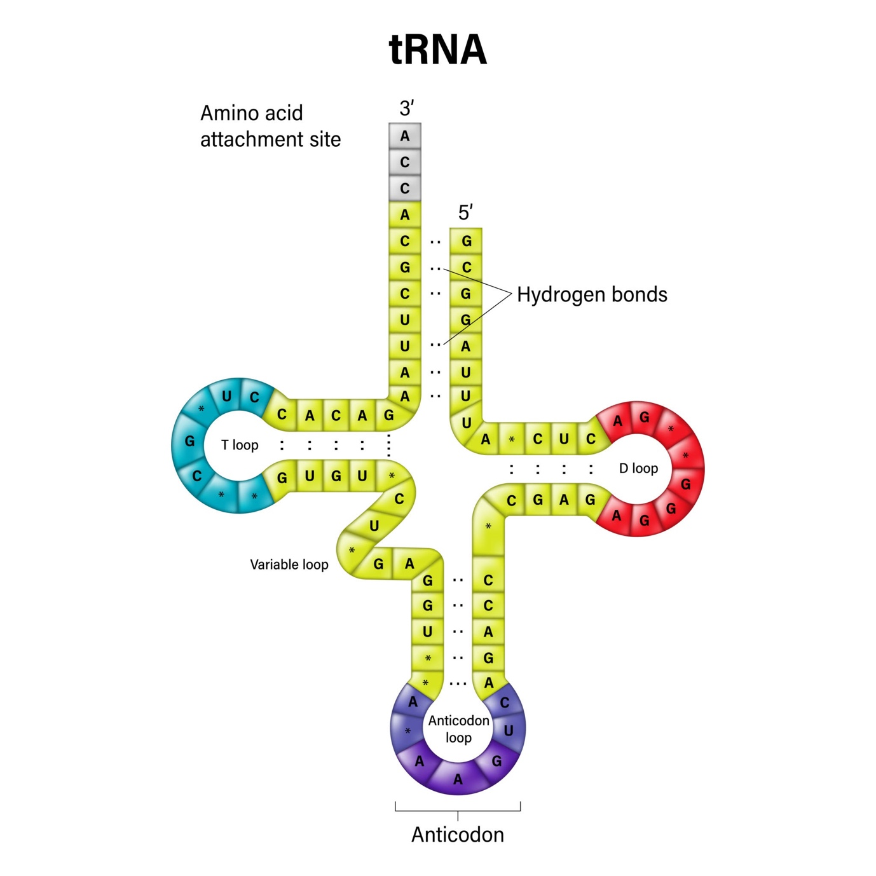
Getty Images
Explore
- Explain the Lac Operon mechanism in E.coli when lactose is present.
- Discuss the Human Evolution lineage from Dryopithecus to Homo sapiens.

Section D: Case Study Question (1 x 5m)
- Case Study: Sickle Cell Anemia A patient has RBCs that turn sickle-shaped under low oxygen. (i) Name the type of mutation involved. (1m) (ii) Which amino acid is substituted and at which position? (1m) (iii) Why is the sickle cell trait common in malaria-prone areas? (2m) (iv) What is the genotype of a carrier? (1m)

