Question Paper Set 3 – Answer Keys
Class XII –Genetics and Evolution
Chapters: Principles of Inheritance, Molecular Basis, Evolution
Time: 60 minutes | Max Marks: 32

Section A: MCQs: Answer (1 Mark)

1(b), 2(c), 3(b), 4(a), 5(b), 6(b), 7(b), 8(a).

Section B: Short Answer (2 Marks)
- Genetic Code Features: (Any two)
  - Triplet: Three bases code for one amino acid.
  - Universal: The same code applies from bacteria to humans.
  - Degenerate: One amino acid can be coded by more than one codon.
- Industrial Melanism: An observation in England where the frequency of dark-colored (melanic) moths increased after the industrial revolution because they were better camouflaged against soot-covered trees than white moths.
- Pea Plant Selection: (1) It has distinct contrasting traits (e.g., Tall/Dwarf). (2) It has a short life cycle and produces many offspring.
- Point Mutation: A change in a single base pair of DNA.
  - Example: Sickle cell anemia (Substitution of GAG by GUG).

Section C: Long Answer (4 Marks)
- Natural Selection Types:
  - Stabilizing: Favors average individuals; the peak gets higher and narrower.
  - Directional: Favors one extreme; the peak shifts in one direction.
  - Disruptive: Favors both extremes; two peaks are formed.
- Miller-Urey Experiment:
  - Created conditions of primitive earth (high temp, lightning, reducing atmosphere).
  - Used , and in a closed flask with electrodes.
  - Result: Formation of amino acids (building blocks of proteins).
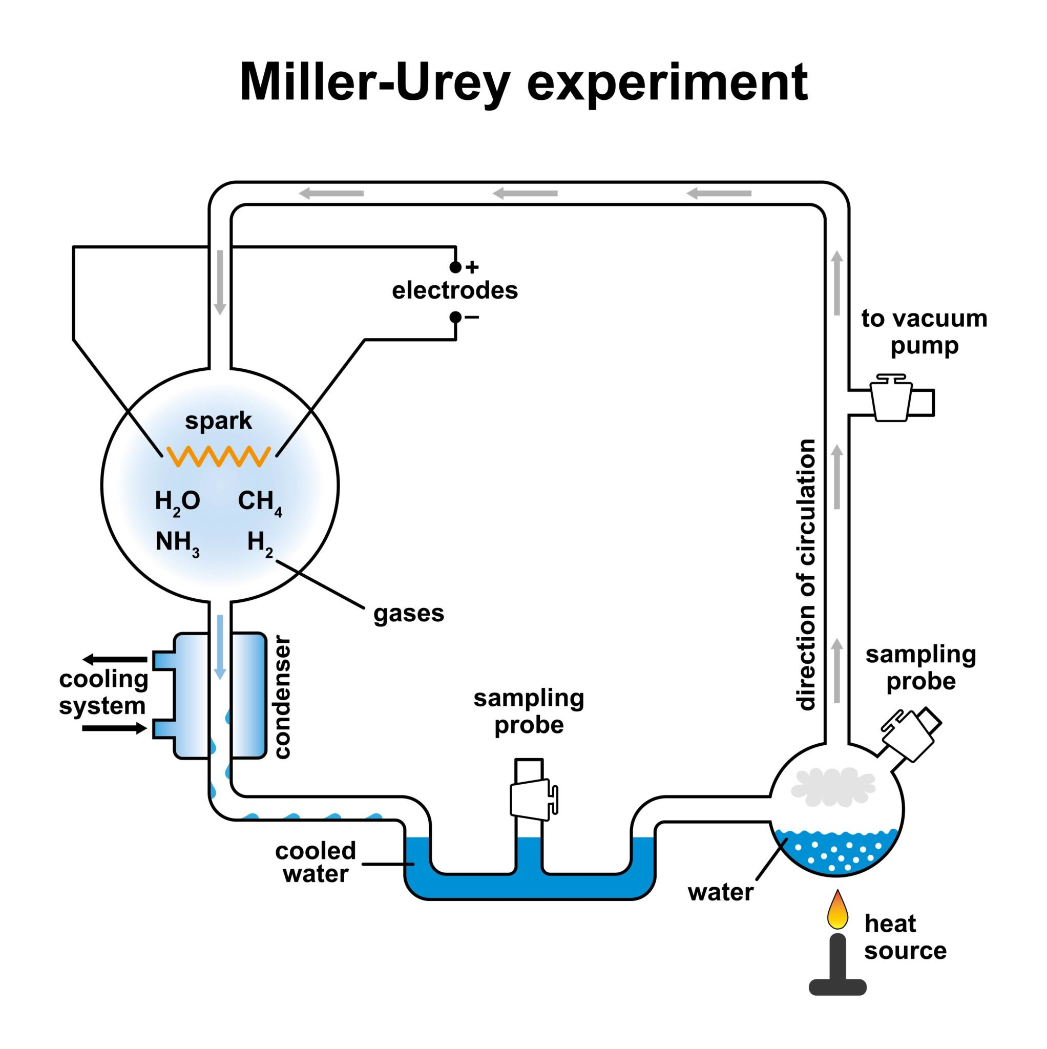
Getty Images
- DNA Fingerprinting Steps:
  - Isolation: Extracting DNA from cells.
  - Digestion: Cutting DNA into fragments using restriction endonucleases.
  - Electrophoresis: Separating fragments based on size.
  - Blotting: Transferring fragments to a synthetic membrane (Nitrocellulose).
  - Hybridization: Using labeled VNTR probes to bind to complementary sequences.
  - Autoradiography: Detecting the bound probes using X-ray film.

Section D: Case Study (5 marks).
- ESTs and Sequence Annotation.
- Sequencing only expressed genes.
- High degree of polymorphism/SNP.
- 3 x 10⁹ bp.

