Question Paper Set 3
Class XII –Genetics and Evolution
Chapters: Principles of Inheritance, Molecular Basis, Evolution
Time: 60 minutes | Max Marks: 32

Section A: Multiple Choice Questions (8 x 1m)
- The distance between two adjacent base pairs in DNA is: (a) 3.4 nm (b) 0.34 nm (c) 20 nm (d) 34 nm
- "Saltations" (single step large mutations) were proposed by: (a) Darwin (b) Mendel (c) Hugo de Vries (d) Morgan
- Which RNA acts as an adapter molecule? (a) mRNA (b) tRNA (c) rRNA (d) hnRNA
- DNA Fingerprinting was developed by: (a) Alec Jeffreys (b) Watson (c) Crick (d) Griffith
- Flippers of Penguins and Dolphins show: (a) Divergent evolution (b) Convergent evolution (c) Homology (d) Anthropogenic evolution
- The termination codons are: (a) AUG, GUG, UUU (b) UAA, UAG, UGA (c) UAA, AUG, UGG (d) GUG, UAA, UGA
- Down's syndrome is caused by: (a) Monosomy of 21st (b) Trisomy of 21st (c) Nullisomy (d) Polyploidy
- During transcription, RNA Polymerase binds to: (a) Promoter (b) Terminator (c) Structural gene (d) Operator

Section B: Short Answer Questions (4 x 2m)
- State two salient features of the Genetic Code.
- What is Industrial Melanism?
- Why did Mendel choose Pea plants for his experiments? (2 reasons)
- Define Point Mutation with an example.

Section C: Long Answer Questions (3 x 4m)
- Explain Natural Selection with the help of Stabilizing, Directional, and Disruptive selection graphs.
- Describe the Miller-Urey Experiment for chemical evolution with a labeled diagram.
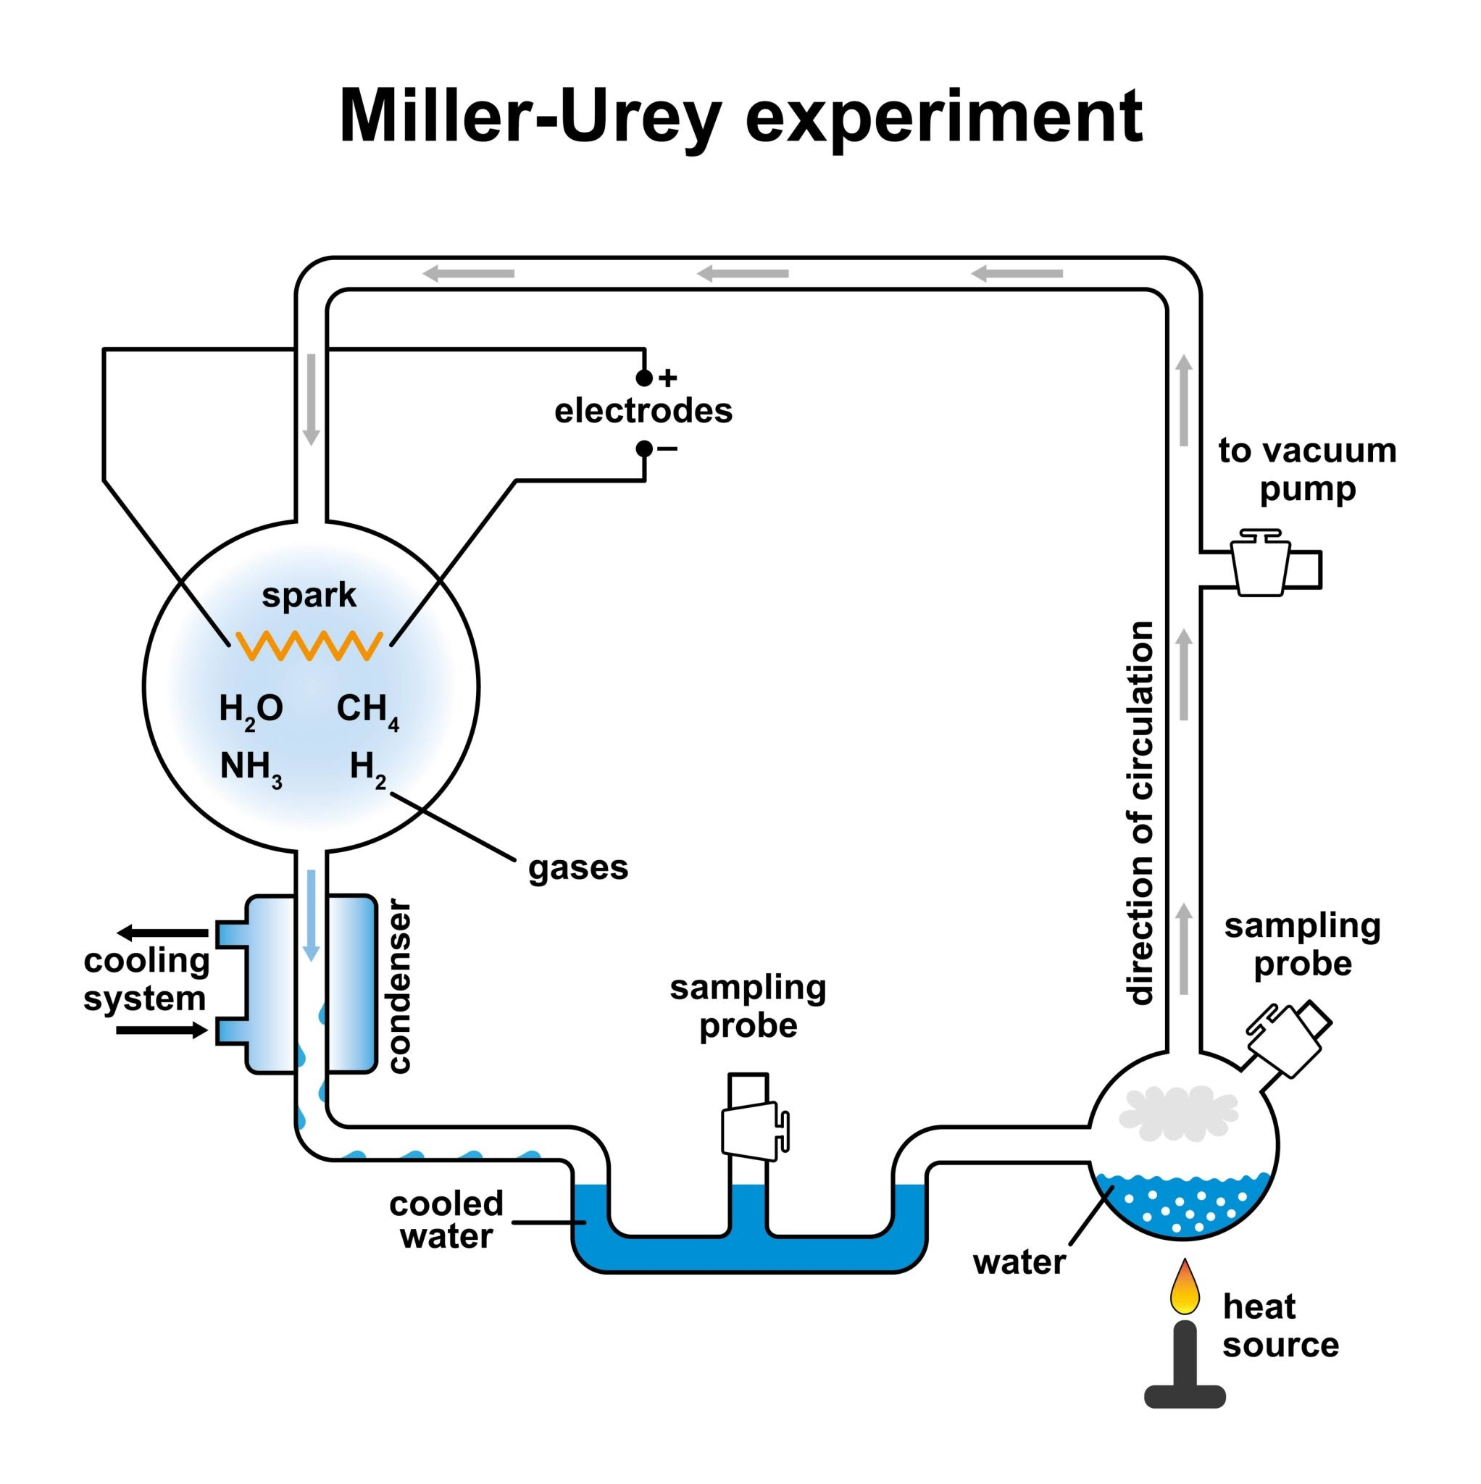
Getty Images
- Explain DNA Fingerprinting steps from isolation to autoradiography.

Section D: Case Study Question (1 x 5m)
- Case Study: The Human Genome Project (HGP) HGP was a 13-year project aimed at sequencing the human genome. (i) What were the two main methodologies used? (1m) (ii) Define 'Expressed Sequence Tags' (ESTs). (1m) (iii) Why is the human genome called a 'Mosaic' of variations? (2m) (iv) How many base pairs are approximately present in the human genome? (1m)

