Section A: 40 MCQs (1 Mark each)
Target: Logic-based and numerical genetics.
- A cross between a tall plant (TT) and a short plant (tt) resulted in all tall plants in . If is self-pollinated, what is the probability of getting a homozygous tall plant in ?
  - (a) 1/2 (b) 1/4 (c) 3/4 (d) 1/3
  - Answer: (b) 1/4
  - Reasoning: The genotypic ratio is ; thus, homozygous tall () is 1 out of 4.
- In a DNA molecule, if Cytosine is 18%, what is the percentage of Adenine?
  - (a) 18% (b) 32% (c) 36% (d) 64%
  - Answer: (b) 32%
  - Reasoning: According to Chargaff's rule, , so . Thus, . .
- Which of the following codons acts as the "Start Codon" and also codes for Methionine?
  - (a) UAA (b) UAG (c) AUG (d) UGA
  - Answer: (c) AUG
  - Reasoning: AUG has a dual function: it initiates translation and codes for the amino acid Methionine.
- The presence of 'Analogous structures' indicates:
  - (a) Common ancestry (b) Divergent evolution (c) Convergent evolution (d) Genetic drift
  - Answer: (c) Convergent evolution
  - Reasoning: Analogous structures (like wings of butterfly and birds) serve similar functions but have different origins, showing adaptation to similar environments.
- A man with blood group A marries a woman with blood group B. They have a child with blood group O. What are the genotypes of the parents?
  - (a) and (b) and (c) and (d) and
  - Answer: (b) and
  - Reasoning: To have an 'O' group child (), both parents must carry the recessive '' allele.
- The "Beads-on-a-string" structure seen under an electron microscope represents:
  - (a) Nucleotides (b) Nucleosomes (c) Genes (d) Amino acids
  - Answer: (b) Nucleosomes
  - Reasoning: DNA wrapped around histone octamers forms nucleosomes, which appear as beads on the chromatin thread.
- The 'Miller-Urey experiment' provided evidence for:
  - (a) Theory of Biogenesis (b) Chemical evolution of life (c) Special creation (d) Panspermi (a)
  - Answer: (b) Chemical evolution
  - Reasoning: It demonstrated that organic molecules (amino acids) could be formed from inorganic precursors under primitive earth conditions.
- Which non-radioactive isotope was used by Meselson and Stahl to prove semi-conservative replication?
  - (a) (b) (c) (d)
  - Answer: (a)
  - Reasoning: They used heavy nitrogen () to label DNA and distinguish it from normal nitrogen () using density gradient centrifugation.
- Sickle cell anemia is an example of:
  - (a) Point mutation (b) Frameshift mutation (c) Aneuploidy (d) Polyploidy
  - Answer: (a) Point mutation
  - Reasoning: It is caused by a single base substitution (GAG to GUG) at the sixth position of the beta-globin chain.
- Hardy-Weinberg equilibrium is affected by all EXCEPT:
  - (a) Gene flow (b) Genetic drift (c) Random mating (d) Mutation
  - Answer: (c) Random mating
  - Reasoning: Random mating maintains equilibrium; the other factors are evolutionary forces that change allele frequencies.
- In a DNA strand, the nucleotides are linked together by:
  - (a) Glycosidic bonds (b) Phosphodiester bonds (c) Peptide bonds (d) Hydrogen bonds
  - Answer: (b) Phosphodiester bonds
  - Reasoning: These bonds form the sugar-phosphate backbone by linking the 3' carbon of one sugar to the 5' carbon of the next.
- The experiment that proved DNA replication is semi-conservative was performed by:
  - (a) Watson and Crick (b) Meselson and Stahl (c) Hershey and Chase (d) Griffith
  - Answer: (b) Meselson and Stahl
  - Reasoning: They used heavy nitrogen isotopes to track the distribution of parental DNA in daughter strands.
- Which RNA carries the amino acids to the site of protein synthesis?
  - (a) mRNA (b) rRNA (c) tRNA (d) hnRNA
  - Answer: (c) tRNA
  - Reasoning: Transfer RNA has an anticodon loop to read mRNA and an amino acid acceptor end to carry the corresponding amino acid.
- In the Lac Operon, the repressor protein binds to the:
  - (a) Promoter (b) Operator (c) Structural genes (d) Inducer
  - Answer: (b) Operator
  - Reasoning: Binding to the operator physically blocks the RNA Polymerase from moving toward the structural genes.
- Which of the following is a "Stop Codon"?
  - (a) AUG (b) UGG (c) UAG (d) GUG
  - Answer: (c) UAG
  - Reasoning: UAG (Amber), UAA (Ochre), and UGA (Opal) do not code for any amino acid and signal the end of translation.
- Homologous organs indicate:
  - (a) Convergent evolution (b) Common ancestry (c) Anthropogenic evolution (d) Genetic equilibrium
  - Answer: (b) Common ancestry
  - Reasoning: Structures like the forelimbs of humans and whales have the same basic anatomical plan despite different functions.
- The 'Theory of Mutation' was proposed by:
  - (a) Charles Darwin (b) Hugo de Vries (c) Lamarck (d) Mendel
  - Answer: (b) Hugo de Vries
  - Reasoning: He worked on Evening Primrose and suggested that evolution occurs through sudden, large changes (saltation).
- A nucleosome consists of DNA wrapped around:
  - (a) RNA (b) Histone octamer (c) Non-histone proteins (d) Ribosomes
  - Answer: (b) Histone octamer
  - Reasoning: Negatively charged DNA wraps around the positively charged histone core ().
- The process of "Splicing" in eukaryotes involves:
  - (a) Removal of exons (b) Addition of introns (c) Removal of introns (d) Capping
  - Answer: (c) Removal of introns
  - Reasoning: Introns are non-coding sequences that must be removed to join coding exons together for a functional mRNA.
- During transcription, the DNA strand that acts as a template has the polarity:
  - (a) (b) (c) Both (d) Neither
  - Answer: (b)
  - Reasoning: RNA Polymerase synthesizes RNA in the direction, so it must read the template in the direction.
- In a dihybrid cross (), what is the ratio of offspring with the genotype ?
  - (a) 1/16 (b) 3/16 (c) 9/16 (d) 1/4
  - Answer: (a) 1/16
  - Reasoning: Only one square out of the 16 in the Punnett square represents the double recessive genotype.
- Genetic drift operates only in:
  - (a) Large populations (b) Small populations (c) Mendelian populations (d) Island populations
  - Answer: (b) Small populations
  - Reasoning: Small populations are more susceptible to random changes in allele frequencies due to chance events.
- The "Human Genome Project" (HGP) used which method for sequencing?
  - (a) Expressed Sequence Tags (ESTs) (b) Sequence Annotation (c) Both a and b (d) None
  - Answer: (c) Both a and b
  - Reasoning: ESTs focused on coding regions, while Sequence Annotation aimed to sequence the entire genome including non-coding parts.
- In DNA fingerprinting, VNTR stands for:
  - (a) Variable Number of Tandem Repeats (b) Various Nucleotide Tandem Regions
  - (c) Vertical Number of Triple Repeats (d) Valid Nucleotide Tandem Repeats
  - Answer: (a)
  - Reasoning: VNTRs are short sequences that repeat a variable number of times and are unique to individuals.
- Which isotope was used in the Hershey-Chase experiment to label DNA?
  - (a) (b) (c) (d)
  - Answer: (b)
  - Reasoning: Phosphorus is a component of DNA but not proteins, making it an ideal label for DNA.
- The phenomenon where a single gene can exhibit multiple phenotypic expressions is:
  - (a) Epistasis (b) Pleiotropy (c) Polygenic inheritance (d) Dominance
  - Answer: (b) Pleiotropy
  - Reasoning: For example, in Phenylketonuria, a single gene mutation causes mental retardation and reduced hair/skin pigmentation.
- "Satellite DNA" is important because it:
  - (a) Codes for proteins (b) Shows high degree of polymorphism (c) Is found only in plants (d) Does not exist in humans
  - Answer: (b) Shows high degree of polymorphism
  - Reasoning: This variation in the non-coding DNA forms the basis of DNA fingerprinting.
- Industrial Melanism (the Peppered Moth) is an example of:
  - (a) Mutation (b) Natural Selection (c) Genetic Drift (d) Artificial Selection
  - Answer: (b) Natural Selection
  - Reasoning: It shows how the frequency of dark moths increased in response to soot-covered trees during the Industrial Revolution.
- The first human-like hominid was:
  - (a) Homo erectus (b) Homo habilis (c) Neanderthal (d) Australopithecus
  - Answer: (b) Homo habilis
  - Reasoning: Known as the "handy man," they had a brain capacity of 650-800cc and were the first to use tools.
- What is the genotypic ratio of a Monohybrid cross in ?
  - (a) (b) (c) (d)
  - Answer: (c)
  - Reasoning: . The phenotypic ratio is .
- In DNA, the distance between two base pairs is:
  - (a) 3.4 nm (b) 0.34 nm (c) 20 nm (d) 34 nm
  - Answer: (b) 0.34 nm
  - Reasoning: One full turn of the helix is 3.4 nm and contains 10 base pairs.
- Frame-shift mutation occurs when:
  - (a) A base is substituted (b) A base is deleted or inserted (c) DNA is methylated (d) A stop codon is reached
  - Answer: (b)
  - Reasoning: Deleting or inserting a base shifts the entire reading frame of the genetic code from that point onwards.
- Which enzyme is known as "molecular glue"?
  - (a) Helicase (b) DNA Polymerase (c) Ligase (d) Primase
  - Answer: (c) Ligase
  - Reasoning: It joins the sugar-phosphate backbones of DNA fragments (like Okazaki fragments).
- "Big Bang Theory" attempts to explain the origin of:
  - (a) Life (b) Universe (c) Earth (d) Humans
  - Answer: (b) Universe
  - Reasoning: It suggests a singular huge explosion in physical terms occurred billions of years ago.
- The primary goal of the "Human Genome Project" was to:
  - (a) Create new humans (b) Sequence all 3 billion base pairs of human DNA (c) Clone human organs (d) Kill viruses
  - Answer: (b)
  - Reasoning: It was an international 13-year project to map the entire human genetic blueprint.
- Crossing over takes place during:
  - (a) Prophase I (Pachytene) (b) Metaphase I (c) Prophase II (d) Anaphase I
  - Answer: (a)
  - Reasoning: It is the exchange of genetic material between non-sister chromatids of homologous chromosomes.
- The units of inheritance are:
  - (a) Chromosomes (b) Genes (c) Nucleotides (d) Proteins
  - Answer: (b) Genes
  - Reasoning: Mendel called them "factors"; they are the functional units of heredity.
- Which of the following evolved first?
  - (a) Amphibians (b) Jawless fish (c) Reptiles (d) Birds
  - Answer: (b) Jawless fish
  - Reasoning: Jawless fish evolved around 350 mya, before amphibians and reptiles.
- The total number of codons in the genetic code is:
  - (a) 20 (b) 44 (c) 64 (d) 61
  - Answer: (c) 64
  - Reasoning: Since there are 4 bases and they act in triplets, .
- The struggle for existence and survival of the fittest are concepts of:
  - (a) Lamarck (b) Darwin (c) Oparin (d) Wallace
  - Answer: (b) Darwin
  - Reasoning: These are the core tenets of his theory of Natural Selection

Section B: 30 Questions (2 Marks each)
- Differentiate between Dominance and Co-dominance with examples.
  - Dominance: Only one allele expresses itself in heterozygote (e.g., Tall pea plants).
  - Co-dominance: Both alleles express themselves fully (e.g., AB blood group).
- What is a "Test Cross"? Why is it performed?
  - Definition: Crossing an individual with dominant phenotype with a homozygous recessive parent.
  - Purpose: To determine whether the dominant individual is homozygous or heterozygous.
- State the two functions of the DNA Polymerase enzyme.
  - Polymerization: Catalyzes the synthesis of DNA strand in direction.
  - Proofreading: Checks and removes wrongly paired nucleotides during replication.
- What are "Introns" and "Exons"?
  - Exons: Coding sequences that appear in mature/processed RNA.
  - Introns: Non-coding intervening sequences that are removed during splicing.
- Define 'Adaptive Radiation' with an example.
  - Definition: Evolution of different species in a given geographical area starting from a point.
  - Example: Darwin’s Finches in Galapagos Islands.
- Why is the "Lac Operon" considered a 'repressible' system?
  - Mechanism: In the absence of an inducer (Lactose), the repressor protein binds to the operator, switching 'off' the transcription.
- Explain "Founder Effect" in genetic drift.
  - Key Point: When a small group of individuals migrates and starts a new population, their limited gene pool becomes the blueprint for the entire future population.
- List two differences between DNA and RNA.
  - DNA: Double-stranded; contains Deoxyribose and Thymine.
  - RNA: Single-stranded; contains Ribose and Uracil.
- What is 'Point Mutation'? Give one clinical example.
  - Definition: Change in a single base pair of DNA. Example: Sickle cell anemia.
- Differentiate between Homologous and Analogous organs.
  - Homologous: Same origin, different function (e.g., Forelimbs of whale/human).
  - Analogous: Different origin, same function (e.g., Eye of octopus/mammal).
- Why is DNA considered a better genetic material than RNA?
  - DNA is chemically more stable (lack of 2'-OH group) and less reactive than RNA. Thymine provides more stability than Uracil.
- Define "Linkage" and "Recombination."
  - Linkage: Physical association of genes on a chromosome. Recombination: Generation of non-parental gene combinations.
- What is a "Capping" and "Tailing" in hnRNA processing?
  - Capping: Addition of Methyl guanosine triphosphate at 5' end. Tailing: Addition of Poly-A tail at 3' end.
- What are the three components of a Nucleotide?
  - Nitrogenous base, Pentose sugar, and Phosphate group.
- Differentiate between a "Cistron" and a "Gene."
  - Gene is the functional unit; Cistron is the specific segment of DNA coding for a polypeptide.
- State the significance of the "AUG" codon.
  - It acts as an initiator (Start) codon and codes for the amino acid Methionine.
- What is "Divergent Evolution"? Give an example.
  - Evolution where same structures develop along different directions due to adaptation to different needs (e.g., Forelimbs of mammals).
- Briefly describe the "Atmosphere of Primitive Earth."
  - It was a reducing atmosphere containing (vapor), and , with no free oxygen.
- What are "Saltations"? Who proposed this term?
  - Single-step large mutations; proposed by Hugo de Vries.
- Define "Aneuploidy" and give an example.
  - Gain or loss of a chromosome due to failure of segregation (e.g., Down’s Syndrome).
- What is the function of the "Sigma Factor" in transcription?
  - It helps the RNA Polymerase to recognize and bind to the promoter region to initiate transcription.
- Explain the "Central Dogma" of molecular biology.
  - The unidirectional flow of information from Protein.
- Why is the genetic code called "Degenerate"?
  - Because some amino acids are coded by more than one codon (e.g., UUU and UUC both code for Phenylalanine).
- What is the role of DNA Ligase in replication?
  - It joins the discontinuous Okazaki fragments on the lagging strand to form a continuous DNA strand.
- Name the human ancestor that first used fire.
  - Homo erectus.
- What are "Analogous structures"?
  - Structures that are anatomically different but perform similar functions (Convergent evolution).
- What is "Pedigree Analysis"?
  - A record of inheritance of specific traits over several generations in a family tree.
- Define "Pleiotropy."
  - When a single gene influences multiple unrelated phenotypic traits.
- What is "Gene Migration"?
  - The movement of alleles into or out of a population due to the migration of individuals.
- What is the difference between "Template strand" and "Coding strand"?
  - Template () is read by RNA Polymerase; Coding () has the same sequence as the RNA (except T replaced by U).

Section C: 15 Questions (4 Marks each)
- Describe the Hershey-Chase experiment. Why was it definitive in proving DNA is the genetic material?
  - Method: Used radioactive (protein) and (DNA) to label bacteriophages.
  - Result: Only entered the bacteria, proving DNA is the hereditary material.
- Explain the process of DNA Replication in E.coli. Mention the enzymes involved.
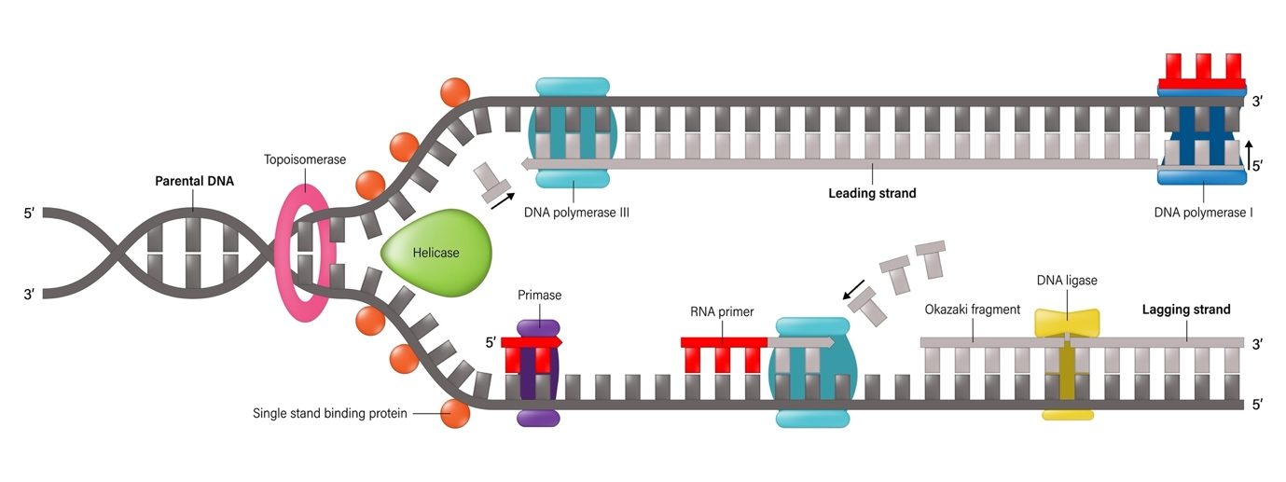
Shutterstock
- Key Points: Origin of replication, Helicase, DNA Polymerase, Leading and Lagging strands (Okazaki fragments), Ligase.
- What is "Natural Selection"? Describe the three types of selection: Stabilizing, Directional, and Disruptive.
- Describe the process of Translation (Protein Synthesis) in prokaryotes.
  - Steps: Charging of tRNA, Initiation (Start codon), Elongation (Peptide bond formation), and Termination.
- State Mendel’s Law of Independent Assortment. Explain it using a dihybrid cross ().
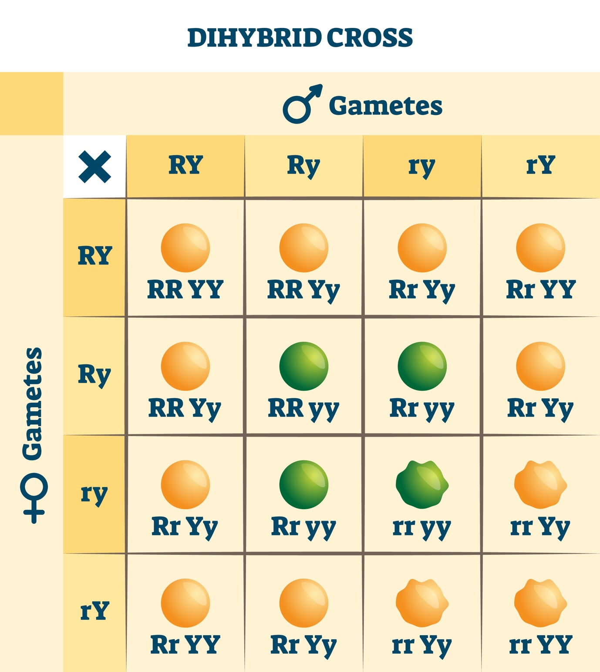

- Describe the process of Transcription in Prokaryotes.
  - Include Initiation (Promoter binding), Elongation, and Termination (Rho factor).
- Explain the Lac Operon model in the presence and absence of Lactose.
- Discuss the salient features of the Genetic Code.
  - Triplet, Universal, Degenerate, Non-overlapping, No punctuation, and Commaless.
- Explain the process of DNA Fingerprinting step-by-step.
  - Isolation → Digestion → Separation (Electrophoresis) → Blotting → Hybridization → Autoradiography.
- State and explain Hardy-Weinberg Principle. What factors affect the equilibrium?
  - Equation: . Factors: Mutation, Selection, Drift, Gene flow.
- Describe the Miller-Urey Experiment with a labeled diagram.
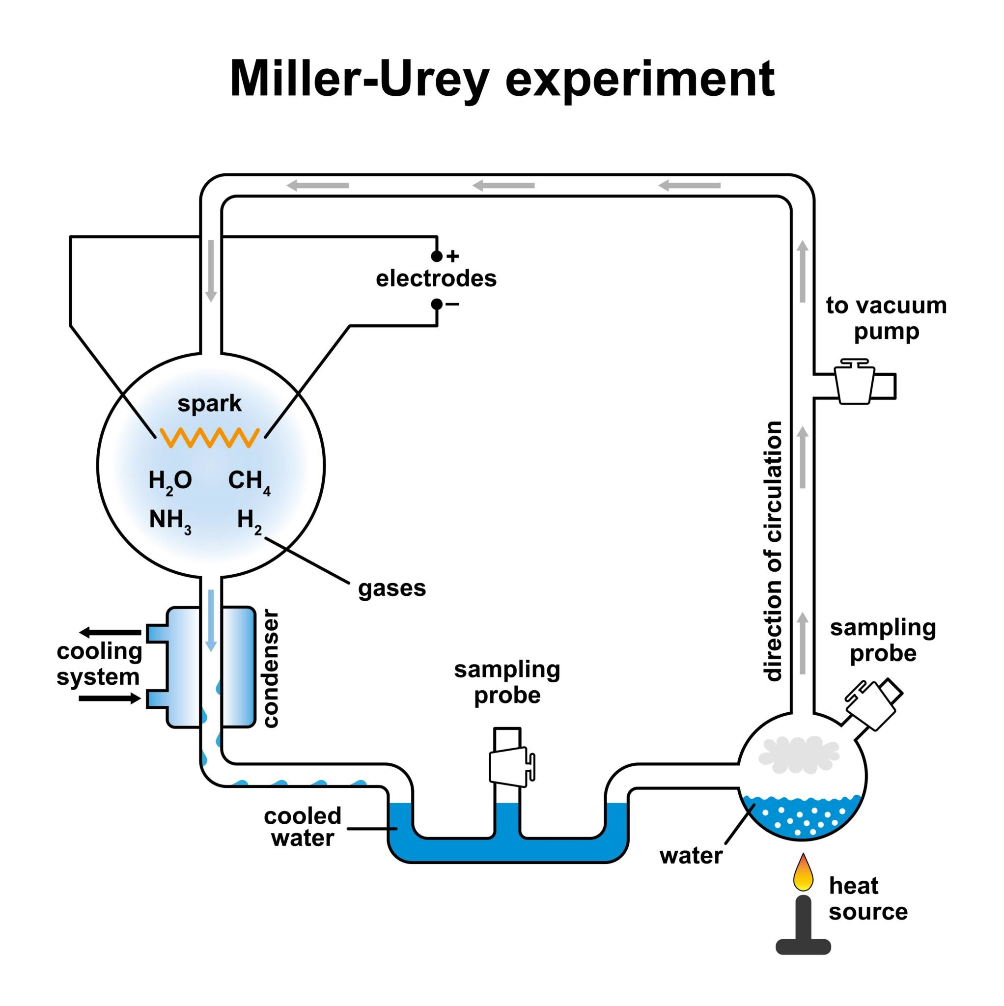
Getty Images
- Explain the chromosomal theory of inheritance. Who proposed it?
  - Proposed by Sutton and Boveri; links the behavior of chromosomes to Mendelian factors.
- Describe the structure of a tRNA molecule (Clover leaf model).
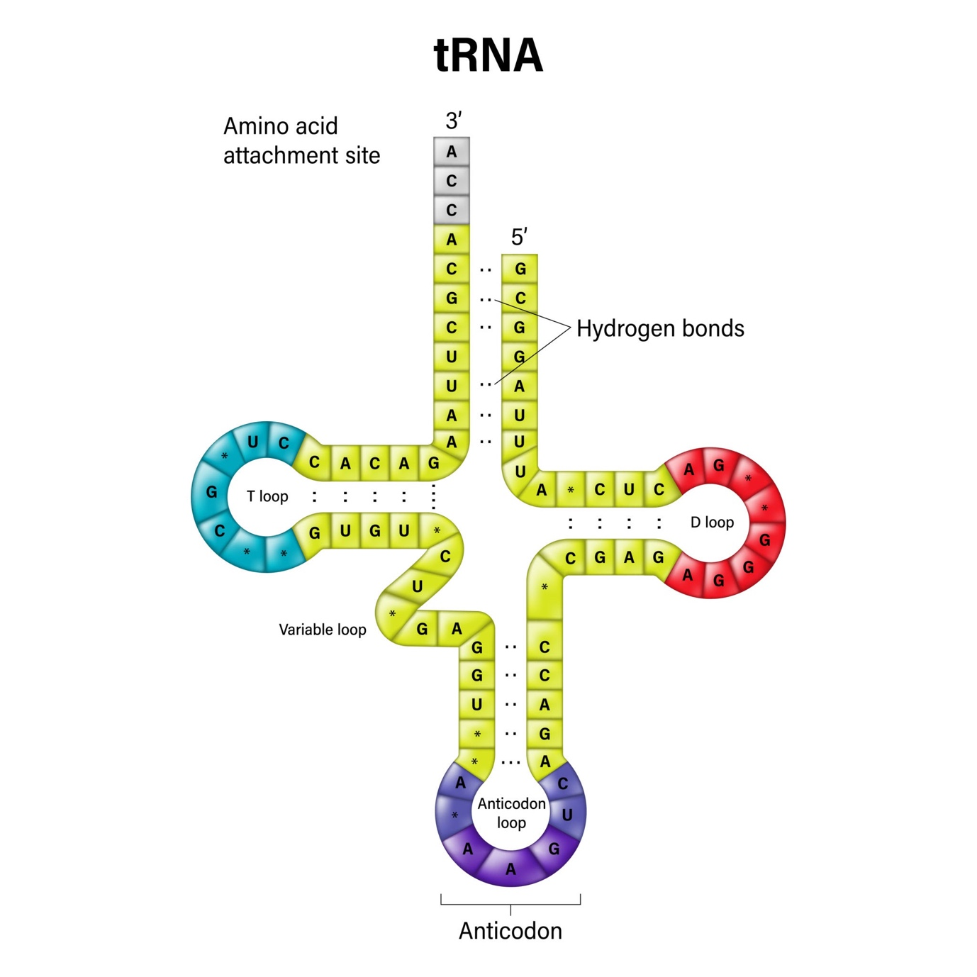
Getty Images
Explore
- What is "Human Evolution"? Trace the lineage from Dryopithecus to Homo sapiens.
  - Dryopithecus → Ramapithecus → Australopithecus → Homo habilis → Homo erectus → Neanderthal → Homo sapiens.
- Explain the different types of Natural Selection with graphical representations.
  - Stabilizing, Directional, and Disruptive selection.

Section D: 5 Case Studies (Total Questions: 3x1m, 3x2m)

Case Study 1: The Royal Disease
A pedigree chart of a famous royal family shows that several males suffer from Hemophilia, while females are mostly unaffected but act as carriers.
- What is the pattern of inheritance for Hemophilia? (1m)
  - Answer: X-linked recessive.
- Why are males more frequently affected by this disorder? (1m)
  - Answer: Males have only one X-chromosome; a single defective allele causes the disease.
- Can a son inherit Hemophilia from his father? (1m)
  - Answer: No.
  - Reasoning: A father passes his Y-chromosome to his son, not his X-chromosome.
- Define 'Criss-cross inheritance'. (2m)
  - Answer: Transmission of a trait from a father to his grandson through his daughter.
- What is the genotype of a carrier female? (2m)
  - Answer: .
  - Reasoning: She has one normal allele and one defective allele; she doesn't show symptoms but can pass it on.
- If a hemophilic man marries a normal (homozygous) woman, what is the probability of their daughter being hemophilic? (2m)
  - Answer: 0%.
  - Reasoning: The daughter will receive one normal X from the mother, making her a carrier () but not affected.

Case Study 2: Molecular Crime Solving
A hair follicle was found at a crime scene. Forensic experts used DNA Fingerprinting to match it with a suspect.
- What is the source of DNA in a hair follicle? (1m)
  - Answer: The cells in the hair root/bulb.
- Why is non-coding DNA used instead of coding DNA for this test? (2m)
  - Answer: Non-coding DNA (Satellite DNA) shows high polymorphism (variation) between individuals, whereas coding DNA is mostly identical.
- What is the role of VNTRs in this process? (2m)
  - Answer: VNTRs act as the "fingerprint"; the number of repeats varies so significantly between people that it is almost unique.

Case Study 3: The Sickle Cell Advantage
In certain parts of Africa, the allele for Sickle Cell Anemia () is surprisingly common despite being a lethal disease in homozygous form.
- What type of mutation causes Sickle Cell Anemia? (1m)
  - Answer: Point mutation (Substitution of Glutamic acid by Valine).
- Explain why the allele persists in these populations. (2m)
  - Answer: Heterozygous individuals () are resistant to Malaria, giving them a survival advantage.
- What happens to the shape of RBCs under low oxygen tension? (2m)
  - Answer: They become sickle-shaped/elongated, which can block capillaries.

