Question Paper Set 1
Class XII
Time: 60 minutes | Max Marks: 32

Section A: Multiple Choice Questions (8 x 1m)
- The 'Widal Test' is used for the susceptibility/confirmation of: (a) Malaria (b) Typhoid (c) AIDS (d) Filariasis
- Which of the following is an 'Autoimmune' disease? (a) Cancer (b) Rheumatoid Arthritis (c) Common Cold (d) Pneumonia
- 'Statins', the blood-cholesterol lowering agents, are obtained from: (a) Monascus purpureus (b) Trichoderma polysporum (c) Saccharomyces (d) Aspergillus
- The immunoglobulin (antibody) involved in allergic reactions is: (a) IgA (b) IgG (c) IgE (d) IgM
- High BOD (Biochemical Oxygen Demand) in a water body indicates: (a) High dissolved oxygen (b) Low organic pollution (c) High organic pollution (d) No microbial activity
- Malignant malaria is caused by: (a) P. vivax (b) P. falciparum (c) P. malariae (d) P. ovale
- The 'Clot Buster' enzyme used for myocardial infarction patients is: (a) Lipase (b) Protease (c) Streptokinase (d) Amylase
- Innate immunity barriers like 'Acid in the stomach' are classified as: (a) Physical (b) Physiological (c) Cellular (d) Cytokine

Section B: Short Answer Questions (4 x 2m)
- Differentiate between Active and Passive immunity.
- What are 'Flocs' in sewage treatment? State their role.
- Why is the HIV virus called a 'Retrovirus'?
- Define 'Metastasis'. Why is it the most feared property of malignant tumors?

Section C: Long Answer Questions (3 x 4m)
- Describe the Life Cycle of Plasmodium with a labeled diagram.
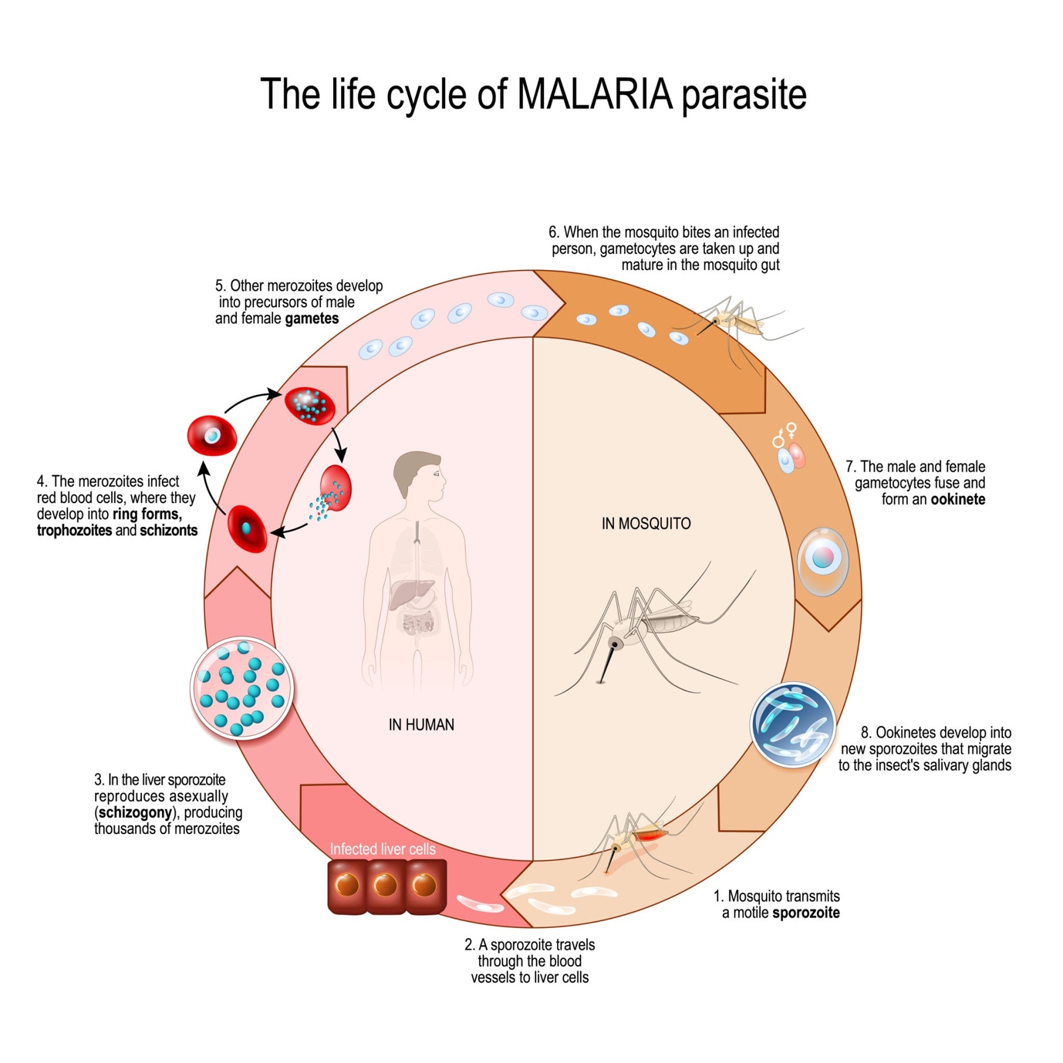
Getty Images
- Explain the Primary and Secondary stages of sewage treatment.
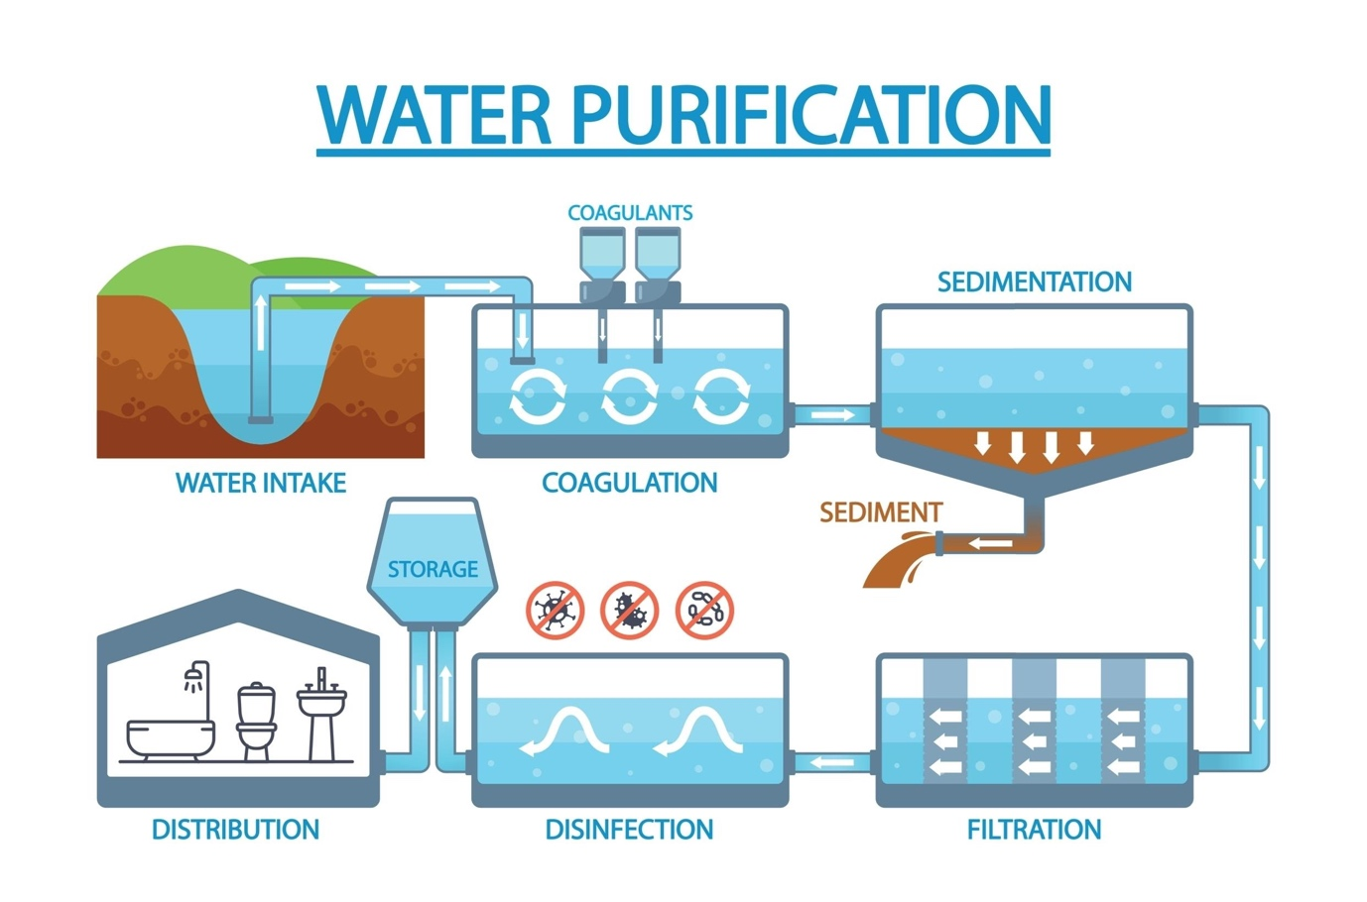
Shutterstock
- Discuss the structure of an Antibody molecule () with a labeled diagram.
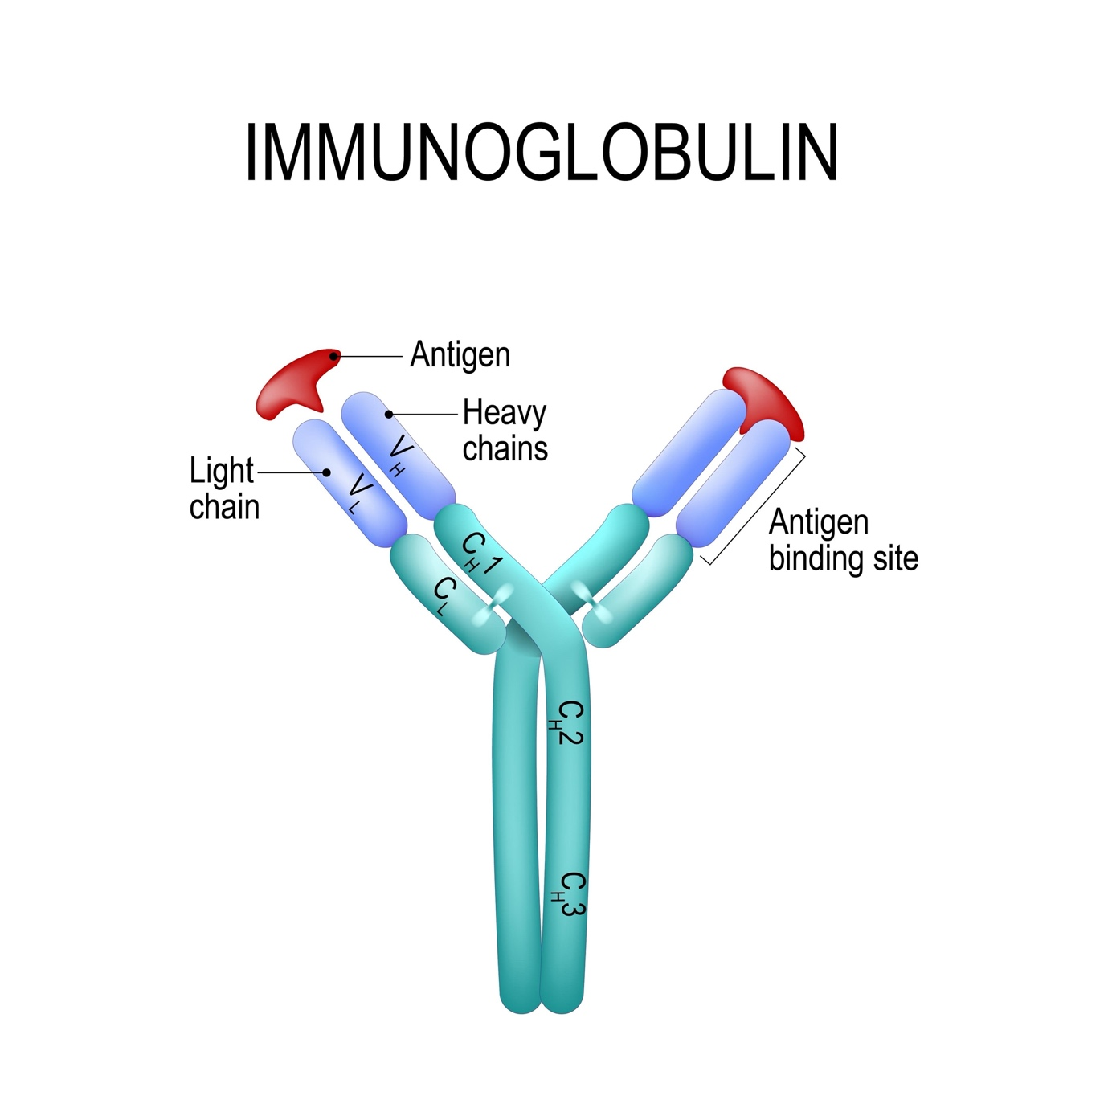
Shutterstock

Section D: Case Study Question (1 x 5m)
- Case Study: The Drug Menace A group of teenagers were found abusing "Smack" and "Marijuana". (i) What is the chemical name and source plant of "Smack"? (1m) (ii) Which part of the body do Cannabinoids primarily affect? (1m) (iii) Define 'Withdrawal Syndrome'. (2m) (iv) Why is it dangerous to share needles for intravenous drug use? (1m)

