Section A: 40 MCQs (1 Mark each)
Focus: Pathogens, immunity, and microbial applications.
- Which of the following is a "Confirmatory Test" for Typhoid?
  - (a) Schick test (b) Widal test (c) ELISA (d) Western Blot
  - Answer: (b) Widal test
  - Reasoning: It detects antibodies against Salmonella typhi in the patient's serum.
- The "Malignant Malaria" is caused by which species of Plasmodium?
  - (a) P. vivax (b) P. malariae (c) P. falciparum (d) P. ovale
  - Answer: (c) P. falciparum
  - Reasoning: P. falciparum is responsible for the most serious and often fatal form of malaria.
- In the life cycle of Plasmodium, where does the sexual stage (gametocytes) develop?
  - (a) Salivary glands of mosquito (b) Liver of human (c) Red blood cells of human (d) Gut of mosquito
  - Answer: (c) Red blood cells of human
  - Reasoning: Gametocytes are formed in human RBCs but are taken up by the mosquito to complete fertilization in its gut.
- "Colostrum" provides which type of immunity to the infant?
  - (a) Active Natural (b) Passive Natural (c) Active Artificial (d) Passive Artificial
  - Answer: (b) Passive Natural
  - Reasoning: It involves the natural transfer of ready-made IgA antibodies from mother to child.
- Which of the following is a lymphoid organ where T-lymphocytes mature?
  - (a) Bone marrow (b) Spleen (c) Thymus (d) Peyer's patches
  - Answer: (c) Thymus
  - Reasoning: While produced in the bone marrow, T-cells migrate to the thymus for maturation and "training."
- The "BOD" (Biochemical Oxygen Demand) of waste water is a measure of:
  - (a) Total organic matter (b) Dissolved Oxygen (c) Inorganic pollutants (d) Rate of aeration
  - Answer: (a) Total organic matter
  - Reasoning: Higher BOD indicates a greater amount of organic matter that microbes must decompose, using up oxygen.
- "Statins," used for lowering blood cholesterol, are produced by:
  - (a) Trichoderma polysporum (b) Monascus purpureus (c) Aspergillus niger (d) Acetobacter aceti
  - Answer: (b) Monascus purpureus
  - Reasoning: This yeast produces statins that competitively inhibit the enzyme responsible for cholesterol synthesis.
- Identify the "Clot Buster" enzyme used for patients who have undergone myocardial infarction:
  - (a) Lipase (b) Protease (c) Streptokinase (d) Pectinase
  - Answer: (c) Streptokinase
  - Reasoning: Produced by Streptococcus, it is used to dissolve blood clots in the vessels of heart patients.
- The primary treatment of sewage involves:
  - (a) Aeration (b) Biological digestion (c) Physical removal of particles (d) Chlorination
  - Answer: (c) Physical removal
  - Reasoning: It consists of sequential filtration and sedimentation to remove floating debris and grit.
- The "Large holes" in Swiss cheese are due to the production of large amounts of by:
  - (a) Saccharomyces cerevisiae (b) Propionibacterium sharmanii (c) Penicillium roqueforti (d) Lactobacillus
  - Answer: (b) Propionibacterium sharmanii
  - Reasoning: This bacterium undergoes fermentation that releases significant gas.
- The chemical released by mast cells during an allergic reaction is:
  - (a) Insulin (b) Histamine (c) Thyroxine (d) Adrenaline
  - Answer: (b) Histamine
  - Reasoning: Histamine and serotonin cause the typical inflammatory symptoms of an allergy (sneezing, watery eyes).
- Which of the following is an "autoimmune" disease?
  - (a) AIDS (b) Rheumatoid arthritis (c) Cancer (d) Typhoid
  - Answer: (b) Rheumatoid arthritis
  - Reasoning: In this condition, the body's immune system mistakenly attacks the joints, failing to distinguish "self" from "non-self."
- "Metastasis" is a characteristic feature of:
  - (a) Benign tumors (b) Malignant tumors (c) Antibiotics (d) Vaccines
  - Answer: (b) Malignant tumors
  - Reasoning: It is the process where cancerous cells slough off and travel through blood to start new tumors in distant organs.
- The "Baker's Yeast" used in bread making is:
  - (a) Saccharomyces cerevisiae (b) Propionibacterium (c) Lactobacillus (d) Aspergillus
  - Answer: (a) Saccharomyces cerevisiae
  - Reasoning: It ferments sugars into ethyl alcohol and , the latter causes the dough to rise (leavening).
- Which microbe is used for the production of Citric Acid?
  - (a) Acetobacter aceti (b) Clostridium butylicum (c) Aspergillus niger (d) Lactobacillus
  - Answer: (c) Aspergillus niger
  - Reasoning: This fungus is industrially cultivated for the high-yield production of citric acid.
- "Cyclosporin A," an immunosuppressive agent for organ-transplant patients, is produced by:
  - (a) Monascus purpureus (b) Trichoderma polysporum (c) Saccharomyces (d) Penicillium
  - Answer: (b) Trichoderma polysporum
  - Reasoning: It suppresses the T-cell mediated immune response to prevent the rejection of the donor organ.
- During sewage treatment, "Flocs" are composed of:
  - (a) Only bacteria (b) Only fungi (c) Masses of bacteria associated with fungal filaments (d) Viruses
  - Answer: (c)
  - Reasoning: These mesh-like structures vigorously consume the organic matter in the secondary treatment aeration tanks.
- The "Greatest breakthrough" in the treatment of infectious diseases was the discovery of:
  - (a) Vaccines (b) Antibiotics (c) Steroids (d) Yoga
  - Answer: (b) Antibiotics
  - Reasoning: Starting with Penicillin, antibiotics allowed for the treatment of previously fatal bacterial infections like pneumonia.
- Cannabinoids primarily affect which system of the human body?
  - (a) Respiratory (b) Cardiovascular (c) Digestive (d) Excretory
  - Answer: (b) Cardiovascular
  - Reasoning: Known for their effects on the brain, their primary systemic physiological effect is on the heart and blood vessels.
- "Heroin" is chemically known as:
  - (a) Benzodiazepine (b) Diacetylmorphine (c) Amphetamine (d) Cannabinoid
  - Answer: (b) Diacetylmorphine
  - Reasoning: It is produced by the acetylation of morphine and acts as a potent depressant.
- The vector for Elephantiasis (Filariasis) is:
  - (a) Female Anopheles (b) Female Culex (c) Aedes aegypti (d) Housefly
  - Answer: (b) Female Culex
  - Reasoning: The Culex mosquito transmits the Wuchereria larvae into the human lymphatic system.
- The "Ringworm" infection in humans is caused by:
  - (a) Bacteria (b) Virus (c) Fungi (d) Nematodes
  - Answer: (c) Fungi
  - Reasoning: Genera like Microsporum and Trichophyton cause these dry, scaly lesions on the skin.
- Which lymphoid organ is known as the "Graveyard of RBCs"?
  - (a) Thymus (b) Spleen (c) Tonsils (d) Bone Marrow
  - Answer: (b) Spleen
  - Reasoning: The spleen filters the blood and removes worn-out red blood cells.
- Innate immunity barriers like the "Acid in the stomach" and "Tears" are classified as:
  - (a) Physical (b) Physiological (c) Cellular (d) Cytokine
  - Answer: (b) Physiological
  - Reasoning: They use chemical/biochemical conditions to prevent microbial growth.
- "Interferons" are proteins secreted by cells to protect against:
  - (a) Bacteria (b) Viruses (c) Fungi (d) Protozoa
  - Answer: (b) Viruses
  - Reasoning: Virus-infected cells secrete interferons to warn and protect neighboring healthy cells.
- Which of the following is a "Living" mechanical vector for Amoebiasis?
  - (a) Mosquito (b) Housefly (c) Tick (d) Rat
  - Answer: (b) Housefly
  - Reasoning: Houseflies mechanically transfer the parasite from feces to food.
- The drug "Cocaine" is obtained from:
  - (a) Erythroxylum coca (b) Atropa belladonna (c) Cannabis sativa (d) Datura
  - Answer: (a)
  - Reasoning: Native to South America, it interferes with the transport of the neurotransmitter dopamine.
- "Biogas" is primarily a mixture of:
  - (a) and (b) Methane and (c) Methane and (d) Ethane and
  - Answer: (b) Methane and
  - Reasoning: Methane makes up roughly 50-70% of biogas, making it highly inflammable.
- Which bacterium is used as a "Biopesticide" to kill butterfly caterpillars?
  - (a) Bacillus thuringiensis (b) Rhizobium (c) Lactobacillus (d) Streptococcus
  - Answer: (a)
  - Reasoning: It produces a toxic protein (Bt-toxin) that kills the larvae upon ingestion.
- What is the common name for Wuchereria bancrofti?
  - (a) Roundworm (b) Filarial worm (c) Hookworm (d) Tapeworm
  - Answer: (b) Filarial worm
  - Reasoning: It causes the swelling of limbs known as elephantiasis.
- Antibodies are chemically:
  - (a) Lipids (b) Steroids (c) Proteins (d) Carbohydrates
  - Answer: (c) Proteins
  - Reasoning: They are specialized globulin proteins (Immunoglobulins).
- The use of "Anti-venom" against a snake bite is an example of:
  - (a) Active immunity (b) Passive immunity (c) Innate immunity (d) Specific immunity
  - Answer: (b) Passive immunity
  - Reasoning: It involves injecting pre-formed antibodies into the body for immediate action.
- Which part of the body is infected in Pneumonia?
  - (a) Nasal passage (b) Alveoli of lungs (c) Throat (d) Intestine
  - Answer: (b) Alveoli
  - Reasoning: The alveoli get filled with fluid, leading to severe breathing difficulties.
- "Bottled juices" are clearer than homemade ones due to the use of:
  - (a) Lipases (b) Pectinases and Proteases (c) Streptokinase (d) Amylase
  - Answer: (b)
  - Reasoning: These enzymes break down the plant cell wall components and proteins that cause cloudiness.
- The symbiotic association between fungi and roots of higher plants is:
  - (a) Lichen (b) Mycorrhiza (c) Biofertilizer (d) Parasitism
  - Answer: (b) Mycorrhiza
  - Reasoning: It helps the plant in phosphorus absorption and provides tolerance to environmental stress.
- Which organism is a "Cyanobacteria" used as a biofertilizer in paddy fields?
  - (a) Anabaena (b) Rhizobium (c) Glomus (d) Azotobacter
  - Answer: (a) Anabaena
  - Reasoning: It can fix atmospheric nitrogen in specialized cells called heterocysts.
- The "Ladybird" beetle is used to control which pest?
  - (a) Mosquitoes (b) Aphids (c) Caterpillars (d) Locusts
  - Answer: (b) Aphids
  - Reasoning: It is a natural predator of aphids, providing a chemical-free pest control option.
- Which of the following drugs is often abused by sportspeople to increase performance?
  - (a) Morphine (b) Anabolic steroids (c) Penicillin (d) Insulin
  - Answer: (b) Anabolic steroids
  - Reasoning: They increase muscle mass and aggressiveness but have severe long-term side effects.
- The primary goal of "IPM" (Integrated Pest Management) is to:
  - (a) Eradicate all pests (b) Use only chemical pesticides
  - (c) Keep pests at manageable levels using biological methods (d) Create GMOs
  - Answer: (c)
  - Reasoning: It focuses on ecosystem balance rather than total extermination.
- "Sewage" contains large amounts of:
  - (a) Only inorganic salts (b) Organic matter and pathogenic microbes
  - (c) Only heavy metals (d) Only plastic waste
  - Answer: (b)
  - Reasoning: This is why it must be treated biologically before disposal in water bodies.

Section B: 30 Questions (2 Marks each
- Differentiate between Benign and Malignant tumrs.
  - Benign: Remain confined to original location; do not spread.
  - Malignant: Mass of proliferating cells (neoplastic); invade and damage surrounding tissues (Metastasis).
- Define "Innate Immunity" and name its four barriers.
  - Definition: Non-specific defense present at birth. Barriers: Physical (Skin), Physiological (Acid in stomach), Cellular (WBCs), and Cytokine (Interferons).
- What is an "Allergy"? Name the Ig antibody and cells involved.
  - Definition: Exaggerated immune response to certain environmental antigens. Antibody: IgE. Cells: Mast cells (release Histamine).
- Why is the HIV virus called a "Retrovirus"?
  - It possesses an RNA genome and the enzyme Reverse Transcriptase, which converts viral RNA into DNA inside the host cell.
- How does "Vaccination" work on the principle of memory?
  - The vaccine introduces inactivated pathogens; the immune system generates B and T memory cells that recognize and attack the actual pathogen quickly upon future exposure.
- Define "Autoimmunity" with an example.
  - Condition where the body’s immune system attacks its own cells (loss of self-tolerance). Example:Rheumatoid arthritis.
- Explain the role of "Methanogens" in a Biogas plant.
  - These anaerobic bacteria (like Methanobacterium) break down cellulosic material in cow dung to produce a mixture of gases, primarily Methane.
- What are "Biofertilizers"? Name two nitrogen-fixing organisms.
  - Organisms that enrich the nutrient quality of soil. Examples: Rhizobium and Azospirillum.
- How do "Mycorrhizae" help plants?
  - Fungal association (e.g., Glomus) that absorbs phosphorus from soil and provides resistance to root-borne pathogens.
- What is "Integrated Pest Management" (IPM)?
  - A biological control method that uses natural predators rather than chemicals to manage pests, preserving the ecosystem.
- Why is the HIV virus called a "Retrovirus"?
  - It has an RNA genome and uses the enzyme Reverse Transcriptase to replicate via a DNA intermediate.
- Name two "Screening" and "Confirmatory" tests for HIV.
  - Screening: ELISA. Confirmatory: Western Blot.
- What is "Metastasis"?
  - The spread of cancer cells from a primary tumor to distant parts of the body via blood or lymph.
- Mention two effects of "Alcohol abuse" on the liver.
  - It leads to Fatty Liver syndrome and eventually Cirrhosis (scarring of liver tissue).
- Why is "Passive Immunity" needed in case of a snake bite?
  - The toxin is fast-acting; the body doesn't have time to produce its own antibodies, so pre-formed ones are injected for an immediate response.
- How do "Statins" lower blood cholesterol?
  - They act as competitive inhibitors for the enzyme responsible for synthesizing cholesterol in the liver.
- What are "Flocs" in sewage treatment?
  - Masses of bacteria held together by fungal filaments to form mesh-like structures that consume organic matter.
- Differentiate between "Primary" and "Secondary" sewage treatment.
  - Primary is a physical process (filtration/sedimentation); Secondary is a biological process using microbes.
- What is "BOD"? What does a high BOD indicate?
  - Biochemical Oxygen Demand; high BOD indicates high organic pollution in the water.
- Name two "Methanogens" and where they are found.
  - Methanobacterium; found in anaerobic sludge and the rumen of cattle.
- How does Bacillus thuringiensis act as a biocontrol agent?
  - It produces toxic protein crystals that kill the larvae (caterpillars) of certain insects by creating pores in their gut.
- What is the function of "Interferons"?
  - They are anti-viral proteins that protect non-infected cells from further viral infection.
- Why are "Lymphoid organs" important?
  - They are the sites where lymphocytes originate, mature, and proliferate to mount an immune response.
- Differentiate between "Active" and "Passive" immunity.
  - Active: Body produces its own antibodies (slow/long-lasting). Passive: Ready-made antibodies are injected (fast/short-lasting).
- What is an "Allergy"? Name one common allergen.
  - An exaggerated immune response to environmental triggers. Example: Pollen or Dust.
- What is "Anaerobic Sludge Digester"?
  - A tank where anaerobic bacteria digest the flocs/sludge, producing biogas (methane, , etc.).
- How does "Streptokinase" help heart patients?
  - It acts as a "clot buster," dissolving blood clots that cause heart attacks.
- Name two fungi used for the commercial production of organic acids.
  - Aspergillus niger (Citric acid) and Penicillium (various metabolites).
- What is "Biological Control"? Give one example.
  - Using natural enemies to control pests. Example: Dragonflies to control mosquitoes.
- Mention two symptoms of "Ascariasis."
  - Internal bleeding, muscular pain, fever, and blockage of the intestinal passage.

Section C: 15 Questions (4 Marks each)
- Describe the Life Cycle of the Malarial Parasite (Plasmodium) with a labeled diagram.
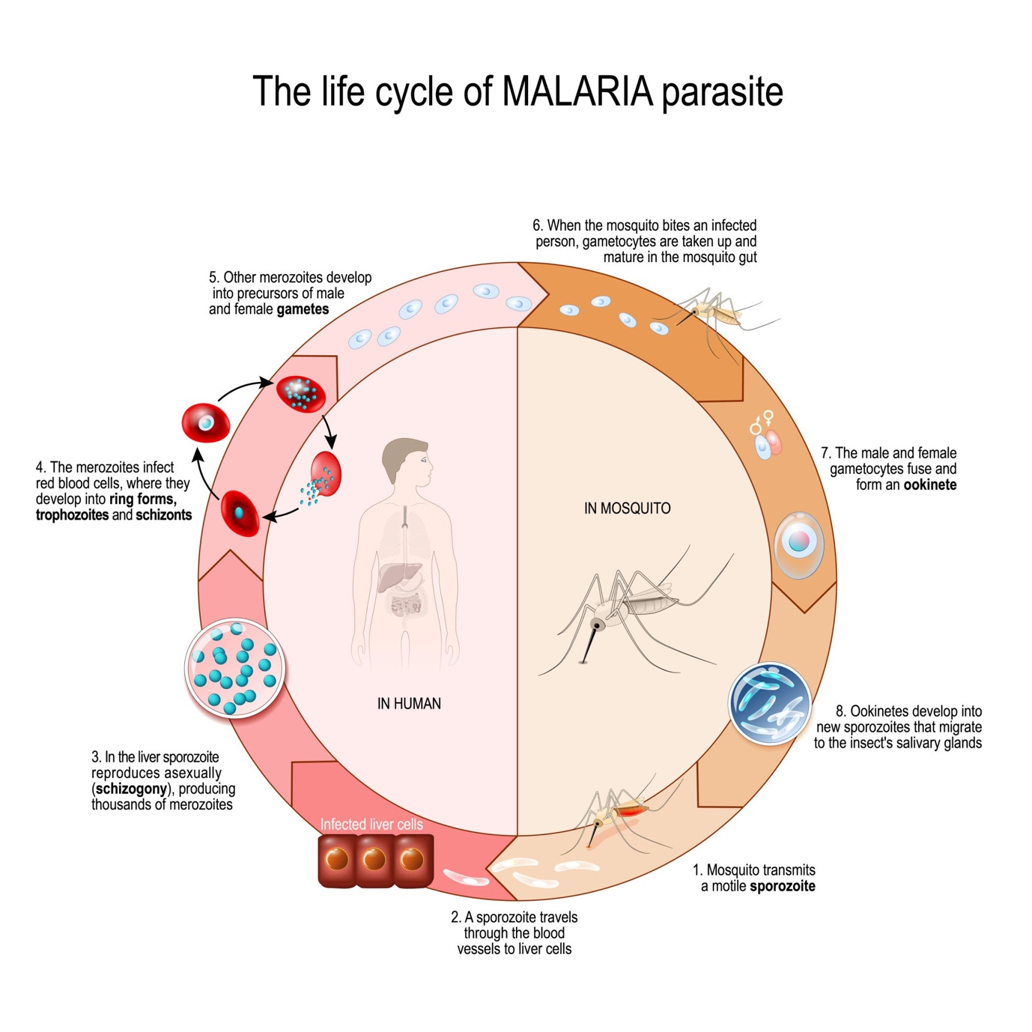
Getty Images
- Key Stages: Sporozoites in mosquito → Liver infection → RBC infection (Hemozoin release) → Gametocyte formation → Fertilization in mosquito gut.
- Explain the structure and functioning of an Antibody molecule.
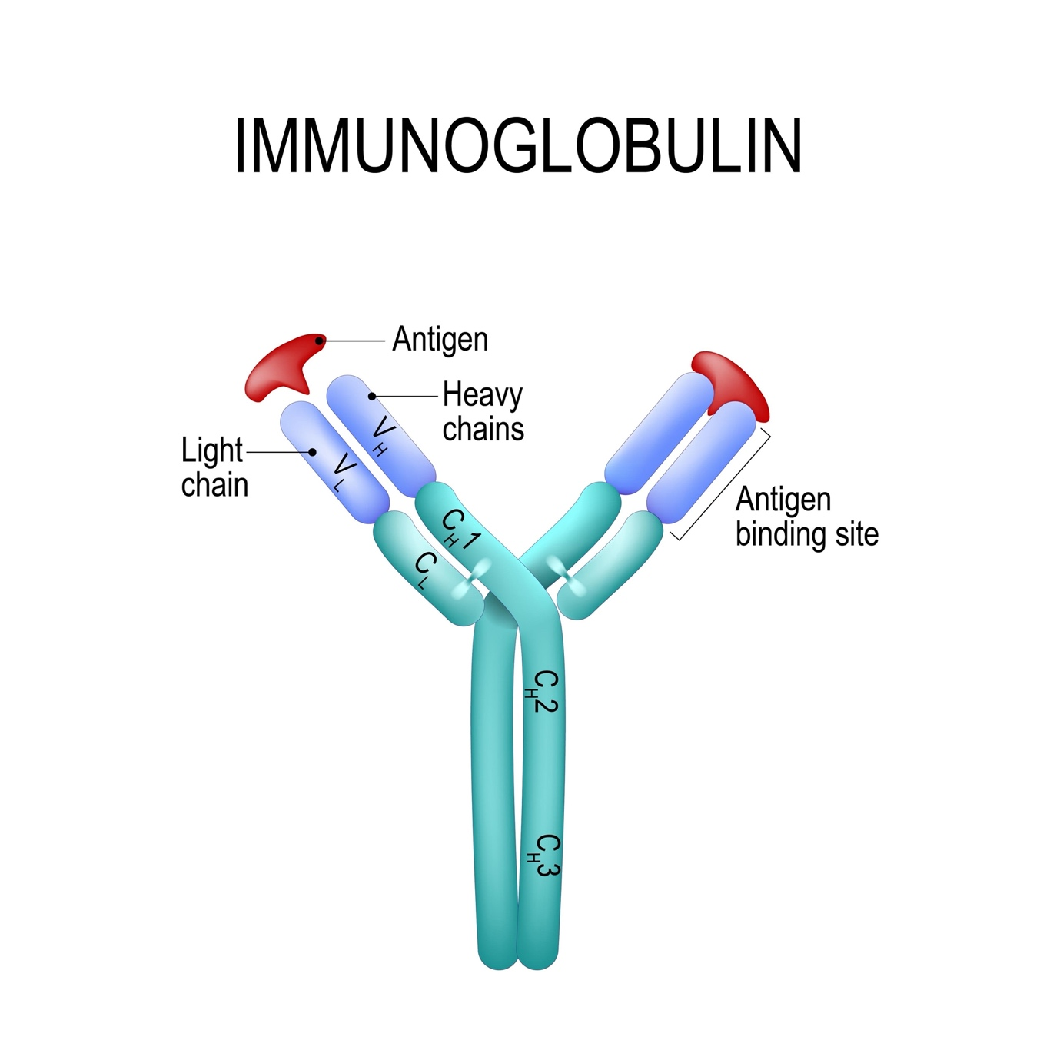
Shutterstock
- Components: Two light chains, two heavy chains (); variable region (antigen binding site) and constant region.
- Describe the stages of Sewage Treatment (Primary and Secondary).
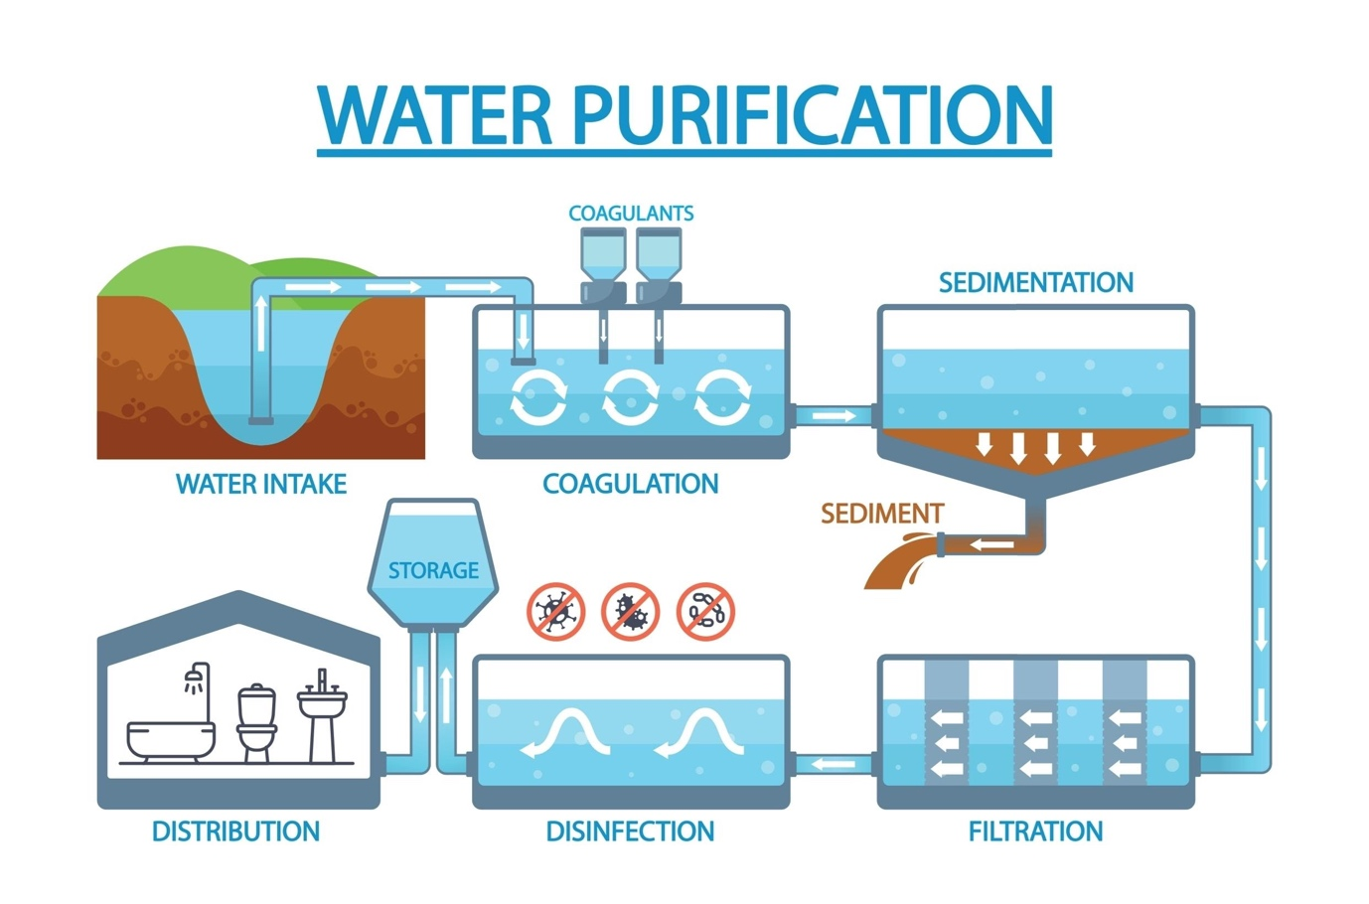
Shutterstock
- Primary: Filtration/Sedimentation. Secondary: Aeration tanks (Flocs) and Anaerobic sludge digesters.
- Explain the "Replication of Retrovirus" (HIV) inside a human cell.
  - Steps: Entry → Reverse Transcription → Integration into host DNA → New viral RNA production → Budding.
- Discuss the "Biological Control of Pests and Diseases" with examples.
  - Examples: Ladybird (against Aphids), Dragonflies (Mosquitoes), Bacillus thuringiensis (Caterpillars), and Trichoderma (Root pathogens).
- Discuss the "Prevention and Control" of drug and alcohol abuse among adolescents.
  - Mention avoiding pressure, education, seeking help from parents/professionals.
- Explain the steps involved in "Sewage Treatment" in detail.
  - Primary (Physical) and Secondary (Biological/Aeration/Anaerobic Digestion).
Shutterstock
- Describe the "Replication of Retrovirus" in a host cell.
  - Viral RNA → DNA (Reverse Transcriptase) → Integration into nucleus → New viral RNA.
- What is "Cancer"? Discuss its causes (Carcinogens) and detection methods.
  - Mention physical, chemical, and biological agents; detection via biopsy, MRI, CT scan.
- Discuss the role of "Microbes as Biofertilizers."
  - Include Bacteria (Rhizobium), Cyanobacteria (Anabaena), and Fungi (Glomus).
- How are Microbes used in "Biogas Production"?
  - Detail the functioning of a biogas plant and the role of methanogens.
- Compare "Acquired Immunity" with "Innate Immunity."
  - Focus on specificity, memory, and time of onset.
- Discuss the "Industrial Products" obtained from microbes.
  - Include Fermented beverages, Antibiotics, Enzymes, and Bioactive molecules.

Section D: 5 Case Studies (Total Questions: 3x1m, 3x2m)

Case Study 1: The Drug Trap
A group of teenagers started using "Smack" for recreation. Over time, they became physically and psychologically dependent, experiencing severe withdrawal symptoms when they tried to stop.
- What is the chemical name of "Smack" and from which plant is it extracted? (1m)
  - Answer: Diacetylmorphine; extracted from the Latex of the Poppy plant (Papaver somniferum).
- Which part of the body do Opioids primarily affect? (1m)
  - Answer: Central Nervous System (CNS) and Gastrointestinal tract.
- Is "Smack" a stimulant or a depressant? (1m)
  - Answer: Depressant.
- Define "Withdrawal Syndrome." (2m)
  - Answer: The unpleasant/painful physical and mental symptoms that occur when a regular dose of a drug is suddenly discontinued.
- What are the social consequences of drug addiction? (2m)
  - Answer: Financial ruin, breakdown of family relationships, and increased risk of infectious diseases (like HIV/Hepatitis B) due to shared needles.
- Suggest two measures to prevent drug abuse among youth. (2m)
  - Answer: Education/Counseling and seeking help from parents or peers during stressful times.

Case Study 2: The Silent Pandemic (HIV/AIDS)
A patient tests positive for HIV after a long period of recurring bouts of fever, diarrhea, and weight loss. Doctors explain that his "Helper T-cells" have significantly decreased.
- What is the confirmatory test for AIDS? (1m)
  - Answer: Western Blot (Screening is ELISA).
- Why does an AIDS patient suffer from multiple opportunistic infections? (1m)
  - Answer: The virus destroys Helper T-lymphocytes (), which are essential for coordinating the entire immune response.
- Can HIV be transmitted through casual touch or sharing food? (1m)
  - Answer: No.
- Explain the "Window Period" in HIV infection. (2m)
  - Answer: The time interval between the initial infection and the point when antibodies become detectable in the blood.
- How does "Reverse Transcriptase" help the virus? (2m)
  - Answer: It allows the viral RNA to be converted into DNA, which can then hide within the human genome.
- List two modes of HIV transmission other than sexual contact. (2m)
  - Answer: Transfusion of contaminated blood and from infected mother to child through the placenta.

Case Study 3: The Sewage Crisis
A city official is worried about the high BOD levels in the local river. He visits a sewage treatment plant to understand how the water is cleaned before discharge.
- What does a high BOD value tell us about the river water? (1m)
  - Answer: It indicates high organic pollution.
- In which tank of the treatment plant is the BOD actually reduced? (1m)
  - Answer: The Aeration Tank (Secondary treatment).
- What are "Flocs" and what is their role? (2m)
  - Answer: Bacterial masses with fungal filaments; they consume the organic matter in the effluent.
- Where does the "Biogas" produced in the plant come from? (1m)
  - Answer: From the Anaerobic Sludge Digester.

Case Study 4: The Immunity Shield
A child is taken to the clinic for his scheduled "DPT" vaccine. The doctor explains that this will protect him from Diphtheria, Pertussis, and Tetanus.
- Is vaccination an example of active or passive immunity? (1m)
  - Answer: Active immunity.
- What is the "memory" component of the immune system? (2m)
  - Answer: B and T-memory cells that "remember" the pathogen for future encounters.
- If the child were bitten by a snake, why would a vaccine not be enough? (2m)
  - Answer: Vaccines take time to work; snake venom needs immediate neutralization via passive immunity (anti-venom).

Case Study 5: The Bio-Control Farm
An organic farmer refuses to use chemical pesticides. Instead, he uses Ladybird beetles and Bacillus thuringiensis to manage his crops.
- What is the advantage of this "Biological Control" over chemical pesticides? (2m)
  - Answer: It is environmentally friendly, non-toxic, and does not kill beneficial insects.
- How does Bt kill the caterpillars but not the humans? (2m)
  - Answer: The toxin is activated only in the alkaline pH of the insect gut; human stomachs are acidic.
- Name the natural predator used to control mosquitoes. (1m)
  - Answer: Dragonfly.

