Question Paper Set 1
Class XII
Time: 60 minutes | Max Marks: 32

Section A: Multiple Choice Questions (8 x 1m)
- In the naming of the restriction enzyme EcoRI, the Roman numeral 'I' indicates: (a) The strain of the bacterium (b) The order in which the enzyme was isolated from the strain (c) The genus of the bacterium (d) The species of the bacterium
- Which of the following DNA sequences is a perfect palindrome that could be recognized by a restriction enzyme? (a) -GAATTC-; -CTTAAG- (b) -GATATC-; -CTATAG- (c) -CCCGGG-; -GGGCCC- (d) All of these
- The "Bt toxin" protein crystals do not kill the Bacillus thuringiensis bacterium because: (a) The bacterium is resistant to the toxin (b) The toxin is present as an inactive protoxin (c) The toxin is stored in a specialized organelle (d) The bacterium lacks the midgut pH required for activation
- "Golden Rice" is a transgenic crop developed to help people suffering from a deficiency of: (a) Vitamin C (b) Vitamin A (c) Iron (d) Iodine
- During the process of gel electrophoresis, DNA fragments move toward the anode because: (a) DNA is positively charged (b) DNA is negatively charged (c) The anode is negatively charged (d) Larger fragments move faster
- The primary function of 'selectable markers' in a cloning vector like pBR322 is to: (a) Initiate replication of DNA (b) Identify and eliminate non-transformants (c) Increase the copy number of the gene (d) Cut the DNA at specific sites
- The first clinical gene therapy (1990) was used to treat a 4-year-old girl suffering from: (a) Diabetes (b) ADA deficiency (c) Hemophilia (d) Cystic fibrosis
- The 'Taq Polymerase' enzyme used in PCR is uniquely useful because it is: (a) Extremely fast (b) Capable of joining DNA fragments (c) Thermostable and active at high temperatures (d) Derived from human cells

Section B: Short Answer Questions (4 x 2m)
- What is 'Biopiracy'? Provide an example involving an Indian bio-resource.
- Briefly explain the steps of 'Denaturation' and 'Annealing' in a PCR cycle.
- Differentiate between 'Pro-insulin' and 'Mature Insulin' with respect to the C-peptide.
- Define 'Downstream Processing'. Why is it necessary before a biosynthetic product is marketed?

Section C: Long Answer Questions (3 x 4m)
- Describe the major steps in the construction of a Recombinant DNA molecule, starting from the isolation of DNA to its insertion into a host cell.
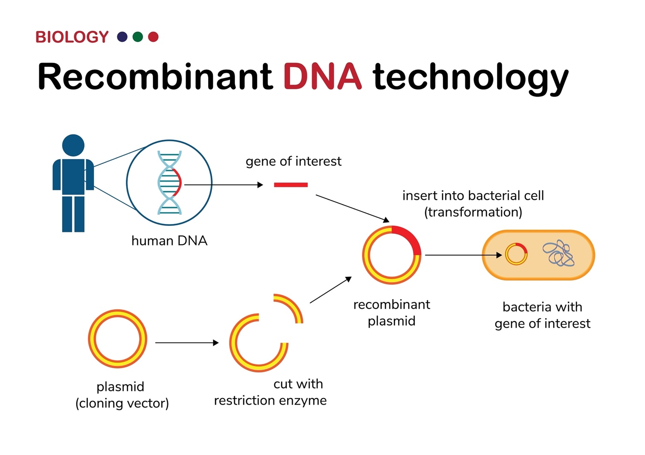
Shutterstock
Explore
- Explain the process of 'Gel Electrophoresis' for the separation and isolation of DNA fragments. Mention the role of Ethidium Bromide and UV light.
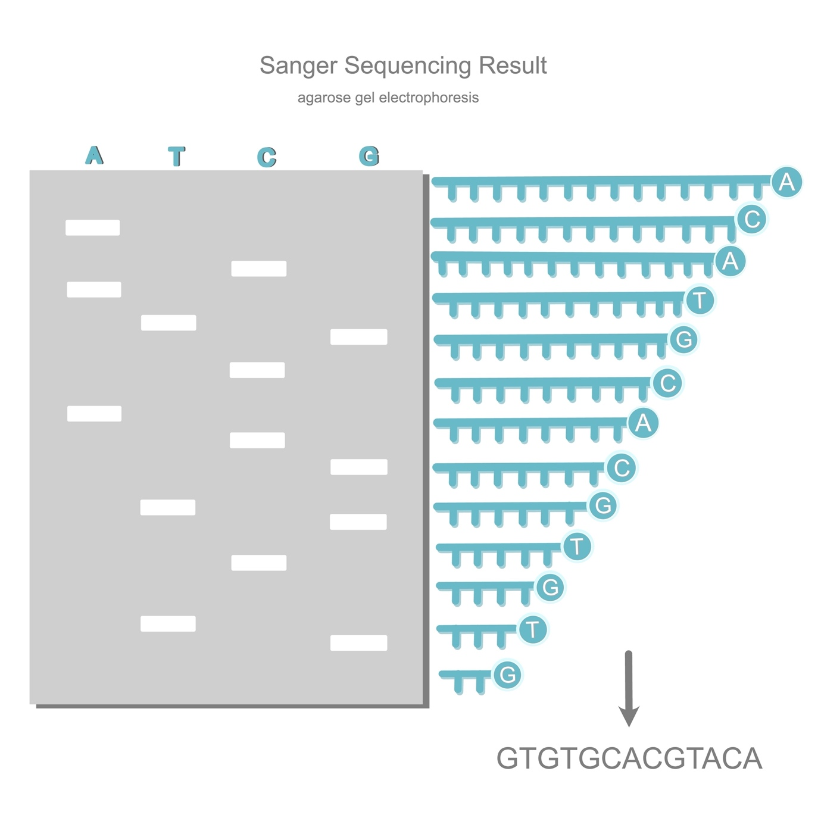
Shutterstock
- Discuss the role of Agrobacterium tumefaciens as a cloning vector for plants. Why is it called a "natural genetic engineer"?

Section D: Case Study Question (1 x 5m)
- Case Study: The Nematode Challenge A tobacco farmer finds that his crop yield is significantly reduced due to root-knot disease caused by the nematode Meloidogyne incognita. Scientists suggest using a cellular defense mechanism called RNA interference (RNAi) to create resistant plants.
(i) What is the fundamental principle of RNA interference? (1m) (ii) How is the nematode-specific DNA introduced into the tobacco plant? (1m) (iii) Explain the role of double-stranded RNA (dsRNA) in silencing the target mRNA. (2m) (iv) What is the ultimate result of this process for the nematode trying to infect the plant? (1m)

