Question Paper Set 2
Class XII
Time: 60 minutes | Max Marks: 32

Section A: Multiple Choice Questions (8 x 1m)
- Which of the following enzymes is used to digest the cell wall of a fungus during DNA isolation? (a) Lysozyme (b) Cellulase (c) Chitinase (d) Protease
- In the pBR322 vector, the 'rop' gene codes for proteins involved in: (a) Antibiotic resistance (b) Replication of the plasmid (c) Selection of recombinants (d) Cutting by restriction enzymes
- The visualization of DNA fragments in an agarose gel is possible only after staining with: (a) Bromophenol blue (b) Acetocarmine (c) Ethidium bromide (d) Methylene blue
- A stirred-tank bioreactor is superior to a shake flask primarily because it provides: (a) Better aeration and mixing (b) A closed environment (c) Higher pressure (d) Ability to use solid medium
- Which methodology of cellular defense is common to all eukaryotic organisms? (a) RNA interference (b) Phagocytosis (c) Immune response (d) Heat shock
- The first transgenic cow 'Rosie' produced human protein-enriched milk. The protein was: (a) Alpha-1-antitrypsin (b) Human alpha-lactalbumin (c) Insulin (d) Growth hormone
- The 'sticky ends' on a DNA strand are so-called because: (a) They contain glue-like proteins (b) They form hydrogen bonds with their complementary cut counter-parts (c) They are difficult to separate (d) They prevent the action of DNA ligase
- Detection of a pathogen by ELISA is based on the principle of: (a) DNA-RNA hybridization (b) Antigen-antibody interaction (c) Amplification of DNA (d) Electrophoresis

Section B: Short Answer Questions (4 x 2m)
- What is a 'Palindromic sequence'? Write the palindrome recognized by EcoRI.
- Explain the term 'Insertional Inactivation' in the context of color-based selection of recombinants.
- Mention two benefits of 'Transgenic Animals' in the field of medicine or vaccine safety.
- Why is the 'Taq Polymerase' enzyme used in PCR instead of normal DNA Polymerase?

Section C: Long Answer Questions (3 x 4m)
- Draw a neat, labeled diagram of a Simple Stirred-tank Bioreactor. Mention the functions of the sparger and the agitator system.
- Describe the various methods of 'Gene Transfer' into competent host cells without using a vector (e.g., Micro-injection, Biolistics, and Disarmed pathogens).
- Discuss the steps involved in 'Gene Therapy' for Adenosine Deaminase (ADA) deficiency. Why is it not a permanent cure if performed only on adult lymphocytes?

Section D: Case Study Question (1 x 5m)
- Case Study: The Molecular Detective In a suspected case of early-stage HIV infection, a patient’s blood report shows no detectable antibodies against the virus. However, the doctor recommends a Polymerase Chain Reaction (PCR) test to confirm the diagnosis.
(i) Why is PCR considered a 'Molecular Diagnostic' tool? (1m) (ii) Explain why PCR can detect the virus even when the viral load is very low. (2m) (iii) List the three main steps of a single PCR cycle in the correct sequence. (1m) (iv) Name the specific enzyme required for the Extension step of PCR. (1m)
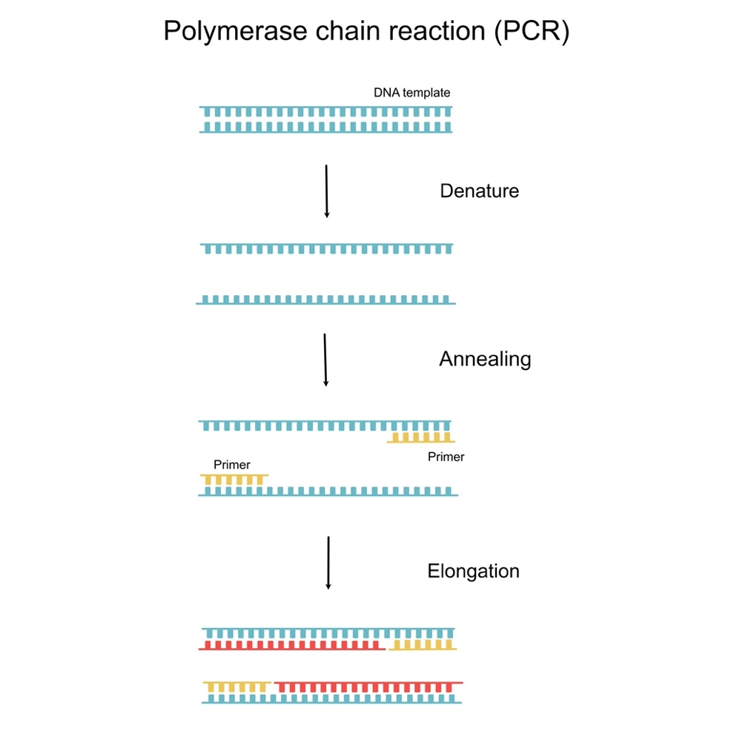
Getty Images

