Question Paper Set 3
Class XII
Time: 60 minutes | Max Marks: 32

Section A: Multiple Choice Questions (8 x 1m)
- Which of the following is required to precipitate purified DNA out of an aqueous solution during isolation?(a) Chilled Ethanol (b) Concentrated HCl (c) Chloroform (d) Ether
- The specific DNA sequence in a genome which is responsible for initiating replication is called: (a) Promoter (b) Terminator (c) Origin of replication (ori) (d) Exon
- An enzyme that cuts only one strand of the double helix to relieve tension during replication (but is not a molecular scissor) is: (a) Ligase (b) Topoisomerase (c) Endonuclease (d) Polymerase
- 'Bt Toxin' genes are named cry because: (a) They make the insect cry (b) The toxin is produced in the form of crystals (c) They were discovered by Dr. Cryer (d) They are active in cold temperatures
- Which human protein is used to treat emphysema and is produced by transgenic animals? (a) Insulin (b) Alpha-1-antitrypsin (c) Lactalbumin (d) Hemoglobin
- The technique of 'RNA interference' involves silencing of mRNA to prevent: (a) Replication (b) Transcription (c) Translation (d) Splicing
- If a recombinant DNA is inserted within the coding sequence of -galactosidase, the colonies will appear: (a) Blue (b) White (c) Red (d) Green
- The 'GEAC' (Genetic Engineering Appraisal Committee) works under the aegis of which Indian Ministry?(a) Ministry of Health (b) Ministry of Environment, Forest and Climate Change (c) Ministry of Science and Technology (d) Ministry of Agriculture

Section B: Short Answer Questions (4 x 2m)
- What is 'Elution' in the process of agarose gel electrophoresis?
- Define 'Biopiracy'. How did India defend its rights over Basmati rice against the US patent?
- Why is pro-insulin called an 'inactive' form? What change makes it active?
- Mention any two ethical issues associated with the production of transgenic animals.

Section C: Long Answer Questions (3 x 4m)
- Describe the process of DNA Isolation step-by-step. Mention the enzymes used for different types of cells (Bacterial, Plant, and Fungal).
- Explain the three major steps of a PCR cycle with the help of a labeled diagram. Why is the use of a thermostable polymerase necessary?
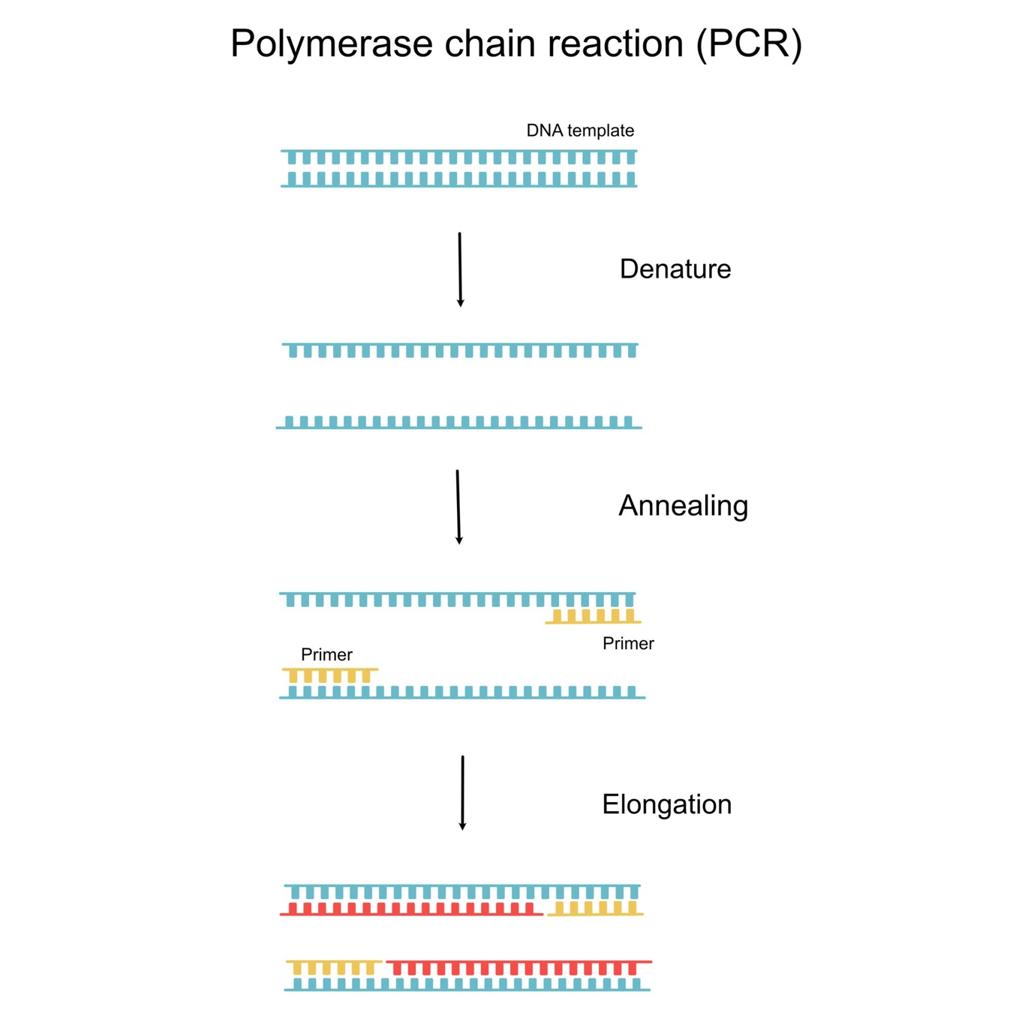
Getty Images
- Discuss the applications of Biotechnology in Medicine. Focus on the production of Genetically Engineered Insulin and its advantages over animal-derived insulin.

Section D: Case Study Question (1 x 5m)
- Case Study: The First Transgenic Cow In 1997, the first transgenic cow, Rosie, was produced. Her milk contained a human protein that made the milk much more nutritionally balanced for human babies than natural cow milk.
(i) Name the specific human protein found in Rosie's milk. (1m) (ii) How much of this protein was present per liter of milk? (1m) (iii) What is a transgenic animal? (1m) (iv) Besides nutritional benefits, list two other reasons why scientists create transgenic animals. (2m)

