Section A: 40 MCQs (1 Mark each)
Includes Answer and Reasoning.
- The "Molecular Scissors" used in genetic engineering are: (a) Ligases (b) Restriction Endonucleases (c) Polymerases (d) Helicases
  - Answer: (b)
  - Reasoning: They cut DNA at specific palindromic sequences.
- In the naming of the enzyme EcoRI, the letter 'R' stands for: (a) Genus (b) Species (c) Strain (d) Order of isolation
  - Answer: (c)
  - Reasoning: 'E' is Escherichia, 'co' is coli, and 'R' represents the strain RY13.
- Which of the following is used as a cloning vector in plants? (a) pBR322 (b) Agrobacterium tumefaciens (Ti plasmid) (c) Bacteriophage (d) SV40
  - Answer: (b)
  - Reasoning: The Ti plasmid of Agrobacterium is naturally able to deliver DNA into plant cells.
- The "Cry" genes obtained from Bacillus thuringiensis are effective against: (a) Viruses (b) Fungi (c) Insect pests (d) Nematodes
  - Answer: (c)
  - Reasoning: Cry proteins are toxic to the larvae of certain insects like bollworms.
- "Biolistics" (Gene gun) is a method suitable for: (a) Disarming pathogens (b) Transformation of plant cells (c) Constructing recombinant DNA (d) DNA fingerprinting
  - Answer: (b)
  - Reasoning: It involves bombarding plant cells with high-velocity micro-particles of gold or tungsten coated with DNA.
- The first clinical gene therapy was given for the deficiency of: (a) Insulin (b) Adenosine Deaminase (ADA) (c) Growth hormone (d) Hemoglobin
  - Answer: (b)
  - Reasoning: It was performed in 1990 on a 4-year-old girl with SCID.
- The enzyme used to join bits of DNA together is: (a) DNA Polymerase (b) Primase (c) DNA Ligase (d) Endonuclease
  - Answer: (c)
  - Reasoning: Ligase facilitates the formation of phosphodiester bonds between DNA fragments.
- In pBR322, the 'ampR' and 'tetR' genes act as: (a) Selectable markers (b) Origins of replication (c) Restriction sites (d) Promoters
  - Answer: (a)
  - Reasoning: They help in identifying and selecting transformants from non-transformants.
- Which technique is used to amplify a specific segment of DNA? (a) Gel Electrophoresis (b) PCR (Polymerase Chain Reaction) (c) Southern Blotting (d) Downstream processing
  - Answer: (b)
  - Reasoning: PCR can make billions of copies of a DNA sequence in a short time.
- The "Bt toxin" is activated in the insect gut due to: (a) Acidic pH (b) Alkaline pH (c) High temperature (d) Presence of enzymes
  - Answer: (b)
  - Reasoning: The protoxin is converted into active toxin in the alkaline environment of the insect's midgut.
- "Golden Rice" is a transgenic variety rich in: (a) Vitamin C (b) Vitamin A (c) Iron (d) Essential amino acids
  - Answer: (b)
  - Reasoning: It is engineered to biosynthesize beta-carotene, a precursor of Vitamin A.
- The "DNA fragments" in gel electrophoresis move towards the anode because: (a) They are positively charged (b) They are negatively charged (c) They are neutral (d) They are very large
  - Answer: (b)
  - Reasoning: DNA is negatively charged due to the phosphate groups in its backbone.
- Which part of the tobacco plant is infected by Meloidogyne incognita? (a) Leaf (b) Stem (c) Root (d) Flower
  - Answer: (c)
  - Reasoning: This nematode causes root-knot disease in tobacco plants.
- The "Stirred-tank bioreactors" have been designed for: (a) Purification of product (b) Availability of oxygen throughout the process (c) Ensuring anaerobiosis (d) Addition of preservatives
  - Answer: (b)
  - Reasoning: The stirrer ensures uniform mixing and oxygen availability.
- What is the purpose of 'Ethidium Bromide' in gel electrophoresis? (a) To digest DNA (b) To make DNA visible under UV light (c) To act as a buffer (d) To join DNA strands
  - Answer: (b)
- The use of RNA interference (RNAi) has been used to develop plants resistant to: (a) Viruses (b) Insects (c) Nematodes (d) Fungi
  - Answer: (c)
- Which of the following is not a component of downstream processing? (a) Separation (b) Purification (c) Preservation (d) Expression
  - Answer: (d)
  - Reasoning: Expression is part of the biosynthetic stage, not the final processing.
- The primary goal of "ELISA" is to detect: (a) DNA sequences (b) Antigen-antibody interactions (c) RNA fragments (d) Protein size
  - Answer: (b)
- "Transgenic animals" are those which have: (a) Foreign DNA in all their cells (b) Foreign RNA in their cells (c) Two nuclei (d) No DNA
  - Answer: (a)
- The 'T-DNA' is a part of: (a) pBR322 (b) Ti Plasmid (c) Lambda phage (d) Bacterial chromosome
  - Answer: (b)
- In PCR, 'Denaturation' is achieved by: (a) High temperature (b) Low temperature (c) Use of enzymes (d) Primers
  - Answer: (a)
- The 'Taq Polymerase' enzyme is obtained from: (a) Escherichia coli (b) Thermus aquaticus (c) Agrobacterium(d) Bacillus
  - Answer: (b)
  - Reasoning: It is a thermophilic bacterium that can survive high temperatures.
- Which enzyme is used to remove the cell wall of plant cells for transformation? (a) Lysozyme (b) Cellulase (c) Chitinase (d) Protease
  - Answer: (b)
- The first transgenic cow, Rosie, produced milk enriched with: (a) Alpha-lactalbumin (b) Beta-carotene (c) Insulin (d) Vitamin C
  - Answer: (a)
- "Biopiracy" refers to: (a) Use of bioresources without authorization (b) Exploitation of poor countries (c) Stealing of farm equipment (d) Both a and b
  - Answer: (d)
- 'Palindromic sequences' are those that read: (a) Same in both directions () (b) Same forward and backward (c) Only in one direction (d) Differently at both ends
  - Answer: (a)
- "Silencing of mRNA" in RNAi is achieved by: (a) single-stranded RNA (b) double-stranded RNA (c) DNA (d) Protein
  - Answer: (b)
- GEAC stands for: (a) Genetic Engineering Action Committee (b) Genetic Engineering Appraisal Committee (c) Gene Extraction and Analysis Centre (d) General Environmental Agency
  - Answer: (b)
- Which of the following is a "molecular diagnostic" technique? (a) Serum analysis (b) Urine analysis (c) PCR (d) Blood count
  - Answer: (c)
- The 'sticky ends' on DNA strands are caused by: (a) DNA Ligase (b) Restriction Endonucleases (c) DNA Polymerase (d) Heat
  - Answer: (b)
- What is the charge of the cathode in gel electrophoresis? (a) Positive (b) Negative (c) Neutral (d) Variable
  - Answer: (b)
  - Reasoning: Since DNA is negative, it moves away from the cathode toward the positive anode.
- DNA can be visualized as bright ________ colored bands in an agarose gel. (a) Blue (b) Orange (c) Yellow (d) Red
  - Answer: (b)
- The 'r' in EcoRI stands for: (a) Reproduction (b) Rough (c) RY13 (strain) (d) Rapid
  - Answer: (c)
- Which enzyme is used for digesting fungal cell walls? (a) Lysozyme (b) Chitinase (c) Cellulase (d) Lipase
  - Answer: (b)
- The process of introducing recombinant DNA into host cells is called: (a) Transcription (b) Transformation (c) Translation (d) Transduction
  - Answer: (b)
- Primers are: (a) Small proteins (b) Small chemically synthesized oligonucleotides (c) Large DNA strands (d) Enzymes
  - Answer: (b)
- The two chains of human insulin are linked together by: (a) Hydrogen bonds (b) Disulfide bridges (c) Peptide bonds (d) Ionic bonds
  - Answer: (b)
- "Basmati rice" is distinct for its unique: (a) Color and size (b) Aroma and flavor (c) High protein (d) Drought resistance
  - Answer: (b)
- The site of origin of replication is called: (a) Promoter (b) ori (c) Terminator (d) Exon
  - Answer: (b)
- Restriction enzymes belong to a larger class of enzymes called: (a) Proteases (b) Nucleases (c) Lipases (d) Polymerases
  - Answer: (b)

Section B: 30 Short Answer Questions (2 Marks each)
- What are Palindromic Nucleotide Sequences? Give an example.
  - Sequences that read the same on the two strands when orientation of reading is kept the same. Example: -GAATTC- and -CTTAAG-.
- Differentiate between Exonucleases and Endonucleases.
  - Exonucleases remove nucleotides from the ends of DNA. Endonucleases make cuts at specific positions within the DNA.
- What is the significance of the 'ori' site in a vector?
  - It is the sequence where replication starts; it also controls the copy number of the linked DNA.
- Why are 'Selectable Markers' essential in a cloning vector?
  - They help in identifying and eliminating non-transformants and selectively permitting the growth of transformants.
- How can DNA be made to enter a host bacterial cell? (Mention any two methods).
  - Chemical treatment () followed by heat shock, or Micro-injection/Biolistics.
- What is 'Elution' in gel electrophoresis?
  - The process of cutting out the DNA band from the agarose gel and extracting the DNA from the gel piece.
- Define 'Downstream Processing'.
  - The series of processes (separation and purification) that a product undergoes before it is ready for marketing.
- What is a 'Bioreactor'?
  - A large vessel (100–1000 liters) in which raw materials are biologically converted into specific products using microbial/plant/animal cells.
- Explain the role of 'Taq Polymerase' in PCR.
  - It is a heat-stable DNA polymerase that remains active during the high-temperature denaturation step of PCR.
- What is 'RNA interference' (RNAi)?
  - A method of cellular defense in eukaryotes where a specific mRNA is silenced due to a complementary dsRNA molecule.
- How was 'Humulin' (human insulin) produced by Eli Lilly?
  - By preparing two DNA sequences corresponding to A and B chains of human insulin and introducing them into plasmids of E. coli.
- What is 'Gene Therapy'?
  - A collection of methods that allows correction of a gene defect that has been diagnosed in a child/embryo.
- Why are transgenic animals produced? (Give two reasons).
  - To study normal physiology/development and to test the safety of vaccines or drugs.
- Define 'Biopiracy'.
  - The use of bio-resources by multinational companies and other organizations without proper authorization from the countries and people concerned.
- What is the role of 'Ligase' in genetic engineering?
  - It acts as molecular glue to join the sugar-phosphate backbones of DNA fragments.
- Why is Agrobacterium tumefaciens called a 'natural genetic engineer'?
  - It has the natural ability to transfer a piece of its DNA (T-DNA) into plant cells and transform them.
- What is the function of the 'Chilled Ethanol' in DNA isolation?
  - To precipitate the purified DNA so it can be collected as fine threads.
- Differentiate between 'Insertional Inactivation' and 'Selectable Markers' using antibiotic resistance.
  - Selectable markers allow transformant growth; insertional inactivation uses the loss of a trait (like color/resistance) to identify the recombinant.
- What are 'Bt crops'? Give an example.
  - Crops that have been genetically modified to contain the toxin from Bacillus thuringiensis. Example: Bt Cotton.
- Why is pro-insulin different from mature insulin?
  - Pro-insulin contains an extra stretch called the C-peptide, which is removed during maturation.
- Mention two advantages of GM crops.
  - Increased tolerance to abiotic stresses and reduced reliance on chemical pesticides.
- What is 'Molecular Diagnosis'? Give two examples.
  - Techniques that detect a disease at a molecular level (very early). Examples: PCR and ELISA.
- What are 'Sticky Ends' and how are they formed?
  - Overhanging single-stranded stretches of DNA formed when restriction enzymes cut slightly away from the center of the palindrome.
- Explain the term 'Bioprospecting'.
  - Exploring molecular, genetic, and species-level diversity for products of economic importance.
- What is the significance of the GEAC?
  - It makes decisions regarding the validity of GM research and the safety of introducing GM organisms for public services.
- Define 'Transformation'.
  - The process by which a cell takes up a piece of foreign DNA from its environment and incorporates it.
- What is a 'Probe'?
  - A single-stranded DNA or RNA, tagged with a radioactive molecule, used to detect complementary sequences.
- How does 'Biolistics' work?
  - Micro-particles of gold/tungsten coated with DNA are "shot" into plant cells at high velocity.
- What is 'Adenosine Deaminase' (ADA) deficiency?
  - A genetic disorder that affects the immune system (SCID) due to the absence of the ADA enzyme.
- Mention two transgenic animals used for chemical safety testing.
  - Transgenic mice and fish.

Section C: 15 Long Answer Questions (4 Marks each)
- Describe the steps in the construction of a Recombinant DNA molecule.
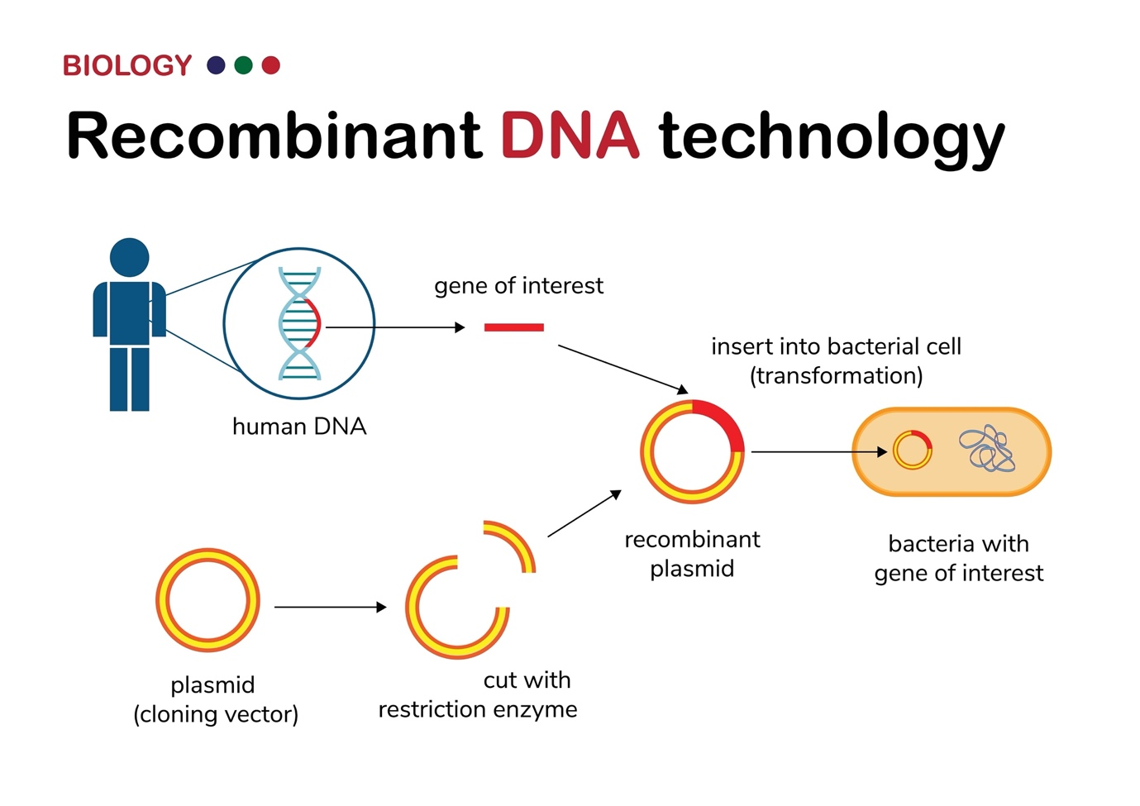
Shutterstock
Explore
- Focus on Restriction digestion, Ligation, Transformation, and Selection.
- Explain the process of Polymerase Chain Reaction (PCR) with a labeled diagram.
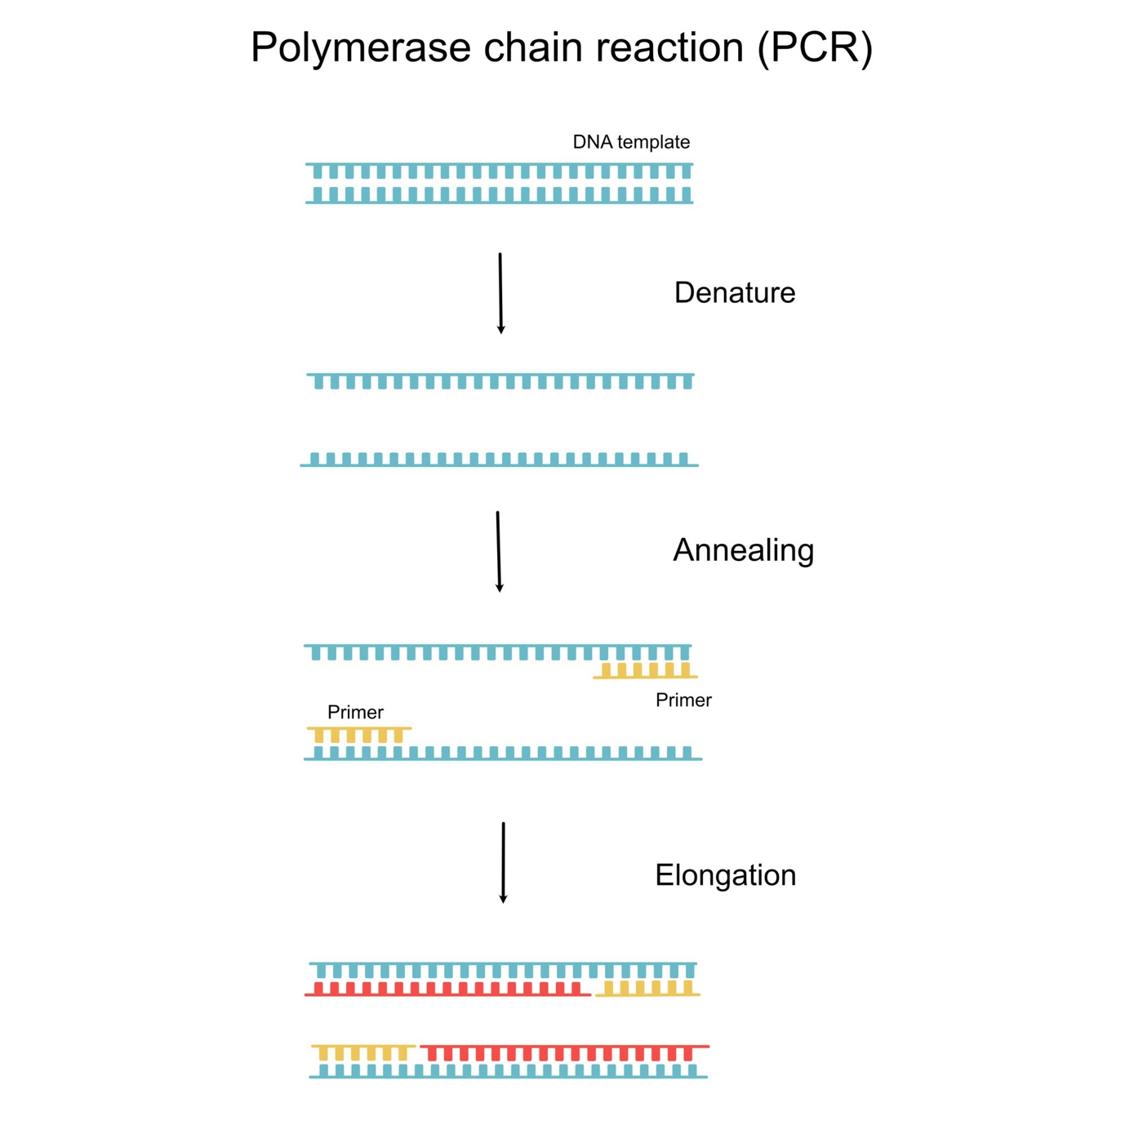
Getty Images
- Explain Denaturation, Annealing, and Extension.
- Describe the structure of the cloning vector pBR322. Label its key features.
  - Explain ori, antibiotic resistance genes, and restriction sites.
- Discuss the various tools of Genetic Engineering.
  - Enzymes (Nucleases, Ligases, Polymerases), Vectors, and Competent Hosts.
- How is a plant made resistant to nematodes using the RNAi technique?
  - Explain the use of Agrobacterium to introduce nematode-specific genes and the formation of dsRNA.
- Describe the production of 'Genetically Engineered Insulin'.
  - Explain the A and B chains, use of E. coli, and disulfide bond formation.
- What is Gene Therapy? Explain the steps involved in treating ADA deficiency.
- Discuss the applications of Biotechnology in Agriculture.
  - GM crops, Bt Cotton, and Pest-resistant plants.
- Explain the 'Downstream Processing' in the production of a biosynthetic product.
- Describe the different methods used to introduce recombinant DNA into competent host cells.
  - Micro-injection, Biolistics, Disarmed pathogens, and Chemical treatment.
- What are Transgenic Animals? Discuss any three benefits of producing them.
- Discuss the 'Ethical Issues' related to Biotechnology and the role of GEAC.
- Explain the process of 'Gel Electrophoresis' for separating DNA fragments.
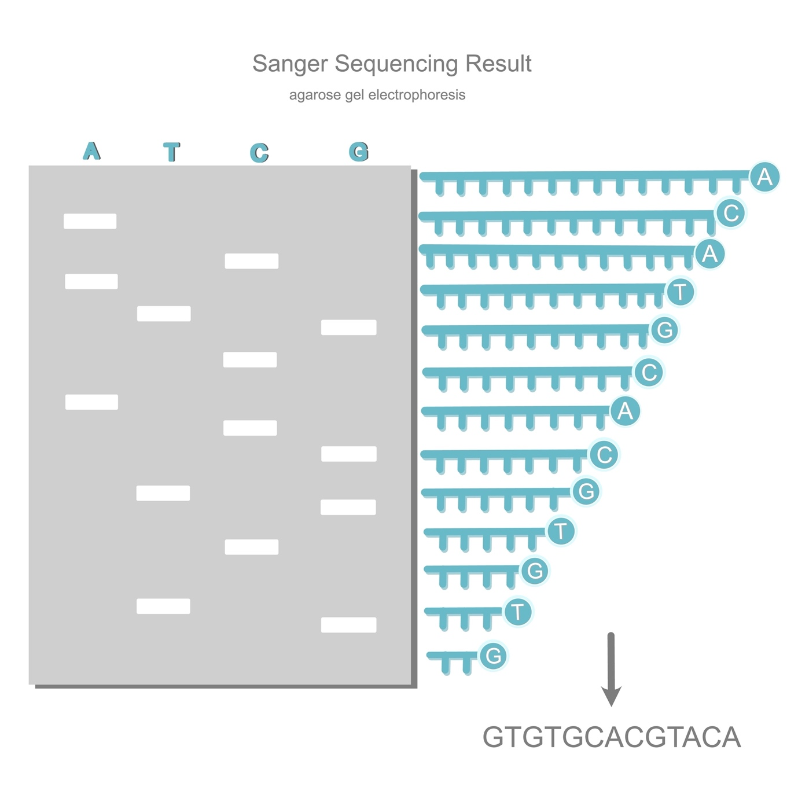
Shutterstock
- Describe the 'Maturation of Pro-insulin into Insulin' with a diagram.
- Discuss the use of Biotechnology in 'Molecular Diagnosis' (PCR and ELISA).

Section D: 5 Case Studies

Case Study 1: The Bt Cotton Success
A farmer in Maharashtra shifted from local cotton to Bt Cotton. He observed that he no longer needed to spray insecticides to control bollworms, and his yield increased significantly.
- What is the source of the 'Bt toxin'? (1m)
  - Answer: Bacillus thuringiensis.
- Why doesn't the Bt toxin kill the bacterium itself? (2m)
  - Answer: The toxin exists as an inactive protoxin in the bacterium. It only becomes active in the alkaline pH of the insect's gut.
- Name the genes responsible for controlling cotton bollworms. (1m)
  - Answer: cryIAc and cryIIAb.
- Is Bt Cotton an example of a biopesticide? Justify. (1m)
  - Answer: Yes, because it uses a biological agent (bacterial toxin) to control pests.

Case Study 2: The First Gene Therapy
In 1990, a four-year-old girl was treated for ADA deficiency. Since the cure was not permanent, she required periodic infusions of genetically engineered cells.
- What is the full form of ADA? (1m)
  - Answer: Adenosine Deaminase.
- What happens to the immune system in ADA deficiency? (1m)
  - Answer: The immune system fails to function (SCID), making the person highly vulnerable to infections.
- Why was the therapy given to the girl not permanent? (2m)
  - Answer: Because lymphocytes are not immortal; they die, and the patient requires periodic infusions of engineered cells.
- How can this disease be cured permanently? (1m)
  - Answer: By introducing the gene into cells at early embryonic stages.

Case Study 3: The Basmati Battle
An American company was granted a patent for "Basmati Rice" by the US Patent and Trademark Office. This allowed the company to sell a "new" variety of Basmati, which was actually derived from Indian varieties.
- Which term describes this act of using bio-resources without authorization? (1m)
  - Answer: Biopiracy.
- Why is Basmati rice special to India? (1m)
  - Answer: It is known for its unique aroma and flavor, with 27 documented varieties grown in India.
- What is a 'Patent'? (2m)
  - Answer: A legal right granted to an inventor to exclude others from making, using, or selling an invention for a limited period.
- Mention another Indian bio-resource that was subject to similar patent battles. (1m)
  - Answer: Neem or Turmeric.

