Question Paper Set 1
Class XII
Time: 60 minutes | Max Marks: 32

Section A: Multiple Choice Questions (8 x 1m)
- Which ecological pyramid is always upright and can never be inverted? (a) Pyramid of Number (b) Pyramid of Biomass (c) Pyramid of Energy (d) All of these
- The 'Rivet Popper Hypothesis' to explain the importance of biodiversity was proposed by: (a) Paul Ehrlich (b) Robert May (c) Alexander von Humboldt (d) David Tilman
- In the equation , what does 'r' represent? (a) Carrying capacity (b) Population density (c) Intrinsic rate of natural increase (d) Environmental resistance
- An association between a sea anemone and a hermit crab, where the anemone provides protection and the crab provides mobility, is an example of: (a) Parasitism (b) Commensalism (c) Mutualism (d) Amensalism
- Which of the following is an 'Ex-situ' conservation method? (a) Biosphere Reserve (b) Wildlife Sanctuary (c) Seed Bank (d) Sacred Grove
- The rate of decomposition is faster when the detritus is rich in: (a) Lignin and Chitin (b) Nitrogen and water-soluble sugars (c) Cellulose (d) Tannins
- Vertical distribution of different species occupying different levels in a forest is known as: (a) Succession (b) Stratification (c) Fragmentation (d) Zonation
- Which factor is the most important cause of animals and plants being driven to extinction? (a) Alien species invasion (b) Co-extinction (c) Over-exploitation (d) Habitat loss and fragmentation

Section B: Short Answer Questions (4 x 2m)
- Define 'Allen’s Rule' with a suitable example.
- Differentiate between 'GPP' (Gross Primary Productivity) and 'NPP' (Net Primary Productivity).
- What are 'Sacred Groves'? Mention their role in biodiversity conservation.
- Explain 'Brood Parasitism' with the help of an example.

Section C: Long Answer Questions (3 x 4m)
- Describe the 'Logistic Growth Model' of a population. Provide the equation and draw the corresponding growth curve.
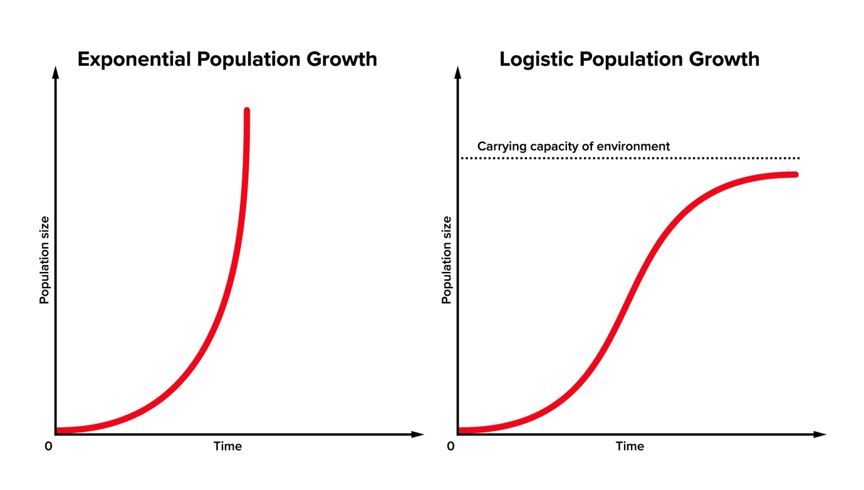
Shutterstock
Explore
- What is 'Ecological Succession'? Briefly explain the different stages of Hydrarch Succession starting from a pond to a forest.
- Discuss the 'Evil Quartet'—the four major causes of biodiversity loss on Earth.

Section D: Case Study Question (1 x 5m)
- Case Study: The Ocean Pyramid In a marine ecosystem, a student observes that the producers (phytoplankton) have a very small standing crop at any given time compared to the large biomass of the fish that feed on them.
(i) Draw the Pyramid of Biomass for this marine ecosystem. (1m)
(ii) Why is this specific pyramid inverted? (1m) (iii) Define the '10% Law' of energy transfer. (1m) (iv) If the primary producers have of energy, how much energy will be available to the secondary consumers? Show the calculation. (2m)

