Question Paper Set 2
Class XII
Time: 60 minutes | Max Marks: 32

Section A: Multiple Choice Questions (8 x 1m)
- A high density of a population in a given habitat indicates: (a) High competition (b) High resources (c) Low predation (d) All of these
- The species-area relationship on a logarithmic scale is a straight line described by the equation: (a) (b) (c) (d)
- The interaction where one species is benefited and the other is neither benefited nor harmed is: (a) Mutualism (b) Amensalism (c) Commensalism (d) Parasitism
- Secondary succession occurs in/on: (a) Bare rock (b) Newly cooled lava (c) Abandoned farmland (d) Newly created pond
- Which of the following is a sedimentary nutrient cycle? (a) Carbon cycle (b) Nitrogen cycle (c) Phosphorus cycle (d) Oxygen cycle
- The total number of biodiversity hotspots identified in the world so far is: (a) 25 (b) 34 (c) 14 (d) 44
- In a food chain, the 'Detritivores' like earthworms are responsible for: (a) Fragmentation (b) Leaching (c) Catabolism (d) Humification
- What will happen to the 'Z' value (slope of line) in a species-area relationship if we analyze the entire continent? (a) It becomes steeper (b) It becomes flatter (c) It remains the same (d) It becomes zero

Section B: Short Answer Questions (4 x 2m)
- Distinguish between Hibernation and Aestivation with examples.
- Define 'Ectoparasites' and 'Endoparasites'. Mention one adaptation of endoparasites.
- What is 'Co-extinction'? Explain with a suitable example.
- Define 'Biopiracy' and its impact on developing nations.

Section C: Long Answer Questions (3 x 4m)
- Describe the 'Species-Area Relationship' observed by Alexander von Humboldt. Draw the graph and explain the significance of the slope 'Z'.
- What are 'Ecological Pyramids'? Explain why the Pyramid of Biomass in a Sea is usually inverted while the Pyramid of Energy is always upright.
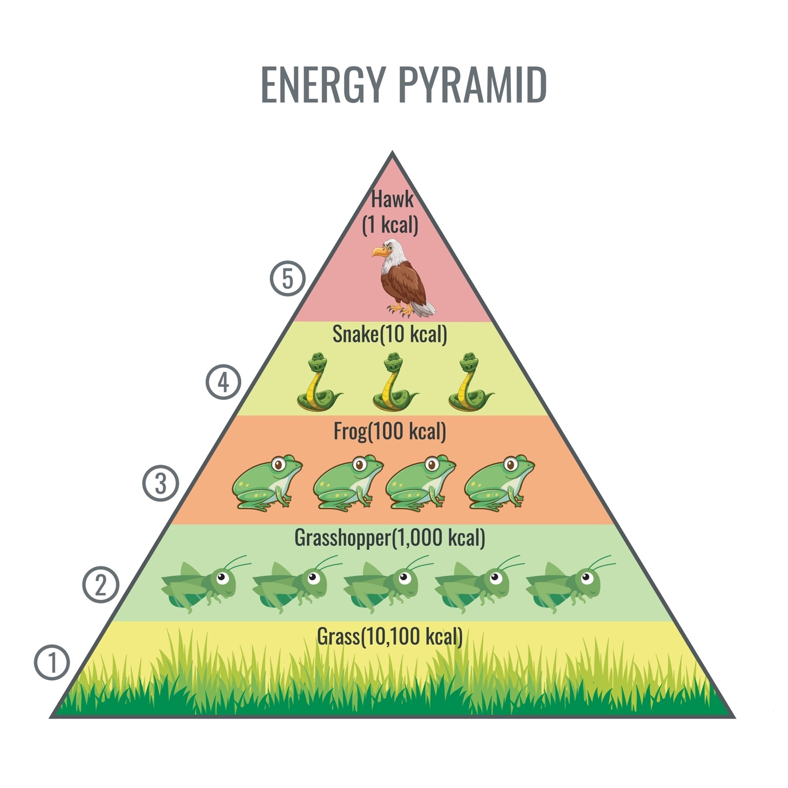
Shutterstock
Explore
- Discuss the five steps involved in the process of 'Decomposition' of detritus.

Section D: Case Study Question (1 x 5m)
- Case Study: The Invasive Weed A beautiful flowering plant, Eichhornia crassipes (Water Hyacinth), was introduced to India. It grew so rapidly that it covered the entire surface of many water bodies, leading to the death of fish.
(i) What is the common name given to this plant in India? (1m) (ii) How does this plant cause the death of fish in the water body? (1m) (iii) Which category of the "Evil Quartet" does this case belong to? (1m) (iv) Differentiate between 'In-situ' and 'Ex-situ' conservation strategies. (2m)

