Question Paper Set 3
Class XII
Time: 60 minutes | Max Marks: 32

Section A: Multiple Choice Questions (8 x 1m)
- Which type of growth curve is obtained when resources in the habitat are unlimited? (a) S-shaped (b) J-shaped (c) Z-shaped (d) Sigmoid
- The percentage of Photosynthetically Active Radiation (PAR) in the incident solar radiation is: (a) 100% (b) More than 50% (c) Less than 50% (d) 10%
- 'Aestivation' is a strategy used by some organisms to avoid: (a) Winter cold (b) Summer heat and desiccation (c) Lack of food (d) Predation
- Which of the following is an example of 'In-situ' conservation? (a) Botanical Garden (b) National Park (c) Cryopreservation (d) Wildlife Safari Park
- The 'climax community' in an ecological succession is: (a) The first community to invade (b) The most unstable community (c) In near equilibrium with the environment (d) Always composed of lichens
- The 'Evil Quartet' factor that describes the extinction of the passenger pigeon is: (a) Habitat loss (b) Over-exploitation (c) Alien species (d) Co-extinction
- Humus is highly resistant to microbial action because it is: (a) Rich in Nitrogen (b) Colloidal in nature (c) Volatile (d) Soluble in water
- The 'Species-Area relationship' was proposed by: (a) Robert May (b) Paul Ehrlich (c) Alexander von Humboldt (d) David Tilman

Section B: Short Answer Questions (4 x 2m)
- What is 'Resource Partitioning'? Give an example.
- Define 'Primary Productivity'. What are the factors that influence it?
- Differentiate between 'Primary' and 'Secondary' succession.
- What are 'Biodiversity Hotspots'? Mention the two criteria for identifying them.

Section C: Long Answer Questions (3 x 4m)
- Describe the 'Carbon Cycle' in nature. Mention the major reservoirs and the processes that add to the atmosphere.
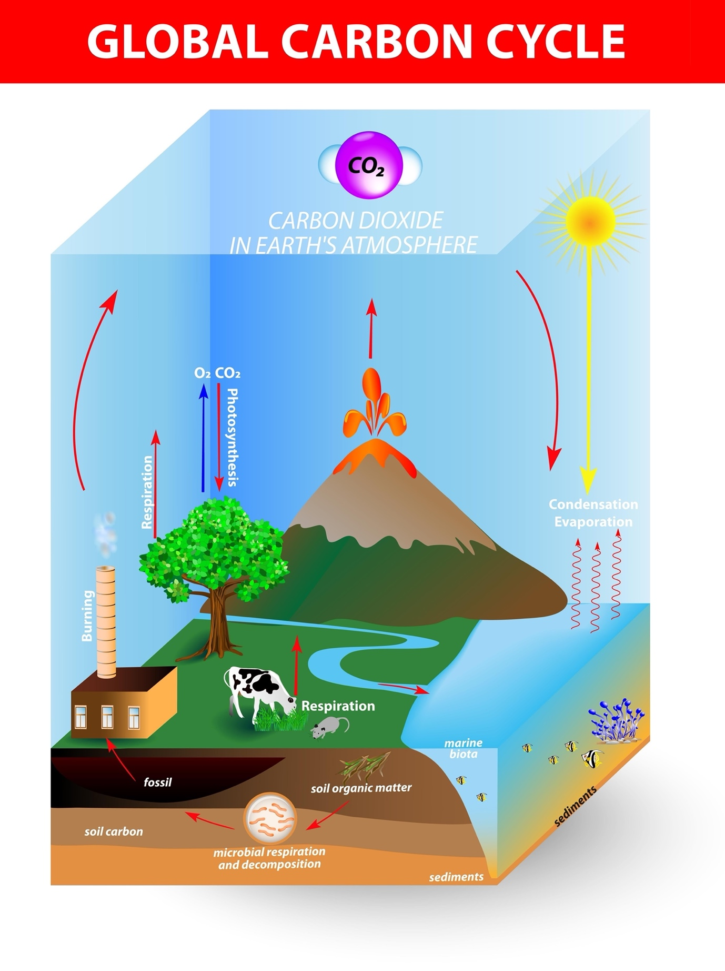
Shutterstock
Explore
- Explain the 'Rivet Popper Hypothesis' proposed by Paul Ehrlich. How does it explain the impact of species loss on an ecosystem?
- Discuss the different ways organisms cope with stressful environmental conditions. Focus on 'Regulate', 'Conform', and 'Suspend'.

Section D: Case Study Question (1 x 5m)
- Case Study: Succession in Water A newly formed pond undergoes changes over hundreds of years. Initially, only small phytoplanktons are seen. Eventually, it transforms into a stable forest community.
(i) What is this type of succession called? (1m) (ii) Name the pioneer species in this succession. (1m) (iii) List the intermediate stages between the pioneer and the climax community. (2m)
(iv) Why is the final stage called a 'Climax Community'? (1m)

