Section A: 40 MCQs (1 Mark each)
Includes Answer and Reasoning.
- Which of the following is a "Suspended" stage of an organism during unfavorable conditions? (a) Hibernation (b) Migration (c) Diapause (d) Both a and c
  - Answer: (d).
  - Reasoning: Hibernation (winter sleep) and Diapause (suspended development in zooplankton) are both ways to avoid stress in time rather than space.
- The "Gause’s Principle of Competitive Exclusion" states that: (a) Two species can coexist indefinitely (b) Closely related species with same niche cannot coexist (c) Competition leads to mutualism (d) Larger species always win.
  - Answer: (b).
  - Reasoning: It posits that two species competing for the exact same resources cannot coexist; the inferior one will eventually be eliminated.
- In a pyramid of numbers in a grassland ecosystem, the largest population is that of: (a) Producers (b) Herbivores (c) Secondary consumers (d) Top carnivores
  - Answer: (a).
  - Reasoning: In most terrestrial ecosystems, the number of producers is significantly higher to support the subsequent trophic levels.
- Identify the "In-situ" conservation method: (a) Zoological Park (b) Botanical Garden (c) National Park (d) Cryopreservation
  - Answer: (c).
  - Reasoning: In-situ conservation protects species in their natural habitat, whereas the others are ex-situ (outside natural habitat).
- The rate of biomass production is called: (a) Decomposition (b) Productivity (c) Stratification (d) Humification
  - Answer: (b).
  - Reasoning: Productivity is measured as the weight or energy produced per unit area over a time period.
- Humus is highly resistant to microbial action and undergoes decomposition at an extremely slow rate because it is: (a) Colloidal in nature (b) Acidic (c) Rich in nitrogen (d) Lignin-poor
  - Answer: (a).
  - Reasoning: Its colloidal nature and complex chemical structure (rich in lignin/cellulose) make it difficult for microbes to break down quickly.
- The 'Rivet Popper Hypothesis' was proposed by: (a) Alexander von Humboldt (b) Paul Ehrlich (c) David Tilman (d) Robert May
  - Answer: (b).
  - Reasoning: It uses an airplane analogy to explain how losing "key" species can lead to ecosystem collapse.
- What is the global species diversity estimate given by Robert May? (a) 1.7 million (b) 7 million (c) 20 to 50 million (d) 1.5 million
  - Answer: (b).
  - Reasoning: May’s estimate is considered more scientifically sound than earlier, more extreme estimates.
- Secondary succession takes place in/on: (a) Bare rock (b) Newly cooled lava (c) Abandoned farm land (d) Newly created pond
  - Answer: (c).
  - Reasoning: Secondary succession occurs where an ecosystem previously existed but was destroyed (soil is already present).
- Lichen is an example of which population interaction? (a) Parasitism (b) Commensalism (c) Mutualism (d) Competition
  - Answer: (c).
  - Reasoning: It is an obligatory relationship between an alga and a fungus where both benefit.
- The 'Evil Quartet' is a term used to describe: (a) Population growth (b) Four major causes of biodiversity loss (c) Trophic levels (d) Nutrient cycles
  - Answer: (b).
- The "climax community" is in a state of: (a) Constant change (b) Equilibrium with environment (c) Rapid growth (d) Decline
  - Answer: (b).
- NPP (Net Primary Productivity) is calculated as: (a) GPP + R (b) GPP - R (c) R - GPP (d) GPP / R
  - Answer: (b).
  - Reasoning: R represents the energy lost during respiration by the producers.
- In 'Commensalism' (), the interaction is: (a) Beneficial for both (b) Beneficial for one, neutral for other (c) Harmful for both (d) Harmful for one, neutral for other
  - Answer: (b).
- Which ecosystem has the maximum net primary productivity? (a) Deserts (b) Tropical Rain Forests (c) Oceans (d) Grasslands
  - Answer: (b).
- Most ecological pyramids are upright, but the pyramid of biomass in an ocean is: (a) Upright (b) Inverted (c) Spindle-shaped (d) Horizontal
  - Answer: (b).
  - Reasoning: The biomass of fish far exceeds the biomass of the phytoplankton they feed upon at any given time.
- Which of the following is a "detritivore"? (a) Earthworm (b) Lion (c) Rabbit (d) Grasshopper
  - Answer: (a).
- The relationship between "Fig and Wasp" is an example of: (a) Commensalism (b) Co-evolution (c) Competition (d) Amensalism
  - Answer: (b).
- The 'species-area relationship' on a log scale is a: (a) Rectangular hyperbola (b) Straight line (c) Sigmoid curve (d) Parabola
  - Answer: (b).
- Sacred Groves are especially useful in: (a) Generating income (b) Conserving rare and threatened species (c) Tourism (d) Industrial growth
  - Answer: (b).
- The 'Verhulst-Pearl' Equation describes: (a) Exponential growth (b) Logistic growth (c) Species area (d) Nutrient cycling
  - Answer: (b).
- The 'Endemic' species are those which are: (a) Critically endangered (b) Found only in a specific region (c) Extinct in the wild (d) Exotic species
  - Answer: (b).
- Detritus food chain (DFC) begins with: (a) Green plants (b) Dead organic matter (c) Herbivores (d) Carnivores
  - Answer: (b).
- 'Aestivation' is also known as: (a) Winter sleep (b) Summer sleep (c) Migration (d) Adaptation
  - Answer: (b).
- The pyramid of 'Energy' is: (a) Always inverted (b) Always upright (c) Bell-shaped (d) Spindle-shaped
  - Answer: (b).
- Which of the following is a sedimentary nutrient cycle? (a) Nitrogen (b) Carbon (c) Phosphorus (d) Oxygen
  - Answer: (c).
- The 'Litter' of a forest is decomposed faster if it is rich in: (a) Nitrogen and sugars (b) Lignin and Chitin (c) Cellulose (d) Tannins
  - Answer: (a).
- An 'Orchid' growing on a mango branch is an example of: (a) Parasitism (b) Commensalism (c) Mutualism (d) Predation
  - Answer: (b).
- Which factor is the most important cause of animals and plants being driven to extinction? (a) Alien species invasion (b) Over-exploitation (c) Habitat loss and fragmentation (d) Co-extinctions
  - Answer: (c).
- 'Kyoto Protocol' was endorsed at: (a) CoP-3 (b) CoP-5 (c) CoP-1 (d) CoP-10
  - Answer: (a).
- The percentage of solar radiation that is PAR (Photosynthetically Active Radiation) is: (a) 100% (b) Less than 50% (c) 10% (d) 80%
  - Answer: (b).
- Vertical distribution of different species occupying different levels is called: (a) Zonation (b) Stratification (c) Succession (d) Fragmentation
  - Answer: (b).
- 'Ecological succession' that starts in a water body is called: (a) Xerarch (b) Hydrarch (c) Halosere (d) Lithosere
  - Answer: (b).
- The 'Ecological footprint' refers to: (a) Land area required to sustain a person (b) Number of trees planted (c) Amount of absorbed (d) Size of a forest
  - Answer: (a).
- The total number of 'Biodiversity Hotspots' in the world is: (a) 25 (b) 34 (c) 14 (d) 44
  - Answer: (b).
- The interaction where one species is harmed and the other is unaffected is: (a) Amensalism (b) Commensalism (c) Parasitism (d) Competition
  - Answer: (a).
- Primary productivity depends on: (a) Photosynthetic capacity of plants (b) Solar radiation (c) Nutrient availability (d) All of these
  - Answer: (d).
- The Earth Summit (1992) was held in: (a) Johannesburg (b) Rio de Janeiro (c) Kyoto (d) Montreal
  - Answer: (b).
- Which of the following has the highest genetic diversity in India? (a) Wheat (b) Mango (c) Rice (d) Tea
  - Answer: (c).
- Decomposition rate is slower if the temperature is: (a) High (b) Low (c) Moderate (d) Very high
  - Answer: (b).

Section B: 30 Short Answer Questions (2 Marks each)
Includes Bulleted Keys.
- Define 'Eurythermal' and 'Stenothermal' organisms.
  - Eurythermal: Can tolerate/thrive in a wide range of temperatures.
  - Stenothermal: Restricted to a narrow range of temperatures.
- Distinguish between Hibernation and Aestivation.
  - Hibernation: Winter sleep to avoid cold (e.g., bears).
  - Aestivation: Summer sleep to avoid heat/desiccation (e.g., snails).
- What is 'Resource Partitioning'?
  - If two species compete for the same resource, they avoid competition by choosing different times for feeding or different foraging patterns (MacArthur's Warblers).
- Define 'Ectoparasites' and 'Endoparasites' with examples.
  - Ectoparasites: Live on external surface (e.g., Lice on humans).
  - Endoparasites: Live inside the body (e.g., Plasmodium in human RBCs).
- What is 'Brood Parasitism'? Give an example.
  - A phenomenon where a parasitic bird lays eggs in the host's nest (e.g., Cuckoo/Koel laying eggs in a Crow's nest).
- State the significance of 'Decomposition' in an ecosystem.
  - It breaks down complex organic matter into inorganic nutrients, facilitating nutrient cycling.
- Differentiate between 'Primary' and 'Secondary' succession.
  - Primary: Starts on bare areas (no soil); very slow.
  - Secondary: Starts in areas that lost previous vegetation (soil present); faster.
- Why is the 'Pyramid of Energy' always upright?
  - Energy is lost as heat at each trophic level (10% law); energy cannot be recycled or increased as it moves up.
- Define 'Biodiversity' and its three levels.
  - The sum total of diversity at all levels of biological organization.
  - Levels: Genetic, Species, and Ecological diversity.
- What are 'Biodiversity Hotspots'? Mention two criteria for their designation.
  - Regions with high levels of species richness and high degree of endemism.
  - Criteria: High species richness and high threat level (habitat loss).
- Explain the 'Species-Area Relationship' (Humboldt’s Observation).
  - Within a region, species richness increases with increasing explored area, but only up to a limit (Log S = Log C + Z Log A).
- What is 'Ex-situ' conservation? Give two examples.
  - Protecting species outside their natural habitat. Examples: Wildlife Safari Parks, Seed Banks.
- Why are 'Sacred Groves' important for conservation?
  - They are forest patches protected by communities due to religious beliefs; they serve as refuges for many rare/threatened species.
- What is 'Primary Productivity'? Distinguish between GPP and NPP.
  - Rate of biomass production. GPP is total production; NPP is GPP minus respiration losses.
- Define 'Allen’s Rule'.
  - Mammals from colder climates generally have shorter ears and limbs to minimize heat loss.
- What is 'Mutualism'? Give an example from the plant-animal world.
  - Interaction where both benefit (). Example: Fig tree and pollinator Wasp.
- Explain 'Camouflage' as a defense mechanism.
  - Organisms blend with the surroundings to avoid being detected by predators (e.g., leaf insects).
- What are 'Pioneer Species'? Give examples for Hydrarch and Xerarch succession.
  - The first species to invade a bare area. Hydrarch: Phytoplankton. Xerarch: Lichens.
- Define 'Endemism'.
  - When a species is confined to a specific geographical region and not found anywhere else.
- List the four major causes of biodiversity loss (The Evil Quartet).
  - Habitat loss/fragmentation, Over-exploitation, Alien species invasion, Co-extinctions.
- What is 'Biopiracy'?
  - Illegal use of biological resources/traditional knowledge by organizations without proper authorization or compensation.
- Define 'Climax Community'.
  - The stable, final stage of ecological succession that is in near equilibrium with the environment.
- How does 'Stratification' help in an ecosystem?
  - It allows different species to occupy different vertical layers, reducing competition and maximizing resource use.
- Distinguish between 'In-situ' and 'Ex-situ' conservation.
  - In-situ: Conserving in natural habitat. Ex-situ: Conserving in man-made environments.
- What is the '10% Law' of energy transfer?
  - Only 10% of the energy available at one trophic level is transferred to the next higher level.
- What are 'Alien Species'? Mention one invasive plant species in India.
  - Non-native species introduced into a new area. Example: Water Hyacinth (Eichhornia).
- Define 'Decomposition' and its five steps.
  - Fragmentation, Leaching, Catabolism, Humification, and Mineralization.
- Explain the 'Competitive Release' phenomenon.
  - A species whose distribution is restricted geographically because of the presence of a superior competitor expands its range when the competitor is removed.
- What is 'Co-extinction'?
  - When a species becomes extinct, the plant and animal species associated with it in an obligatory way also become extinct.
- What is 'Carrying Capacity' (K)?
  - The maximum population size that a particular environment can support sustainably given the available resources.

Section C: 15 Long Answer Questions (4 Marks each)
Includes Answer Outlines.
- Describe the Logistic Growth Model (). Draw the Sigmoid curve.
  - Explanation: Resources are limited; growth has an initial lag, then acceleration, and finally reaches a plateau (Carrying Capacity).
  - Diagram: S-shaped curve (Sigmoid).
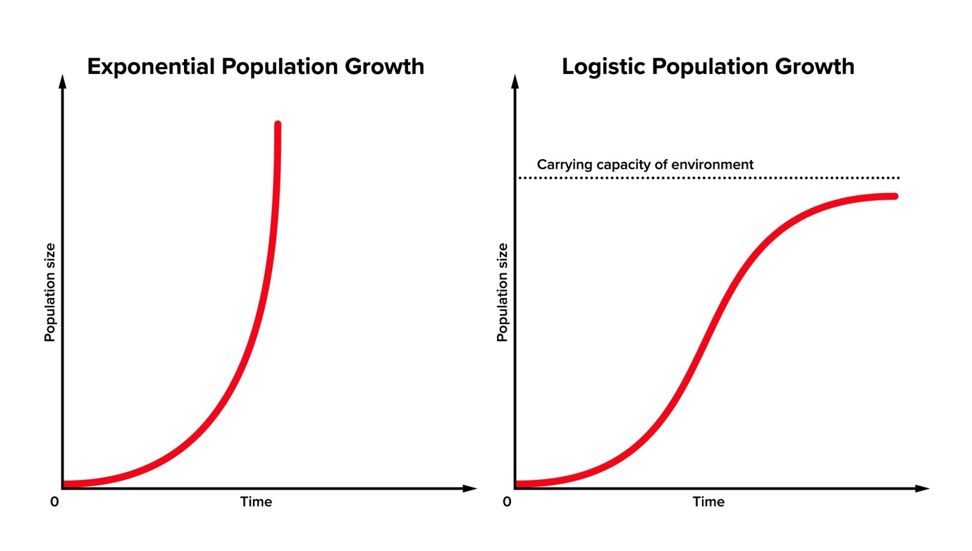
Shutterstock
Explore
- Discuss the five steps of Decomposition in detail.
  - Fragmentation (detritivores), Leaching (water-soluble nutrients sink), Catabolism (enzymatic action), Humification (humus formation), Mineralization (inorganic nutrient release).
- Explain the three levels of Biodiversity with suitable examples.
  - Genetic (Rauwolfia vomitoria potency), Species (Western Ghats amphibians), Ecological (Deserts vs. Rainforests).
- What are 'Ecological Pyramids'? Describe the Pyramids of Number, Biomass, and Energy with diagrams.
  - Note: Mention why biomass in oceans is inverted and why energy is always upright.
- Describe the 'Species-Area Relationship' observed by Alexander von Humboldt.
  - Plotting richness vs. area; the log-log scale graph. Discuss the significance of the slope 'Z'.
- Explain the 'In-situ' and 'Ex-situ' conservation strategies in detail.
  - In-situ: Hotspots, National Parks, Sanctuaries, Biosphere Reserves.
  - Ex-situ: Zoo, Botanical gardens, Seed banks, Cryopreservation.
- Describe the 'Hydrarch Succession' (Succession in Water).
  - Stages: Phytoplankton Submerged Free-floating Reed-swamp Marsh-meadow Scrub Forest.
- What is 'Predation'? Discuss its roles in an ecosystem.
  - Roles: Energy transfer, keeping prey population under control, maintaining species diversity.
- Explain the 'Carbon Cycle' in nature.
  - Reservoirs (Ocean/Atmosphere), Inputs (Respiration/Decomposition/Burning), Outputs (Photosynthesis).
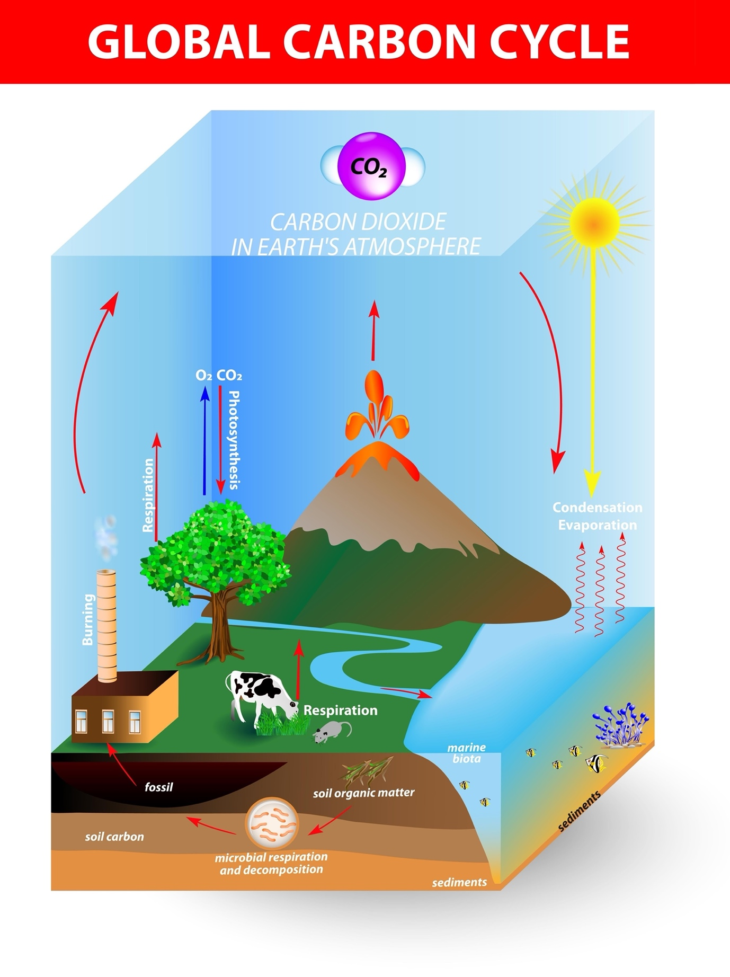
Shutterstock
Explore
- Describe the adaptation of 'Kangaroo Rat' to desert life.
  - Internal fat oxidation for water, highly concentrated urine, nocturnal behavior.
- Discuss the 'Evil Quartet' as the main drivers of biodiversity loss.
  - Detail Habitat loss, Over-exploitation, Alien species, and Co-extinctions.
- What are the functional components of an Ecosystem?
  - Productivity, Decomposition, Energy Flow, and Nutrient Cycling.
- Explain 'Phosphorus Cycle' in an ecosystem.
  - Sedimentary cycle; reservoir is rocks; weathering releases phosphate into soil/water.
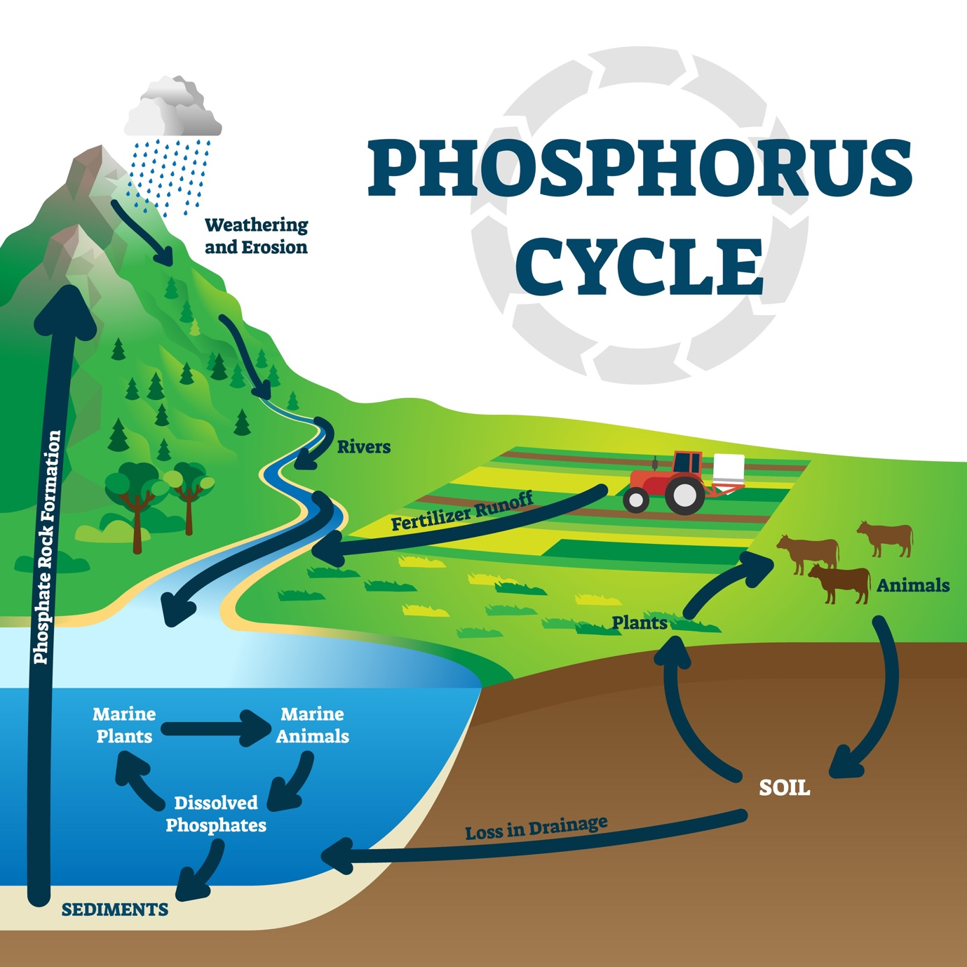
Shutterstock
- How do organisms cope with stressful conditions? (Regulate, Conform, Migrate, Suspend).
  - Explain each with examples: Homeostasis (birds/mammals), Changing with ambient temp (reptiles), Siberian cranes (migrate), Bacteria spores (suspend).
- Discuss the importance of 'Species Diversity' to an Ecosystem (David Tilman’s experiments).
  - Plots with more species show less year-to-year variation in total biomass and increased productivity.

Section D: 5 Case Studies (Total Questions: 3x1m, 3x2m)

Case Study 1: The Disappearing Sparrows
A city observes a sharp decline in the house sparrow population. Research suggests that high-rise glass buildings, mobile tower radiation, and the loss of native insect-bearing plants are to blame.
- Which of the "Evil Quartet" factors is primarily responsible here? (1m)
  - Answer: Habitat loss and fragmentation.
- If sparrows are the primary seed dispersers for a specific tree, what happens to that tree? (1m)
  - Answer: Co-extinction (The tree's population will decline/become extinct).
- Define 'Urban Ecology'. (1m)
  - Answer: The study of interactions of living organisms with each other and their environment in an urban setting.
- How does fragmentation lead to extinction? (2m)
  - Answer: Large habitats are broken into small fragments; animals requiring large territories (like birds/mammals) suffer, and the gene pool shrinks.
- Suggest two in-situ ways to bring sparrows back. (2m)
  - Answer: Planting native shrubs/trees and creating "bird-friendly" green corridors in urban planning.
- Why is the sparrow considered a "consumer" in this food chain? (2m)
  - Answer: It feeds on seeds/grains (primary consumer) and insects (secondary consumer), thus transferring energy from producers.

Case Study 2: The Invasive Weed
Eichhornia crassipes (Water Hyacinth) was introduced to India for its beautiful flowers. It has now clogged major waterways and killed fish populations.
- Name the phenomenon illustrated by this case. (1m)
  - Answer: Alien Species Invasion.
- Why is this weed known as the "Terror of Bengal"? (1m)
  - Answer: It drains oxygen from the water, leading to massive fish mortality in the ponds of Bengal.
- Define 'Eutrophication'. (1m)
  - Answer: Natural aging of a lake by nutrient enrichment, often accelerated by pollutants.
- How does an invasive species out-compete native species? (2m)
  - Answer: They lack natural predators in the new environment, allowing them to spread unchecked and hog resources like space/light.
- What is 'Biological Control' in this context? (2m)
  - Answer: Introducing a natural predator/insect from its native land to keep its population in check.
- Explain the impact on the local 'Food Web'. (2m)
  - Answer: It replaces native aquatic plants (producers), disrupting the food supply for native herbivores and their predators.

