Question Paper Set 1
Class XII
Time: 75 minutes | Max Marks: 35

Section A: MCQs (7 x 1m = 7 Marks)
- A charged particle moves through a magnetic field in a direction perpendicular to it. Which of the following quantities of the particle will change?
  - (a) Speed
  - (b) Kinetic Energy
  - (c) Momentum
  - (d) Mass
- The magnetic field at a distance 'r' from a long straight wire carrying current 'I' is 'B'. If the current is doubled and distance is halved, the new magnetic field will be:
  - (a) B
  - (b) 2B
  - (c) 4B
  - (d) B/4
- A cyclotron cannot accelerate which of the following?
  - (a) Alpha particle
  - (b) Proton
  - (c) Deuteron
  - (d) Electron
- Two parallel wires carrying currents in the same direction exert a force 'F' on each other. If the current in one wire is reversed, the force will be:
  - (a) Attractive
  - (b) Repulsive
  - (c) Zero
  - (d) Infinite
- The conversion of a galvanometer into an ammeter requires a:
  - (a) Low resistance in series
  - (b) Low resistance in parallel
  - (c) High resistance in series
  - (d) High resistance in parallel
- The magnetic dipole moment of a current-carrying coil does NOT depend on:
  - (a) Number of turns
  - (b) Current
  - (c) Area of the coil
  - (d) Magnetic field strength
- A solenoid of length 'L' has 'N' turns. The magnetic field at its end is:
  - (a) μ₀nI
  - (b) (1/2) μ₀nI
  - (c) Zero
  - (d) 2μ₀nI

Section B: Short Answer (4 x 2m = 8 Marks)
- Numerical: A circular coil of 100 turns and radius 10 cm carries a current of 0.5 A. Calculate the magnetic field at its center.
- Conceptual: Why does a magnetic field not perform any work on a moving charge?
- Definition: Define 'Bohr Magneton'. Write its value in SI units.
- Numerical: A galvanometer has a resistance of 100 ohms and gives full-scale deflection for 1 mA. Calculate the shunt resistance required to convert it into an ammeter of range 0 to 1 A.

Section C: Long Answer Type I (2 x 3m = 6 Marks)
- State Biot-Savart Law. Use it to derive the expression for the magnetic field at the center of a circular current-carrying loop.
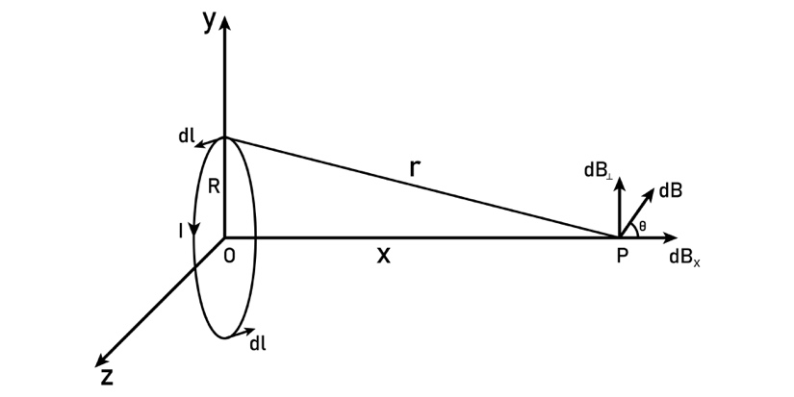
Shutterstock
Explore
- Derive an expression for the Torque acting on a rectangular current loop placed in a uniform magnetic field.

Section D: Case Study Based (1 x 4m = 4 Marks)
- Lorentz Force and Velocity Selector: In a region, crossed electric and magnetic fields (E and B) are applied. A beam of charged particles is passed through this region.
  - (i) Write the expression for the total Lorentz force acting on the particle. (1m)
  - (ii) Under what condition will the particle move undeflected? (1m)
  - (iii) If an electron and a proton enter this selector with the same velocity 'v = E/B', will both pass undeflected? Justify. (2m)

Section E: Long Answer Type II (2 x 5m = 10 Marks)
- (a) State Ampere’s Circuital Law. (1m) (b) Use this law to derive the expression for the magnetic field inside a long straight Solenoid. (3m) (c) What is the effect on the magnetic field if a soft iron core is inserted? (1m)
- (a) Derive an expression for the Force per unit length between two long straight parallel conductors carrying currents I₁ and I₂. (4m) (b) Define one 'Ampere' based on this expression. (1m)

