Section A: Multiple Choice Questions (40 questions each of 1 Mark)

- A charge 'q' is moving with velocity 'v' in a magnetic field 'B'. The force acting on it is maximum when the angle between 'v' and 'B' is:
  - (a) 0°
  - (b) 45°
  - (c) 90°
  - (d) 180°
  - Answer: (c) Logic: F = qvB sinθ. Sin 90° = 1 (Maximum).
- The SI unit of magnetic induction (B) is:
  - (a) Weber
  - (b) Tesla
  - (c) Gauss
  - (d) Weber / meter
  - Answer: (b)
- Which of the following rules is used to find the direction of the magnetic force on a moving charge?
  - (a) Fleming's Left Hand Rule
  - (b) Fleming's Right Hand Rule
  - (c) Right Hand Thumb Rule
  - (d) Ampere's Swimming Rule
  - Answer: (a)
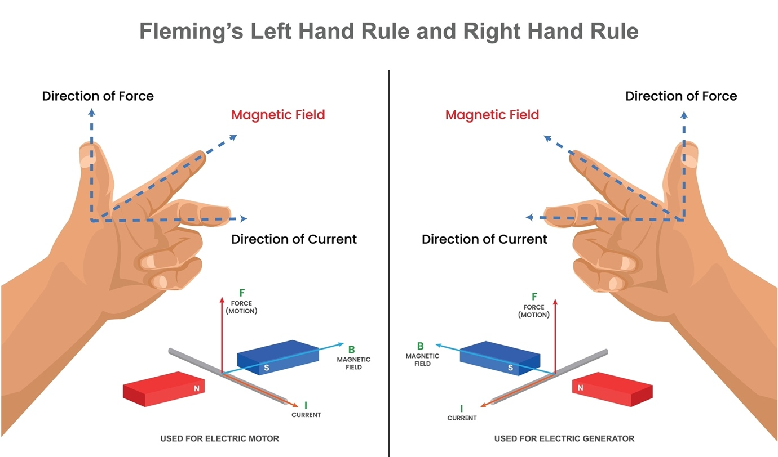
Shutterstock
- The magnetic field at the center of a circular coil of radius 'R' carrying current 'I' is:
  - (a) μ₀I / 2R
  - (b) μ₀I / 4R
  - (c) μ₀I / 2πR
  - (d) μ₀I / R
  - Answer: (a)
- A proton and an alpha particle enter a uniform magnetic field perpendicularly with the same speed. The ratio of the radii of their circular paths (rp / rα) is:
  - (a) 1:1
  - (b) 1:2
  - (c) 2:1
  - (d) 1:4
  - Answer: (b) Logic: r = mv / qB. For alpha, m is 4x and q is 2x, so rα = 2rp.
- The work done by a magnetic field on a moving charge is:
  - (a) Always positive
  - (b) Always negative
  - (c) Always zero
  - (d) Depends on the velocity
  - Answer: (c) Logic: Force is always perpendicular to velocity (v), so F.v = 0.
- The magnetic field inside a long straight solenoid carrying current 'I' is:
  - (a) Zero
  - (b) μ₀nI
  - (c) (1/2) μ₀nI
  - (d) μ₀I / 2πr
  - Answer: (b)
- Two parallel wires carrying currents in the same direction:
  - (a) Attract each other
  - (b) Repel each other
  - (c) Exert no force
  - (d) Rotate each other
  - Answer: (a)
- The sensitivity of a moving coil galvanometer can be increased by:
  - (a) Decreasing the number of turns
  - (b) Decreasing the area of the coil
  - (c) Increasing the magnetic field
  - (d) Increasing the spring constant
  - Answer: (c) Logic: Sensitivity S = NBA / k.
- A cyclotron cannot accelerate:
  - (a) Protons
  - (b) Neutrons
  - (c) Alpha particles
  - (d) Deuterons
  - Answer: (b) Logic: Cyclotrons only accelerate charged particles.
- The conversion of a galvanometer into an ammeter is done by connecting:
  - (a) Low resistance in series
  - (b) Low resistance in parallel (shunt)
  - (c) High resistance in series
  - (d) High resistance in parallel
  - Answer: (b)
- The conversion of a galvanometer into a voltmeter is done by connecting:
  - (a) Low resistance in parallel
  - (b) Low resistance in series
  - (c) High resistance in series
  - (d) High resistance in parallel
  - Answer: (c)
- The magnetic moment of a current-carrying loop of area 'A' and current 'I' is:
  - (a) I / A
  - (b) I * A
  - (c) I * A²
  - (d) I² * A
  - Answer: (b)
- Biot-Savart Law is the magnetic analog of:
  - (a) Ohm's Law
  - (b) Coulomb's Law
  - (c) Gauss's Law
  - (d) Faraday's Law
  - Answer: (b)
- The trajectory of a charged particle entering a magnetic field at an angle θ (where 0 < θ < 90°) is:
  - (a) Circle
  - (b) Straight line
  - (c) Helix
  - (d) Parabola
  - Answer: (c)
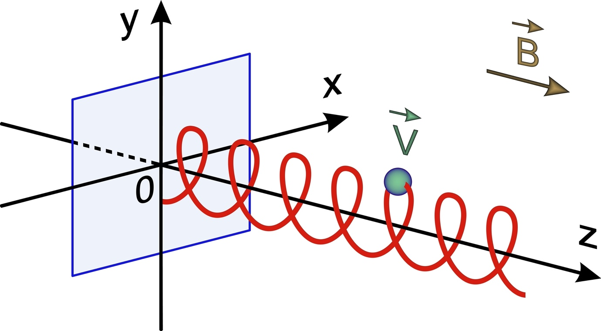
Shutterstock
- The force per unit length between two parallel current-carrying wires is:
- (a) μ₀I₁I₂ / 2πd
- (b) μ₀I₁I₂ / 4πd
- (c) μ₀I₁ / 2πd
- (d) μ₀I₁I₂ / 2d
- Answer: (a)
- Lorentz Force is given by the expression:
- (a) F = qE
- (b) F = q(v x B)
- (c) F = q[E + (v x B)]
- (d) F = q[E - (v x B)]
- Answer: (c)
- A current-carrying rectangular loop placed in a uniform magnetic field experiences:
- (a) Only a net force
- (b) Only a torque
- (c) Both force and torque
- (d) Neither force nor torque
- Answer: (b) Net force is zero in a uniform field.
- The resistance of an ideal ammeter is:
- (a) Infinite
- (b) Very high
- (c) Very low
- (d) Zero
- Answer: (d)
- The radius of curvature of the path of a charged particle in a magnetic field is directly proportional to its:
- (a) Charge
- (b) Magnetic field
- (c) Momentum
- (d) Energy
- Answer: (c) Logic: r = p / qB.
- 1 Tesla is equal to:
- (a) 10⁴ Gauss
- (b) 10⁻⁴ Gauss
- (c) 10⁶ Gauss
- (d) 10² Gauss
- Answer: (a)
- The magnetic field due to a straight current-carrying conductor at a distance 'r' varies as:
- (a) 1 / r
- (b) 1 / r²
- (c) r
- (d) r²
- Answer: (a) Logic: B = μ₀I / 2πr.
- Ampere’s Circuital Law is mathematically expressed as:
- (a) Integral B.dl = μ₀I
- (b) Integral B.dA = 0
- (c) Integral E.dl = -dΦ/dt
- (d) Integral B.dl = I / μ₀
- Answer: (a)
- In a Moving Coil Galvanometer, the magnetic field is made radial to:
- (a) Make the scale linear
- (b) Increase the magnetic field strength
- (c) Decrease the torque
- (d) Protect the coil
- Answer: (a) Logic: It ensures θ = 90° always, so torque τ = NIAB.
- The gyro-magnetic ratio of an electron is:
- (a) e / m
- (b) e / 2m
- (c) 2e / m
- (d) e / 4m
- Answer: (b)
- Which particle will experience maximum force in a magnetic field B if all move with velocity v?
- (a) Electron
- (b) Proton
- (c) Alpha particle
- (d) Neutron
- Answer: (c) Logic: F ∝ q. Alpha has charge 2e.
- A toroid is essentially:
- (a) A straight solenoid
- (b) A circular solenoid
- (c) A flat coil
- (d) A bar magnet
- Answer: (b)
- The magnetic field at an axial point of a solenoid is B. At the ends of the solenoid, the field is:
- (a) B
- (b) 2B
- (c) B / 2
- (d) Zero
- Answer: (c)
- The time period of a charged particle circulating in a magnetic field is independent of:
- (a) Speed
- (b) Mass
- (c) Charge
- (d) Magnetic field
- Answer: (a) Logic: T = 2πm / qB.
- When a current-carrying conductor is placed parallel to the magnetic field, the force is:
- (a) Maximum
- (b) Minimum (Zero)
- (c) μ₀I
- (d) BIl
- Answer: (b) Logic: sin 0° = 0.
- The SI unit of magnetic dipole moment is:
- (a) A m
- (b) A m²
- (c) T m
- (d) T / m
- Answer: (b)
- A shunt is a:
- (a) High resistance in series
- (b) High resistance in parallel
- (c) Low resistance in series
- (d) Low resistance in parallel
- Answer: (d)
- The magnetic field at a distance 'r' on the axis of a circular current loop of radius 'R' is proportional to:
- (a) 1 / (R² + r²)
- (b) 1 / (R² + r²)^(3/2)
- (c) 1 / (R + r)
- (d) (R² + r²)^(3/2)
- Answer: (b)
- The magnetic field due to a current-carrying wire does not depend on:
- (a) Current
- (b) Distance
- (c) Medium
- (d) Material of the wire
- Answer: (d)
- The force between two parallel wires is attractive if:
- (a) Currents are in same direction
- (b) Currents are in opposite direction
- (c) One wire is at rest
- (d) Both are made of copper
- Answer: (a)
- Bohr Magneton is the magnetic moment of:
- (a) A proton
- (b) An electron in the first orbit of H-atom
- (c) A neutron
- (d) A nucleus
- Answer: (b)
- A galvanometer can be used as a detector of:
- (a) High voltage
- (b) Large current
- (c) Small current
- (d) Resistance
- Answer: (c)
- The deflection in a moving coil galvanometer is:
- (a) Directly proportional to the current
- (b) Inversely proportional to the current
- (c) Proportional to the square of the current
- (d) Independent of current
- Answer: (a) Logic: φ = (NBA / k) * I.
- Magnetic field lines:
- (a) Form closed loops
- (b) Do not form closed loops
- (c) Start at North and end at South inside the magnet
- (d) Intersect each other
- Answer: (a)
- The value of μ₀ (Permeability of free space) is:
- (a) 4π * 10⁻⁷ T m / A
- (b) 4π * 10⁻⁹ T m / A
- (c) 8.85 * 10⁻¹² T m / A
- (d) 1 T m / A
- Answer: (a)

Section B: Short Answer Questions (30 questions each of 2 Marks)
1. State Biot-Savart Law in vector form.
- Answer: It states that the magnetic field (dB) due to a current element (Idl) is:
- Formula: dB = (μ₀ / 4π) * [I (dl x r) / r³]
- Logic: The field is perpendicular to both the current element and the position vector.
2. Define one 'Tesla'.
- Answer: The magnetic field is said to be 1 Tesla if a charge of 1 Coulomb moving with a velocity of 1 m/s perpendicular to the field experiences a force of 1 Newton.
3. What is the path of a charged particle moving (i) parallel and (ii) perpendicular to a uniform magnetic field?
- Answer: 1. Parallel: Straight line (Force = 0). 2. Perpendicular: Circular path (Magnetic force provides centripetal force).
4. Under what condition is the force experienced by a moving charge in a magnetic field zero?
- Answer: The force is zero when:
  - The charge is at rest (v = 0).
  - The charge moves parallel or anti-parallel to the magnetic field (θ = 0° or 180°).
5. State Ampere’s Circuital Law.
- Answer: The line integral of the magnetic field (B) around any closed loop is equal to μ₀ times the total current (I) threading through the loop.
- Expression: Integral B.dl = μ₀I.
6. What is a 'Cyclotron'? State its basic principle.
- Answer: A device used to accelerate charged particles to very high energies.
- Principle: A charged particle can be accelerated to high energy by making it pass through a small electric field repeatedly using a strong magnetic field to cross the field in a circular path.
7. Why can a cyclotron not accelerate neutrons?
- Answer: Neutrons are electrically neutral. Since the Lorentz force (F = qvB) depends on charge, a magnetic field cannot exert a force on a neutron to make it move in a circular path.
8. Define 'Magnetic Dipole Moment' of a current loop.
- Answer: It is the product of the current (I) flowing through the loop and the area (A) of the loop.
- Formula: m = IA. It is a vector quantity directed normal to the plane of the loop.
9. What is the function of a 'Shunt' in a galvanometer?
- Answer: A shunt is a low resistance connected in parallel with the galvanometer to:
  - Protect the galvanometer from large currents.
  - Convert the galvanometer into an ammeter.
10. How can a galvanometer be converted into a voltmeter?
- Answer: By connecting a high resistance in series with the galvanometer coil. This limits the current and allows the device to measure potential difference without drawing significant current.
11. State the principle of a Moving Coil Galvanometer.
- Answer: When a current-carrying coil is placed in a uniform magnetic field, it experiences a torque which is proportional to the current flowing through it (τ = NIAB sinθ).
12. Why is a radial magnetic field used in a Moving Coil Galvanometer?
- Answer: It ensures that the plane of the coil is always parallel to the magnetic field lines (θ = 90°), making the torque maximum and the scale linear (deflection ∝ Current).
13. Define 'Current Sensitivity' and 'Voltage Sensitivity' of a galvanometer.
- Answer: 1. Current Sensitivity: Deflection per unit current (Φ/I = NBA/k). 2. Voltage Sensitivity: Deflection per unit voltage (Φ/V = NBA/kR).
14. Two parallel wires carrying currents in opposite directions repel each other. Why?
- Answer: The magnetic field of one wire exerts a Lorentz force on the other wire. When currents are opposite, the direction of the force (determined by Fleming’s Left Hand Rule) acts outward for both wires, leading to repulsion.
15. What is the 'Lorentz Force'? Write its expression.
- Answer: The total force experienced by a charge 'q' moving with velocity 'v' in a region where both electric field (E) and magnetic field (B) coexist.
- Expression: F = q [E + (v x B)].
16. Define 'Bohr Magneton'.
- Answer: It is the magnetic dipole moment associated with an electron orbiting in the first Bohr orbit of a hydrogen atom.
- Value: μb = eh / 4πm ≈ 9.27 * 10⁻²⁴ A m².
17. What is the magnetic field at a point on the axis of a long solenoid?
- Answer: B = μ₀nI, where 'n' is the number of turns per unit length and 'I' is the current.
18. What is the magnetic field at the center of a circular current-carrying loop?
- Answer: B = μ₀I / 2R, where R is the radius and I is the current.
19. Define the 'Gyromagnetic Ratio'.
- Answer: It is the ratio of the magnetic moment to the angular momentum of an orbiting electron.
- Value: Ratio = e / 2m.
20. Why do we prefer a phosphor-bronze strip for suspension in a galvanometer?
- Answer: Because it has a very small restoring torque per unit twist (low k), which increases the sensitivity of the galvanometer, and it has high tensile strength.
21. A moving charge is not deflected while passing through a magnetic field. What does this tell us about the direction of the field?
- Answer: It indicates that the magnetic field is either parallel or anti-parallel to the velocity of the charge (θ = 0° or 180°).
22. How does the magnetic field of a solenoid change if we insert a soft iron core?
- Answer: The magnetic field increases significantly because soft iron has high permeability and gets magnetized, adding its own field to the solenoid's field.
23. What is a Toroid? Write the expression for the magnetic field inside it.
- Answer: A toroid is a solenoid bent into the form of a closed ring.
- Expression: B = μ₀nI, where n = N / 2πr.
24. What is the net force on a current-carrying loop placed in a uniform magnetic field?
- Answer: The net force is zero. However, the loop may experience a torque if it is not perpendicular to the field.
25. Define 'Figure of Merit' of a galvanometer.
- Answer: It is the current required to produce a deflection of one scale division in the galvanometer. It is the reciprocal of current sensitivity.
26. An electron and a proton enter a magnetic field with the same kinetic energy. Which one will have a smaller radius of path?
- Answer: The electron.
- Logic: r = √(2mK) / qB. Since charge (q), kinetic energy (K), and field (B) are the same, r ∝ √m. As mass of electron < mass of proton, the electron has a smaller radius.
27. State the direction of the magnetic field produced by a straight current-carrying conductor.
- Answer: It is given by the Right-Hand Thumb Rule: If the thumb points in the direction of current, the curled fingers give the direction of the magnetic field lines.
28. What is the SI unit of magnetic flux? How is it related to Tesla?
- Answer: The SI unit is Weber (Wb). 1 Wb = 1 Tesla * 1 meter².
29. Can a magnetic field increase the speed of a charged particle? Why?
- Answer: No. The magnetic force is always perpendicular to the velocity, so it only changes the direction of motion, not the magnitude of velocity (speed). Thus, work done is zero.
30. Write the expression for the torque acting on a current loop in a magnetic field in vector form.
- Answer: Torque (τ) = m x B, where 'm' is the magnetic dipole moment and 'B' is the magnetic field.

Section C: Categorized Numerical Gallery

Level 1: Direct Application (Single Formula & SI Units)
1. Force on a Moving Charge: An electron is moving with a speed of 3 * 10⁶ m/s perpendicular to a magnetic field of 5 * 10⁻⁴ T. Calculate the force acting on the electron. (Charge of electron = 1.6 * 10⁻¹⁹ C).
- Formula: F = qvB sinθ
- Solution: F = (1.6 * 10⁻¹⁹) * (3 * 10⁶) * (5 * 10⁻⁴) * sin(90°) F = 1.6 * 3 * 5 * 10⁻¹⁷ = 24 * 10⁻¹⁷ F = 2.4 * 10⁻¹⁶ N.
2. Magnetic Field of a Circular Coil: A circular coil of wire consisting of 100 turns, each of radius 8 cm, carries a current of 0.40 A. What is the magnitude of the magnetic field at the center of the coil?
- Trap: Radius must be in meters. 8 cm = 0.08 m.
- Solution: B = (μ₀ * N * I) / 2R B = (4π * 10⁻⁷ * 100 * 0.40) / (2 * 0.08) B = (4 * 3.14 * 10⁻⁵ * 0.40) / 0.16 = 5.024 * 10⁻⁵ / 0.16 B = 3.14 * 10⁻⁴ T.
3. Force on a Current-Carrying Wire: A straight wire of length 0.5 m carrying a current of 2 A is placed in a uniform magnetic field of 0.1 T at an angle of 30° to the field. Calculate the force on the wire.
- Solution: F = BIl sinθ = 0.1 * 2 * 0.5 * sin(30°) F = 0.1 * 1 * 0.5 = 0.05 N.

Level 2: Multi-Formula (Combining Concepts)
4. Radius of a Charged Particle's Path: A proton (mass = 1.67 * 10⁻²⁷ kg) is accelerated through a potential difference of 10 kV and then enters a uniform magnetic field of 0.2 T perpendicularly. Calculate the radius of its path.
- Step 1: Calculate Velocity (v). (1/2)mv² = qV v = √[ (2 * 1.6 * 10⁻¹⁹ * 10000) / 1.67 * 10⁻²⁷ ] ≈ 1.38 * 10⁶ m/s.
- Step 2: Calculate Radius. r = mv / qB r = (1.67 * 10⁻²⁷ * 1.38 * 10⁶) / (1.6 * 10⁻¹⁹ * 0.2) r ≈ 0.072 m or 7.2 cm.
5. Magnetic Moment and Torque: A rectangular coil of dimensions 10 cm x 5 cm has 50 turns and carries a current of 2 A. It is placed in a uniform magnetic field of 0.5 T. Calculate the maximum torque acting on the coil.
- Step 1: Area A = 0.1 * 0.05 = 0.005 m².
- Step 2: Magnetic Moment m = NIA = 50 * 2 * 0.005 = 0.5 A m².
- Step 3: Max Torque τ = mB = 0.5 * 0.5 = 0.25 N m.
6. Solenoid Calculations: A solenoid of length 0.5 m has a radius of 1 cm and is made of 500 turns. It carries a current of 5 A. What is the magnitude of the magnetic field inside the solenoid?
- Step 1: Calculate turns per unit length (n). n = N / L = 500 / 0.5 = 1000 turns/m.
- Step 2: B = μ₀nI = 4π * 10⁻⁷ * 1000 * 5 B = 20π * 10⁻⁴ = 6.28 * 10⁻³ B = 6.28 * 10⁻³ T.

Level 3: Conceptual Application (HOTS)
7. Force Between Parallel Wires: Two long parallel wires A and B are separated by a distance of 4 cm and carry currents of 8 A and 5 A in the same direction. Calculate the force per unit length on wire A.
- Solution: F/L = (μ₀ * I1 * I2) / 2πd F/L = (4π * 10⁻⁷ * 8 * 5) / (2π * 0.04) F/L = (2 * 10⁻⁷ * 40) / 0.04 = 80 * 10⁻⁷ / 0.04 F/L = 2 * 10⁻⁴ N/m (Attractive).
8. Galvanometer to Ammeter Conversion: A galvanometer coil has a resistance of 15 ohms and the meter shows full-scale deflection for a current of 4 mA. How will you convert it into an ammeter of range 0 to 6 A?
- Solution: Shunt resistance S = (Ig * G) / (I - Ig) S = (0.004 * 15) / (6 - 0.004) = 0.06 / 5.996 S ≈ 0.01 ohms (connected in parallel).
9. Cyclotron Frequency: A cyclotron's oscillator frequency is 10 MHz. What should be the operating magnetic field for accelerating protons? (Mass of proton = 1.67 * 10⁻²⁷ kg).
- Concept: f = qB / 2πm
- Solution: B = 2πmf / q B = (2 * 3.14 * 1.67 * 10⁻²⁷ * 10⁷) / 1.6 * 10⁻¹⁹ B = 10.48 * 10⁻²⁰ / 1.6 * 10⁻¹⁹ B ≈ 0.655 T.
10. Toroid Magnetic Field: A toroid has a core of inner radius 25 cm and outer radius 26 cm, around which 3500 turnsof wire are wound. If the current in the wire is 11 A, what is the magnetic field (a) outside the toroid and (b) inside the core?
- Answer (a): Zero (Field outside a toroid is always zero).
- Step 1 (b): Mean radius r = (25 + 26) / 2 = 25.5 cm = 0.255 m.
- Step 2 (b): B = (μ₀ * N * I) / 2πr B = (4π * 10⁻⁷ * 3500 * 11) / (2π * 0.255) B = (2 * 10⁻⁷ * 38500) / 0.255 B ≈ 3.02 * 10⁻² T.

Section D: Long Answer Questions (15 questions each of 4 marks)

1. State Biot-Savart Law. Use it to derive an expression for the magnetic field at the center of a circular current-carrying loop.
- Step 1: Statement. Describe the field due to a current element .
- Step 2: Integration Setup. For a circular loop, the distance is constant (radius ) and the angle between and is always 90°.
- Step 3: Summation. Integrate around the full circumference.
- Result: B = μ₀I / 2R.
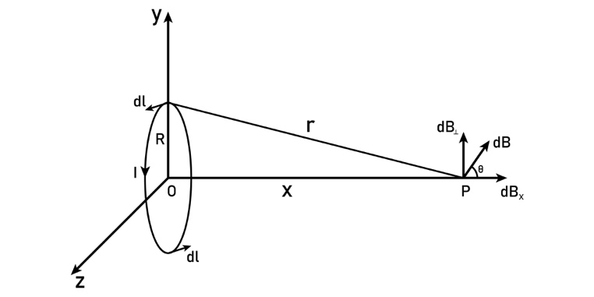
Shutterstock
Explore
- Marking Markers: Diagram (1m), Biot-Savart statement (1m), Integration steps (2m), Final result (1m).
2. Derive an expression for the magnetic field at a point on the axis of a circular current-carrying loop.
- Step 1: Geometry. Consider a loop of radius and a point at distance from the center.
- Step 2: Components. Resolve into components. The perpendicular components cancel out, and the axial components () add up.
- Step 3: Substitution. Substitute and .
- Result: B = (μ₀ I R²) / [2(R² + x²)^{3/2}].
3. State Ampere’s Circuital Law. Use it to find the magnetic field inside a long straight solenoid.
- Step 1: Statement. .
- Step 2: Amperian Loop. Choose a rectangular loop partly inside and partly outside the solenoid.
- Step 3: Line Integral. Evaluate the integral for four sides. Only the side inside the solenoid () contributes as outside.
- Result: B = μ₀nI, where is turns per unit length.
4. Derive an expression for the force per unit length between two long parallel current-carrying conductors.
- Step 1: Field Calculation. Find the field produced by wire 1 at the location of wire 2.
- Step 2: Force on Wire 2. Use .
- Step 3: Force per length. Divide by .
- Result: f = (μ₀ I₁ I₂) / 2πd.
5. Define the 'Ampere' based on the force between parallel conductors.
- Definition: One Ampere is that steady current which, when flowing through two infinitely long, straight parallel conductors of negligible cross-section placed 1 meter apart in vacuum, produces a force of Newton per meter of length.
6. Explain the principle, construction, and working of a Cyclotron with a labeled diagram.
- Principle: Lorentz force for circular motion and electric field for acceleration.
- Construction: Two 'Dees', oscillator, and magnetic poles.
- Working: Particle gains energy every time it crosses the gap; frequency is independent of speed.
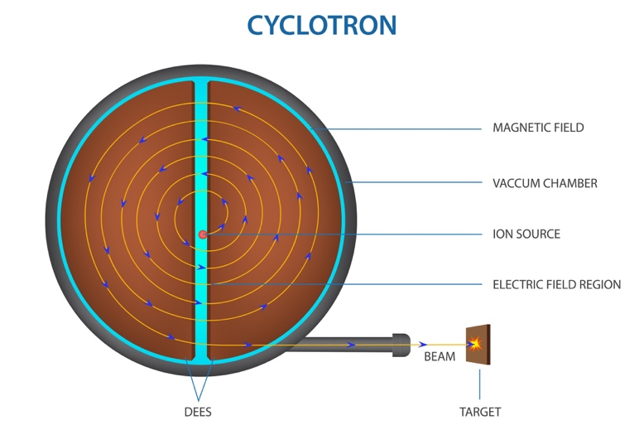
Shutterstock
Explore
7. Derive the expression for the torque acting on a rectangular current loop in a uniform magnetic field.
- Step 1: Force on sides. Forces on horizontal sides cancel. Vertical sides experience forces .
- Step 2: Torque Calculation. Torque = Force * perpendicular distance. .
- Result: \tau = NIAB \sin\theta or \tau = m x B.
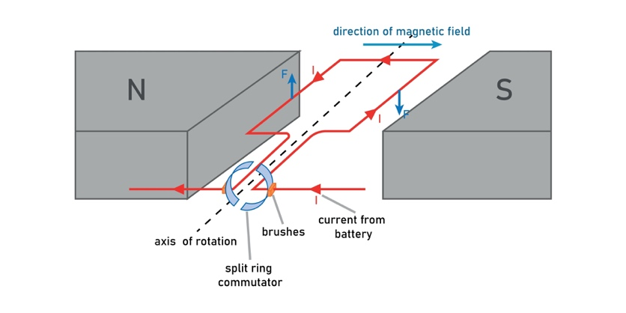
Shutterstock
8. Discuss the motion of a charged particle in a uniform magnetic field when it enters at an arbitrary angle θ.
- Components: (parallel to ) and (perpendicular to ).
- Trajectory: The perpendicular component causes circular motion, and the parallel component causes linear motion, resulting in a Helical path.
- Derivations: Radius and Pitch .
9. Explain the principle, construction, and working of a Moving Coil Galvanometer.
- Principle: A current loop in a magnetic field experiences a torque.
- Working: Deflecting torque = Restoring torque .
- Result: I = (k / NAB) * \phi.
10. How is a galvanometer converted into (i) an Ammeter and (ii) a Voltmeter? Derive the necessary formulas.
- Ammeter: Shunt in parallel. S = (I_g G) / (I - I_g).
- Voltmeter: High resistance in series. R = (V / I_g) - G.
11. Derive an expression for the magnetic field of a Toroid using Ampere’s Circuital Law.
- Setup: Use a circular Amperian loop of radius inside the core.
- Integral: .
- Enclosed Current: .
- Result: B = (μ₀ N I) / 2\pi r = μ₀nI.
12. Using the Biot-Savart Law, derive the magnetic field due to an infinitely long straight conductor.
- Setup: Consider a current element at distance from point .
- Integration: Integrate from to .
- Result: B = μ₀I / 2\pi r.
13. Define Magnetic Dipole Moment of an orbiting electron. Derive the expression for the Bohr Magneton.
- Step 1: Current .
- Step 2: Moment .
- Step 3: Use .
- Result: μb = eh / 4\pi m.
14. Compare and contrast a Solenoid and a Toroid.
- Solenoid: Straight, field is uniform inside but has edge effects; magnetic field lines are straight inside.
- Toroid: Circular, no edge effects (closed loop); field is confined within the core.
15. Describe the phenomenon of 'Velocity Selector'. Under what condition does a charge pass undeflected through crossed E and B fields?
- Setup: Perpendicular and fields.
- Forces: Electric force and Magnetic force .
- Equilibrium: .
- Result: v = E / B. Only particles with this specific velocity pass without deflection.

Section E: Case Studies ( each of 4 marks)

Case Study 1: The Mass Spectrometer
A mass spectrometer is a powerful analytical tool used to identify the chemical composition of a sample. In one part of the device, ions are accelerated and passed through a "Velocity Selector" (crossed Electric and Magnetic fields). Only ions with a specific speed emerge. These ions then enter a second uniform magnetic field where they follow a circular path and hit a detector. The radius of the path helps determine the mass of the ion.
- What is the condition for an ion to pass undeflected through the velocity selector? (1m)
  - Answer: The electric force must balance the magnetic force (), which means the velocity must be v = E / B.
- In the second magnetic field, why do ions follow a circular path? (1m)
  - Answer: Because the magnetic force () acts perpendicular to the velocity at every point, providing the necessary centripetal force.
- If two ions have the same charge and velocity but different masses, which one will have a larger radius? (2m)
  - Solution: Using r = mv / qB. Since are constant, r is proportional to m. Therefore, the heavier ionwill have a larger radius.

Case Study 2: The Cyclotron in Medical Science
Cyclotrons are widely used in hospitals to produce radioactive isotopes for PET (Positron Emission Tomography) scans.They accelerate protons or deuterons to high speeds and collide them with target atoms to create medical isotopes like Fluorine-18.
- What is the role of the magnetic field in a cyclotron? (1m)
  - Answer: The magnetic field is used to make the charged particles move in circular paths, allowing them to pass through the same accelerating electric field repeatedly.
- Does the time taken for one semi-circle depend on the speed of the particle? (1m)
  - Answer: No. The time period is independent of the speed and radius.
- Why can't a cyclotron be used to accelerate electrons to very high speeds? (2m)
  - Answer: Electrons have a very small mass. As they reach high speeds, relativistic effects cause their mass to increase significantly, which changes their frequency and takes them out of "step" with the oscillating electric field.

Case Study 3: The Earth's Magnetic Shield (Magnetosphere)
The Earth is constantly bombarded by the "Solar Wind"—a stream of high-energy charged particles (mostly protons and electrons) from the Sun. The Earth’s magnetic field acts as a shield, trapping these particles. Instead of hitting the atmosphere directly, they spiral along the magnetic field lines toward the North and South poles.
- What type of trajectory do the solar wind particles follow when they enter the Earth's magnetic field at an angle? (1m)
  - Answer: A Helical path.
- What phenomenon is caused when these trapped particles collide with atoms in the upper atmosphere near the poles? (1m)
  - Answer: The Auroras (Aurora Borealis in the North and Aurora Australis in the South).
- Write the expression for the pitch of the helical path followed by these particles. (2m)
  - Solution: Pitch is the linear distance covered in one rotation. Pitch = (v cosθ) * T, where T = 2πm / qB.

Case Study 4: Magnetic Levitation (Maglev) Trains
Maglev trains use the principle of magnetic repulsion between the train and the track. Superconducting magnets on the train generate strong magnetic fields. According to the laws of electromagnetism, parallel currents and magnetic poles can create large upward forces that "lift" the train, eliminating friction.
- Two parallel wires carry current in opposite directions. Do they attract or repel? (1m)
  - Answer: They repel each other.
- What is the magnitude of the force per unit length between two parallel wires separated by distance 'd'? (1m)
  - Answer: f = (μ₀ * I₁ * I₂) / (2πd).
- Why are superconductors used in Maglev trains instead of normal copper wires? (2m)
  - Answer: Superconductors have zero electrical resistance, allowing them to carry extremely high currents without heating up. This produces the massive magnetic fields required to lift a heavy train.

Case Study 5: The Sensitive Galvanometer
Galvanometers are used to detect tiny currents in electrical circuits. In a Moving Coil Galvanometer, a soft iron core is placed inside the coil, and the poles of the magnet are made concave (cylindrical) to create a radial magnetic field.
- Why is a soft iron core used inside the galvanometer coil? (1m)
  - Answer: It increases the magnetic field strength and makes it radial, ensuring high sensitivity.
- What is the condition for a galvanometer to be "dead-beat"? (1m)
  - Answer: When the electromagnetic damping is so high that the coil comes to rest almost immediately without oscillations.
- A galvanometer has a sensitivity of 5 div/mA. If its resistance is 100 ohms, calculate its voltage sensitivity.(2m)
  - Solution: Voltage Sensitivity = Current Sensitivity / Resistance Vs = 5 / 100 = 0.05 div/mV.

