SentinelX — AI Market Surveillance Platform
Project Documentation Report

>>Project Overview
SentinelX is an AI-powered market surveillance platform developed to detect suspicious market behavior such as insider trading, pump-and-dump schemes, abnormal volatility, and coordinated social media manipulation.
The system combines real-time stock monitoring, AI-based risk prediction, sentiment analysis, and insider trading visualization into a single intelligent dashboard.

>>Problem Statement
Financial markets are vulnerable to manipulation through coordinated trading activities, misinformation campaigns, and insider trading.
Traditional monitoring systems often fail to identify anomalies in real time. SentinelX addresses this challenge using AI-powered anomaly detection and predictive analytics.

>>Core Features
- Real-time Market Analytics Dashboard
- AI Risk Alert System
- Predictive AI Engine
- News Sentiment Analysis
- Social Media Intelligence
- Insider Trading Network Analysis
- Interactive Charts & Dashboards
- Generate alert
- Toggle theme

>>Setup Instructions
Step 1:
Save the project as: index.html Step 2:
Open the file directly in a browser.
Step 3:
For VS Code:
- Install Live Server Extension
- Right click index.html
- Select 'Open with Live Server'

>>Tech Stack
Frontend:
- HTML5
- CSS3
- TailwindCSS
- JavaScript
Visualization:
- Chart.js
APIs:
- Alpha Vantage API
- Fetch API

>>Architecture Summary
User Interface
↓
JavaScript Logic Layer
↓
External APIs
↓
AI Analysis Engine
↓
Visualization Dashboard

>>AI Prediction Workflow
User Selects Stock
↓
Fetch Market Data
↓
Analyze Price Changes
↓
AI Risk Detection
↓
Generate Manipulation Score
↓
Display Prediction

>>Alert Detection Workflow
Market Data + Social Signals
↓
AI Monitoring Engine
↓
Pattern Detection
↓
Suspicious Activity Detection
↓
Generate Alert Notification

>>Modules Description
Dashboard Module:
Displays charts, market activity, suspicious trades, and risk scores.
Prediction Engine:
Calculates volatility and manipulation probability.
News Sentiment Module:
Tracks positive and negative market sentiment.
Social Intelligence Module:
Detects coordinated hype campaigns and manipulation signals.
Insider Network Module:
Analyzes linked trading accounts and insider relationships.

>>API Integration
Alpha Vantage API is used for:
- Historical stock prices
- Daily market activity
- Real-time financial data

>>Future Enhancements
- TensorFlow AI Integration
- Real NLP Sentiment Analysis
- Twitter/Reddit API Integration
- Backend Database
- Cloud Deployment
- Authentication System

>>Security Recommendations
- Hide API keys using backend
- Add user authentication
- Use HTTPS APIs
- Implement secure storage
- Add rate limiting

>>Use Cases
- Financial Fraud Detection
- Market Surveillance
- Investment Intelligence
- Risk Analysis
- Hackathons & Research Projects

>>Conclusion
SentinelX demonstrates how AI, financial analytics, and real-time visualization can work together to detect suspicious market activity and improve market transparency.
The platform provides a strong foundation for future enterprise-grade financial intelligence systems.

>>Team Members
S.No | Team Member
1 | Deepasri R
2 | Ennam Dilli Kumar
3 | Rohith P
4 | V S Niharika
5 | Tharun C

>>Demo Screenshots:
Dashboard Screen
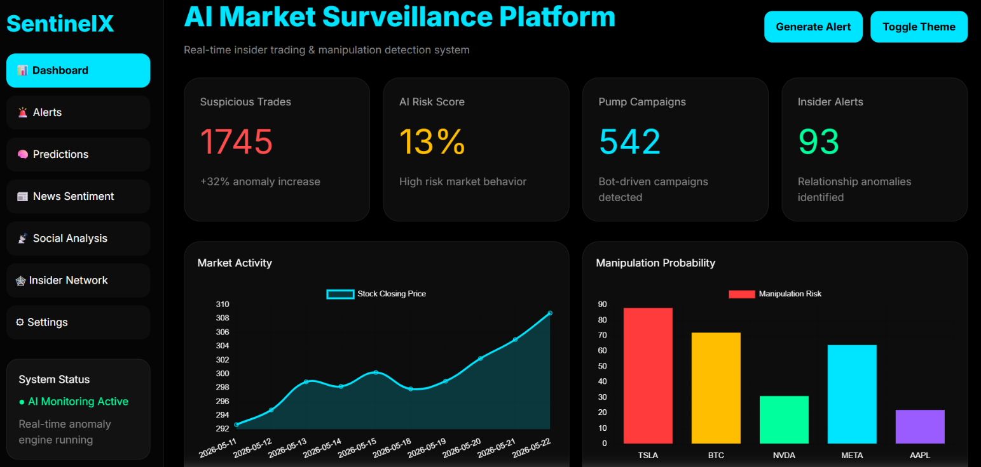
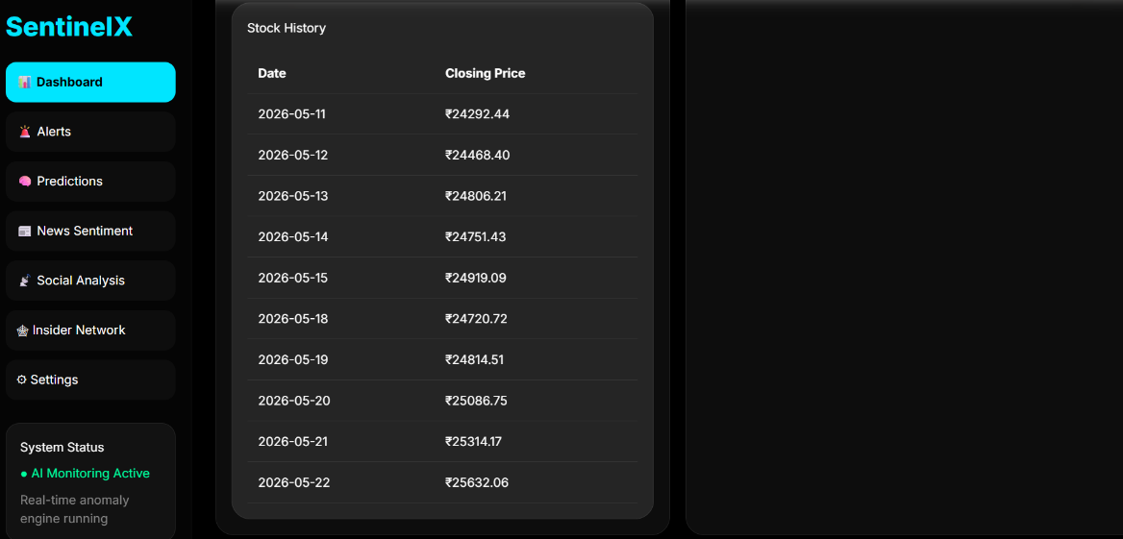

Alerts Screen
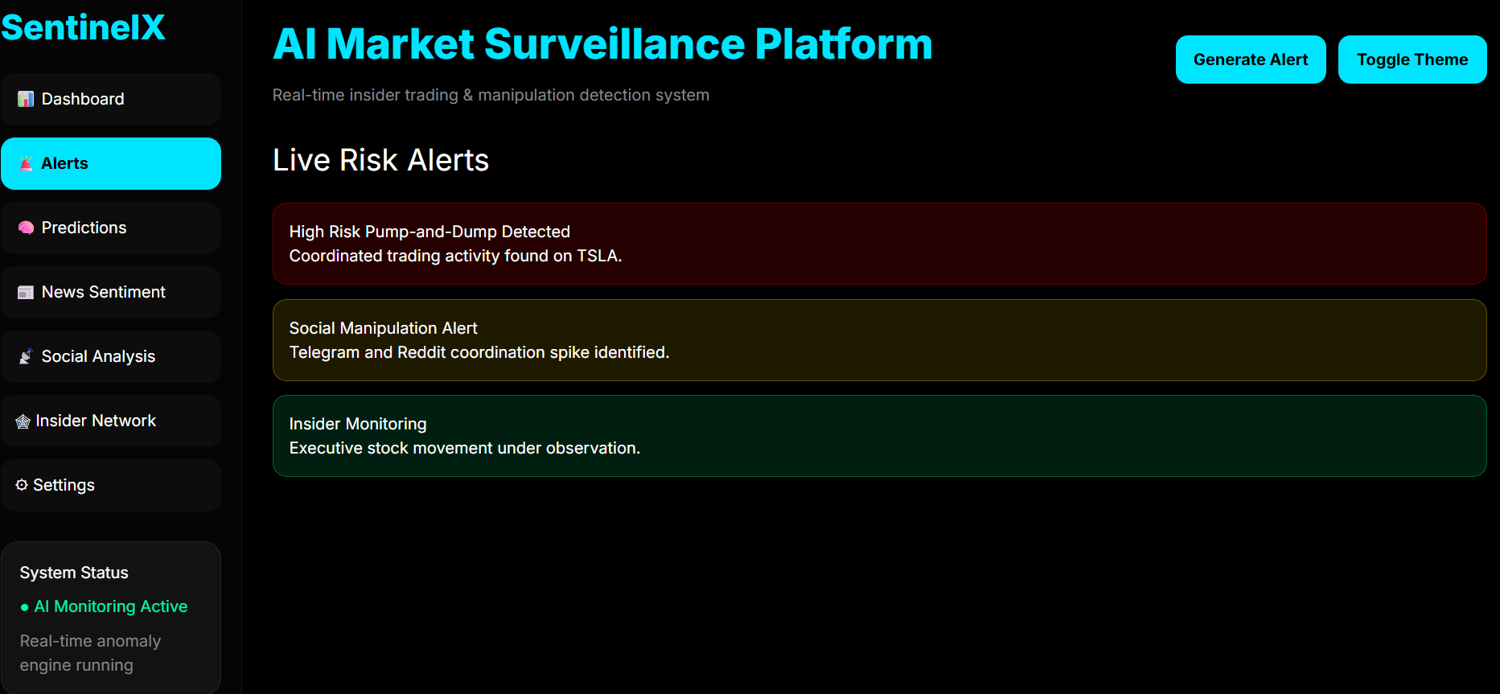

Prediction Engine Screen
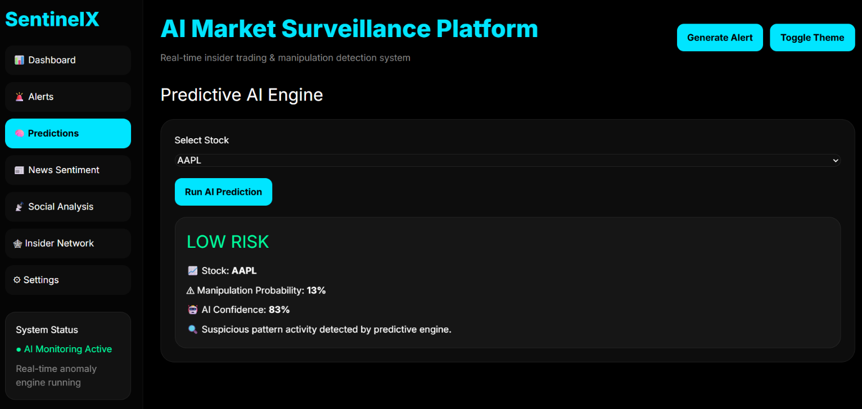

News Sentiment Screen
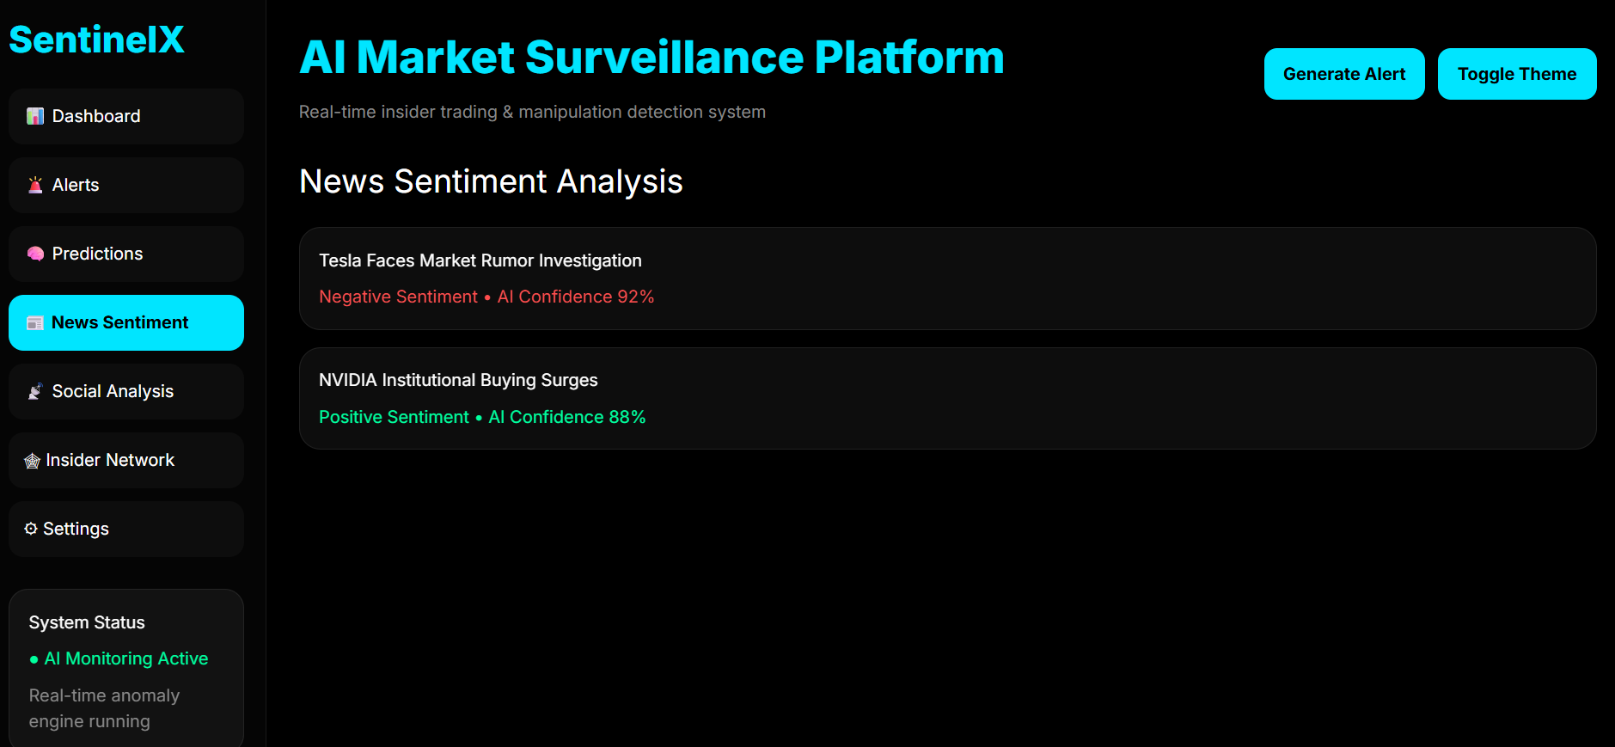

Social Media Intelligence Screen
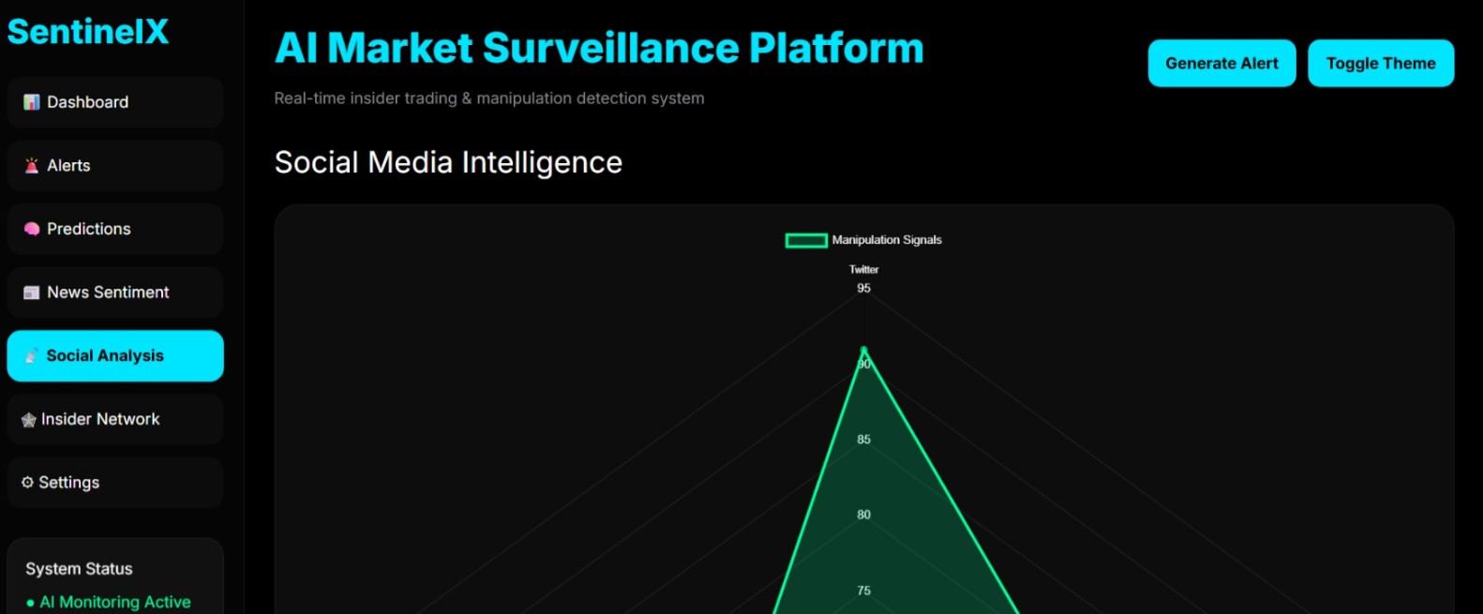

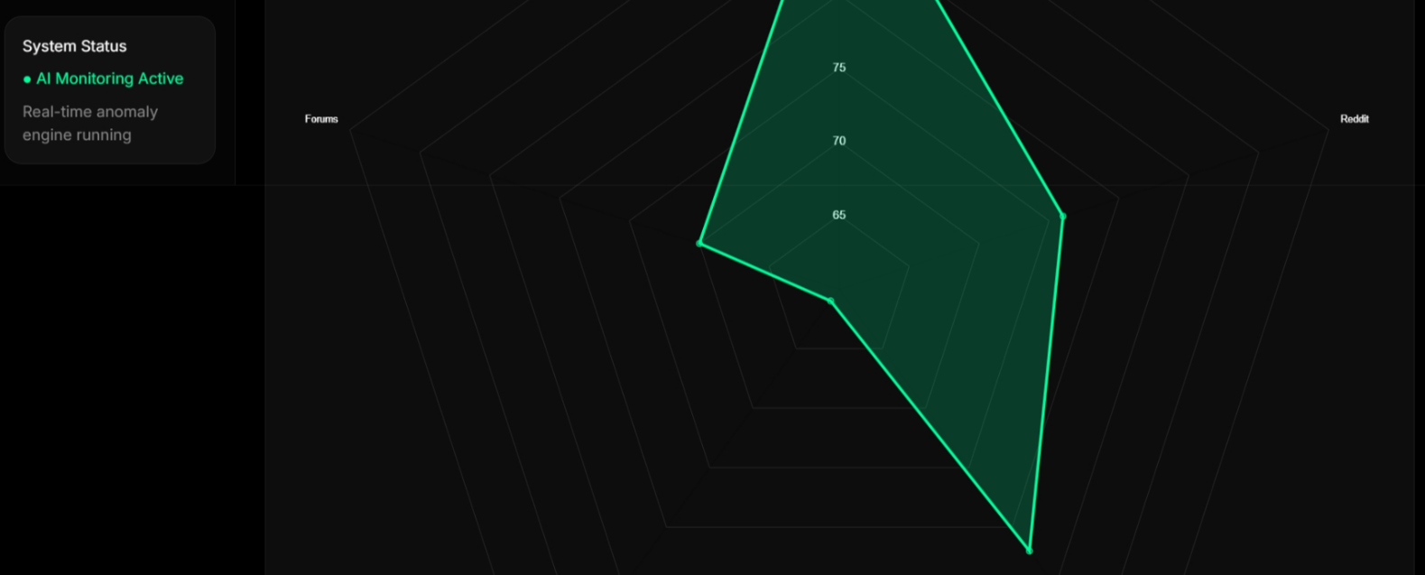

Insider Trading Network Screen