Screenshots

1) Frame 54 — RED State, LOW Density

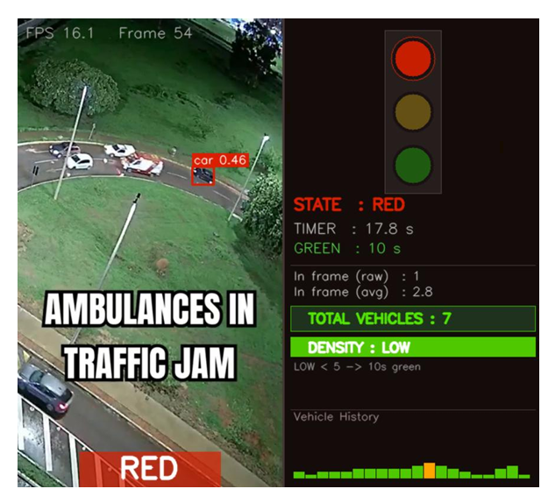

Frame 196 — Ambulance Priority Override

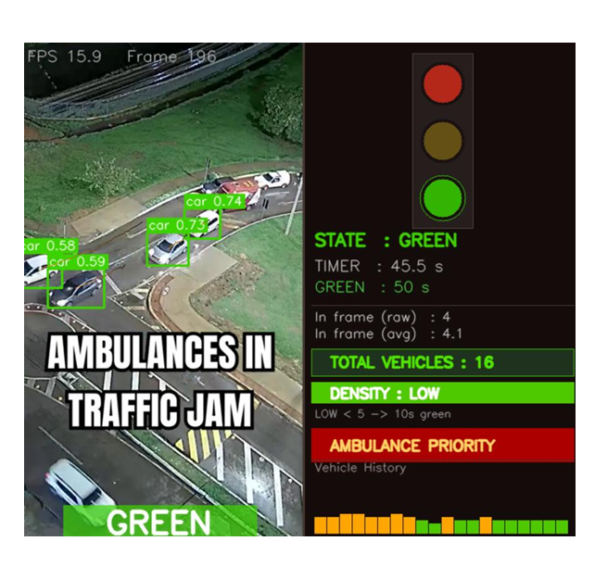

Frame 418 — Post Clearance GREEN
