Project Design Phase-II
Technology Stack (Architecture & Stack)
Date | July 2026
Team ID
Project Name | Sports Hall Booking System
Maximum Marks | 4 Marks

Technical Architecture
The Sports Hall Booking System is a custom-built ServiceNow solution developed using Service Portal to simplify and automate sports facility reservations. It enables users to view real-time slot availability, submit booking requests, and track approvals through an intuitive portal interface. The system automates approvals, notifications, and status updates using Flow Designer and scheduled jobs, ensuring a secure, efficient, and scalable booking experience.
Project developed on a ServiceNow Developer Instance using Service Portal widgets (HTML, CSS, Client Scripts, Server Scripts).
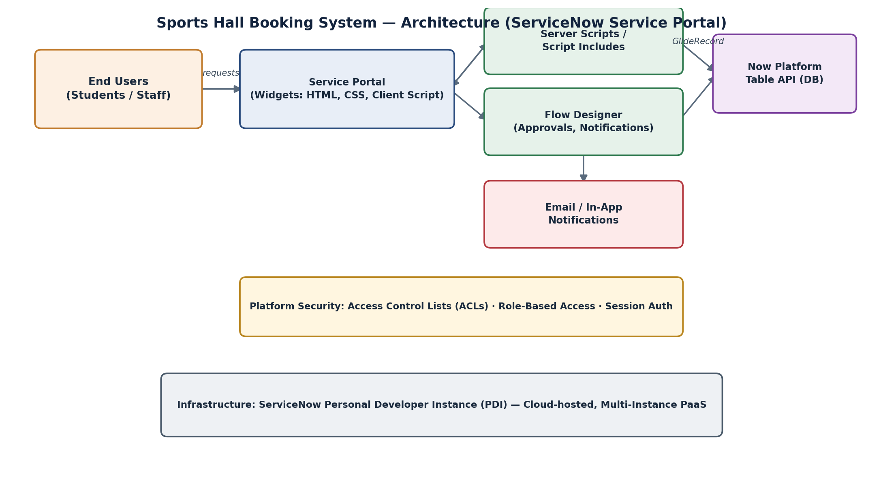
Fig 1: High-level architecture of the Sports Hall Booking System

Table-1: Components & Technologies
S.No | Component | Description | Technology
1 | User Interface | How the user interacts with the application — Web-based self-service portal for booking sports facilities. | ServiceNow Service Portal (HTML, CSS, Bootstrap, AngularJS – built-in Service Portal framework)
2 | Application Logic-1 | Client-side logic for form behaviour, field validation and dynamic UI updates. | Client Scripts (JavaScript, ServiceNow g_form API)
3 | Application Logic-2 | Server-side business logic for processing booking requests and data operations. | Server Scripts / Script Includes (JavaScript, GlideRecord API)
4 | Application Logic-3 | Automates approval workflow, status updates and notification triggers. | Flow Designer & Scheduled Jobs (ServiceNow native automation)
5 | Database | Data type, configuration for storing bookings, slots and approval status. | ServiceNow Now Platform database (built-in tables via Table API)
6 | Cloud Database | Database service on cloud hosting the application data. | ServiceNow Cloud – Now Platform (PaaS hosted instance)
7 | File Storage | File storage requirements for attachments/booking documents, if any. | ServiceNow Attachment API (native platform storage on Developer Instance)
8 | External API-1 | Purpose of external API used in the application. | Not used – all notifications handled natively via ServiceNow Notification/Email engine
9 | External API-2 | Purpose of external API used in the application. | Not Applicable
10 | Machine Learning Model | Purpose of Machine Learning model, if used. | Not Applicable
11 | Infrastructure (Server / Cloud) | Application deployment environment. | ServiceNow Personal Developer Instance (PDI) – Cloud-hosted, multi-instance PaaS

Table-2: Application Characteristics
S.No | Characteristics | Description | Technology
1 | Open-Source Frameworks | Open-source frameworks used in the application. | Bootstrap, AngularJS, jQuery (bundled within ServiceNow Service Portal)
2 | Security Implementations | Security / access controls and firewalls implemented. | ServiceNow Access Control Lists (ACLs), Role-Based Access Control (RBAC), session-based authentication
3 | Scalable Architecture | Justification of scalability of the architecture. | Multi-tier Now Platform architecture (Portal → Business Logic → Database) on a scalable cloud PaaS
4 | Availability | Justification of application availability. | Hosted on ServiceNow's managed cloud infrastructure with platform-level high availability
5 | Performance | Design considerations for performance. | Optimised GlideRecord queries, client-side script efficiency, and Service Portal widget caching

References
https://developer.servicenow.com/dev.do
https://docs.servicenow.com/bundle/service-portal
https://developer.servicenow.com/dev.do#!/learn/learning-plans/utah/new_to_servicenow/app_store_learningv2_buildmyfirstapp_service_portal

