Internship Project Documentation
Data Flow Diagram & User Stories
Date | July 2026
Team ID
Project Name | Sports Hall Booking System

Project Description
The Sports Hall Booking System is a custom-built ServiceNow solution developed using Service Portal to simplify and automate sports facility reservations. It enables users to view real-time slot availability, submit booking requests, and track approvals through an intuitive portal interface. The system automates approvals, notifications, and status updates using Flow Designer and scheduled jobs, ensuring a secure, efficient, and scalable booking experience.
Data Flow Diagram
A Data Flow Diagram (DFD) is a visual representation of the information flows within a system. It shows how data enters and leaves the system, what processes transform the data, and where data is stored. The diagram below represents the Level 0 (context) view of the Sports Hall Booking System.
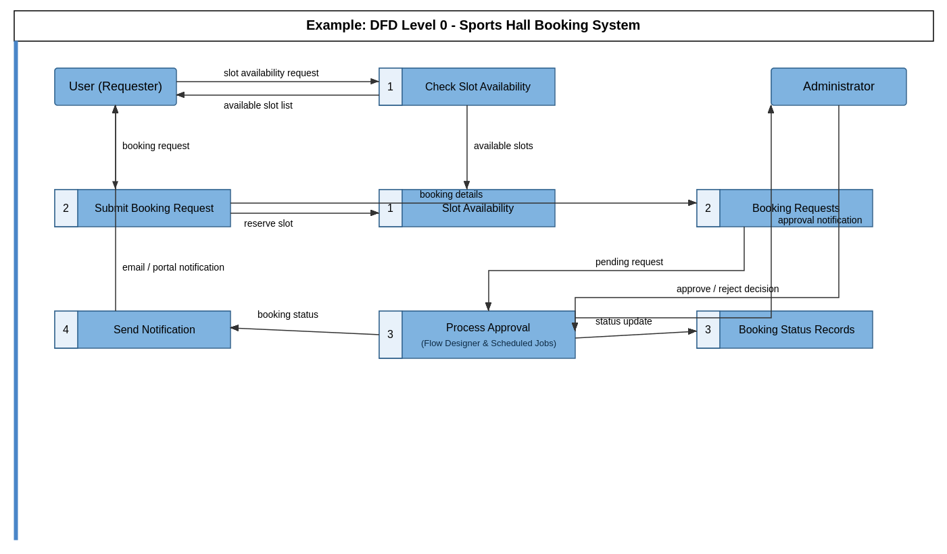
User Stories
The table below lists the user stories for the Sports Hall Booking System, covering the portal user, the approver, and the automated system functions delivered through Flow Designer and scheduled jobs.
User Type | Functional Requirement (Epic) | User Story Number | User Story / Task | Acceptance Criteria | Priority | Release
Employee (Portal User) | Portal Login | USN-1 | As a user, I can log into the Sports Hall Booking Portal using my ServiceNow credentials. | I can access the portal dashboard after successful login. | High | Sprint-1
Employee (Portal User) | Slot Availability | USN-2 | As a user, I can view real-time availability of sports hall slots on the portal. | I can see available and booked slots by date and time. | High | Sprint-1
Employee (Portal User) | Booking Request | USN-3 | As a user, I can submit a booking request for an available slot through the portal. | I can select a slot and submit the request successfully. | High | Sprint-1
Employee (Portal User) | Booking Tracking | USN-4 | As a user, I can track the status of my booking request (pending, approved, or rejected). | I can view the current status of my request on my dashboard. | High | Sprint-2
Employee (Portal User) | Notifications | USN-5 | As a user, I receive a notification when the status of my booking request is updated. | I receive an email/portal notification when my request is approved or rejected. | Medium | Sprint-2
Approver (Administrator) | Booking Approval | USN-6 | As an approver, I can view pending booking requests assigned to me in an approval queue. | Pending requests are visible in my approval queue on the portal. | High | Sprint-2
Approver (Administrator) | Booking Approval | USN-7 | As an approver, I can approve or reject a submitted booking request. | The booking status updates automatically once I approve or reject it. | High | Sprint-2
System (Automation) | Approval Routing | USN-8 | As the system, I can automatically route booking requests to the correct approver using Flow Designer. | Requests are automatically assigned to the approver without manual intervention. | High | Sprint-3
System (Automation) | Status Automation | USN-9 | As the system, I can automatically update slot availability once a booking request is approved. | The slot status changes to "Booked" in real time after approval. | High | Sprint-3
System (Automation) | Scheduled Jobs | USN-10 | As the system, I can run scheduled jobs to release expired or unconfirmed booking requests. | Expired or unconfirmed bookings are automatically cleared by the scheduled job. | Medium | Sprint-3

