Project Design Phase
Solution Architecture
Date | July 2026
Team ID
Project Name | Sports Hall Booking System
Maximum Marks | 4 Marks

Solution Architecture:
Solution architecture is a complex process – with many sub-processes – that bridges the gap between business problems and technology solutions. Its goals are to:
- Find the best tech solution to solve existing business problems.
- Describe the structure, characteristics, behavior, and other aspects of the software to project stakeholders.
- Define features, development phases, and solution requirements.
- Provide specifications according to which the solution is defined, managed, and delivered.

Solution Architecture Diagram — Sports Hall Booking System:
The diagram below shows the end-to-end architecture and data flow of the Sports Hall Booking System, built on ServiceNow using Service Portal, Client/Server Scripts, Flow Designer, and the Now Platform database. It illustrates how a booking request travels from the requester through the portal and business logic layers to storage, approval, and notification.
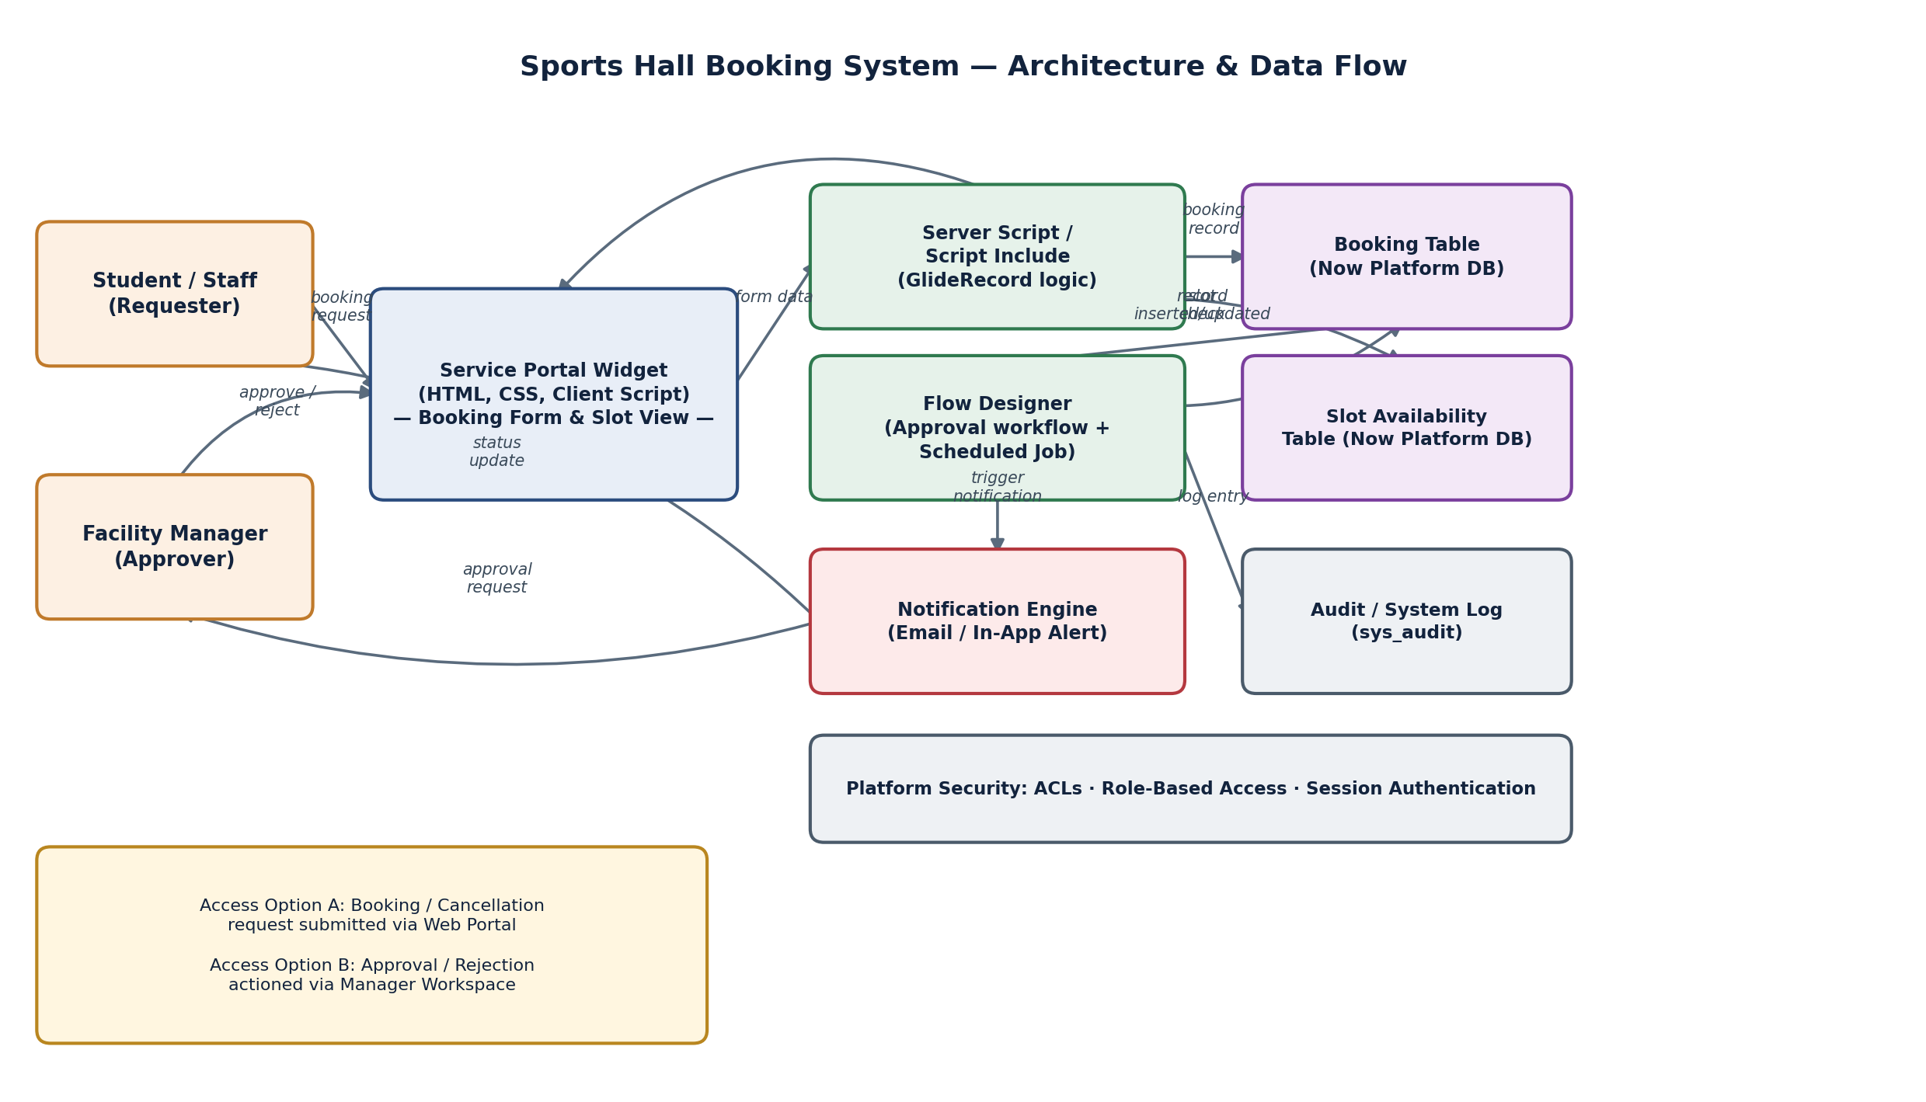
Figure 1: Architecture and data flow of the Sports Hall Booking System
Reference: https://docs.servicenow.com/bundle/service-portal

