Contribution of the members:

We are four members in the group: Monil Nisar, Samip Thakkar, Vishwarajsinh Sodha and Pushparajsinh Zala

The respective models trained for each student are:

**Vishwarajsinh Sodha: MLP (Multilayer perceptron) classifier**

**Pushparajsinh Zala: K nearest neighbor (KNN)**

**Monil Nisar: Logistic Regression classifier**

**Samip Thakkar: Gradient Boost classifier**

Other than four, Monil Nisar and Samip Thakkar have developed six more classification models: **Neural network, Random Forest, Perceptron classifier, Support Vector Machine (SVM), Naïve Bayes (NB), and eXtreme Gradient Boosting (XGB) classifier.**

Pushparajsinh Zala and Vishwarajsinh Sodha have also tried variations of following models for increasing task accuracy: **K nearest neighbor (KNN), Neural network with different params & solvers, Perceptron & multi-layer perceptron classifiers, Support Vector Machine (SVM) and Logistic regression with different params.**

Also, to note that due to changing training data, we might get different model accuracies at different run. When running on our machine following is the screenshot of accuracy when **k = 4 for k-fold cross-validation**:

**Trial 1:**

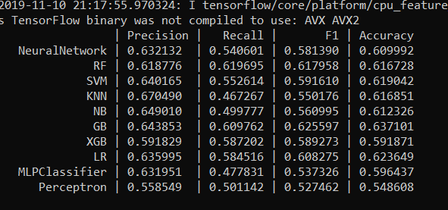

**Trial 2:**

