**Product Delivery Report – Pink Lady Project**

**Project Overview**

The Pink Lady website has been successfully developed and deployed as a modern e-commerce solution. It allows customers to place orders, and receive order confirmations, while the Admin can manage products and monitor orders.

**Hosting & Services Details**

**1. Firebase – Authentication & Database**

* **Platform:** Firebase
* **Usage:**
  + **Authentication:** Secure login for Admin.
  + **Firestore Database:** Stores product details, customer orders, and admin data.
* **Purpose:** Provides real-time database access and secure role-based authentication.

Credentials:

* Userid: paapatchienterprises@gmail.com
* Password: Sundar@80

**2. Hosting – Hostinger**

* **Platform:** Hostinger
* **Usage:** Hosts the React frontend of the website.
* **Domain Connected:** [pinkladypaapatchi.com]
* **Domain Purchased On:** [30/09/2025] (as per Hostinger panel).
* **Domain Purchased On:** [30/09/2026] (as per Hostinger panel).
* **Purpose:** Provides fast and reliable website hosting with SSL.

**3. Email Service – EmailJS**

* **Platform:** EmailJS
* **Usage:**
  + Sends **order notification emails** to Admin.
* **Purpose:** Automates communication between Pink Lady and customers.

Credentials:

* Userid: suganthisundarrajan@gmail.com
* Password: Sundar@80
* Userid: paapatchienterprises@gmail.com
* Password: SundarRajan@01

**4. Payment Integration – Razor Pay**

* **Platform:** Razor Pay
* **Usage:** Payment Integration is done in Razor Pay.
* **Credentials:**
  + **User Name:** paapatchienterprises@gmail.com
  + **PassWord:** ValiSundarRajan@01

**5. Backend – Render**

* **Platform:** Render
* **Usage:** Hosts the Node.js/Express backend API.
* **Purpose:** Handles order processing, Payment Methods and connection to Firebase database.
* **Status:** Live & running.
* **Credentials:**
  + **User Name:** paapatchienterprises@gmail.com
  + **Password**: Sundar@01

**6. Admin Panel**

* **Access:** Secured via Firebase Authentication.
* **Features:**
  + Create, Edit, Delete products Details.
  + Can set offer to each and every product.
  + Manage order status.

**Admin Credentials:**

* **Username/Email:** paapatchienterprises@gmail.com
* Password: Paapatchi
* Admin Link: https://pinkladypaapatchi.com/adminlogin.

**6. Image to URL:** Link 🡪 <https://imgbb.com/>

1)

Here Click START UPLOADING button and select the image you want to convert.

2)

Select the DON’T AUTODELETE option in that dropdown and hit upload, you will get the url copy and paste the url in new tab.

3)

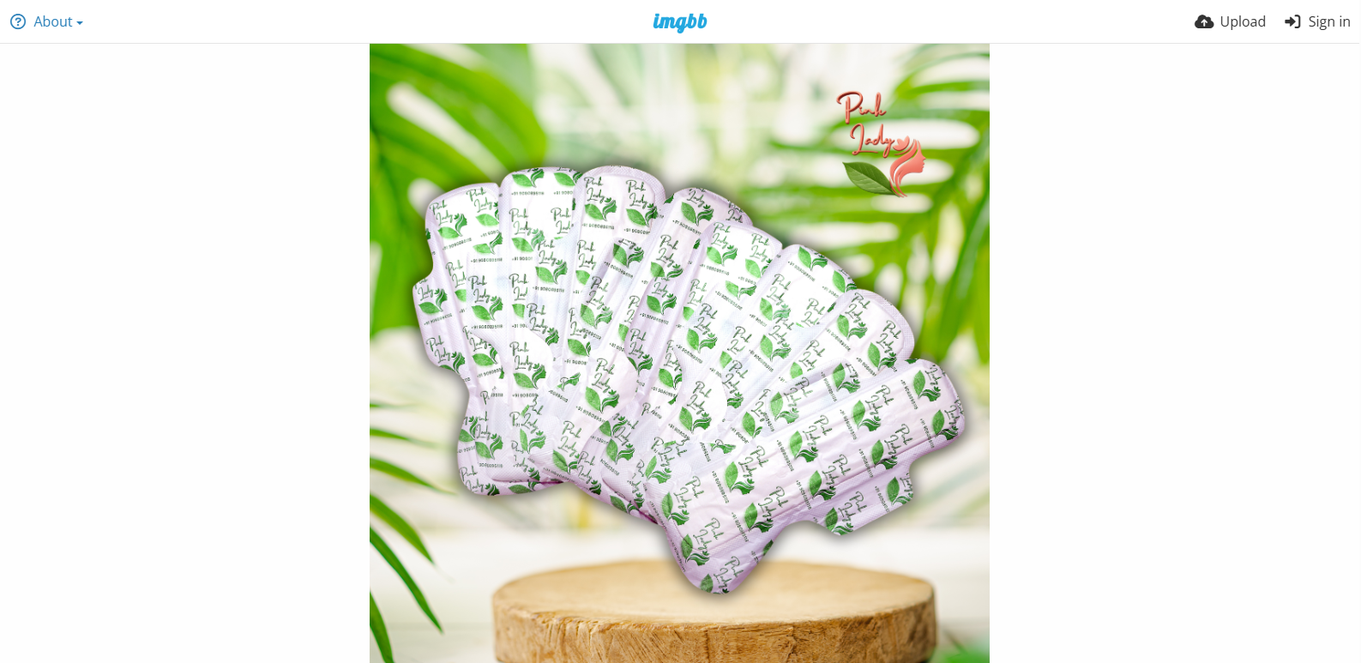

Here click COPY IMAGE ADDRESS and paste that URL in the Image Url Input column

**Delivery Summary**

* Authentication & Database managed via **Firebase**.
* Domain purchase is done in Hostinger
* EmailJS integrated for order confirmations.
* Admin credentials securely shared with Pink Lady.
* Backend successfully hosted on **Render**.