[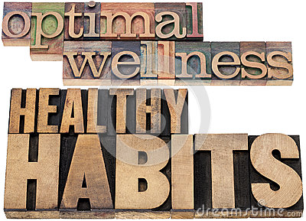](http://thumbs.dreamstime.com/z/optimal-wellness-healthy-habits-38129111.jpg)

**HOLY SPIRIT RETREAT CENTER IS OFFERING A RARE OPPORTUNITY FOR A WELLNESS CONVERSATION WITH**

**DR. ARNEL REYES, FAMILY PHYSICIAN**

* The importance of physical fitness and diet
* The connections between medicine and spirituality
* How to deal with stress using faith, meditation, prayer

and movement

Dr. Reyes is a multi-sport athlete, a coach and certified personal trainer. He will speak to the issues of wellness, how to develop a healthy diet, how to combine yoga and meditation, and relaxation so as to remain healthy and feel wonderful! In addition, Lala Rukh Khan, Wellness Educator, and Deborah Lorentz, L.Ac. will intersperse Dr. Reyes’ talks with a short meditation, qi gong, and laughter yoga. Bring your questions!

**Saturday, October 25, 2014** **9:00 a.m. register, 9:30 a.m.-3:00 p.m.**

**Cost:** $15.00 which includes lunch.

_________________________________________________________

**Send registration to: Holy Spirit Retreat Center, 4316 Lanai Rd. Encino, CA 91436**

**Wellness Presentation with Dr. Arnel Reyes**

Name _________________________________________________________________

E-mail _____________________________________________Phone: ______________

Address ___________________________City _______________Zip_______________

Fee enclosed: ___________________________