**RMK COLLEGE OF ENGINEERING AND TECHNOLOGY**

**2019-20**

**HOTEL MANAGEMENT**

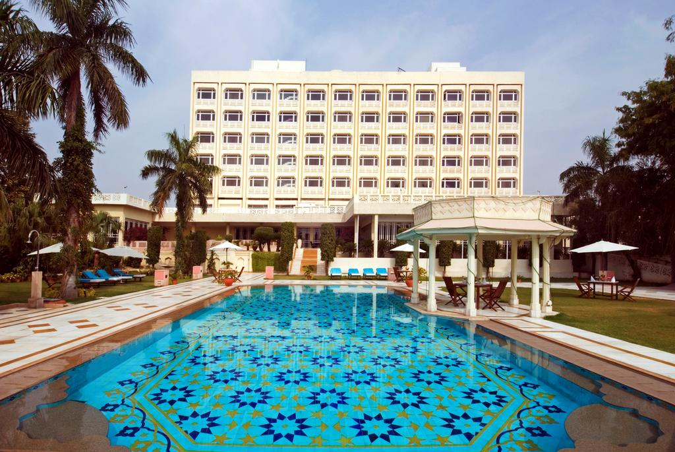

**CONTENT :**

1. Introduction
2. System configuration
3. Data files
4. Header files / class
5. Program Code
6. Sample Input / Output
7. Conclusion
8. Bibliography

**INTRODUCTION :**

A typical luxury hotel requires a management system to control its various operations such as maintaining account of all the people in its domain of services, attending to various needs of customers and also achieving increased efficiency in overall working of the hotel.

HOTEL MANAGEMENT project in C++ is a simple console application built without the use of graphics. This project Hotel Management help in managing the record of the customer according to the name, requirements and much more. In this project we tried to enter all details of customer and tried to maintain all the possibility which may help the user to enter more record if he/she requires.

**Create record**: This feature creates a new customer records. For this the information to be provided arethe number of persons, name, number of days of staying and the choice for AC or NON-AC, etc.

**To book a room:**This feature allows the user to book a room on the basics of number of persons, name, number of days staying&choice for AC or NON-AC, etc.

**Delete Customer’s record**: This feature deletes the record of a particular customer; it asks for the room number whose record is to be deleted.

**Search customer’s record**: In Hotel Management project in C++, this feature is used to search the record of a particular customer. It asks for the room number for searching of records. Upon successful searching, the program displays the records of a particular customer,but on unsuccessful searching it display the message “there is no such record”.

**Displayall the record**: Thedisplay*()* function in  project in C++ has been used for this feature. It basically shows the Room no, Name and the phone number.

**To know the room bill**: This feature show the bill of a particular customer. It asks the room no of the hotel.

**To Exit:**This feature allows the user to exit program. It terminates the program.

**SYSTEM CONFIGURATION:**

**HARDWARE:**

4GB RAM

16GB PENDRIVE

**SOFTWARE:**

DOSBOX

TURBO C++ 4.0

**DATA FILES USED**

1. record.dat – input obtained from user and data is stored in binary file ”record.dat”.
2. tempo.dat – used for delete function

**HEADER FILES / CLASS:**

**HEADER FILES**

IOSTREAM.H

FSTREAM.H

CONIO.H

CTYPE.H

STDIO.H

STRING.H

PROCESS.H

GRAPHICS.H

**Class**

Class Data which stores data members and member functions under public.

**Data members:**

name

roomno

PHONENO

NO_OF_DAYS

price

AC

**Member Functions:**

A constructor to initialize the values.

entername()

show_record()

show_bill()

prices()

getroomno()

totalprice()

modify_data()

**PROGRAM CODE :**

#include<iostream.h>

#include<fstream.h>

#include<conio.h>

#include<ctype.h>

#include<stdio.h>

#include<string.h>

#include<process.h>

#include<graphics.h>

class data

{

public:

char name[30];

int roomno;

char PHONENO[11];

int NO_OF_DAYS;

int total_no_rooms;

int price,no;

char AC;

data()

{

roomno=0;

strcpy(name,"");

PHONENO;

NO_OF_DAYS =0;

price=0;

}

void enter_name()

{

cout<<"\n Enter room no. : ";

cin>>roomno;

cout<<"\n Enter customer name : ";

gets(name);

cout<<"\n Enter PHONENO : ";

gets(PHONENO);

cout<<"\n Enter the no. of days you\n want to accomodate the room : ";

cin>>NO_OF_DAYS;

prices();

}

void show_record()

{

cout<<"\n room No. : "<<roomno;

cout<<"\n customer name : "<<name;

cout<<"\n Phone no. : "<<PHONENO;

cout<<"\n No. of days : "<<NO_OF_DAYS;

cout<<"\n";

}

void show_bill()

{

cout<<"\n Room no. :"<<roomno;

cout<<"\nCustomer name :"<<name;

cout<<"\nPhone no. :"<<PHONENO;

cout<<"\nNo. of days :"<<NO_OF_DAYS;

cout<<"\nPrice : Rs."<<price;

cout<<"\n";

}

void prices()

{

char AC;

cout<<"\nDo you want your room to \n be air contioned?(y/n) : ";

cin>>AC;

if(AC=='y'||AC=='Y')

{

price=NO_OF_DAYS*1500;

}

else

{

price=NO_OF_DAYS*1000;

}

}

int getroomno()

{

return roomno;

}

int totalprice()

{

return price;

}

char* get_name()

{

return name;

}

void modify_data()

{

clrscr();

cout<<"\n Enter new data for modification \n";

cout<<"\n Enter your name : ";

gets(name);

cout<<"\n Enter Phone no. : ";

cin>>PHONENO;

cout<<"\n Enter no. of days : ";

cin>>NO_OF_DAYS;

prices();

}

};

data d;

fstream file;

fstream file1;

int getno()

{

file.read((char *)&d,sizeof(d));

return d.no;

}

void insert()

{

clrscr();

textbackground(WHITE);

textcolor(BLUE);

int i,p;

file.open("record.dat",ios::in|ios::app|ios::binary);

cout<<"\n:::::::::::::::::: INSERT NEW RECORD ::::::::::::::::::\n ";

cout<<"\n How many record you want to enter : ";

cin>>d.no;

file.write((char *)&d,sizeof(d));

p=getno();

if(p<=d.total_no_rooms)

{

for(i=1;i<=p;i++)

{

d.enter_name();

file.write((char*)&d,sizeof(d));

}

file.close();

}

else

{

cout<<"\n Sorry...All rooms are occupied... ";

}

}

void check_available_rooms()

{

cout<<"\n::::::::::::::::: TOTAL NO. OF AVALABLE ROOMS :::::::: \n";

int temp=d.total_no_rooms;

int p=getno();

temp=temp-p;

cout<<"Total no. of rooms available : "<<temp;

}

void display()

{

clrscr();

file.open("record.dat",ios::in|ios::binary);

cout<<"\n:::::::::::::::::: DISPLAY RECORDS ::::::::::::::::::";

file.read((char*)&d,sizeof(d));

while(file)

{

d.show_record();

file.read((char*)&d,sizeof(d));

}

file.close();

}

void search()

{

clrscr();

int p,r,srch=0;

file.open("record.dat",ios::in|ios::binary);

cout<<"\n:::::::::::::::::: SEARCH RECORD ::::::::::::::::::\n";

cout<<"\n Enter the room no. you are searching for : ";

cin>>r;

file.seekg(0);

file.read((char*)&d,sizeof(d));

while(file)

{

p=d.getroomno();

if(r==p)

{

d.show_record();

srch=1;

break;

}

else

{

file.read((char*)&d,sizeof(d));

}

}

file.close();

if(srch==0)

{

cout<<"\n There is no such record ";

}

}

void bill()

{

clrscr();

int k,l,m=0;

file.open("record.dat",ios::in|ios::binary);

cout<<"\n:::::::::::::::::::BILL::::::::::::::::::::\n";

cout<<"Enter room no. to show the bill :";

cin>>l;

file.seekg(0);

file.read((char*)&d,sizeof(d));

while(file)

{

k=d.getroomno();

if(l==k)

{

d.show_bill();

m=1;

break;

}

else

{

file.read((char*)&d,sizeof(d));

}

}

file.close();

if(m==0)

{

cout<<"\nNo such record";

}

}

void modify()

{

clrscr();

int posi=0,got=0,dmd=0;

cout<<"\n:::::::::::::::::: MODIFY RECORD ::::::::::::::::::\n";

cout<<"\n Enter the room no. whose record to be modified : ";

cin>>dmd;

int ifdata=1;

file.open("record.dat",ios::in|ios::out|ios::binary);

posi=file.tellg();

while(file)

{

file.read((char*)&d,sizeof(d));

got=d.getroomno();

if(dmd==got)

{

file.seekg(posi);

d.modify_data();

ifdata=2;

file.write((char*)&d,sizeof(d));

break;

}

posi=file.tellg();

}

file.close();

if(ifdata==1)

{

cout<<"\n Data not available for modification ";

}

}

void delete_record()

{

clrscr();

int o,p;

int remove_record=0,code_get=0;

cout<<"\n:::::::::::::::::: DELETE RECORD ::::::::::::::::::\n";

cout<<"\n Enter the room no. whose record to be deleted : ";

cin>>remove_record;

file.open("record.dat",ios::in|ios::out|ios::binary);

file1.open("tempo.dat",ios::in|ios::out|ios::binary);

file.seekg(0);

while(file)

{

file.read((char*)&d,sizeof(d));

code_get=d.getroomno();

if(remove_record==code_get)

{

cout<<" ";

}

else

{

file1.write((char*)&d,sizeof(d));

}

}

file.close();

file1.close();

remove("record.dat");

rename("tempo.dat","record.dat");

cout<<"\n\n Record deleted...";

getno();

}

void main()

{

clrscr();

textbackground(YELLOW);

textcolor(BLACK);

cout<<"\n\n\t\t R.M.K COLLEGE OF ENGINEERING AND TECHNOLOGY";

cout<<"\n\t =*=*=*=*=*=*=*=*=*=*=*=*=*=*=*=*=*=*=*=*=*=*=*=*=*=*=*=*";

cout<<"\n\n\t\t\t WELCOME TO OUR C++ PROJECT ";

cout<<"\n\t\t =*=*=*=*=*=*=*=*=*=*=*=*=*=*=*=*=*=*";

cout<<"\n\n\n\t TOPIC :- HOTEL MANAGEMENT";

cout<<"\n\n\n\t By :- \n\t\t SOWMYA.V \n\t\t SHAKTHI.A.S \n\t\t V.SARASWATHY \n\t\t D.VIDHYAVARSHINI";

getch();

clrscr();

int choice;

char pw[8];

cout<<"\nEnter password : ";

gets(pw);

if(strcmp(pw,"abc")==0)

{

char ans='n';

cout<<"Enter total no. of rooms available in your hotel : ";

cin>>d.total_no_rooms;

file.write((char *)&d,sizeof(d));

do

{

clrscr();

cout<<"\n=*=*=*=*=*=*=*=*=* HOTEL MANAGEMENT*=*=*=*=*=*=*=*=*=*";

cout<<"\n 1.CHECK AVAILABLE ROOMS \n 2.INSERT RECORD \n 3.DISPLAY RECORD \n 4.SEARCH RECORD \n 5.MODIFY RECORD \n 6.SHOW BILL\n 7.DELETE RECORD \n 8.EXIT ";

cout<<"\n=*=*=*=*=*=*=*=*=*=*=*=*=*=*=*=*=*=*=*=*=*=*=*=*=*=*=*";

cout<<"\n Enter any one of the options (1-8) : ";

cin>>choice;

cout<<"\n=*=*=*=*=*=*=*=*=*=*=*=*=*=*=*=*=*=*=*=*=*=*=*=*=*=*=*";

switch(choice)

{

case 1: check_available_rooms();

break;

case 2: insert();

break;

case 3: display();

break;

case 4: search();

break;

case 5: modify();

break;

case 6: bill();

break;

case 7: delete_record();

break;

case 8: exit(0);

break;

}

cout<<"\n=*=*=*=*=*=*=*=*=*=*=*=*=*=*=*=*=*=*=*=*=*=*=*=*=*=*=*";

cout<<"\n\n Do you want to choose any other option ? (y/n): ";

cin>>ans;

clrscr();

}

while(ans=='y'||ans=='Y');

}

else

{

cout<<"\nInvalid password... ";

}

getch();

}

**CONCLUSION**

Records of hotel inmates are created, andstored. When required, records are searched, displayed, added, modified and deleted. This helps in storing customer details and retrieval of information.

**BIBLIOGRAPHY:**

[www.google.com](http://www.google.com)

[www.wikipedia.com](http://www.wikipedia.com)