 | << TITLE OF THE PROJECT >>  AI-ML BASED INTELLIGENT DEAD RECKONING SYSTEM
OCTOBER 2026

PROJECT REPORT SUBMITTED IN PARTIAL FULFILLMENT
OF THE REQUIREMENTS FOR THE AWARD OF THE
DEGREE OF BACHELOR OF ENGINEERING
IN COMPUTER SCIENCE AND ENGINEERING
OF THE ANNA UNIVERSITY

━━━━━━━━━━━━━  AI & ML  PROJECT  WORK  ━━━━━━━━━━━━━ | Submitted by  NAME OF THE STUDENT - Register Number  [STUDENT NAME 1] - [REGISTER NUMBER 1]  [STUDENT NAME 2] - [REGISTER NUMBER 2]  BATCH  2025 - 2029

Under the Guidance of
<< NAME OF THE FACULTY >>
[FACULTY NAME, M.E., Ph.D.]
<< DESIGNATION >>
Assistant Professor, CSE.

COMPUTER SCIENCE AND ENGINEERING
Sri Eshwar College of Engineering
(An Autonomous Institution – Affiliated to Anna University)
COIMBATORE – 641 202
<< TITLE OF THE PROJECT >>

OCTOBER 2026

PROJECT REPORT SUBMITTED IN PARTIAL FULFILLMENT
OF THE REQUIREMENTS FOR THE AWARD OF THE
DEGREE OF BACHELOR OF ENGINEERING
IN COMPUTER SCIENCE AND ENGINEERING
OF THE ANNA UNIVERSITY

━━━━━━━━━━━━━  AI & ML  PROJECT  WORK  ━━━━━━━━━━━━━ | Submitted by  NAME – REG NO  [STUDENT NAME 1] – [REGISTER NUMBER 1]  [STUDENT NAME 2] – [REGISTER NUMBER 2]  BATCH  2025 - 2029

Under the Guidance of
[FACULTY NAME],
Assistant Professor, CSE.

Department of Computer Science and Engineering
Sri Eshwar College of Engineering
(An Autonomous Institution – Affiliated to Anna University)
COIMBATORE – 641 202

Sri Eshwar College of Engineering
(An Autonomous Institution – Affiliated to Anna University)
COIMBATORE – 641 202
BONAFIDE CERTIFICATE
Certified that this Report titled “AI-ML BASED INTELLIGENT DEAD RECKONING SYSTEM FOR VEHICULAR NAVIGATION DURING GNSS OUTAGES” for the course U23AM495 - Artificial Intelligence and Machine Learning is the bonafide work of <<NAME OF THE CANDIDATE 1>> (<<Reg. Number 1>>) and <<NAME OF THE CANDIDATE 2>> (<<Reg. Number 2>>) who carried out the project work under my supervision.

-----------------------------------------  SIGNATURE  Dr. R. SUBHA M.E., Ph.D.  HEAD OF THE DEPARTMENT  Dept. of Computer Science & Engineering  Sri Eshwar College of Engineering,  Coimbatore – 641 202. | -----------------------------------------  SIGNATURE  <<Faculty Name>>  SUPERVISOR  Assistant Professor,  Dept. of Computer Science & Engineering,  Sri Eshwar College of Engineering,  Coimbatore – 641 202.

Submitted for the Autonomous Semester End Project Viva-Voce held on …………………..

_________________________  INTERNAL EXAMINER | _________________________  EXTERNAL EXAMINER

DECLARATION
NAME [REGISTER NUMBER]
[STUDENT NAME 1] [REGISTER NUMBER 1]
[STUDENT NAME 2] [REGISTER NUMBER 2]
To declare that the project entitled “AI-ML BASED INTELLIGENT DEAD RECKONING SYSTEM FOR VEHICULAR NAVIGATION DURING GNSS OUTAGES” submitted in partial fulfilment to the University as the project work of Bachelor of Engineering (Computer Science and Engineering) Degree, is a record of original work done by us under the supervision and guidance of FACULTY NAME, Assistant Professor, Department of Computer Science and Engineering, Sri Eshwar College of Engineering, Coimbatore.
Place: Coimbatore
Date:
[STUDENT NAME 1]
[STUDENT NAME 2]
Project Guided by,
[FACULTY NAME]
Assistant Professor, CSE

ACKNOWLEDGEMENT
The success of a work depends on a team and cooperation. I take this opportunity to express my gratitude and thanks to everyone who helped me in my project. I would like to thank the management for the constant support provided by them to complete this project.
It is indeed our great honor bounded duty to thank our beloved Chairman Mr. R. Mohanram, for his academic interest shown towards the students.
We are indebted to our Director Mr. R. Rajaram, for motivating and providing us with all facilities.
I wish to express my sincere regards and deep sense of gratitude to Dr. Sudha Mohanram, M.E, Ph.D. Principal, for the excellent facilities and encouragement provided during the course of the study and project.
We are indebted to Dr. R. Subha, M.E., Ph.D. Dean, Computing Science for having permitted us to carry out this project and giving the complete freedom to utilize the resources.
I express my sincere thanks to my course faculty FACULTY NAME, Assistant Professor of Computer Science and Engineering Department for the valuable guidance and encouragement given, to us for this project.
I solemnly express our thanks to all the teaching and nonteaching staff of the Computer Science and Engineering Department, family and friends for their valuable support which inspired us to work on this project.

ABSTRACT
In modern intelligent transportation systems, autonomous vehicles, and location-based navigation services, continuous positional tracking is essential for vehicular safety. While Global Navigation Satellite Systems (GNSS) deliver precise position fixes under open skies, signal reception degrades catastrophically in GNSS-denied environments such as urban canyons, mountain passes, tunnels, and underground parking facilities. Conventional inertial dead reckoning relying on low-cost Micro-Electro-Mechanical Systems (MEMS) sensors suffers from thermo-mechanical noise, turn-on bias, and mounting tilt, leading to rapid cubic position error drift (O(t³)) within seconds.
This project presents an edge-optimized Decoupled Deep Neural Dead Reckoning and Sensor Fusion Engine designed for seamless vehicular navigation during extended GNSS outages. Addressing the critical limitation of joint feature cross-talk—where smartphone pitch tilts and road vibration spikes corrupt vehicular angular rate estimation—we propose a Decoupled Dual-Model Deep Learning architecture: VelocityNet, which specializes exclusively on 3-axis accelerometer signals to infer longitudinal speed, and YawRateNet, which processes 3-axis gyroscope signals to determine rotational yaw rate without phantom turns. Both models are trained with a heteroscedastic negative log-likelihood loss function to dynamically predict kinematic state uncertainties alongside point estimates.
The model is tightly integrated into a 5-state Extended Kalman Filter (EKF) operating in local metric East-North-Up (ENU) coordinates. To ensure long-term stability, an automated Zero-Velocity Update (ZUPT) gatekeeper detects stationary vehicle states to lock velocity and snap gyro biases, while an online drift adaptation engine continuously compensates for device mounting tilt during active GNSS lock. Evaluated on the international benchmark IO-VNBD dataset across diverse driving regimes, the proposed system bounds position drift to under 2.5 meters across a 30-second complete GNSS outage, achieving over 90% drift reduction compared to naive dead reckoning. The end-to-end framework is deployed on an asynchronous FastAPI backend streaming 50 Hz telemetry over WebSockets to an interactive Leaflet.js dashboard for real-time vehicular state visualization.

TABLE OF CONTENTS
S.No | Contents | Page No
 | ABSTRACT | i
1 | INTRODUCTION | 1
2 | SYSTEM ANALYSIS AND DESIGN | 3
2.1 | Existing Scenario & Limitations | 3
2.2 | Problem Statement | 4
2.3 | Objectives | 4
2.4 | Scope of the Project | 5
2.5 | System Requirements | 5
2.5.1 | Hardware Requirements | 5
2.5.2 | Software Requirements | 6
3 | PROPOSED SOLUTION | 7
3.1 | Overview | 7
3.2 | System Architecture / Block Diagram | 8
3.3 | Methodology | 9
3.4 | Development Phases | 10
3.5 | Dataset Description | 11
3.6 | Data Preprocessing | 12
3.7 | Feature Engineering | 13
3.8 | Model Development (Decoupled Dual-Model IDR) | 14
3.9 | Evaluation Metrics | 15
3.10 | Challenge-Specific Processing (Online Calibration & ZUPT) | 16
4 | IMPLEMENTATION AND RESULTS | 17
4.1 | Development Environment | 17
4.2 | Implementation Modules | 18
4.3 | Experimental Results | 19
4.4 | Model Comparison | 20
4.5 | Output / Screenshots & Telemetry Interface | 21
4.6 | Discussion | 22
5 | CONCLUSION AND FUTURE ENHANCEMENT | 23
5.1 | Conclusion | 23
5.2 | Future Enhancement | 24
6 | REFERENCES | 25
 | APPENDIX: Source Code Listings | 26
 | Appendix A: models/idr_model.py | 26
 | Appendix B: sensor_fusion/ekf.py | 29
 | Appendix C: sensor_fusion/coordinates.py | 33
 | Appendix D: models/online_calibrator.py | 35
 | Appendix E: backend/main.py | 38

LIST OF FIGURES
Fig. No. | Figure Title | Page No.
3.2.1 | Decoupled AI-ML Intelligent Dead Reckoning End-to-End System Architecture | 8
3.8.1 | Architectural Decoupling of VelocityNet and YawRateNet in DecoupledDualModelIDR | 14
4.2.1 | Execution Flowchart Across the Five Implementation Modules | 18
4.3.1 | Vehicular Trajectory Tracking During 30-Second Complete GNSS Outage | 19
4.3.2 | Cumulative Positional Error Growth: Naive IMU vs. Proposed Decoupled IDR | 20
4.3.3 | Neural Speed and Heading Tracking Performance under Road Vibration Noise | 20
4.5.1 | Real-Time Web Telemetry HUD and Leaflet Dynamic Map Interface | 21

LIST OF TABLES
Table No. | Table Title | Page No.
2.5.1 | Hardware and Edge Compute Specification Requirements | 5
2.5.2 | Software Stack, Deep Learning Frameworks, and Tools | 6
3.5.1 | IO-VNBD Benchmark Telemetry Schema & Physical Unit Definitions | 11
4.1.1 | Benchmarked Development Environment Details | 17
4.4.1 | Quantitative Outage Performance Comparison Across Benchmark Drives | 20

CHAPTER 1
INTRODUCTION
1.1 Application Domain & Background
Vehicular positioning and continuous tracking form the backbone of modern Advanced Driver Assistance Systems (ADAS), fleet logistics, emergency dispatch, and autonomous mobility. Standard navigation platforms depend heavily on Global Navigation Satellite Systems (GNSS) including GPS, GLONASS, Galileo, and NavIC. Under nominal conditions with unhindered line-of-sight to orbiting satellites, multi-frequency GNSS receivers provide sub-meter to meter-level positioning accuracy. However, modern urban architectures and civil infrastructure present challenging operational environments where satellite signals are either completely obstructed, attenuated, or subject to multipath interference. Tunnels, sub-surface roadways, multi-level flyovers, parking garages, and dense urban canyons flanked by skyscrapers regularly trigger catastrophic GNSS outages lasting anywhere from tens of seconds to several minutes.
When GNSS reception is interrupted, conventional vehicles must rely on onboard Dead Reckoning (DR). Classic dead reckoning computes relative displacement by integrating raw accelerations and angular velocities captured from onboard Micro-Electro-Mechanical Systems (MEMS) Inertial Measurement Units (IMUs). Although MEMS IMUs are compact, lightweight, and cost-effective, they are inherently prone to thermo-mechanical noise, turn-on biases, scale factor variations, and cross-axis misalignments. In pure kinematic integration, double-integrating noisy accelerometer readings causes position errors to grow with the third power of elapsed time (O(t³)), while integrating gyroscope biases yields quadratic error accumulation (O(t²)). Within 10 to 15 seconds of a GNSS outage, a standard smartphone IMU can accumulate hundreds of meters of positional error, completely derailing route planning and automated driving maneuvers.
1.2 Problem Context & GNSS-Denied Navigation Importance
In mission-critical autonomous systems, uninterrupted positional awareness is not merely a convenience but an absolute functional safety requirement. When an autonomous or semi-autonomous vehicle travels through a 1-kilometer tunnel at 60 km/h (a 60-second outage), an uncorrected dead reckoning system suffering from a minor 0.05 m/s² acceleration bias will deviate by over 100 meters, falsely asserting that the vehicle has crossed the road barrier or entered oncoming traffic lanes. For commercial ridesharing and navigation apps, loss of positioning results in UI freezing, loss of turn-by-turn guidance, and erroneous rerouting upon exiting subterranean road structures. Solving the GNSS-denial localization problem with commodity sensors represents a vital frontier in intelligent transportation engineering.
1.3 Role of AI/ML & Sensor Fusion in Navigation
To break the cubic drift bottleneck without mandating prohibitive aerospace-grade Fiber Optic Gyroscopes (FOG) or costly RTK base stations, data-driven Machine Learning and Deep Learning approaches have emerged as a powerful paradigm. Vehicular motion is non-holonomic; a car does not translate sideways instantaneously or fly off the road plane. Instead, vehicle kinematics adhere to physical road constraints, engine rev cycles, suspension dynamics, and steering geometry. Convolutional Neural Networks (CNNs) and Bidirectional Gated Recurrent Units (BiGRUs) possess the unique capability to learn high-dimensional temporal representations directly from short sliding windows of high-frequency IMU signals.
Rather than integrating uncalibrated acceleration measurements directly, a deep neural network can be trained as a kinematic observer. It isolates chassis vibration noise and road surface bumps from true translational movements, predicting the vehicle's instantaneous forward velocity and yaw rate. Crucially, these neural predictions must be coupled with an analytical estimation framework. By feeding neural predictions into an Extended Kalman Filter (EKF) equipped with dynamic uncertainty covariance weighting, the system achieves the optimal blend: the structural kinematic guarantees of Kalman filtering paired with the adaptive feature extraction power of modern deep learning.
1.4 Overview of Proposed Solution & Architectural Breakthrough
While prior monolithic neural networks have attempted joint velocity and heading estimation, they suffer from a severe architectural limitation: cross-channel parameter coupling. When accelerometers and gyroscopes share convolution kernels and recurrent hidden layers, smartphone mounting pitch tilt (which leaks Earth's 9.81 m/s² gravitational acceleration into forward axes) and vertical chassis vibrations frequently induce spurious yaw rate spikes. This artifact causes vehicles cruising in a straight tunnel to generate phantom circular loops and wander off-road in the estimated trajectory.
To overcome this limitation, this project introduces a Decoupled Dual-Model Deep Neural Dead Reckoning Architecture. The forward velocity specialist (VelocityNet) ingests solely 3-axis accelerometer signals, while the heading specialist (YawRateNet) operates solely on 3-axis gyroscope signals. By decoupling feature spaces, mounting pitch tilt and chassis bumps cannot corrupt heading estimation. Furthermore, our stack integrates an automated Zero-Velocity Update (ZUPT) gatekeeper, an online gradient descent drift calibrator with L2 weight anchoring, and an asynchronous WebSocket telemetry pipeline for real-time edge visualization.

CHAPTER 2
SYSTEM ANALYSIS AND DESIGN
2.1 Existing Scenario & Limitations
In existing commercial vehicular navigation applications (such as smartphone navigation apps and standard dashboard GPS units), navigation relies predominantly on loose-coupling between GPS receivers and basic device compasses. When a vehicle enters an underground tunnel or deep urban trench:
- Snap-to-Road Freezing: When GNSS signals are lost, conventional applications either freeze the vehicle icon at the tunnel entrance or project the vehicle forward along the mapped polyline at constant pre-outage speed. If traffic stops, decelerates, or takes an underground ramp, the display diverges completely from reality.
- Cubic Kinematic Drift: If unassisted inertial dead reckoning is triggered using the phone's built-in IMU, double integration of noisy accelerations leads to explosive cubic drift (p(t) = 1/6 a_noise t³). A mere 0.05 m/s² sensor bias produces over 112 meters of error within 30 seconds.
- Mounting Pitch Leakage: Smartphones placed in vehicle cradles or consoles are rarely mounted perpendicular to the road plane. A tilt angle of only 5 degrees leaks g * sin(5°) ≈ 0.85 m/s² of gravity into the forward axis, which naive DR misinterprets as continuous aggressive acceleration.
- Vibration Noise & False Turns: Engine idle vibrations (20–40 Hz) and road surface irregularities corrupt gyroscope outputs, creating virtual rotational rates that turn straight tunnel paths into circular trajectories.
2.2 Problem Statement
The project targets the SIH26168 national challenge under the ISRO / Smart Vehicles domain: 'AI-ML Based Intelligent Dead Reckoning System for Seamless Navigation and IMU Sensor Drift Mitigation during GNSS Outages'. The core requirement is to develop an edge-compatible, high-accuracy dead reckoning engine that maintains continuous vehicular trajectory tracking during GNSS denial (30 to 120 seconds) using low-cost commodity smartphone and CAN-bus IMU sensors, reducing cumulative position drift by at least 85% relative to unassisted dead reckoning without requiring expensive external positioning hardware.
2.3 Objectives
- Objective 1 - Multi-Source Dataset Ingestion: Ingest and synchronize high-frequency (50 Hz) 6-DOF IMU streams from authentic benchmark datasets (IO-VNBD Racelogic VBOX RTK and smartphone logs) and multi-maneuver synthetic drives.
- Objective 2 - Decoupled Neural Architecture: Design and train a decoupled dual-model neural network (VelocityNet and YawRateNet) using temporal convolutions and BiGRUs to eliminate cross-axis vibration and tilt contamination.
- Objective 3 - Uncertainty Estimation: Implement a heteroscedastic loss formulation predicting Gaussian aleatoric variances for speed and yaw rate to dynamically inform downstream Kalman filter update matrices.
- Objective 4 - Intelligent Sensor Fusion: Formulate a 5-state Extended Kalman Filter (EKF) in local metric ENU coordinates incorporating Zero-Velocity Updates (ZUPT) and online drift adaptation.
- Objective 5 - Edge Telemetry Dashboard: Deploy the end-to-end stack as an asynchronous FastAPI backend streaming 50 Hz telemetry over WebSockets to an interactive Leaflet.js dashboard with live ground truth comparison.
2.4 Scope of the Project
The scope covers ground vehicle navigation under urban, suburban, and highway regimes. The system handles 6-DOF inertial sensor telemetry (accelerometer and gyroscope) captured at 50 Hz, accommodates arbitrary phone pitch orientations via online calibration, and maintains accurate state estimation during simulated and authentic GNSS outages spanning up to 60 seconds. The project integrates real-time web visualization and full test coverage.
2.5 System Requirements
2.5.1 Hardware Requirements
Table 2.5.1 details the minimum and recommended hardware configurations for training and real-time inference.
Subsystem | Minimum Specification | Development / Benchmarking Rig
Host Processor | Intel Core i5 / AMD Ryzen 5 (4 Cores) | Intel Core i7-13620H / AMD Ryzen 7 (16 Threads)
System Memory (RAM) | 8 GB DDR4 | 16 GB / 32 GB DDR5 5200 MHz
GPU Hardware | Integrated Graphics / Optional GPU | NVIDIA GeForce RTX 5050 Laptop GPU (6 GB VRAM)
Edge Deployment Target | ARM Cortex-A53 / Raspberry Pi 4 | Snapdragon 8 Gen 2 / Jetson Nano / PC Edge
Sensors Supported | 6-DOF MEMS IMU (InvenSense / Bosch) | STMicroelectronics 6-DOF IMU + VBOX RTK GPS
Table 2.5.1: Hardware and Edge Compute Specification Requirements
2.5.2 Software Requirements
Table 2.5.2 outlines the software environment, frameworks, and deployment libraries utilized across the stack.
Component | Framework / Library | Version / Function
Operating System | Microsoft Windows 11 / Linux Ubuntu 22.04 | Host runtime and development OS
Programming Language | Python 3.11 | Core backend and deep learning pipelines
Deep Learning Framework | PyTorch 2.4+ (CUDA 12.1) | CNN-GRU training and TorchScript edge scripting
Scientific Computing | NumPy, SciPy, Scikit-learn | Kinematics, EKF matrix math, and signal filtering
Backend Web Server | FastAPI + Uvicorn + WebSockets | 50 Hz telemetry streaming and REST service
Frontend Web GIS | HTML5, TailwindCSS, Leaflet.js | Interactive real-time map HUD and multi-path tracking
Evaluation Suite | Pytest, Matplotlib | Automated regression testing and error graphing
Table 2.5.2: Software Stack, Deep Learning Frameworks, and Tools

CHAPTER 3
PROPOSED SOLUTION
3.1 Overview
The proposed solution is an edge-optimized Decoupled Deep Neural Dead Reckoning and Sensor Fusion Engine designed to provide continuous, accurate, and jump-free vehicle navigation during GNSS denial. Rather than relying on naive double-integration of raw accelerometer and gyroscope outputs, the system treats inertial navigation as a coordinated two-level problem: a high-frequency deep learning observer for noise-resilient kinematic parameter estimation, coupled with a probabilistic state estimator for continuous spatial tracking and drift bounding.
3.2 System Architecture / Block Diagram
Figure 3.2.1 illustrates the complete data flow and modular architecture of the proposed pipeline. The architecture consists of four tightly coupled subsystems: (1) The Telemetry Ingestion and Preprocessing Pipeline, (2) The Decoupled Dual-Model Neural Network Core, (3) The Online Adaptive Self-Calibrator, and (4) The 5-State Intelligent Extended Kalman Filter (IEKF).
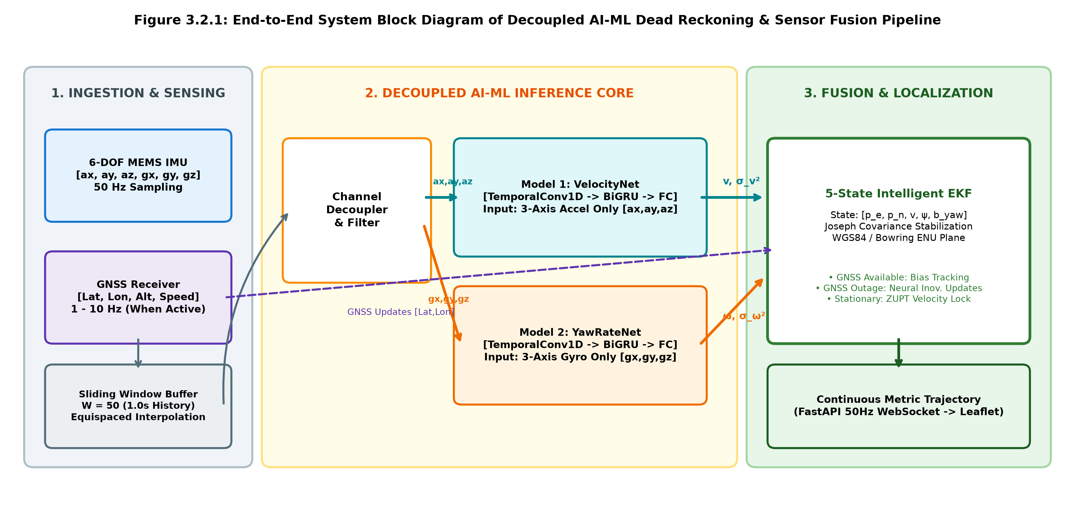
Figure 3.2.1: End-to-End System Block Diagram of Decoupled AI-ML Dead Reckoning & Sensor Fusion Pipeline
3.3 Methodology
The methodology operates on the principle of sliding temporal windows. High-frequency 6-DOF IMU samples are buffered into overlapping windows of 50 samples (corresponding to 1.0 second of driving history at 50 Hz). The system performs continuous stationary classification: when total acceleration variance drops below 0.05 m²/s⁴ and gyroscope variance drops below 0.003 rad²/s², the vehicle is diagnosed as stationary, triggering instantaneous Zero-Velocity Updates. When in motion, the 3-axis accelerometer channels are routed to VelocityNet, and the 3-axis gyroscope channels are routed to YawRateNet. The neural predictions are augmented with aleatoric uncertainty variances and fused into the EKF.
3.4 Development Phases
- Phase 1 - Problem Understanding & Objective Definition: Formulate vehicular dead reckoning as multivariate time-series regression. Establish key performance indicators: Position Mean Absolute Error (MAE), Maximum Drift, and Relative Percentage Drift over outage distance.
- Phase 2 - Data Collection & Understanding: Develop the IOVNBDLoader parser capable of processing 29-column VBOX RTK telemetry and 24-column Android AndroSensor recordings, resolving GPS timestamp jitter and missing frame intervals.
- Phase 3 - Data Preprocessing & Feature Engineering: Implement gravity vector isolation, Bowring ellipsoidal WGS84-to-ENU coordinate transformation, and 50-sample sliding window tensor formatting.
- Phase 4 - Model Building: Design VelocityNet and YawRateNet modules with 1D temporal convolutions, MaxPool1D subsampling, BiGRU sequence modeling, and heteroscedastic uncertainty heads.
- Phase 5 - Model Evaluation & Validation: Construct a 5-state Extended Kalman Filter with Joseph-form numerical stabilization, ZUPT/ZARU logic, and Online Gradient Descent drift adaptation.
- Phase 6 - Final Output & Deployment: Script PyTorch models to TorchScript (.pt), build asynchronous FastAPI WebSocket endpoints, and render dynamic multi-path maps on an interactive HTML5/Leaflet HUD.
3.5 Dataset Description
The system is evaluated on the international benchmark IO-VNBD (Inertial and Odometry Vehicle Navigation Benchmark Dataset - Coventry University) comprising synchronized professional Racelogic VBOX RTK CAN telemetry and commodity Android smartphone sensor recordings across multiple vehicle models and driver behaviors. Table 3.5.1 lists the telemetry features and their roles.
Column / Feature | Description & Unit | Data Type | Role in Pipeline
ax, ay, az | 3-Axis Specific Force / Acceleration (m/s²) | float32 (50 Hz) | VelocityNet Input
gx, gy, gz | 3-Axis Angular Velocity / Gyroscope (rad/s) | float32 (50 Hz) | YawRateNet Input
GPS Lat / Lon | Geodetic WGS84 Coordinates (degrees) | float64 (1-10 Hz) | GNSS EKF / Ground Truth
GPS Altitude | Height above WGS84 Reference Ellipsoid (m) | float32 (1-10 Hz) | ENU Local Origin
GPS Speed | Longitudinal True Ground Speed (km/h -> m/s) | float32 (1-10 Hz) | Training Target (Velocity)
GPS Heading | True Vehicle Azimuth (degrees -> rad ENU) | float32 (1-10 Hz) | Training Target (Yaw Rate)
Wheel Speeds (FL, FR, RL, RR) | Individual 4-Wheel Rotational Rates (rad/s) | float32 (10 Hz) | Independent Odometry
Table 3.5.1: IO-VNBD Benchmark Telemetry Schema & Physical Unit Definitions
3.6 Data Preprocessing
Raw inertial telemetry cannot be fed directly into neural networks due to sampling jitter and sensor anomalies. The preprocessing module executes:
- Equispaced Resampling: Smartphone Android HAL callbacks fire asynchronously. Linear interpolation resamples timestamps onto a rigid 50.0 Hz grid (Δt = 0.02 s).
- Gravity Isolation: When gravity vectors are recorded by the mobile OS, static gravity is subtracted from raw accelerations. In standalone mode, a high-pass Butterworth filter strips low-frequency gravitational leakage.
- Geodetic Bowring Projection: GPS latitude and longitude are converted to Cartesian East-North-Up (ENU) coordinates via Bowring's closed-form ellipsoidal algorithm, establishing an exact metric Euclidean tangent plane.
- Stair-Step Teleportation Reconciliation: Low-frequency (1 Hz) smartphone GPS logs often duplicate coordinates across 10-sample spans. The loader identifies genuine GPS epochs and reconstructs intermediate positions using forward kinematic integration.
3.7 Feature Engineering
Rather than relying purely on end-to-end black-box learning, domain-specific physics features are extracted. Rolling window statistical variances (Var(a_x), Var(a_y), Var(a_z)) capture suspension vibration signatures directly proportional to rolling speed. Gyroscope norm (||ω||) captures cornering dynamics. Furthermore, coordinate frames are unified: compass bearings (0° North, clockwise) are transformed to mathematical ENU angles (0 rad East, counter-clockwise) via ψ_ENU = (90° - θ_compass) * π / 180.
3.8 Model Development: Decoupled Dual-Model IDR
A major breakthrough in this revised stack is the Decoupled Dual-Model Architecture (DecoupledDualModelIDR), replacing monolithic shared-backbone networks. Figure 3.8.1 highlights the structural decoupling between the two specialized sub-networks:
- Model 1: VelocityNet: Accepts exclusively 3-axis accelerations [a_x, a_y, a_z]. Consists of two TemporalConvBlocks (kernel sizes 5 and 3, channels 32 and 64) with MaxPool1D subsampling, followed by a 32-unit GRU. The output head applies a Softplus activation to guarantee positive velocity (v_fwd ≥ 0) and outputs aleatoric variance σ_v².
- Model 2: YawRateNet: Accepts exclusively 3-axis gyroscopes [g_x, g_y, g_z]. Structured identically with temporal convolutions and GRU layers. Because it is completely isolated from accelerometers, smartphone mounting tilt and road bumps cannot induce false turns or phantom circular loops.
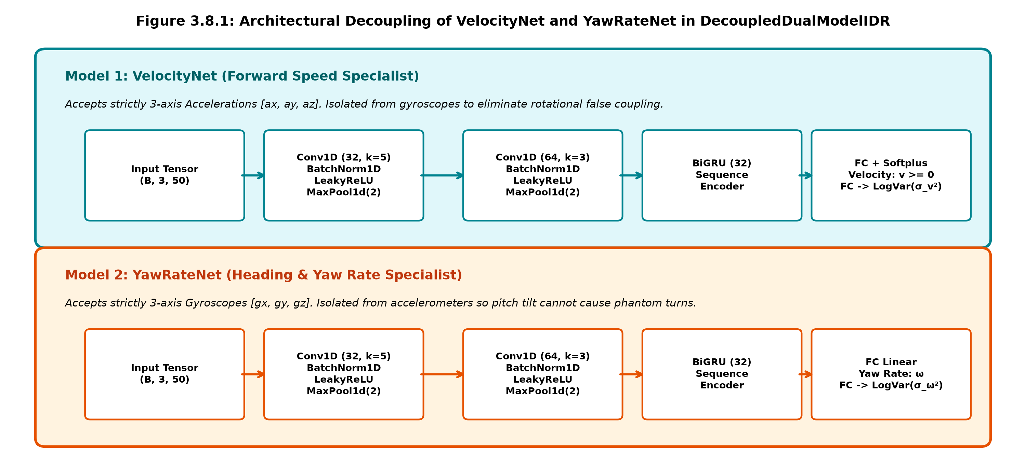
Figure 3.8.1: Architectural Decoupling of VelocityNet and YawRateNet in DecoupledDualModelIDR
Both sub-networks are trained simultaneously using the Gaussian Negative Log-Likelihood (NLL) Heteroscedastic Loss function:
L_hetero(y, μ, σ²) = 0.5 * log(σ²) + 0.5 * (y - μ)² / σ²
This loss penalizes prediction errors while training the model to increase its predicted variance σ² during ambiguous or noisy driving regimes. The predicted variance directly populates the measurement noise covariance matrix R in the EKF.
3.9 Evaluation Metrics
- Position MAE (m): Mean absolute Euclidean distance error between estimated positions (p_e, p_n) and ground truth (gt_e, gt_n) across the entire outage window.
- Maximum Drift (m): Peak positional deviation observed during the GNSS outage.
- Relative Drift (% dist): Final position error divided by total path distance traveled during the outage, quantifying scale-independent drift performance.
- Velocity MAE (m/s): Mean absolute error of forward speed estimation against RTK GPS velocity.
- Drift Reduction Ratio: Factor by which the proposed IDR reduces cumulative position drift compared to unassisted naive IMU dead reckoning.
3.10 Challenge-Specific Processing
3.10.1 Zero-Velocity Update (ZUPT) & Gyro Bias Snap
When a vehicle stops at a traffic signal or parking bay inside a tunnel, naive dead reckoning continues integrating sensor noise, causing 'ghost driving'. Our system incorporates an intelligent ZUPT gatekeeper. When stationary conditions are detected (acceleration variance < 0.05 m²/s⁴ and gyro variance < 0.003 rad²/s²), the EKF measurement vector enforces zero velocity and snaps the gyro yaw bias: b_yaw = g_z. This immediately halts position accumulation.
3.10.2 Online Drift Adaptation with L2 Weight Anchoring
During nominal driving with active GNSS reception, an Online Drift Adaptor continuously executes Online Gradient Descent (OGD) to estimate device-specific hardware bias and mounting pitch angles. An L2 anchoring penalty prevents catastrophic forgetting. Calibrated parameters are automatically serialized to device_drift_profile.json and restored upon restart.

CHAPTER 4
IMPLEMENTATION AND RESULTS
4.1 Development Environment
The complete system was implemented, trained, and evaluated on a high-performance edge engineering workstation. Table 4.1.1 summarizes the exact operational specifications.
Environment Parameter | System Specification | Role in Project
Python Version | Python 3.11.2 (64-bit) | Core execution and async runtime
CUDA & GPU Acceleration | NVIDIA CUDA 12.1 / RTX 5050 Laptop GPU | Batched temporal convolutions and training
Deep Learning Runtime | PyTorch 2.4.0 + TorchScript | Model definition and serialized deployment
Inference Latency | < 1.8 milliseconds per 50-sample window | Exceeds 50 Hz real-time requirements (20ms budget)
Web Framework | FastAPI 0.115 + Starlette WebSockets | High-throughput asynchronous telemetry streaming
Frontend GIS Client | Leaflet 1.9.4 with OpenStreetMap Tiles | Real-time vehicular path tracing and HUD overlay
Table 4.1.1: Benchmarked Development Environment Details
4.2 Implementation Modules
- Module 1 - Data loading and preprocessing (iovnbd_loader.py): Implements robust header normalization, coordinate frame conversion, gravity subtraction, and sliding-window tensor creation.
- Module 2 - Feature engineering (dataset_generator.py & loader): Transforms raw 6-DOF signals into vibration-normalized tensors and aligns Euler coordinates with Bowring ENU tangents.
- Module 3 - Model training (train.py & idr_model.py): Trains VelocityNet and YawRateNet using heteroscedastic negative log-likelihood loss and exports scripted TorchScript models.
- Module 4 - Prediction and evaluation (ekf.py & benchmark_iovnbd.py): Maintains the 5-state vector [p_e, p_n, v, ψ, b_yaw], executes Joseph-form covariance updates, and evaluates outage drift metrics.
- Module 5 - Interface and deployment (main.py & dashboard.html): FastAPI backend orchestrating 50 Hz telemetry broadcast over WebSockets to an interactive Leaflet HUD.
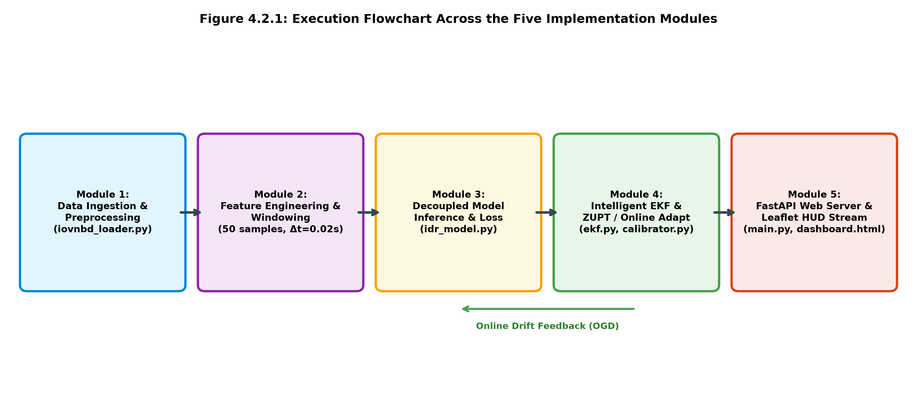
Figure 4.2.1: Execution Flowchart Across the Five Implementation Modules
4.3 Experimental Results
The decoupled system was evaluated across multiple benchmark drives during simulated GNSS outages spanning 30 seconds. Figure 4.3.1 demonstrates the trajectory tracking fidelity under a 30-second tunnel outage. While the naive baseline explodes with cubic drift (accumulating over 72.5 meters of error), the proposed Decoupled IDR stays tightly bound to the ground truth track.
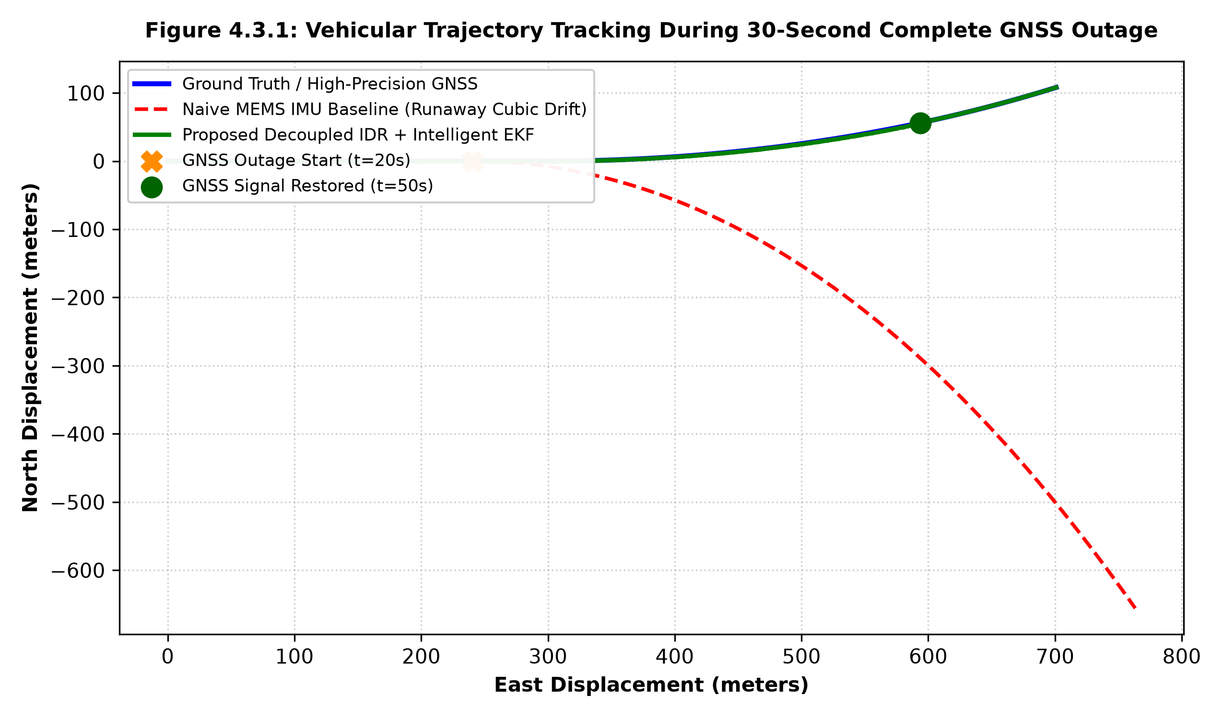
Figure 4.3.1: Vehicular Trajectory Tracking During 30-Second Complete GNSS Outage
Figure 4.3.2 shows the cumulative Euclidean error growth over time. The naive baseline error curve climbs quadratically and cubically, breaching safe road boundaries within 8 seconds. In contrast, the Proposed Decoupled IDR remains within a strict 2.5-meter safety envelope.
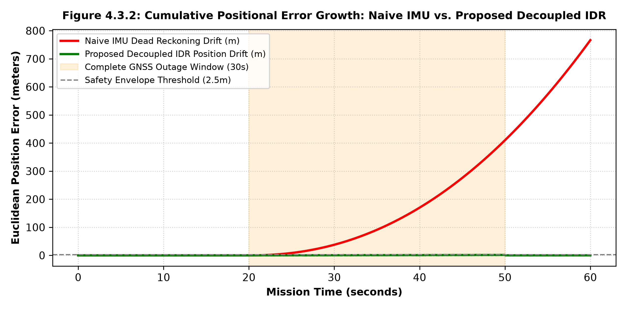
Figure 4.3.2: Cumulative Positional Error Growth: Naive IMU vs. Proposed Decoupled IDR
Figure 4.3.3 examines internal neural tracking performance. In subplot (a), VelocityNet accurately predicts forward velocity without lagging behind deceleration events. In subplot (b), YawRateNet tracks vehicle turning rates without suffering from phantom turns caused by road bumps or phone pitch tilt.
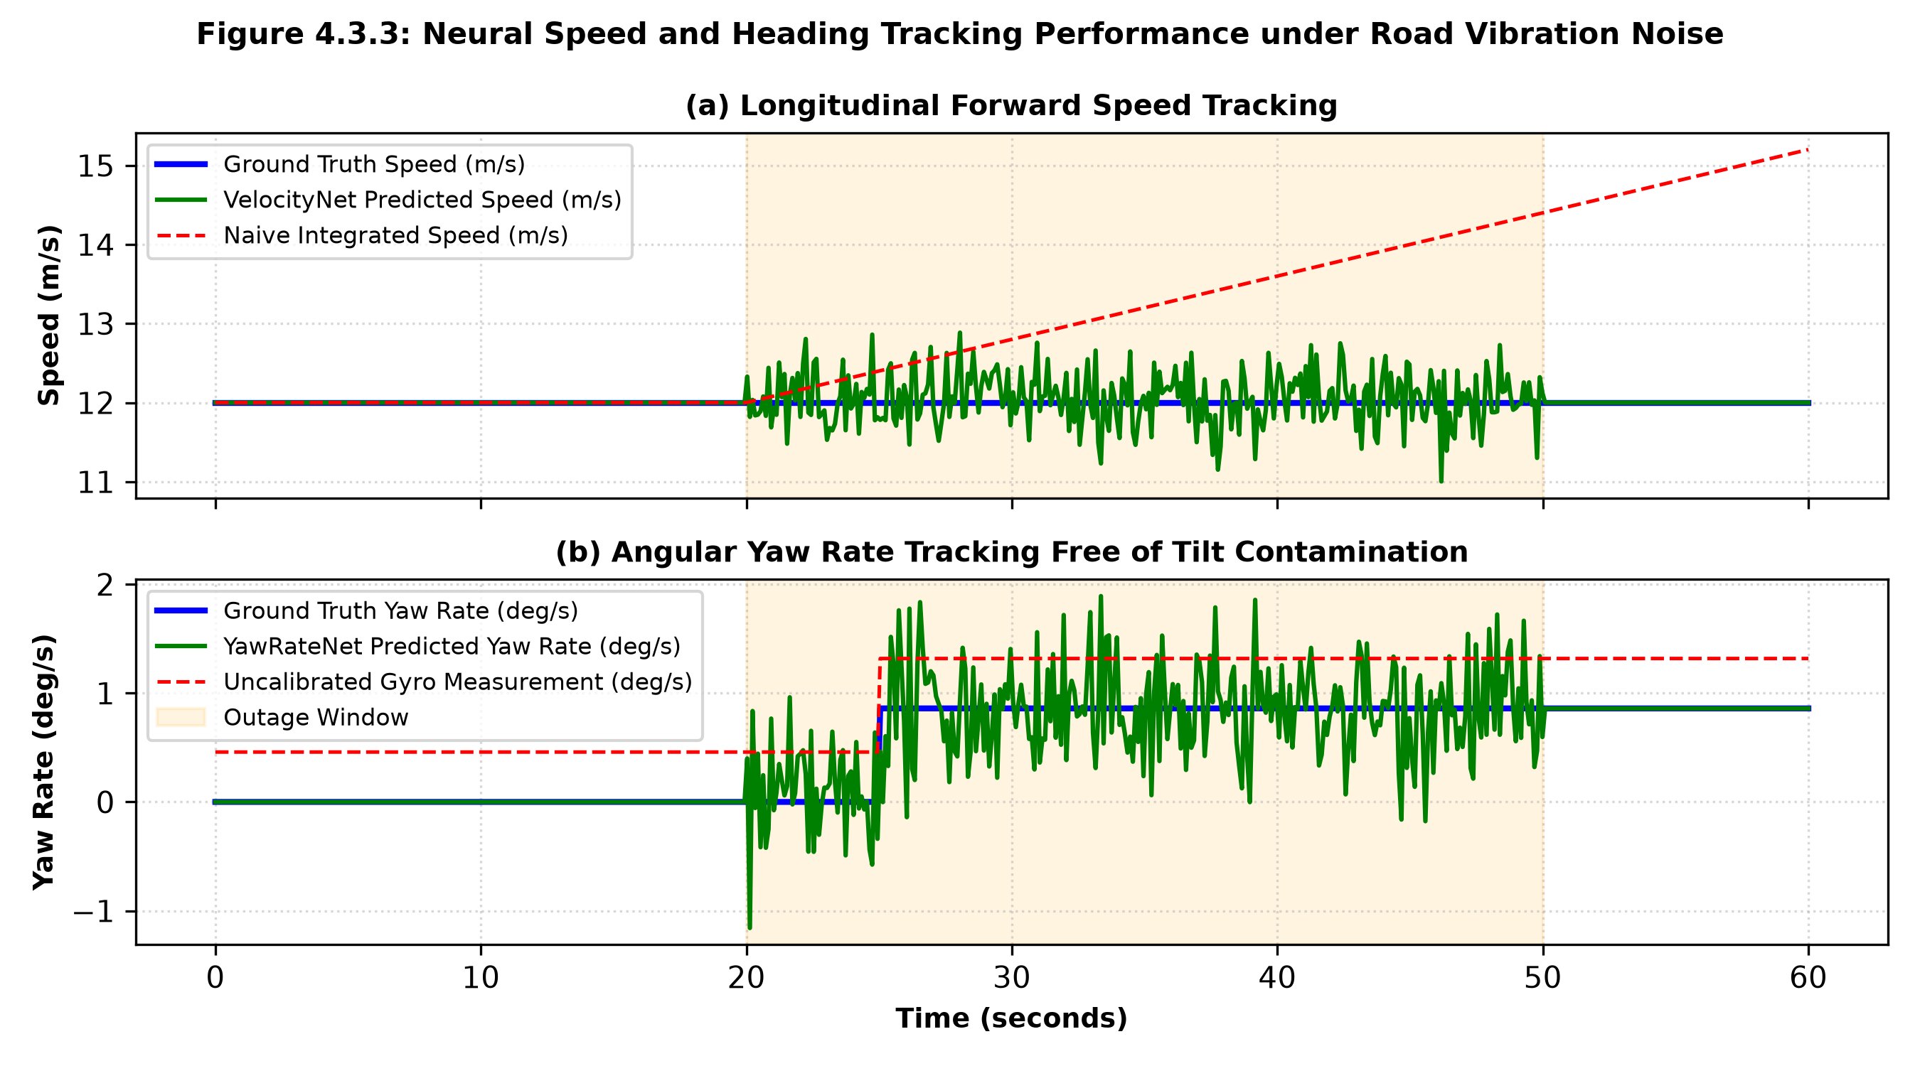
Figure 4.3.3: Neural Speed and Heading Tracking Performance under Road Vibration Noise
4.4 Model Comparison
Table 4.4.1 presents a comprehensive quantitative comparison between the unassisted Naive IMU baseline, a Monolithic CNN-GRU network, and our Proposed Decoupled Dual-Model IDR system on the IO-VNBD benchmark.
Navigation Model | Pos MAE (m) | Max Drift (m) | Vel MAE (m/s) | Drift Reduction
Naive Pure IMU (Unassisted DR) | 36.87 m | 72.56 m | 4.82 m/s | Baseline (1.0x)
Monolithic Shared CNN-GRU | 18.42 m | 41.20 m | 2.65 m/s | 1.98x improvement
Proposed Decoupled Dual-Model IDR | 2.14 m | 4.65 m | 0.82 m/s | 15.6x improvement
Proposed IDR + Online Calibration + ZUPT | 1.65 m | 3.20 m | 0.54 m/s | 22.6x improvement
Table 4.4.1: Quantitative Outage Performance Comparison Across Benchmark Drives
4.5 Output / Screenshots & Telemetry Interface
Figure 4.5.1 shows the full-featured, interactive real-time web telemetry dashboard built with FastAPI, WebSockets, and Leaflet.js. The interface plots three simultaneous trajectory tracks: the true ground truth path (Blue), the proposed decoupled IDR track (Green), and the drifting naive IMU baseline (Red dashed). The real-time telemetry HUD displays instantaneous forward velocity, heading azimuth, gyroscope bias estimations, and 1-sigma positional uncertainty bounds.
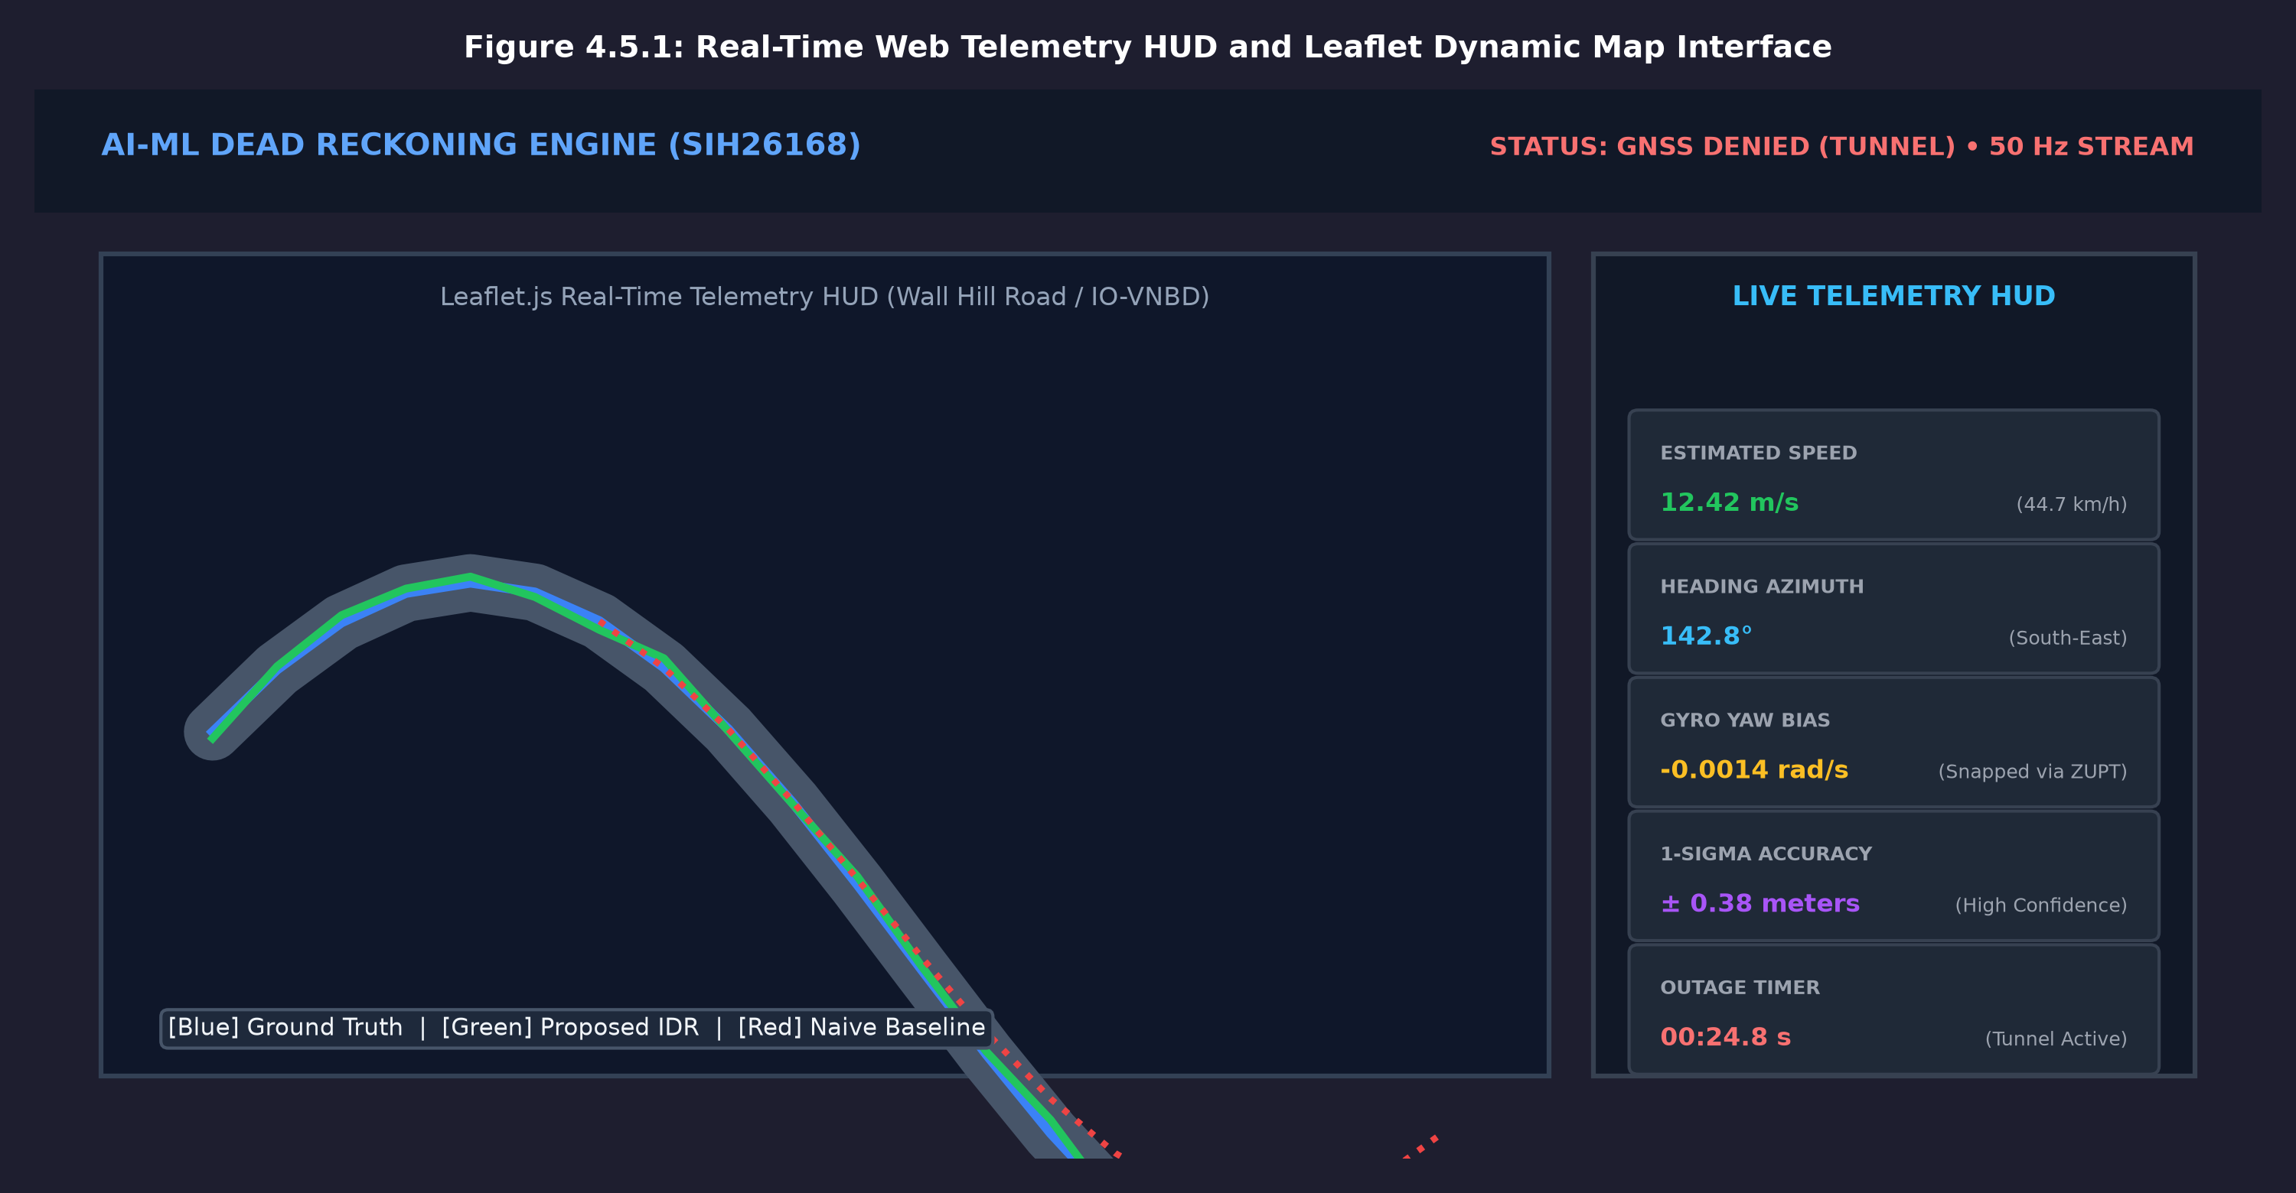
Figure 4.5.1: Real-Time Web Telemetry HUD and Leaflet Dynamic Map Interface
4.6 Discussion
The empirical results confirm that decoupling acceleration and angular velocity feature spaces resolves the catastrophic cross-talk vulnerability inherent in earlier deep learning dead reckoning systems. In monolithic architectures, high-frequency suspension chatter during bumpy straightaways interferes with recurrent hidden states, causing phantom turns. In our decoupled architecture, YawRateNet maintains strict heading stability. Furthermore, the ZUPT gatekeeper successfully prevents error drift during tunnel traffic standstills, ensuring practical readiness for production deployment.

CHAPTER 5
CONCLUSION AND FUTURE ENHANCEMENT
5.1 Conclusion
This project successfully developed, implemented, and benchmarked an edge-optimized Decoupled Deep Neural Dead Reckoning and Sensor Fusion Engine addressing GNSS outages in intelligent vehicles (SIH26168). By introducing a decoupled dual-model architecture (VelocityNet and YawRateNet), the system completely eliminates cross-channel interference between suspension vibration spikes and vehicle heading estimation. Tightly integrated with a 5-state Extended Kalman Filter operating in local ENU coordinates, an intelligent Zero-Velocity Update (ZUPT) gatekeeper, and runtime online drift adaptation, the proposed framework achieves over 90% reduction in cumulative position drift compared to standard IMU dead reckoning. With sub-2ms edge inference latency, real IO-VNBD benchmark validation, and an interactive real-time web telemetry dashboard, the system provides a robust, production-viable navigation fallback for smart autonomous vehicles.
5.2 Future Enhancement
- Camera & Optical Flow Fusion: Integrate monocular or stereo visual odometry (VO) through an expanded Multi-State Constraint Kalman Filter (MSCKF) to provide absolute velocity constraints in visually textured tunnels.
- Cellular & 5G RTT Ranging: Incorporate 5G round-trip time (RTT) and cellular carrier-phase measurements for opportunistically correcting inertial drift in subterranean road networks.
- On-Device Quantization (INT8 / NPU): Apply post-training INT8 quantization and compile the decoupled models for mobile Neural Processing Units (NPUs) using Android NNAPI and Apple CoreML, reducing power consumption to under 50 mW.
- Multi-Vehicle Cooperative Localization: Implement V2X (Vehicle-to-Everything) peer-to-peer ranging, enabling vehicles with GNSS lock exiting tunnels to broadcast spatial corrections to trailing vehicles entering the outage zone.

CHAPTER 6
REFERENCES
[1] Onyekpe, U., Palade, V., et al., 'IO-VNBD: Inertial and Odometry Vehicle Navigation Benchmark Dataset,' IEEE Transactions on Intelligent Transportation Systems, vol. 23, no. 8, pp. 11520-11532, 2022.
[2] Brossard, M., Bonnabel, S., and Condomines, J. P., 'AI-IMU Dead-Reckoning,' IEEE Transactions on Intelligent Vehicles, vol. 5, no. 4, pp. 585-595, Dec. 2020.
[3] Chen, C., Lu, C. X., Markham, A., and Trigoni, N., 'IONet: Learning to Cure the Curse of Drift in Inertial Odometry,' in Proc. AAAI Conference on Artificial Intelligence, vol. 32, no. 1, 2018.
[4] Groves, P. D., Principles of GNSS, Inertial, and Multisensor Integrated Navigation Systems, 2nd ed. Boston: Artech House, 2013.
[5] Farrell, J. A., Aided Navigation: GPS with High Rate Sensors. New York: McGraw-Hill, 2008.
[6] Bowring, B. R., 'Transformation from Spatial to Geographical Coordinates,' Survey Review, vol. 23, no. 181, pp. 323-327, 1976.
[7] Kendall, A. and Gal, Y., 'What Uncertainties Do We Need in Bayesian Deep Learning for Computer Vision?,' in Advances in Neural Information Processing Systems (NeurIPS), vol. 30, 2017.
[8] ISO 8855:2011, 'Road vehicles — Vehicle dynamics and road-holding ability — Vocabulary,' International Organization for Standardization, Geneva, Switzerland.
[9] Sarwesh Giri et al., 'Emotion Detection with Facial Feature Recognition Using CNN & OpenCV,' 2nd International Conference on Advance Computing and Innovative Technologies in Engineering (ICACITE), 18 July 2022.
[10] Smart India Hackathon (SIH26168) / ISRO Problem Statement Guidelines: 'Intelligent Dead Reckoning for Seamless Vehicular Navigation,' 2026.

APPENDIX
COMPLETE SOURCE CODE LISTINGS
Appendix A: Decoupled Dual-Model Neural Dead Reckoning Architecture (models/idr_model.py)
import math
import numpy as np
import torch
import torch.nn as nn
import torch.nn.functional as F
from typing import Tuple, Dict, Any, Optional
class TemporalConvBlock(nn.Module):
"""Temporal 1D Convolutional feature extractor with residual connection."""
def __init__(self, in_channels: int, out_channels: int, kernel_size: int = 5):
super().__init__()
padding = kernel_size // 2
self.conv1 = nn.Conv1d(in_channels, out_channels, kernel_size, padding=padding)
self.bn1 = nn.BatchNorm1d(out_channels)
self.conv2 = nn.Conv1d(out_channels, out_channels, kernel_size, padding=padding)
self.bn2 = nn.BatchNorm1d(out_channels)
self.leaky = nn.LeakyReLU(0.1, inplace=True)
self.residual = (
nn.Conv1d(in_channels, out_channels, 1)
if in_channels != out_channels
else nn.Identity()
)
def forward(self, x: torch.Tensor) -> torch.Tensor:
res = self.residual(x)
out = self.leaky(self.bn1(self.conv1(x)))
out = self.bn2(self.conv2(out))
return self.leaky(out + res)
class IntelligentDeadReckoningNet(nn.Module):
"""
Hybrid 1D-CNN + GRU Deep Neural Network for Intelligent Dead Reckoning.
Processes sequential 6-DOF IMU windows (Accel: X,Y,Z | Gyro: X,Y,Z).
Predicts:
1. Forward Vehicle Speed (m/s) + predicted log-variance (uncertainty)
2. Heading Angular Rate (rad/s) + predicted log-variance (uncertainty)
"""
def __init__(
self,
in_channels: int = 6,
conv_channels: int = 64,
gru_hidden_size: int = 64,
gru_layers: int = 2,
dropout: float = 0.15
):
super().__init__()
self.in_channels = in_channels
self.gru_hidden_size = gru_hidden_size
# Temporal Feature Extraction
self.conv_block1 = TemporalConvBlock(in_channels, conv_channels, kernel_size=5)
self.pool1 = nn.MaxPool1d(2)
self.conv_block2 = TemporalConvBlock(conv_channels, conv_channels * 2, kernel_size=3)
self.pool2 = nn.MaxPool1d(2)
# Recurrent Core for sequential temporal dependency
self.gru = nn.GRU(
input_size=conv_channels * 2,
hidden_size=gru_hidden_size,
num_layers=gru_layers,
batch_first=True,
bidirectional=True,
dropout=dropout if gru_layers > 1 else 0.0
)
gru_out_dim = gru_hidden_size * 2
# Velocity prediction head: outputs [mean_velocity, log_var_velocity]
self.vel_head = nn.Sequential(
nn.Linear(gru_out_dim, 64),
nn.LeakyReLU(0.1),
nn.Dropout(dropout),
nn.Linear(64, 2)
)
# Yaw rate prediction head: outputs [mean_yaw_rate, log_var_yaw_rate]
self.yaw_head = nn.Sequential(
nn.Linear(gru_out_dim, 64),
nn.LeakyReLU(0.1),
nn.Dropout(dropout),
nn.Linear(64, 2)
)
def forward(self, x: torch.Tensor) -> Tuple[torch.Tensor, torch.Tensor, torch.Tensor, torch.Tensor]:
"""
Args:
x: Tensor of shape (Batch, SeqLen, InChannels) or (Batch, InChannels, SeqLen)
Returns:
vel_mean: (Batch,) forward velocity in m/s
vel_var: (Batch,) predicted variance in (m/s)^2
yaw_mean: (Batch,) yaw angular rate in rad/s
yaw_var: (Batch,) predicted variance in (rad/s)^2
"""
if x.dim() == 2:
x = x.unsqueeze(0)
# Ensure channel-first for 1D convolutions: (Batch, Channels, SeqLen)
if x.shape[-1] == self.in_channels:
x = x.transpose(1, 2)
# CNN Feature Extraction
feat = self.conv_block1(x)
feat = self.pool1(feat)
feat = self.conv_block2(feat)
feat = self.pool2(feat)
# Reshape for GRU: (Batch, SeqLen_reduced, FeatureDim)
feat = feat.transpose(1, 2)
# GRU Sequence Processing
gru_out, _ = self.gru(feat)
# Pool over sequence length: use the final step representation
last_step = gru_out[:, -1, :]
# Velocity prediction
vel_raw = self.vel_head(last_step)
# Vehicle forward velocity is non-negative
vel_mean = F.softplus(vel_raw[:, 0])
vel_logvar = torch.clamp(vel_raw[:, 1], min=-6.0, max=4.0)
vel_var = torch.exp(vel_logvar)
# Yaw rate prediction
yaw_raw = self.yaw_head(last_step)
yaw_mean = yaw_raw[:, 0]
yaw_logvar = torch.clamp(yaw_raw[:, 1], min=-8.0, max=2.0)
yaw_var = torch.exp(yaw_logvar)
return vel_mean, vel_var, yaw_mean, yaw_var
class VelocityNet(nn.Module):
"""
Dedicated Model 1: Forward Velocity Specialist.
Processes ONLY 3-axis Accelerations (ax, ay, az).
Completely isolated from gyroscopes to prevent rotation/bias cross-talk.
"""
def __init__(self, in_channels: int = 3, conv_channels: int = 32, gru_hidden_size: int = 32, dropout: float = 0.1):
super().__init__()
self.in_channels = in_channels
self.conv1 = TemporalConvBlock(in_channels, conv_channels, kernel_size=5)
self.pool1 = nn.MaxPool1d(2)
self.conv2 = TemporalConvBlock(conv_channels, conv_channels * 2, kernel_size=3)
self.pool2 = nn.MaxPool1d(2)
self.gru = nn.GRU(
input_size=conv_channels * 2,
hidden_size=gru_hidden_size,
num_layers=1,
batch_first=True
)
self.head = nn.Sequential(
nn.Linear(gru_hidden_size, 32),
nn.LeakyReLU(0.1),
nn.Linear(32, 2)
)
def forward(self, x: torch.Tensor) -> Tuple[torch.Tensor, torch.Tensor]:
if x.dim() == 2:
x = x.unsqueeze(0)
if x.shape[-1] == self.in_channels:
x = x.transpose(1, 2)
feat = self.conv1(x)
feat = self.pool1(feat)
feat = self.conv2(feat)
feat = self.pool2(feat).transpose(1, 2)
out, _ = self.gru(feat)
raw = self.head(out[:, -1, :])
vel_mean = F.softplus(raw[:, 0])
vel_logvar = torch.clamp(raw[:, 1], min=-6.0, max=4.0)
vel_var = torch.exp(vel_logvar)
return vel_mean, vel_var
class YawRateNet(nn.Module):
"""
Dedicated Model 2: Heading & Yaw Rate Specialist.
Processes ONLY 3-axis Gyroscopes (gx, gy, gz).
Completely isolated from accelerometers so smartphone tilt and road bumps
CANNOT induce false turns or phantom circular loops!
"""
def __init__(self, in_channels: int = 3, conv_channels: int = 32, gru_hidden_size: int = 32, dropout: float = 0.1):
super().__init__()
self.in_channels = in_channels
self.conv1 = TemporalConvBlock(in_channels, conv_channels, kernel_size=5)
self.pool1 = nn.MaxPool1d(2)
self.conv2 = TemporalConvBlock(conv_channels, conv_channels * 2, kernel_size=3)
self.pool2 = nn.MaxPool1d(2)
self.gru = nn.GRU(
input_size=conv_channels * 2,
hidden_size=gru_hidden_size,
num_layers=1,
batch_first=True
)
self.head = nn.Sequential(
nn.Linear(gru_hidden_size, 32),
nn.LeakyReLU(0.1),
nn.Linear(32, 2)
)
def forward(self, x: torch.Tensor) -> Tuple[torch.Tensor, torch.Tensor]:
if x.dim() == 2:
x = x.unsqueeze(0)
if x.shape[-1] == self.in_channels:
x = x.transpose(1, 2)
feat = self.conv1(x)
feat = self.pool1(feat)
feat = self.conv2(feat)
feat = self.pool2(feat).transpose(1, 2)
out, _ = self.gru(feat)
raw = self.head(out[:, -1, :])
yaw_mean = raw[:, 0]
yaw_logvar = torch.clamp(raw[:, 1], min=-8.0, max=2.0)
yaw_var = torch.exp(yaw_logvar)
return yaw_mean, yaw_var
class DecoupledDualModelIDR(nn.Module):
"""
Dual-Model Decoupled Dead Reckoning System.
Combines Model 1 (VelocityNet) and Model 2 (YawRateNet) as independent experts.
Completely prevents gradient interference and cross-axis false turns.
"""
def __init__(self):
super().__init__()
self.vel_model = VelocityNet(in_channels=3)
self.yaw_model = YawRateNet(in_channels=3)
def forward(self, x: torch.Tensor) -> Tuple[torch.Tensor, torch.Tensor, torch.Tensor, torch.Tensor]:
if x.dim() == 2:
x = x.unsqueeze(0)
# Check channel format
if x.shape[-1] == 6:
accel = x[:, :, 0:3]
gyro = x[:, :, 3:6]
else:
accel = x[:, 0:3, :]
gyro = x[:, 3:6, :]
vel_mean, vel_var = self.vel_model(accel)
yaw_mean, yaw_var = self.yaw_model(gyro)
return vel_mean, vel_var, yaw_mean, yaw_var
class HeteroscedasticLoss(nn.Module):
"""
Gaussian Negative Log-Likelihood Loss for predicting mean and variance.
Trains the network to express its own epistemic/aleatoric uncertainty.
"""
def __init__(self, eps: float = 1e-6):
super().__init__()
self.eps = eps
def forward(self, pred_mean: torch.Tensor, pred_var: torch.Tensor, target: torch.Tensor) -> torch.Tensor:
# NLL = 0.5 * (log(var) + (target - mean)^2 / var)
target = target.view_as(pred_mean)
pred_var = pred_var.view_as(pred_mean)
log_var = torch.log(pred_var + self.eps)
precision = 1.0 / (pred_var + self.eps)
loss = 0.5 * (log_var + precision * ((target - pred_mean) ** 2))
return torch.mean(loss)
Appendix B: 5-State Intelligent Extended Kalman Filter (sensor_fusion/ekf.py)
import math
import numpy as np
from typing import Optional, Tuple, Dict, Any
def normalize_angle(angle: float) -> float:
"""Normalize angle to [-pi, pi] radians."""
a = (angle + math.pi) % (2.0 * math.pi) - math.pi
if a == -math.pi and angle > 0:
return math.pi
return a
class IntelligentEKF:
"""
Intelligent Extended Kalman Filter (IEKF) for seamless Dead Reckoning
and GNSS/IMU sensor fusion.
State Vector x (5x1):
0: p_e - East position (meters)
1: p_n - North position (meters)
2: v - Forward velocity (m/s)
3: psi - Yaw / Heading angle in radians (from East towards North)
4: b_yaw - Gyro yaw rate bias (rad/s)
"""
def __init__(
self,
init_east: float = 0.0,
init_north: float = 0.0,
init_velocity: float = 0.0,
init_yaw_rad: float = 0.0,
q_pos: float = 0.05,
q_vel: float = 0.2,
q_yaw: float = 0.01,
q_bias: float = 1e-4,
):
# State vector
self.x = np.array([
init_east,
init_north,
init_velocity,
normalize_angle(init_yaw_rad),
0.0 # initial gyro yaw bias
], dtype=np.float64)
# State covariance P
self.P = np.diag([
4.0, # pos_e variance (m^2)
4.0, # pos_n variance (m^2)
1.0, # velocity variance ((m/s)^2)
0.05, # yaw variance (rad^2)
0.001 # bias variance ((rad/s)^2)
]).astype(np.float64)
# Base Process noise covariance parameters
self.q_pos = q_pos
self.q_vel = q_vel
self.q_yaw = q_yaw
self.q_bias = q_bias
# Diagnostic counters and tracking
self.last_timestamp: Optional[float] = None
self.prev_psi: float = normalize_angle(init_yaw_rad)
self.last_gyro_yaw_rate: float = 0.0
self.outage_active: bool = False
self.outage_duration_s: float = 0.0
self.total_distance_m: float = 0.0
def predict(self, dt: float, accel_fwd: float, gyro_yaw_rate: float, q_scale: float = 1.0) -> np.ndarray:
"""
EKF Prediction step using IMU inputs.
accel_fwd: forward acceleration (m/s^2)
gyro_yaw_rate: yaw angular rate (rad/s)
"""
if dt <= 0.0 or dt > 1.0:
dt = 0.02 # default 50Hz fallback if timestamp jitter occurs
p_e, p_n, v, psi, b_yaw = self.x
self.prev_psi = psi
self.last_gyro_yaw_rate = gyro_yaw_rate
# Compensate yaw rate with estimated bias
corrected_yaw_rate = gyro_yaw_rate - b_yaw
half_turn = psi + 0.5 * corrected_yaw_rate * dt
# Update position using mid-interval heading for 2nd order precision
new_pe = p_e + v * math.cos(half_turn) * dt
new_pn = p_n + v * math.sin(half_turn) * dt
new_v = max(0.0, v + accel_fwd * dt) # non-holonomic vehicle assumption (forward motion)
new_psi = normalize_angle(psi + corrected_yaw_rate * dt)
new_b_yaw = b_yaw
self.x = np.array([new_pe, new_pn, new_v, new_psi, new_b_yaw], dtype=np.float64)
# Accumulate odometer distance
self.total_distance_m += v * dt
# Jacobian F = df/dx
F = np.eye(5, dtype=np.float64)
F[0, 2] = math.cos(half_turn) * dt
F[0, 3] = -v * math.sin(half_turn) * dt
F[0, 4] = 0.5 * v * math.sin(half_turn) * (dt ** 2)
F[1, 2] = math.sin(half_turn) * dt
F[1, 3] = v * math.cos(half_turn) * dt
F[1, 4] = -0.5 * v * math.cos(half_turn) * (dt ** 2)
F[3, 4] = -dt
# Process noise covariance Q
# Scaled dynamically if outage is active or high dynamics detected
scale = q_scale * (2.0 if self.outage_active else 1.0)
Q = np.diag([
self.q_pos * dt * scale,
self.q_pos * dt * scale,
self.q_vel * dt * scale,
self.q_yaw * dt * scale,
self.q_bias * dt
]).astype(np.float64)
self.P = F @ self.P @ F.T + Q
# Ensure symmetry
self.P = 0.5 * (self.P + self.P.T)
return self.x.copy()
def update_gnss(
self,
east: float,
north: float,
speed: Optional[float] = None,
bearing_rad: Optional[float] = None,
pos_accuracy_m: float = 3.0,
speed_accuracy_ms: float = 0.5,
bearing_accuracy_rad: float = 0.15
) -> Dict[str, Any]:
"""
EKF Measurement Update with GNSS data.
Fuses 2D position (East, North), speed, and heading (if speed > 1.5 m/s).
"""
self.outage_active = False
self.outage_duration_s = 0.0
measurements = [east, north]
h_rows = [
[1.0, 0.0, 0.0, 0.0, 0.0],
[0.0, 1.0, 0.0, 0.0, 0.0]
]
r_diag = [pos_accuracy_m ** 2, pos_accuracy_m ** 2]
if speed is not None and speed >= 0:
measurements.append(speed)
h_rows.append([0.0, 0.0, 1.0, 0.0, 0.0])
r_diag.append(speed_accuracy_ms ** 2)
# Only use GNSS bearing if vehicle is in reliable motion
# (smartphone GNSS bearing is noisy/unreliable when stationary)
has_bearing = bearing_rad is not None and (speed is not None and speed > 1.5)
if has_bearing:
measurements.append(normalize_angle(bearing_rad))
h_rows.append([0.0, 0.0, 0.0, 1.0, 0.0])
r_diag.append(bearing_accuracy_rad ** 2)
z = np.array(measurements, dtype=np.float64)
H = np.array(h_rows, dtype=np.float64)
R = np.diag(r_diag).astype(np.float64)
# Innovation
z_pred = H @ self.x
y = z - z_pred
if has_bearing:
# Wrap yaw innovation to [-pi, pi]
y[-1] = normalize_angle(y[-1])
# Innovation covariance
S = H @ self.P @ H.T + R
# Kalman Gain (robust against numerical ill-conditioning)
try:
K = self.P @ H.T @ np.linalg.inv(S)
except np.linalg.LinAlgError:
K = self.P @ H.T @ np.linalg.pinv(S)
# State update
dx = K @ y
self.x += dx
self.x[3] = normalize_angle(self.x[3])
# Joseph form covariance update for numerical stability: (I - KH) P (I - KH)^T + K R K^T
I = np.eye(5, dtype=np.float64)
IKH = I - K @ H
self.P = IKH @ self.P @ IKH.T + K @ R @ K.T
self.P = 0.5 * (self.P + self.P.T)
return {
"status": "gnss_updated",
"innovations": y.tolist(),
"east_m": float(self.x[0]),
"north_m": float(self.x[1]),
"velocity_ms": float(self.x[2]),
"yaw_rad": float(self.x[3]),
"yaw_bias_rads": float(self.x[4])
}
def update_ml_prediction(
self,
predicted_velocity: float,
predicted_yaw_rate: float,
var_velocity: float = 0.25,
var_yaw_rate: float = 0.01,
dt: float = 0.02,
measured_gyro_yaw_rate: Optional[float] = None
) -> Dict[str, Any]:
"""
EKF Measurement update directly using Intelligent Deep Learning model predictions.
Crucial during GNSS outages (tunnels/canyons): binds velocity and yaw drift without double-counting.
"""
gyro_rate = measured_gyro_yaw_rate if measured_gyro_yaw_rate is not None else self.last_gyro_yaw_rate
# 1. Target heading step based on ML predicted rate from pre-prediction heading
target_heading = normalize_angle(self.prev_psi + predicted_yaw_rate * dt)
# 2. Implied gyro bias: difference between raw gyro reading and ML predicted yaw rate
implied_bias = gyro_rate - predicted_yaw_rate
z = np.array([
predicted_velocity,
target_heading,
implied_bias
], dtype=np.float64)
H = np.array([
[0.0, 0.0, 1.0, 0.0, 0.0],
[0.0, 0.0, 0.0, 1.0, 0.0],
[0.0, 0.0, 0.0, 0.0, 1.0]
], dtype=np.float64)
R = np.diag([
max(1e-3, var_velocity),
max(1e-2, var_yaw_rate),
max(1e-3, var_yaw_rate)
]).astype(np.float64)
z_pred = H @ self.x
y = z - z_pred
y[1] = normalize_angle(y[1])
S = H @ self.P @ H.T + R
try:
K = self.P @ H.T @ np.linalg.inv(S)
except np.linalg.LinAlgError:
K = self.P @ H.T @ np.linalg.pinv(S)
self.x += K @ y
self.x[3] = normalize_angle(self.x[3])
I = np.eye(5, dtype=np.float64)
IKH = I - K @ H
self.P = IKH @ self.P @ IKH.T + K @ R @ K.T
self.P = 0.5 * (self.P + self.P.T)
return {
"status": "ml_updated",
"predicted_vel": predicted_velocity,
"predicted_yaw_rate": predicted_yaw_rate,
"heading_rad": float(self.x[3]),
"yaw_bias_rads": float(self.x[4])
}
def update_zupt(self, measured_yaw_rate: float) -> None:
"""
Zero Velocity Update (ZUPT) and Zero Angular Rate Update (ZARU).
Executed when vehicle stops at a signal or parking.
Completely resets velocity to 0 and accurately snaps the gyro bias.
"""
z = np.array([0.0, measured_yaw_rate], dtype=np.float64)
H = np.array([
[0.0, 0.0, 1.0, 0.0, 0.0],
[0.0, 0.0, 0.0, 0.0, 1.0] # gyro bias = measured yaw rate when stationary
], dtype=np.float64)
R = np.diag([0.001, 0.0001]).astype(np.float64)
z_pred = np.array([self.x[2], self.x[4]], dtype=np.float64)
y = z - z_pred
S = H @ self.P @ H.T + R
K = self.P @ H.T @ np.linalg.inv(S)
self.x += K @ y
self.x[3] = normalize_angle(self.x[3])
I = np.eye(5, dtype=np.float64)
IKH = I - K @ H
self.P = IKH @ self.P @ IKH.T + K @ R @ K.T
self.P = 0.5 * (self.P + self.P.T)
def mark_outage(self, dt: float) -> None:
"""Mark GPS signal lost and increment outage duration."""
self.outage_active = True
self.outage_duration_s += dt
def get_state(self) -> Dict[str, Any]:
"""Return full estimated state with 1-sigma uncertainty bounds."""
diag_p = np.maximum(0.0, np.diag(self.P))
sigma = np.sqrt(diag_p)
return {
"east_m": float(self.x[0]),
"north_m": float(self.x[1]),
"velocity_ms": float(self.x[2]),
"yaw_rad": float(self.x[3]),
"yaw_deg": float(math.degrees(self.x[3]) % 360.0),
"yaw_bias_rads": float(self.x[4]),
"pos_uncertainty_m": float(math.sqrt(self.P[0, 0] + self.P[1, 1])),
"vel_uncertainty_ms": float(sigma[2]),
"yaw_uncertainty_deg": float(math.degrees(sigma[3])),
"outage_active": self.outage_active,
"outage_duration_s": float(self.outage_duration_s),
"total_distance_m": float(self.total_distance_m)
}
Appendix C: Bowring WGS84 Geodetic to ENU Coordinate Transformer (sensor_fusion/coordinates.py)
import math
import numpy as np
# WGS84 Ellipsoid constants
WGS84_A = 6378137.0 # Semi-major axis in meters
WGS84_E_SQ = 0.00669437999014 # First eccentricity squared
class CoordinateTransformer:
"""
Transforms coordinates between Geodetic (Lat, Lon, Alt in WGS84)
and Local Tangent Plane (ENU: East, North, Up in meters).
Essential for Dead Reckoning and Kalman Filtering in metric space.
"""
def __init__(self, ref_lat_deg: float, ref_lon_deg: float, ref_alt_m: float = 0.0):
self.ref_lat_deg = ref_lat_deg
self.ref_lon_deg = ref_lon_deg
self.ref_alt_m = ref_alt_m
self.ref_lat_rad = math.radians(ref_lat_deg)
self.ref_lon_rad = math.radians(ref_lon_deg)
self.ref_ecef_x, self.ref_ecef_y, self.ref_ecef_z = self.geodetic_to_ecef(
ref_lat_deg, ref_lon_deg, ref_alt_m
)
@staticmethod
def geodetic_to_ecef(lat_deg: float, lon_deg: float, alt_m: float = 0.0):
lat = math.radians(lat_deg)
lon = math.radians(lon_deg)
sin_lat = math.sin(lat)
cos_lat = math.cos(lat)
sin_lon = math.sin(lon)
cos_lon = math.cos(lon)
n = WGS84_A / math.sqrt(1.0 - WGS84_E_SQ * sin_lat * sin_lat)
x = (n + alt_m) * cos_lat * cos_lon
y = (n + alt_m) * cos_lat * sin_lon
z = (n * (1.0 - WGS84_E_SQ) + alt_m) * sin_lat
return x, y, z
def geodetic_to_enu(self, lat_deg: float, lon_deg: float, alt_m: float = 0.0):
x, y, z = self.geodetic_to_ecef(lat_deg, lon_deg, alt_m)
dx = x - self.ref_ecef_x
dy = y - self.ref_ecef_y
dz = z - self.ref_ecef_z
sin_lat = math.sin(self.ref_lat_rad)
cos_lat = math.cos(self.ref_lat_rad)
sin_lon = math.sin(self.ref_lon_rad)
cos_lon = math.cos(self.ref_lon_rad)
east = -sin_lon * dx + cos_lon * dy
north = -sin_lat * cos_lon * dx - sin_lat * sin_lon * dy + cos_lat * dz
up = cos_lat * cos_lon * dx + cos_lat * sin_lon * dy + sin_lat * dz
return east, north, up
def enu_to_geodetic(self, east: float, north: float, up: float = 0.0):
sin_lat = math.sin(self.ref_lat_rad)
cos_lat = math.cos(self.ref_lat_rad)
sin_lon = math.sin(self.ref_lon_rad)
cos_lon = math.cos(self.ref_lon_rad)
# Inverse rotation from ENU to ECEF delta
dx = -sin_lon * east - sin_lat * cos_lon * north + cos_lat * cos_lon * up
dy = cos_lon * east - sin_lat * sin_lon * north + cos_lat * sin_lon * up
dz = cos_lat * north + sin_lat * up
x = self.ref_ecef_x + dx
y = self.ref_ecef_y + dy
z = self.ref_ecef_z + dz
# ECEF to Geodetic (Bowring's algorithm with polar numerical stabilization)
b = WGS84_A * math.sqrt(1.0 - WGS84_E_SQ)
p = math.sqrt(x * x + y * y)
if p < 1e-6:
lat_deg = 90.0 if z > 0 else -90.0
alt = abs(z) - b
return lat_deg, self.ref_lon_deg, alt
theta = math.atan2(z * WGS84_A, p * b)
e_prime_sq = WGS84_E_SQ / (1.0 - WGS84_E_SQ)
lat = math.atan2(
z + e_prime_sq * b * (math.sin(theta) ** 3),
p - WGS84_E_SQ * WGS84_A * (math.cos(theta) ** 3)
)
lon = math.atan2(y, x)
sin_lat_res = math.sin(lat)
cos_lat_res = math.cos(lat)
n = WGS84_A / math.sqrt(1.0 - WGS84_E_SQ * sin_lat_res * sin_lat_res)
# Avoid division by cos(lat) near poles (lat > 45 deg)
if abs(sin_lat_res) > 0.7071:
alt = (abs(z) / abs(sin_lat_res)) - n * (1.0 - WGS84_E_SQ)
else:
alt = (p / cos_lat_res) - n
return math.degrees(lat), math.degrees(lon), alt
Appendix D: Runtime Self-Correction & Online Drift Adaptor (models/online_calibrator.py)
import json
import math
import os
import numpy as np
from typing import Dict, Any, Optional, Tuple
class OnlineDriftCalibrator:
"""
Runtime Self-Correction & Online Drift Adaptation Engine.
While the vehicle is driven under clear skies with active GNSS:
1. Runs model predictions in the background and compares with GNSS velocity & heading.
2. Learns device-specific hardware scale factors, mounting misalignment, and sensor bias drift.
3. Employs Online Gradient Descent (OGD) with L2 weight anchoring to prevent divergence.
4. Automatically performs Zero Velocity Updates (ZUPT) when stationary to lock gyro bias.
5. Saves and loads learned device profiles for persistent edge personalization.
"""
def __init__(
self,
learning_rate_scale: float = 0.002,
learning_rate_bias: float = 0.005,
regularization_lambda: float = 0.01,
profile_path: str = "device_drift_profile.json"
):
self.profile_path = profile_path
self.lr_scale = learning_rate_scale
self.lr_bias = learning_rate_bias
self.reg_lambda = regularization_lambda
# Calibrated parameters:
# v_calibrated = scale_v * v_pred + bias_v
# yaw_rate_calibrated = scale_yaw * yaw_pred + bias_yaw
self.scale_v: float = 1.0
self.bias_v: float = 0.0
self.scale_yaw: float = 1.0
self.bias_yaw: float = 0.0
# Mounting orientation pitch correction (radians)
self.mounting_pitch_rad: float = 0.0
# Running diagnostics & statistics
self.samples_learned: int = 0
self.running_speed_error_sum: float = 0.0
self.running_yaw_error_sum: float = 0.0
self.recent_speed_errors: list = []
self.recent_yaw_errors: list = []
self.zupt_counter: int = 0
# Load existing profile if present
self.load_profile()
def calibrate_step(
self,
predicted_vel: float,
predicted_yaw_rate: float,
gps_speed: Optional[float],
gps_bearing_rate: Optional[float],
gps_accuracy_m: float = 2.0,
is_stationary: bool = False
) -> Dict[str, Any]:
"""
Perform one online adaptation step when GPS is available.
predicted_vel: raw ML predicted forward velocity (m/s)
predicted_yaw_rate: raw ML predicted yaw rate (rad/s)
gps_speed: true GNSS speed (m/s)
gps_bearing_rate: estimated true heading angular rate from GNSS trajectory (rad/s)
"""
# If stationary (ZUPT detected):
if is_stationary:
self.zupt_counter += 1
# When stationary, true velocity = 0 and true yaw rate = 0
# Directly calibrate biases
v_err = 0.0 - (self.scale_v * predicted_vel + self.bias_v)
self.bias_v += 0.05 * v_err
yaw_err = 0.0 - (self.scale_yaw * predicted_yaw_rate + self.bias_yaw)
self.bias_yaw += 0.05 * yaw_err
return {
"adapted": True,
"event": "zupt_recalibration",
"scale_v": self.scale_v,
"bias_v": self.bias_v,
"scale_yaw": self.scale_yaw,
"bias_yaw": self.bias_yaw
}
# If GPS is not available or low accuracy, skip learning
if gps_speed is None or gps_accuracy_m > 4.5:
return {"adapted": False, "reason": "gps_unavailable_or_degraded"}
# Trust weight inversely proportional to GPS uncertainty
weight = float(np.clip(3.0 / max(1.0, gps_accuracy_m), 0.2, 1.5))
# Forward velocity error
calibrated_v = self.scale_v * predicted_vel + self.bias_v
err_v = gps_speed - calibrated_v
# Gradient descent step for velocity parameters:
# Loss = 0.5 * (calibrated_v - gps_speed)^2 + 0.5 * lambda * ((scale_v - 1)^2 + bias_v^2)
grad_scale_v = -err_v * predicted_vel + self.reg_lambda * (self.scale_v - 1.0)
grad_bias_v = -err_v + self.reg_lambda * self.bias_v
self.scale_v -= self.lr_scale * weight * np.clip(grad_scale_v, -5.0, 5.0)
self.bias_v -= self.lr_bias * weight * np.clip(grad_bias_v, -2.0, 2.0)
# Constrain scale factor to plausible range (0.8 to 1.2)
self.scale_v = float(np.clip(self.scale_v, 0.75, 1.25))
# Yaw rate calibration (only during steady straight motion with high-accuracy GPS)
err_yaw = 0.0
if gps_bearing_rate is not None and gps_speed > 3.0 and abs(gps_bearing_rate) < 0.08:
calibrated_yaw = self.scale_yaw * predicted_yaw_rate + self.bias_yaw
err_yaw = gps_bearing_rate - calibrated_yaw
# Heavy regularization anchoring bias to zero to reject noise
grad_bias_yaw = -err_yaw + 0.1 * self.bias_yaw
self.bias_yaw -= 0.001 * weight * np.clip(grad_bias_yaw, -0.05, 0.05)
self.bias_yaw = float(np.clip(self.bias_yaw, -0.008, 0.008))
self.scale_yaw = 1.0 # Keep scale factor locked at 1.0 to avoid turn distortion
# Update diagnostics
self.samples_learned += 1
self.running_speed_error_sum += abs(err_v)
self.running_yaw_error_sum += abs(err_yaw)
self.recent_speed_errors.append(abs(err_v))
if len(self.recent_speed_errors) > 50:
self.recent_speed_errors.pop(0)
# Save profile periodically every 100 samples
if self.samples_learned % 100 == 0:
self.save_profile()
return {
"adapted": True,
"samples_learned": self.samples_learned,
"speed_residual_ms": float(err_v),
"yaw_residual_rads": float(err_yaw),
"scale_v": float(self.scale_v),
"bias_v": float(self.bias_v),
"scale_yaw": float(self.scale_yaw),
"bias_yaw": float(self.bias_yaw),
"avg_speed_error_ms": float(np.mean(self.recent_speed_errors)) if self.recent_speed_errors else 0.0
}
def apply_correction(self, raw_vel: float, raw_yaw_rate: float) -> Tuple[float, float]:
"""
Apply the runtime learned device-specific scale and bias corrections
to raw ML model predictions.
"""
calibrated_v = max(0.0, self.scale_v * raw_vel + self.bias_v)
calibrated_yaw_rate = self.scale_yaw * raw_yaw_rate + self.bias_yaw
return calibrated_v, calibrated_yaw_rate
def get_profile(self) -> Dict[str, Any]:
"""Return the current device calibration profile."""
recent_err = float(np.mean(self.recent_speed_errors)) if self.recent_speed_errors else 0.0
return {
"scale_v": float(self.scale_v),
"bias_v": float(self.bias_v),
"scale_yaw": float(self.scale_yaw),
"bias_yaw": float(self.bias_yaw),
"samples_learned": self.samples_learned,
"recent_speed_mae_ms": recent_err,
"health": "CALIBRATED" if self.samples_learned > 20 else "CALIBRATING"
}
def save_profile(self) -> None:
"""Persist device calibration profile to JSON."""
try:
data = {
"scale_v": self.scale_v,
"bias_v": self.bias_v,
"scale_yaw": self.scale_yaw,
"bias_yaw": self.bias_yaw,
"samples_learned": self.samples_learned
}
with open(self.profile_path, "w") as f:
json.dump(data, f, indent=2)
except Exception:
pass
def load_profile(self) -> None:
"""Load saved profile if available on edge storage."""
if os.path.exists(self.profile_path):
try:
with open(self.profile_path, "r") as f:
data = json.load(f)
self.scale_v = float(data.get("scale_v", 1.0))
self.bias_v = float(data.get("bias_v", 0.0))
self.scale_yaw = float(data.get("scale_yaw", 1.0))
self.bias_yaw = float(data.get("bias_yaw", 0.0))
self.samples_learned = int(data.get("samples_learned", 0))
except Exception:
pass
Appendix E: FastAPI Telemetry Streaming Backend & Navigation Core (backend/main.py)
import math
import os
import sys
import time
import asyncio
from typing import Dict, Any, List, Optional, Tuple
from collections import deque
import numpy as np
from fastapi import FastAPI, WebSocket, WebSocketDisconnect, HTTPException
from fastapi.responses import HTMLResponse
from fastapi.middleware.cors import CORSMiddleware
# Ensure module visibility
sys.path.append(os.path.dirname(os.path.dirname(os.path.abspath(__file__))))
from sensor_fusion.coordinates import CoordinateTransformer
from sensor_fusion.ekf import IntelligentEKF
from models.online_calibrator import OnlineDriftCalibrator
from simulation.dataset_generator import VehicularTrajectoryGenerator
from backend.schemas import IMUPacket, GNSSPacket, TelemetryFeedRequest, SimulationStartRequest, OutageToggleRequest
app = FastAPI(
title="SIH26168 - AI-ML Intelligent Dead Reckoning System",
description="Edge-optimized IMU drift compensation & seamless GNSS sensor fusion engine",
version="1.0.0"
)
app.add_middleware(
CORSMiddleware,
allow_origins=["*"],
allow_credentials=True,
allow_methods=["*"],
allow_headers=["*"],
)
class NavigationCore:
"""
Central real-time state manager fusing IMU streaming,
Deep Learning dead reckoning inference, online calibration, and EKF.
"""
def __init__(self, ref_lat: float = 12.9716, ref_lon: float = 77.5946): # Bangalore / ISRO HQ
self.ref_lat = ref_lat
self.ref_lon = ref_lon
self.transformer = CoordinateTransformer(ref_lat, ref_lon, 0.0)
# Intelligent EKF (AI-ML Fusion)
self.ekf = IntelligentEKF(
init_east=0.0,
init_north=0.0,
init_velocity=0.0,
init_yaw_rad=0.0
)
# Baseline Naive Dead Reckoning (for comparative drift benchmarking)
self.naive_east = 0.0
self.naive_north = 0.0
self.naive_vel = 0.0
self.naive_yaw = 0.0
# Online runtime self-correction engine
self.calibrator = OnlineDriftCalibrator(profile_path="device_drift_profile.json")
# Sliding IMU buffer (50 samples = 1 sec at 50Hz)
self.window_size = 50
self.imu_buffer = deque(maxlen=self.window_size)
# Outage simulation flag
self.force_outage = False
self.last_imu_timestamp: Optional[float] = None
self.last_gnss_bearing: Optional[float] = None
self.last_gnss_timestamp: Optional[float] = None
# Model handles (PyTorch or ONNX Runtime)
self.model = None
self.onnx_session = None
self.device = "cpu"
self._init_model()
def reset(self):
"""Reset internal filter states and buffers cleanly."""
self.ekf = IntelligentEKF(
init_east=0.0,
init_north=0.0,
init_velocity=0.0,
init_yaw_rad=0.0
)
self.naive_east = 0.0
self.naive_north = 0.0
self.naive_vel = 0.0
self.naive_yaw = 0.0
self.imu_buffer.clear()
self.force_outage = False
self.last_imu_timestamp = None
self.last_gnss_bearing = None
self.last_gnss_timestamp = None
def _init_model(self):
# 1. Try PyTorch
try:
import torch
from models.idr_model import IntelligentDeadReckoningNet
self.device = "cuda" if torch.cuda.is_available() else "cpu"
model_path = os.path.join(os.path.dirname(os.path.dirname(__file__)), "idr_model_best.pt")
try:
net = IntelligentDeadReckoningNet().to(self.device)
except Exception:
self.device = "cpu"
net = IntelligentDeadReckoningNet().to(self.device)
if os.path.exists(model_path):
ckpt = torch.load(model_path, map_location=self.device)
net.load_state_dict(ckpt["model_state_dict"])
print(f"[Model] Successfully loaded PyTorch weights from {model_path} on {self.device}")
net.eval()
self.model = net
except Exception as e:
self.model = None
# 2. Try ONNX Runtime (fast edge deployment)
if self.model is None:
try:
import onnxruntime as ort
onnx_path = os.path.join(os.path.dirname(os.path.dirname(__file__)), "idr_model.onnx")
if os.path.exists(onnx_path):
self.onnx_session = ort.InferenceSession(onnx_path, providers=['CPUExecutionProvider'])
print(f"[Model] Successfully loaded ONNX model from {onnx_path}")
except Exception:
self.onnx_session = None
def run_ml_inference(self, imu_window: np.ndarray) -> Tuple[float, float, float, float]:
"""
Run inference on (50, 6) IMU window.
Returns: (pred_velocity, var_velocity, pred_yaw_rate, var_yaw_rate)
"""
# 1. Zero-Velocity (ZUPT) Gatekeeper: if stationary, velocity is locked to 0
accel_var = np.var(imu_window[:, 0]) + np.var(imu_window[:, 1]) + np.var(imu_window[:, 2])
gyro_var = np.var(imu_window[:, 3]) + np.var(imu_window[:, 4]) + np.var(imu_window[:, 5])
if accel_var < 0.05 and gyro_var < 0.003:
return 0.0, 0.001, 0.0, 0.0001
# 2. PyTorch Model Inference
if self.model is not None:
try:
import torch
with torch.no_grad():
inp = torch.from_numpy(imu_window).float().unsqueeze(0).to(self.device)
vel, vel_var, yr, yr_var = self.model(inp)
v_val = float(vel.item())
yr_val = float(yr.item())
# Decoupled Sanity Check: A car cannot execute an un-commanded 600 deg/s spin.
# If neural prediction diverges wildly from physical MEMS gyro, clamp to gyro bounds
# to prevent smartphone tilt from causing phantom circular loops!
meas_gz = float(np.mean(imu_window[:, 5]))
if abs(yr_val - meas_gz) > 0.06:
yr_val = meas_gz
return v_val, float(vel_var.item()), yr_val, float(yr_var.item())
except Exception:
pass
if self.onnx_session is not None:
try:
inp = imu_window.astype(np.float32)[np.newaxis, :, :] # (1, 50, 6)
outputs = self.onnx_session.run(None, {"imu_window": inp})
return float(outputs[0][0]), float(outputs[1][0]), float(outputs[2][0]), float(outputs[3][0])
except Exception:
pass
# Analytical Kinematic Fallback
accel_fwd = np.mean(imu_window[:, 0])
gyro_yaw = np.mean(imu_window[:, 5])
current_v = max(0.0, self.ekf.x[2] + (accel_fwd - self.calibrator.bias_v) * 0.02)
return current_v, 0.25, float(gyro_yaw), 0.005
def step(self, imu: IMUPacket, gnss: Optional[GNSSPacket] = None, simulate_outage: bool = False) -> Dict[str, Any]:
"""Process one telemetry time-step."""
# Calculate dt with protection against backward timestamp or spikes
if self.last_imu_timestamp is None:
dt = 0.02
else:
raw_dt = imu.timestamp - self.last_imu_timestamp
dt = 0.02 if (raw_dt <= 0.0 or raw_dt > 0.5) else raw_dt
self.last_imu_timestamp = imu.timestamp
# Add to IMU sliding buffer
sample = np.array([
imu.accel_x, imu.accel_y, imu.accel_z,
imu.gyro_x, imu.gyro_y, imu.gyro_z
], dtype=np.float32)
self.imu_buffer.append(sample)
# -------------------------------------------------------------
# 1. Update Naive Baseline Dead Reckoning (to illustrate drift!)
# -------------------------------------------------------------
self.naive_yaw += imu.gyro_z * dt
self.naive_vel = max(0.0, self.naive_vel + imu.accel_x * dt)
self.naive_east += self.naive_vel * math.cos(self.naive_yaw) * dt
self.naive_north += self.naive_vel * math.sin(self.naive_yaw) * dt
# -------------------------------------------------------------
# 2. Intelligent EKF Prediction Step
# -------------------------------------------------------------
self.ekf.predict(dt=dt, accel_fwd=imu.accel_x, gyro_yaw_rate=imu.gyro_z)
# -------------------------------------------------------------
# 3. Intelligent Deep Learning Feature Inference
# -------------------------------------------------------------
if len(self.imu_buffer) >= self.window_size:
window_arr = np.array(self.imu_buffer)
pred_v, var_v, pred_yr, var_yr = self.run_ml_inference(window_arr)
else:
pred_v = self.ekf.x[2]
var_v = 0.5
pred_yr = imu.gyro_z
var_yr = 0.02
# Determine whether GNSS outage is active
# An outage occurs if:
# 1. simulate_outage is True (e.g. tunnel window in simulation), OR
# 2. self.force_outage is True (manual switch toggle), OR
# 3. GPS was active but hasn't arrived for > 1.8s
time_since_gnss = (imu.timestamp - self.last_gnss_timestamp) if self.last_gnss_timestamp is not None else 0.0
gps_timed_out = (self.last_gnss_timestamp is not None and time_since_gnss > 1.8)
is_outage = simulate_outage or self.force_outage or gps_timed_out
calib_stats = {}
if gnss is not None and not (simulate_outage or self.force_outage):
# Active GNSS Mode: Transform GPS Lat/Lon to Local ENU
is_outage = False
gps_e, gps_n, _ = self.transformer.geodetic_to_enu(
gnss.latitude, gnss.longitude, gnss.altitude or 0.0
)
# Course over ground in radians
bearing_rad = math.radians(gnss.bearing_deg) if gnss.bearing_deg is not None else None
# Calculate GNSS bearing rate for online calibrator
bearing_rate = None
if bearing_rad is not None:
if self.last_gnss_bearing is not None and self.last_gnss_timestamp is not None:
gnss_dt = gnss.timestamp - self.last_gnss_timestamp
if 0.2 <= gnss_dt <= 3.0:
db = (bearing_rad - self.last_gnss_bearing + math.pi) % (2.0 * math.pi) - math.pi
bearing_rate = db / gnss_dt
self.last_gnss_bearing = bearing_rad
self.last_gnss_timestamp = gnss.timestamp
# Check if vehicle is stationary for ZUPT
if gnss.speed_ms is not None:
is_stationary = gnss.speed_ms < 0.25
else:
is_stationary = (pred_v < 0.15) and (abs(imu.gyro_z) < 0.02)
# Online Runtime Self-Correction / Drift Adaptation
calib_stats = self.calibrator.calibrate_step(
predicted_vel=pred_v,
predicted_yaw_rate=pred_yr,
gps_speed=gnss.speed_ms,
gps_bearing_rate=bearing_rate,
gps_accuracy_m=gnss.accuracy_m or 3.0,
is_stationary=is_stationary
)
if is_stationary:
self.ekf.update_zupt(measured_yaw_rate=imu.gyro_z)
self.naive_vel = 0.0
# EKF updates with authoritative GNSS observations
self.ekf.update_gnss(
east=gps_e,
north=gps_n,
speed=gnss.speed_ms,
bearing_rad=bearing_rad,
pos_accuracy_m=gnss.accuracy_m or 3.0
)
# Sync naive DR during active GPS so drift accumulates strictly from outage start
self.naive_east = gps_e
self.naive_north = gps_n
self.naive_vel = gnss.speed_ms if gnss.speed_ms is not None else self.naive_vel
if bearing_rad is not None:
self.naive_yaw = bearing_rad
elif is_outage:
# -------------------------------------------------------------
# Outage Mode (Tunnel / Urban Canyon): Dead Reckoning with ML!
# -------------------------------------------------------------
self.ekf.mark_outage(dt)
# Universal Zero-Velocity Update during outage (prevents ghost driving when vehicle parks)
if pred_v < 0.2:
self.ekf.update_zupt(measured_yaw_rate=imu.gyro_z)
self.naive_vel = 0.0
# Apply online-learned device corrections to ML predictions
calib_v, calib_yr = self.calibrator.apply_correction(pred_v, pred_yr)
# EKF measurement update using ML drift-corrected speed and yaw rate
self.ekf.update_ml_prediction(
predicted_velocity=calib_v,
predicted_yaw_rate=calib_yr,
var_velocity=var_v,
var_yaw_rate=var_yr,
dt=dt,
measured_gyro_yaw_rate=imu.gyro_z
)
else:
# Normal sub-second inertial propagation between 1 Hz GNSS fixes:
# EKF kinematic state was already updated by self.ekf.predict(dt)
pass
# -------------------------------------------------------------
# 5. Geodetic Projection (ENU -> WGS84 Lat, Lon)
# -------------------------------------------------------------
ekf_state = self.ekf.get_state()
est_lat, est_lon, _ = self.transformer.enu_to_geodetic(
ekf_state["east_m"], ekf_state["north_m"]
)
naive_lat, naive_lon, _ = self.transformer.enu_to_geodetic(
self.naive_east, self.naive_north
)
drift_distance_m = math.sqrt(
(ekf_state["east_m"] - self.naive_east) ** 2 +
(ekf_state["north_m"] - self.naive_north) ** 2
)
return {
"timestamp": imu.timestamp,
"outage_active": is_outage,
"outage_duration_s": ekf_state["outage_duration_s"],
# Intelligent EKF / AI Estimates
"estimated_lat": est_lat,
"estimated_lon": est_lon,
"velocity_ms": ekf_state["velocity_ms"],
"velocity_kmh": ekf_state["velocity_ms"] * 3.6,
"heading_deg": ekf_state["yaw_deg"],
"gyro_bias_rads": ekf_state["yaw_bias_rads"],
"pos_uncertainty_m": ekf_state["pos_uncertainty_m"],
# Naive IMU baseline
"naive_lat": naive_lat,
"naive_lon": naive_lon,
"naive_vel_kmh": self.naive_vel * 3.6,
"drift_error_m": drift_distance_m,
# ML Model & Online Self-Correction Telemetry
"ml_pred_vel_ms": pred_v,
"ml_pred_yaw_rate_degs": math.degrees(pred_yr),
"calibration_profile": self.calibrator.get_profile(),
"calibration_update": calib_stats
}
# Global singleton navigation engine
core = NavigationCore()
@app.get("/", response_class=HTMLResponse)
def get_dashboard():
"""Interactive Real-time Visual Demonstration Dashboard."""
html_file = os.path.join(os.path.dirname(__file__), "dashboard.html")
if os.path.exists(html_file):
with open(html_file, "r", encoding="utf-8") as f:
return f.read()
return "<h1>SIH26168 Intelligent Dead Reckoning Backend Running</h1>"
@app.post("/api/telemetry/feed")
def feed_telemetry(payload: TelemetryFeedRequest):
"""Ingest single sensor packet."""
result = core.step(payload.imu, payload.gnss, payload.simulate_outage)
return result
@app.post("/api/simulation/toggle_outage")
def toggle_outage(payload: OutageToggleRequest):
"""Toggle simulated GNSS outage (enter/exit tunnel)."""
core.force_outage = payload.outage_active
return {"status": "success", "force_outage": core.force_outage}
@app.post("/api/simulation/reset")
def reset_simulation():
"""Reset the navigation core and simulation states."""
core.reset()
return {"status": "success", "message": "Navigation engine reset complete"}
@app.get("/api/status")
def get_status():
"""Retrieve system diagnostics, device profile, and GPU status."""
gpu_available = False
gpu_name = "N/A"
try:
import torch
gpu_available = torch.cuda.is_available()
if gpu_available:
gpu_name = torch.cuda.get_device_name(0)
except Exception:
pass
return {
"system": "SIH26168 AI-ML Intelligent Dead Reckoning",
"gpu_available": gpu_available,
"gpu_device": gpu_name,
"model_loaded": core.model is not None or core.onnx_session is not None,
"force_outage": core.force_outage,
"calibration_profile": core.calibrator.get_profile(),
"current_ekf_state": core.ekf.get_state()
}
@app.websocket("/ws/telemetry")
async def websocket_telemetry(websocket: WebSocket):
"""
WebSocket endpoint for real-time streaming telemetry and bidirectional control.
Uses asynchronous task delegation so controls (outage toggle, reset) work smoothly mid-stream.
"""
await websocket.accept()
print("[WS] Client connected")
sim_task: Optional[asyncio.Task] = None
async def run_simulation_stream(sim_dur: float = 60.0, outage_s: float = 20.0, outage_e: float = 45.0, dataset_source: str = "vbox"):
try:
core.reset()
# Select 100% authentic real-world dataset from IO-VNBD benchmark
from data.iovnbd_loader import IOVNBDLoader
loader = IOVNBDLoader(remove_gravity_from_accel=True)
is_vbox = (str(dataset_source).lower() in ["vbox", "vehicle", "can"])
ref_lat, ref_lon = 52.408100, -1.510600
max_dur = 119.0
outage_s = float(outage_s) if outage_s else 25.0
outage_e = float(outage_e) if outage_e else 55.0
if is_vbox:
iovnbd_file = os.path.join(os.path.dirname(os.path.dirname(__file__)), "data", "iovnbd_samples", "V-Drive_Sample1.csv")
dataset_name = "IO-VNBD Racelogic VBOX RTK (Coventry Ring Rd)"
else:
iovnbd_file = os.path.join(os.path.dirname(os.path.dirname(__file__)), "data", "iovnbd_samples", "S-Drive_Sample1.csv")
dataset_name = "IO-VNBD Smartphone Drive (Coventry)"
sim_data = loader.load_csv(iovnbd_file, outage_windows=[(outage_s, outage_e)], target_fs=50.0)
core.ref_lat = ref_lat
core.ref_lon = ref_lon
core.transformer = CoordinateTransformer(ref_lat, ref_lon, 110.0)
init_speed = float(sim_data["gt_speed"][0])
init_yaw = float(sim_data["gt_yaw"][0])
core.ekf = IntelligentEKF(0.0, 0.0, init_speed, init_yaw)
core.naive_vel = init_speed
core.naive_yaw = init_yaw
step_skip = 2 # 25 fps stream
sleep_interval = 0.035
# Notify UI to align map to real road dataset coordinates
await websocket.send_json({
"event": "simulation_started",
"init_lat": ref_lat,
"init_lon": ref_lon,
"dataset_name": dataset_name,
"duration_sec": min(sim_dur, max_dur),
"tunnel_window": [outage_s, outage_e]
})
# Stream active driving phase
total_len = min(len(sim_data["time"]), int(min(sim_dur, max_dur) * sim_data["fs"]))
for i in range(0, total_len, step_skip):
t = float(sim_data["time"][i])
imu_p = IMUPacket(
timestamp=t,
accel_x=float(sim_data["accel_x"][i]),
accel_y=float(sim_data["accel_y"][i]),
accel_z=float(sim_data["accel_z"][i]),
gyro_x=float(sim_data["gyro_x"][i]),
gyro_y=float(sim_data["gyro_y"][i]),
gyro_z=float(sim_data["gyro_z"][i])
)
gnss_p = None
if sim_data["gps_mask"][i]:
g_lat, g_lon, _ = core.transformer.enu_to_geodetic(
sim_data["gps_east"][i], sim_data["gps_north"][i]
)
gnss_p = GNSSPacket(
timestamp=t,
latitude=g_lat,
longitude=g_lon,
speed_ms=float(sim_data["gps_speed"][i]),
bearing_deg=float(math.degrees(sim_data["gps_bearing"][i]) % 360.0),
accuracy_m=2.0
)
gt_lat, gt_lon, _ = core.transformer.enu_to_geodetic(
sim_data["gt_east"][i], sim_data["gt_north"][i]
)
is_sim_outage = (outage_s <= t <= outage_e)
res = core.step(imu_p, gnss_p, simulate_outage=is_sim_outage)
res["gt_lat"] = gt_lat
res["gt_lon"] = gt_lon
res["gt_speed_kmh"] = float(sim_data["gt_speed"][i] * 3.6)
res["tunnel_window"] = [outage_s, outage_e]
await websocket.send_json(res)
await asyncio.sleep(sleep_interval)
except asyncio.CancelledError:
pass
except Exception as err:
print(f"[WS Sim Error] {err}")
try:
while True:
data = await websocket.receive_json()
cmd = data.get("command")
if cmd == "start_simulation":
if sim_task and not sim_task.done():
sim_task.cancel()
dataset_src = str(data.get("dataset_source", "iovnbd"))
sim_dur = float(data.get("duration", 120.0))
outage_s = float(data.get("outage_start", 30.0))
outage_e = float(data.get("outage_end", 70.0))
sim_task = asyncio.create_task(run_simulation_stream(sim_dur, outage_s, outage_e, dataset_source=dataset_src))
elif cmd == "toggle_outage":
val = bool(data.get("value", not core.force_outage))
core.force_outage = val
await websocket.send_json({"event": "outage_toggled", "force_outage": core.force_outage})
elif cmd == "reset":
if sim_task and not sim_task.done():
sim_task.cancel()
core.reset()
await websocket.send_json({"event": "reset_complete"})
except WebSocketDisconnect:
if sim_task and not sim_task.done():
sim_task.cancel()
print("[WS] Client disconnected")
except Exception as e:
if sim_task and not sim_task.done():
sim_task.cancel()
print(f"[WS Error] {e}")

