**Design Document**

**Software/Libraries Used**

1. python 2.7
2. mysql
3. smtplib
4. pywin32
5. paramiko 1.8.0
6. pycrypto-2.6.1
7. psutil
8. mysql-connector-python-2.1.4-py2.7-winx64.msi
9. Python built-in Libraries:

ast, threading, xml etree, random, base64, time, datetime, socket, sys, hashlib

**Assumption:**

Client sends more information than required, in this case server uses total CPU usage, memory usage and uptime information. If required more information can be used.

**Architecture & Process Flow**

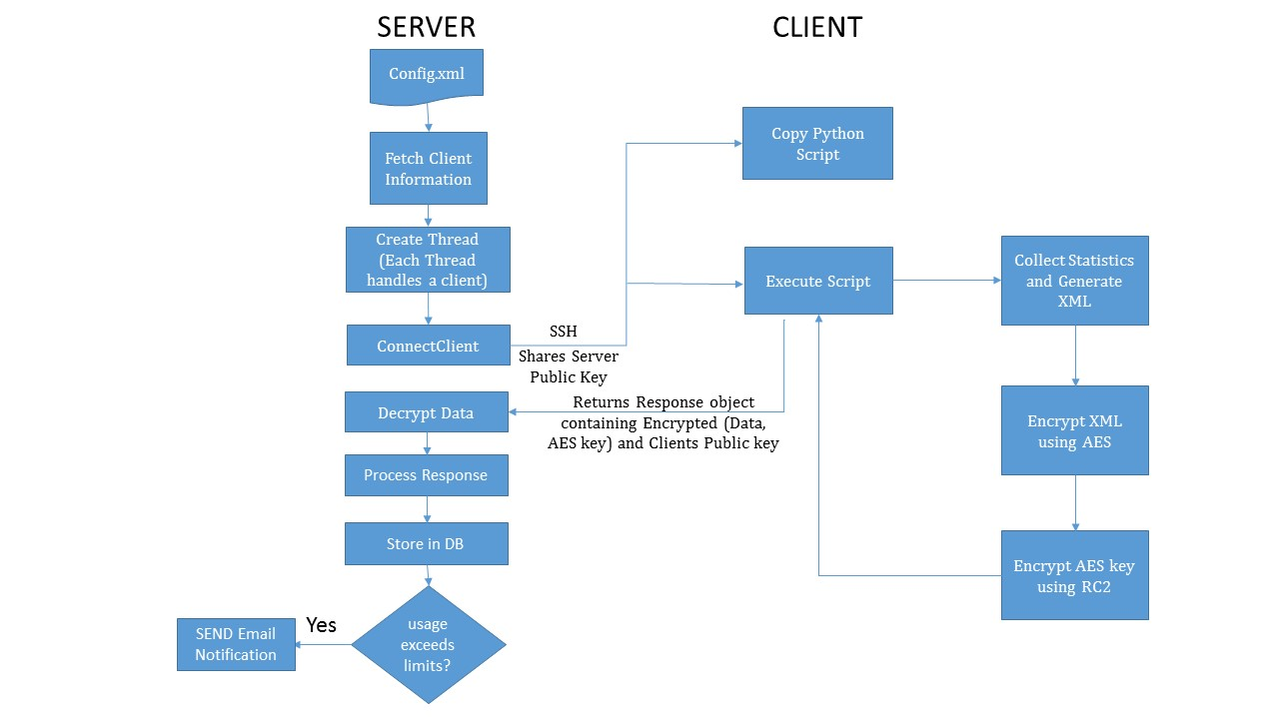

**System Components**

1. **Fetch Clients:** Parses Config.xml and fetches client information. Entire client information is stored in list of dictionaries.
2. **Thread Management:** Creates thread for each client and it collects statistics from client.
3. **Connect Client via SSH:** Each thread establishes a connection to client using SSH. After successful connection it transfers client script which collects system statistics on execution.
4. **Diffie Hellman key Exchange:** Diffie Hellman key exchange is used to share symmetric key which is used for encrypting system statistic data.
5. **Collect Statistics:** This module collects system statistics – cpu usage, individual cpu usage, memory usage, swap usage, uptime. Returns the data in xml format
6. **AES Encryption:** Statistics collected in XML format is encrypted before transferring it client.
7. **Secured Transfer:** Data is encrypted using AES and corresponding encryption key is encrypted with RC2 using shared key generated by DiffieHellman.
8. **Process Response:** Decrypts AES key using shared key, statistical data is decrypted using AES. Stat data is processed and stored in database. If the usage limit exceeds the limits, alert mail is sent to the user
9. **SMTP Module:** This module is configured to use outgoing smtp servers and sends alert notifications to the client address.