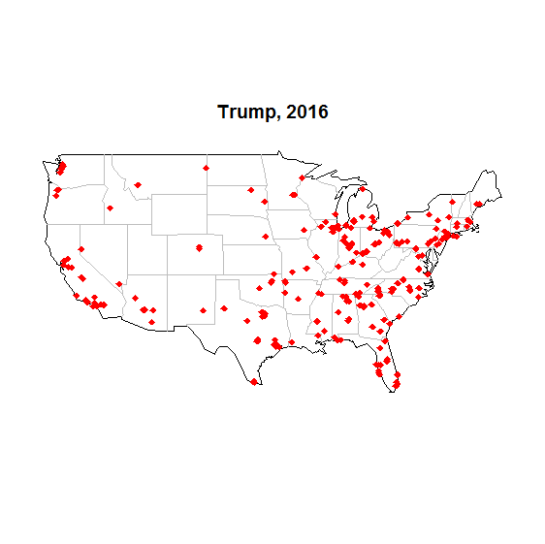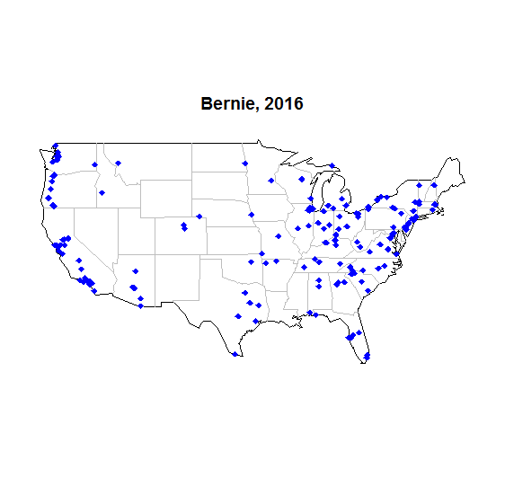 **Bernie vs. Trump, 2016**

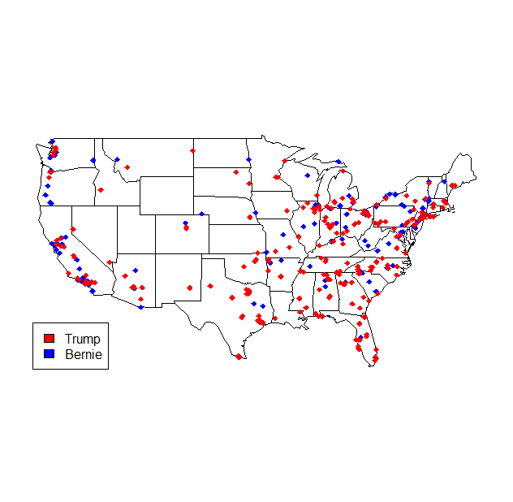



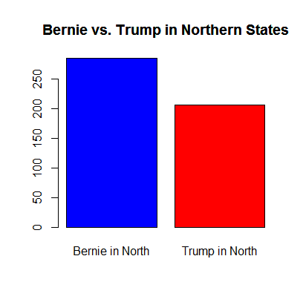

# Souther States on count of postive tweets

**>** sum_below_line_trump_south **=** sum**(**mydata_trump**$**lat **<** 38**)**

**>** sum_below_line_trump_south

**[**1**]** 278

**>** sum_below_line_bernie_south **=** sum**(**mydata_bernie**$**lat **<** 38**)**

**>** sum_below_line_bernie_south

**[**1**]** 189

# Northern States on count of postive tweets

**>** sum_above_line_trump_north **=** sum**(**mydata_trump**$**lat **>** 38**)**

**>** sum_above_line_trump_north

**[**1**]** 206

**>** sum_above_line_bernie_north **=** sum**(**mydata_bernie**$**lat **>** 38**)**

**>** sum_above_line_bernie_north

**[**1**]** 284