1. Clone git repo
https://github.com/vspup/mps2gui/tree/win_build
2. Go to QT Creator and open project with root Cmake file
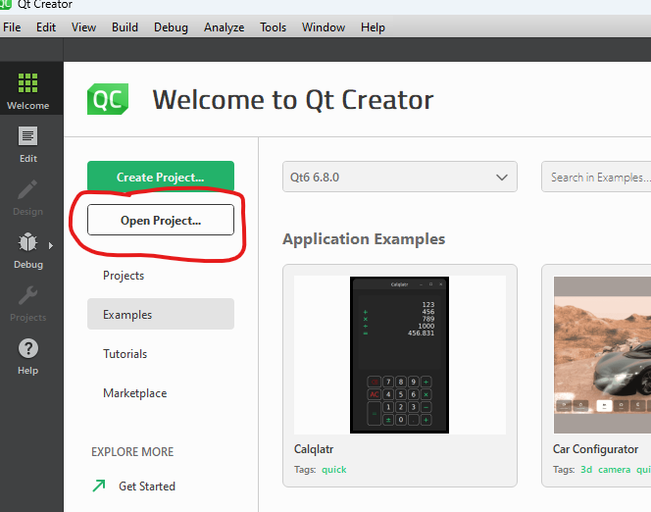
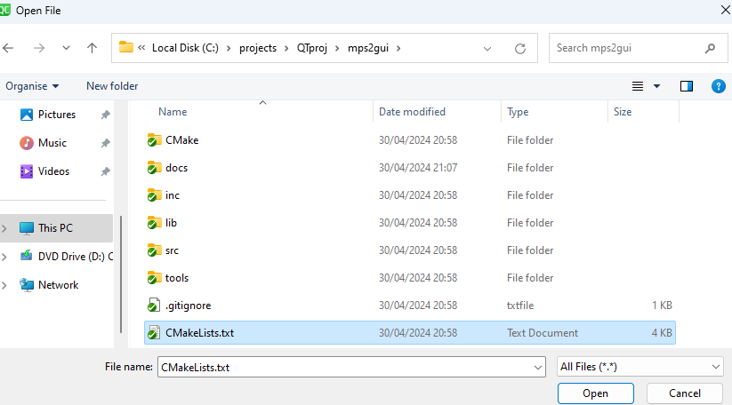
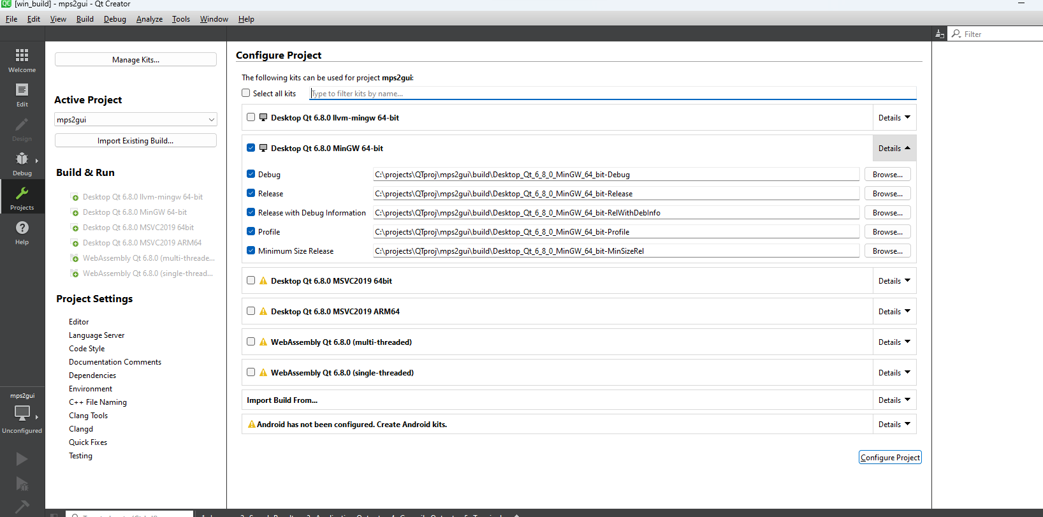
3. Use MINGW option (default are ok)

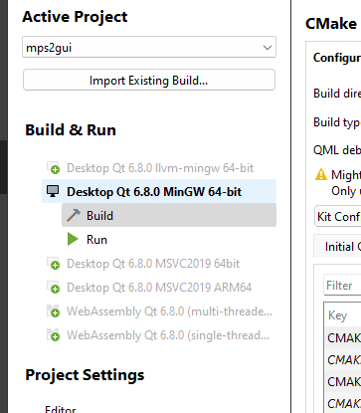
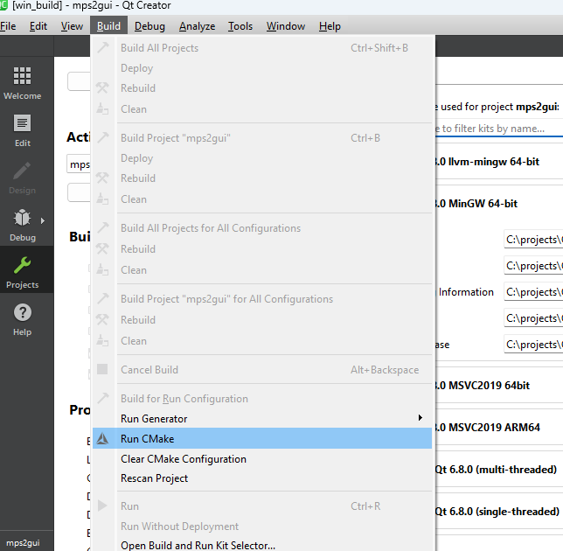
4. Go Build – Run Cmake
In General Messages Tab should be so:
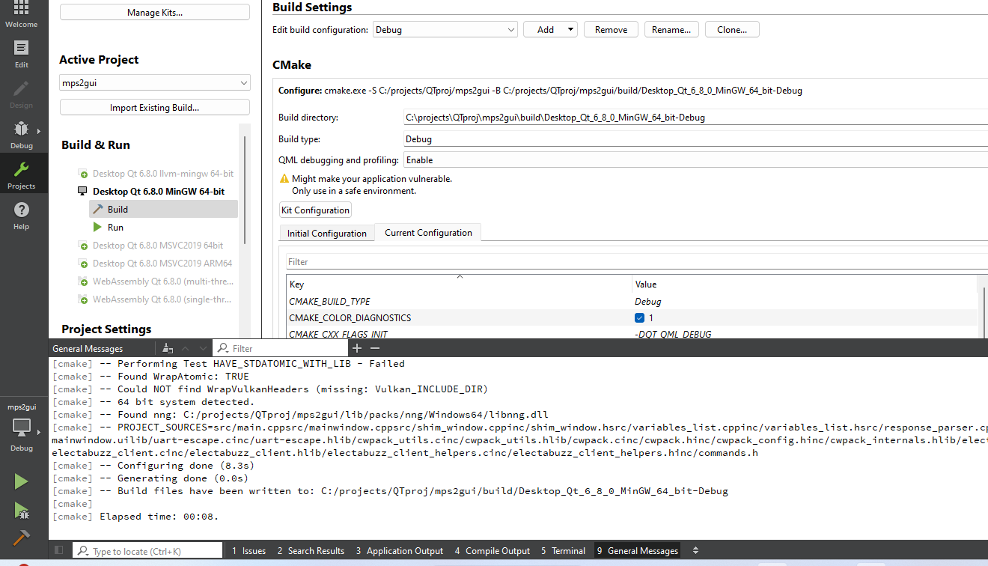
Output in General Messages:
5. Go Build – Build Project

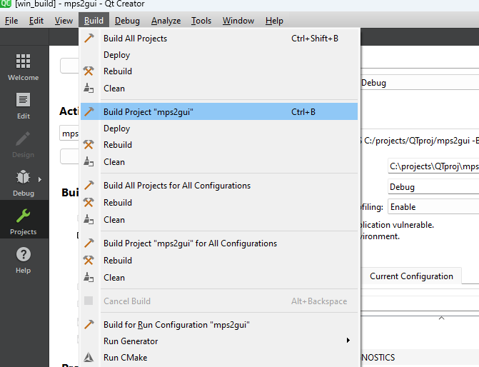
Output in Compile output:
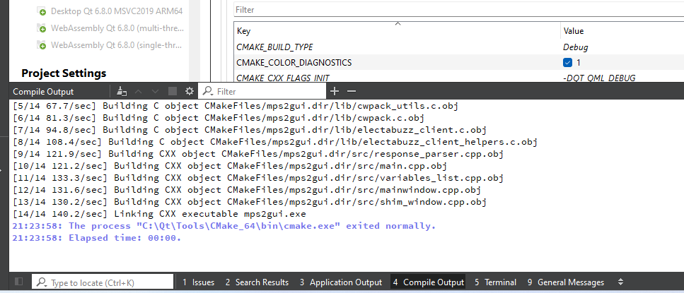
At this stage project can start by pressing “Run” from QT Creator.
Prepare executable in next step.

6. Go to Project settings and to Build Steps section, press Add Build Step - Custom process step
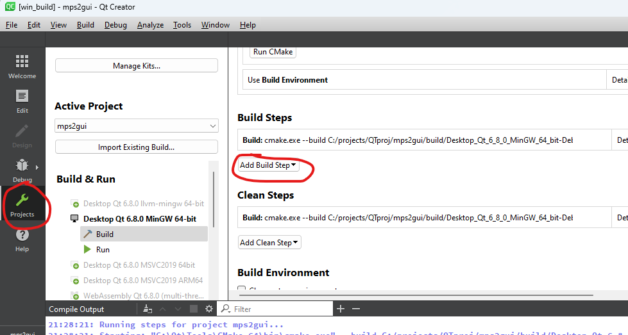
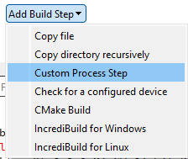
Fill as follows:

Command:
%{sourceDir}\tools\post_build.bat
Arguments:
%{ActiveProject::QT_HOST_LIBEXECS}\windeployqt.exe %{ActiveProject:RunConfig:Executable:NativeFilePath} %{ActiveProject:RunConfig:Executable:NativePath}
Working dir:
%{ActiveProject:RunConfig:Executable:NativePath}
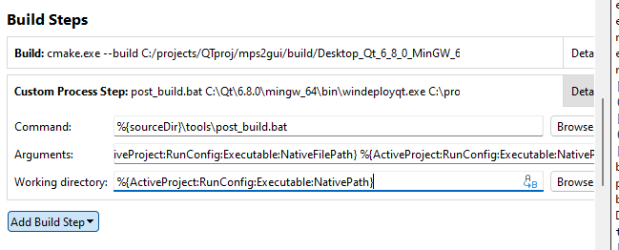
Now in working build directory will be created EXE folder, that contains all nested libs and files.
