1. Clone git repo

https://github.com/vspup/mps2gui/tree/win_build

2. Go to QT Creator and open project with root Cmake file

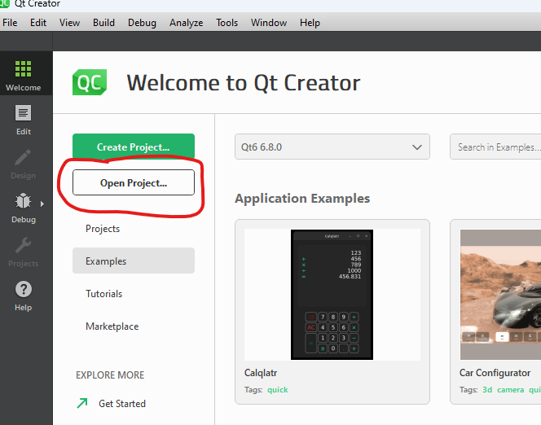

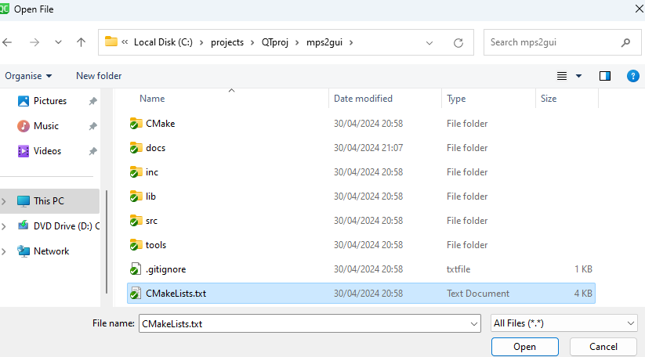

3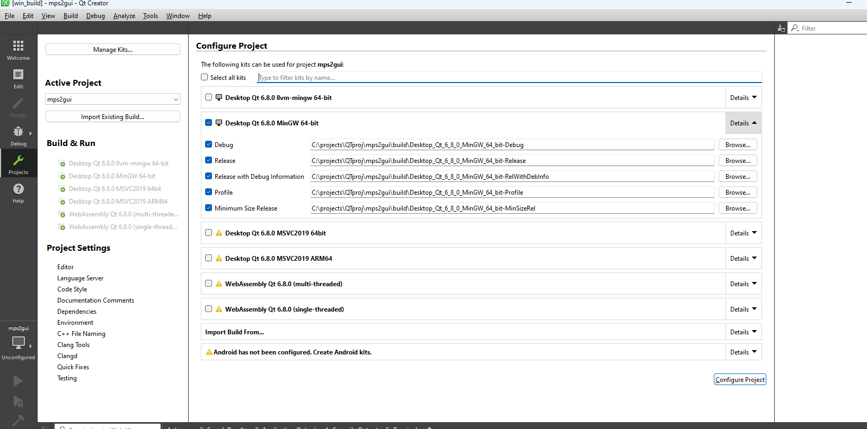. Use MINGW option (default are ok)

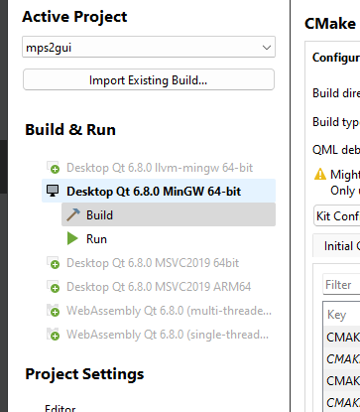

4.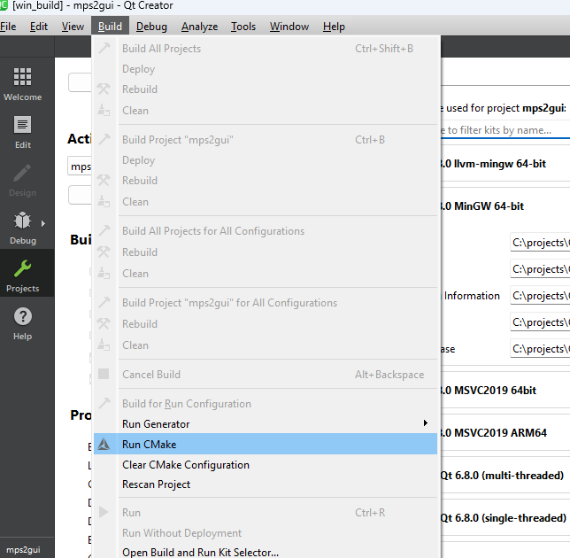 Go Build – Run Cmake

In General Messages Tab should be so:

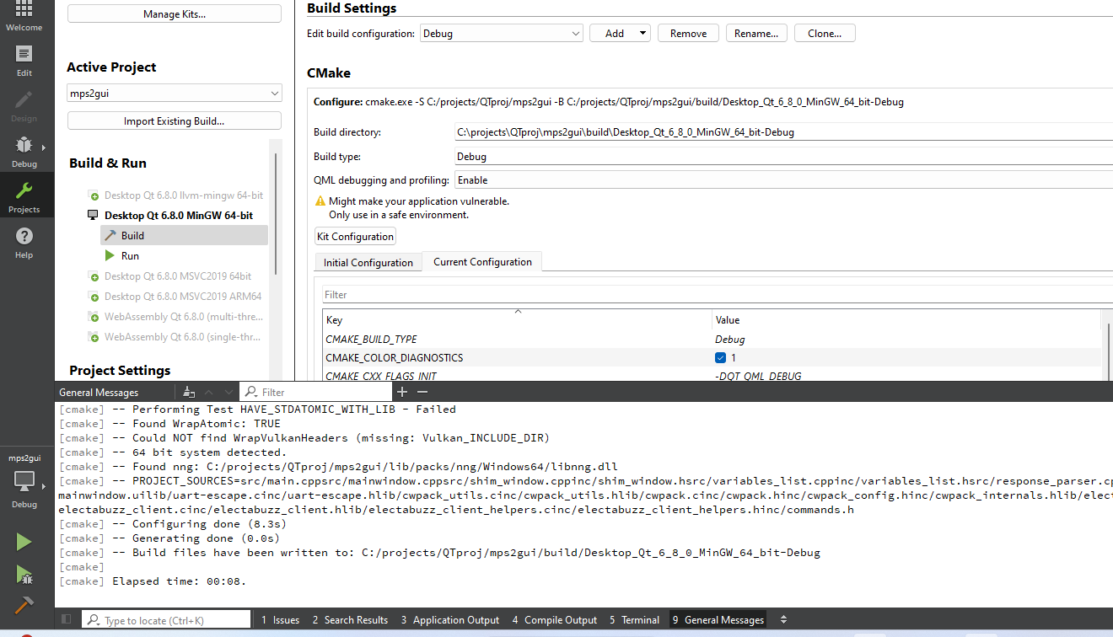Output in General Messages:

5. Go Build – Build Project

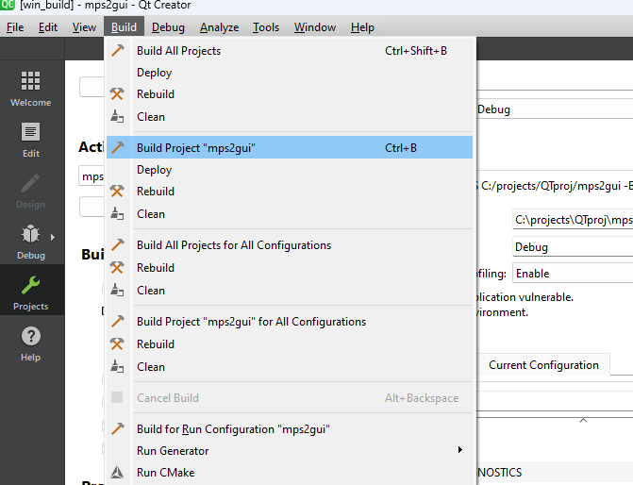  
Output in Compile output:

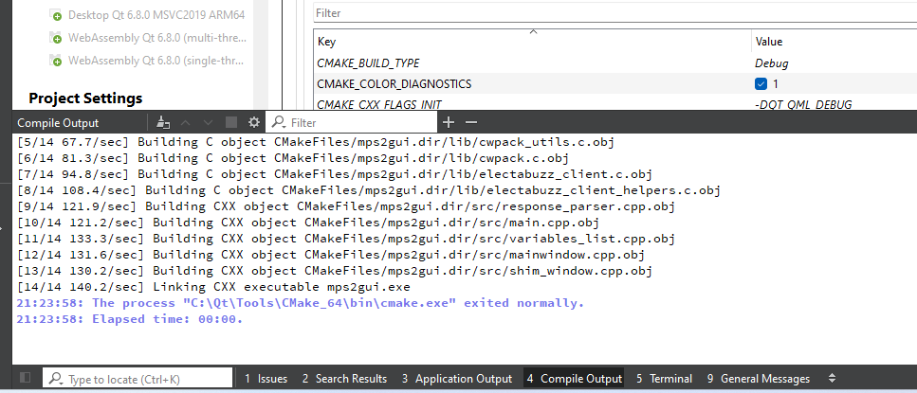

At this stage project can start by pressing “Run” from QT Creator.

Prepare executable in next step.

6. Go to Project settings and to Build Steps section, press Add Build Step - Custom process step

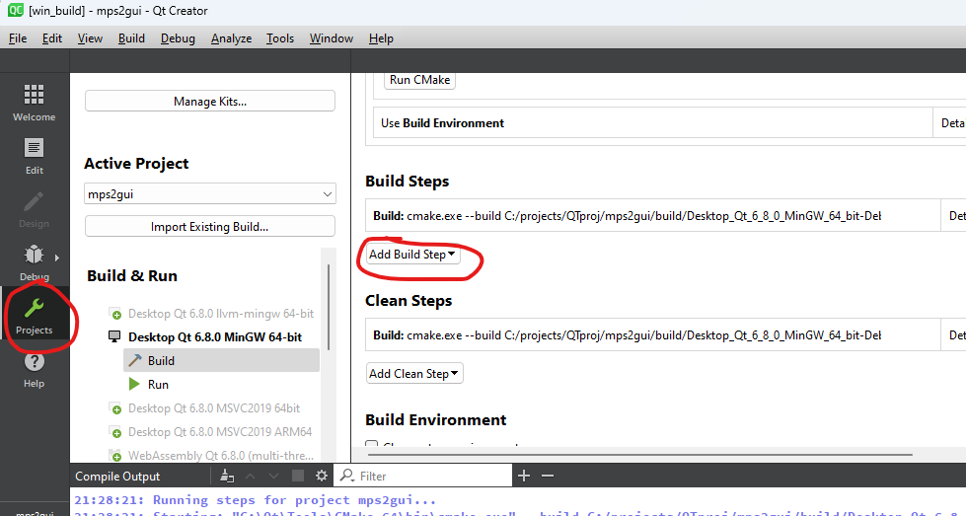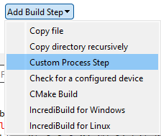

Fill as follows:

**Command:**

*%{sourceDir}\tools\post_build.bat*

**Arguments:**

*%{ActiveProject::QT_HOST_LIBEXECS}\windeployqt.exe %{ActiveProject:RunConfig:Executable:NativeFilePath} %{ActiveProject:RunConfig:Executable:NativePath}*

**Working dir:**

*%{ActiveProject:RunConfig:Executable:NativePath}*

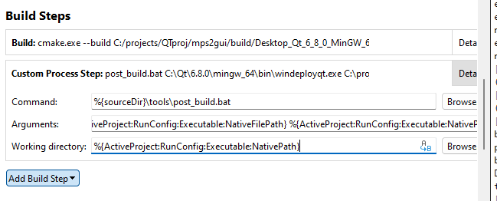

Now in working build directory will be created EXE folder, that contains all nested libs and files.

