Session-01:

SDLC
======
Software Development Lifecycle

Business Analyst

Business
Requirements gathering
Planning and Designing
Implementation
Deployment
Testing
Release into public

Maintanance

Waterfall
===========
School Management System

Stakeholders --> Who is part of the system

Teachers Students Parents Staff(Principal) Investors and Management Government

Grand Final
100 years

Students -> they don't read from DAY-1
Teachers -> they don't teach from DAY-1
Parents -> They worry from DAY-1

20-30%
why 70% failed

Problems
=========
1. only exam time. scared about exam
2. teachers wont ask to study seriously

Changes
==========
UNIT Tests - I, II, III, IV
Quarterly, Half yearly, Pre-Final

20-30%

II --> 30-35%

80%

Changes
=========
Slip/Daily tests

365 days
200 days
150 slip tests

95%

Gurukul -> Waterfall
Unit test --> Agile
Daily Tests -> DevOps

Waterfall
=========
2 years --> 100cr

requirements
1 year

development, testing

6 months
after 6 months testing

100 defects --> 10 invalid defects

Ferrari -> Maruti 800

Agile
=========
Sprint basis

Signup Login
Product management
Order management
Shipping and delivery
Payment
Reviews

SPRINT-1
========
Signup and Login

1 month

15 days development
15 days testing and deployment

10 -> 2 invalid defects

development and testing is improved

Ferrari --> Honda City

SPRINT-2
========
Product management
Backlog and bug fixing

Final product

DevOps
=======
Development --> DEV and SIT Deploy(Build and Release) --> Testing

Whatever the code developed by developer should be tested and deployed on the same days

Signup form
===========
Enter your firstname
Enter your lastname

2 defects -> 1 invalid defects

DevOps is the process developing, building, deploying and testing on the same day, that can improve co-ordination between all the teams. We use multiple DevOps tools to acheive this. Configuration management, CICD, etc.

Session-02:

Rules
=======
1. Private bank debit cards, Rupay will not work. Canara bank, Union Bank is working
2. International transactions should be enabled. SBI also works
3. Min balance 500.
4. Use same address as in bank card.
5. PAN card mandatory.

Don't create 2 accounts with same card. Use diff email and diff card

6 months, after 6 months create another account
=========
100$ credit
once we start use we get another 100$
17,000 INR

below 1000 dont ask for refund

more than 1000 we can ask for refund, 3 chances

What is computer? -> IP enabled device
Communication between computers -> IT
Server, Mobile, Laptop, TV, AC, etc are computers

Based on purpose we call with diff names

Server -> hosting the applications
Computer -> Internet browsing, songs, videos, banking, etc
Mobile -> Calling, Social media, etc.

RAM, CPU(processor), Storage, OS

Linux
======
Why Linux is better than windows?
OS --> Bridge between Hardware and Software

Server -> Speed

Windows
=========
heavy graphics
more Cost
Slow
heavy resources consumption
performance -> frequent restarts
Security -> Anti virus installation is mandatory
upgrade to other version is little tough

Linux Server edition
===================
Opensource
Free
no graphics, only text
super fast
less resources -> 9MB of OS can be installed
run for years without restart
by default security is present in OS
upgrade is easy
Learning curve

Create Linux Server
Connect to it
start issuing basic commands

Region and Availability Zone
============================
North virginia is the first AWS region. Cost is less compared to any other regions

us-east-1

AZ --> region has multiple AZ, atleast 2 AZ

EC2 -> Elastic compute cloud

AMI(Amazon machine image) -> OS

t2.micro or t3.micro --> free tier

t3.micro -> 2 CPU, 1GB RAM

Firewall and authentication
===========================

Authentication
===================
what you know? -> Username and password
what you have? -> Username, RSA/OTP/Google/Microsoft auth
what you are? -> finger prints, retina, palm, etc.

keys
====
SSH keys
public key and private key algorithm

SSH -> Secure Shell

Client Server architecture
==========================
Whoever provide service they are servers

Lawyer -> Servers
Public -> Clients

facebook.com server, client is browser

Linux Server -> clients -> putty, mobaxterm, cmd, mac terminal, git bash, etc..

git bash is one of the SSH client, git client and a mini linux in windows, etc.

once we open git bash, it lands into user directory

C:\Users\<your-lap-username>

C:\Users\siva

Windows -> \(backward)
Linux -> /(forward)

Git Bash -> You can run basic linux commands in windows, but not completely

pwd -> present working directory

C:\devops\daws-86s

cd /c/devops/daws-86s

change directory --> cd

ssh-keygen -f daws-86s

firewall == Security Groups
=========
incoming and outgoing

inbound and outbound

SSH -> Secure Shell
Port -> 22

13.222.189.109

ec2-user

ssh -i <private-key> ec2-user@13.218.241.144
/home/pp-in-405/Desktop/My_Documents/daws-86s

ec2 -user
ec2- user

ls -l -> list the file

Session-3:

ssh-keygen -f daws-86s

ssh -i <private-key> ec2-user@IP

inbound -> SSH 22 0.0.0.0/0
outbound -> All traffic -> 0.0.0.0/0

C:\Users\siva

GitBash -> Mini Linux

cd /c/devops/daws-86s

/c/devops/daws-86s -> absolute. starts from root directory
daws-86s --> relative. make sure you have that file exist file

<command-name> <inputs> <options>

inputs, options are sometime mandatory sometimes optional

copy source destination

uname -> command
-a -> one of the option

pwd -> print working directory
$ -> normal user
# -> root user

/root -> root user home directory
/home/<user-name> -> /home/ec2-user

/ --> starting path. root path

CRUD -> Create Read Update Delete

touch <file-name> -> create the file

ls -> list subdirectories

cat > file-name

enter the text... press enter and then ctrl+d

> -> redirection
>> -> don't replace, just add/append

mkdir -> make directory
rmdir -> deletes the directory

rm -r -> delete recursively, means delete the contents also inside the directory

cd .. -> one step back

Cd != cd

ls -l -> alphabetical order
ls -lr -> reverse alphabetical order
ls -lt -> latest on top
ls -ltr -> oldest on top

cp <source> <destination>

mv <source> <destination> -> moves/cut the file
. -> represents current directory

grep -> search the text inside file

grep <word-to-search> <file-name>

grep -n -> line number
grep -c -> count of lines the word occured
grep -i -> ignore the case
grep -v -> invert, non matching lines

~/.ssh/config
config should not have any file extensions

Host *
ServerAliveInterval 60
ServerAliveCountMax 3

wget <url> -> Downloads the file
curl <url> -> print the information on the screen

https://raw.githubusercontent.com/daws-86s/notes/refs/heads/main/session-02.txt

print Hello World

echo "Hello World"

cut command can delimit the text and give us the required fragment

awk -F "/" '{print $1F}'

sudo su - -> I will land into root user home directory
sudo su -> land into same directory as root

Session-04:

uname
pwd
touch
cat
cd
mkdir
rmdir
rm -r
cp
mv
grep
cut
awk
piping
echo
ls
curl
wget

vim editor
============
vi improved editor

touch <file-name>
cat >
cat >>

vim <file-name>
1. if file already exists, it will open
2. if file does not exists, then it will create and open

Default mode is esc mode.

Colon/Command Mode
=================
:wq -> write and quit
:q! -> quit without saving
:q -> just quit
:set nu -> display line numbers
:set nonu -> remove line no
:<line-number> -> cursor will go that line
:/<word-to-search> -> search from top
:?<word-to-search> -> search from bottom
:<line-number>d -> deletes that line
:noh -> no highlight
:28s/root/ROOT -> line number 28, replace root with ROOT. It replaces the first occurence in that line

:29s/root/ROOT/g -> g for global. means 29th line all root occurences should be replaced with ROOT

:%s/root/ROOT/g -> all lines all occurences in the file

Esc Mode
============
gg --> takes us to top of the file
shift+g -> takes us to bottom of the file
u -> undo
ctrl+r -> redo
dd -> deletes the line
yy(yank) -> copies the line
p -> paste below the line
shift+p -> paste above the line

head <file-name> -> displays top 10 lines of the file
tail <file-name> -> displays bottom 10 lines

head -n 8 | tail -n 3

55-65

head -n 65 | tail -n 11

Linux Administration
======================
User Management

User Groups Roles Permissions

User -> A human
Group -> A team of humans
Roles -> position
Permissions -> Access to the roles

1. create user
2. create group
3. add user to the group
4. remove user from the group
5. remove user
6. remove group

1. create devops group
2. create suresh user
3. add suresh to devops group
4. remove suresh from devops group
5. remove suresh user

useradd suresh -> creates suresh user
groupadd devops -> creaes devops group

id <user-name>
id suresh
uid=1001(suresh) gid=1001(suresh) groups=1001(suresh)

when you create user in Linux, by default it will create one group with same username

/etc/passwd
suresh:x:1001:1001::/home/suresh:/bin/bash

/etc/group
devops:x:1002:

/etc/shadow -> encrypted password

A user in Linux must have 1 primary group and atleast 1 secondary group

usermod -g <group-name> <user-name> --> adding suresh to devops group
usermod -aG <group-name> <user-name> --> adding suresh to secondary group

passwd <user-name>

/etc/ssh/sshd_config --> SSH configuration

PasswordAuthentication no

vim /etc/ssh/sshd_config
sshd -t -> checks the syntax of ssh

systemctl restart sshd

gpasswd -d <user-name> <group-name>

id suresh
suresh suresh suresh

files and permissions
=====================
Read -> 4
Write -> 2
Execute -> 1

- rw- r-- r--
owner/user group others
u g o

chmod g+w
chmod 744

Session-05:

File Ownership
================
chmod -> either the owner of the file or root
chown <user>:<group> file/folder --> not even owner can change the ownership, only root user

chown -R -> recursive. all files and folders inside

How a user can login with keys
==============================
/home/suresh/.ssh
authorized_keys -> suresh public key

ssh -i suresh suresh@IP

An employee should generate keys..

ssh-keygen -f ramesh
ramesh.pub
ramesh -> private key

sivakumar should send his public key to admins

1. useradd sivakumar
2. admin should create .ssh folder in /home/sivakumar
3. permissions should be 700 for .ssh means only owner has full access
4. .ssh ownership should be only sivakumar including group
5. create authorized_keys inside .ssh with max permissions 600 and again ownership should be sivakumar
6. keep the public file from sivakumar inside authorized_keys

ssh -i sivakumar sivakumar@3.87.244.153

/etc/sudoers -> sudoers information
vimsudo -> edit safely with syntax checks

How to give sudo access to user?

add him to wheel group and then modify /etc/sudoers wheel group without password

usermod -aG wheel sivakumar
/etc/sudoers ->

how many ports in a computer -> 0 - 65,535

Delhi -> HYD courier

gandhi apartments, ameerpeta, hyd, 500082
102

https://facebook.com -> facebook web application
username and password we can able to see our home feed

protocol -> https (443)
IP

Package management
===================
package managers

dnf is the command to install/remove the packages from server
previously called as yum

RHEL => dnf install <package-name>
Ubuntu => apt-get install <package-name>

/etc/yum.repos.d

dnf list installed -> already installed in server
dnf list available -> not installed but available in web repos

install remove update info

Service Management
==================
nginx -> http web server
systemctl start nginx
systemctl status nginx

http://3.87.244.153:80

systemctl stop nginx
systemctl restart nginx

systemctl enable nginx -> whenever system restarted automatically this nginx will run
systemctl disable nginx

Session-06:
Process Management
==================
Team Manager
Team Lead
Senior Engineer
Junior Engineer
Trainees

ls -l -> It will create one process and assign ID, i,e PID and display the result

TL -> Senior Engineer
TL is his parent for that task, Senior Engineer is Child

TL creates one process and his process ID PPID (Parent process Instance ID)
TL assigns this to Senior Engineer. PID(Process Instance ID)

PPID

ps -> lists the process started by current user

ps -ef
UID PID PPID C STIME TTY TIME CMD
root 1 0 0 01:53 ? 00:00:00 /usr/lib/systemd/systemd --switched-root --system --deseria
root 2 0 0 01:53 ? 00:00:00 [kthreadd]
root 3 2 0 01:53 ? 00:00:00 [rcu_gp]
root 4 2 0 01:53 ? 00:00:00 [rcu_par_gp]

1. foreground -> blocks the current screen, will not allow to do anything
2. background ->

sleep 10 &

ps -ef | grep nginx
top -> list all process with their usage of resources

1. High traffic
10 users, 10% CPU, 25% RAM
100 users, 20% CPU, 40% RAM

2. Problems in application
10 users, 20% CPU, 40% RAM
if a task runs it takes CPU and RAM, if it is completed then it should release CPU and RAM.
Sometime application will not release these resources, then we need to fix the application

restart

get all the logs, app logs, server logs, etc..

restart the server or application

kill PID -> Request
kill -9 PID --> force kill(demand)

Network Management
=====================
AWS is responsible to provide power, network, etc.

systemctl status nginx
ps -ef | grep nginx

http://13.221.17.167:80

netstat -ltnp

Linux Hierarchy
SoftLink, Hardlink, inode
forward proxy vs reverse proxy

3 tier architecture
========================
Desktop vs Web based

Desktop
==========
resources usage is more
Installation, repair and upgrade
ocassionally hangs
storage in local, if crashes no recovery
can't access everywhere
no data security

Web based
==========

Road Side hotel -> 1 tier
===============
Cooking, money collection, order management

5-10 members
if 20 members, he can't handle

Hotel -> 2 tier
===============
owner issues token
cook is cooking dosa
20 members
cooking
order management
50 members

Restaurant Model -> 3 tier
================
Captain -> welcomes the guest and shows them a table
Waiter -> taking order, order management
Chef -> Cooking
Waiter --> Garnish, and delivers the order

50 members

Dosa Batter -> Cooks into Dosa(Chef) -> Waiter delivers the order
Raw items -> Eatable format(Chef) -> Waiter

Raw format(SQL or NoSQL) -> Application Servers(Java, Python, .NET, NodeJS, Golang) -> Web Servers -> Load Balncer(Captain)

everything in single server is called as 1 tier application
Database -> Application and Webserver (2 tier)
Database -> Application Server -> Webserver and Load Balncer (3 tier)

decoupling or loose coupling

Web/Frontend Tier
=========
Load Balancing
Web Server -> nginx -> place web application here
HTML, CSS and Javascript

Application/Backend/Middleware Server/Tier
==============
Java, .NET, Python, C++, Goland, NodeJS

CRUD
=====

Database Tier
===============
Storing the data

MySQL
Oracle
MSSQL
Postgress

MongoDB
Cassandra

Redis

ActiveMQ
Websphere MQ

Session-07:

ps -ef -> list all the process running
top -> it will display live process with cpu and ram

kill PID -> request to terminate
kill -9 PID -> order to terminate

netstat -lntp -> shows the ports openend and PID

Database -> Application -> Web -> Load Balancer -> User

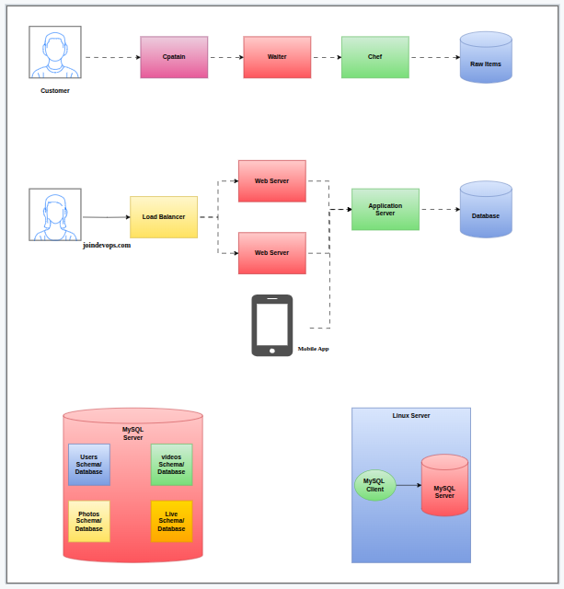

CRUD
======
1. Create operation
2. Read operation
3. Update operation
4. Delete operation

amazon.in

devops-practice -> AMI(Amazon Machine image)

What is image == image is everything around us
Image = OS + Some required softwares

Linux is OS or Kernel?
=======================
Linus Torwalds -> Linux and Git

Mac -> Hardware + MacOS
Dell -> Hardware + OS(Optional) -> we have freedom to install any OS

dominating OS for servers was Unix
Unix -> Hardware+UnixOS

He completely developed a Kernel from the scratch using C language.

Kernel = a component that connects with Hardware
OS = Kernel + some utilities or applications for user

Centos, Fedora, Ubuntu, Android, Oracle Suse, Redhat

Redhat Family
==============
Opensource vs Enterprise

Opensource -> free and community driven. we need to wait for fix
Enterprise -> We pay money for support. if there are defects immidiately we get help

Enterprise = Opensource + Support

Redhat = Kernel + Application Utilities + Support

Amazon Linux == Redhat == Centos == Fedora == Almalinux

devops-practice = RHEL based

Username=ec2-user
Password=DevOps321

34.228.199.227

ssh ec2-user@13.217.226.210
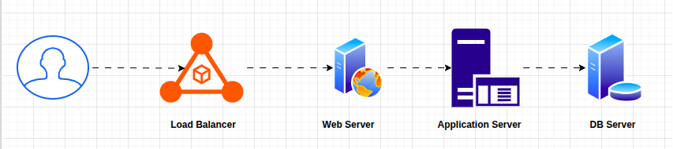

Database Tier
===========
Database Server -> It is physical server
Server == Box == Node

database server software should be installed

RDBMS -> relational database management system
Excel -> Rows and Columns = Sheets
RDBMS = Rows and Columns = Tables

There is a relation between tables

MySQL, MSSQL Admin, Oracle Admin,
3306 -> MySQL port number

default admin username == root
password needs to setup

mysql_secure_installation --set-root-pass ExpenseApp@1

IP, port, protocol, username and password/key

https
IP/facebook.com
username
password
443

mysql -u root -p<password>

-p<password> -> nospace between p and password

mysql -u root -pExpenseApp@1

Database Linux Server -> Database Server Installation -> Schema/databases -> tables -> Data

Application Tier
=============
dnf module disable nodejs -y -> Disabling default nodejs version
dnf module enable nodejs:20 -y -> enable especially node js 20

dnf install nodejs -y

dnf is the next version of yum

useradd expense
system users or service accounts -> non human users

mkdir /app

Session-08:

How internet works?
What is public IP and private IP?

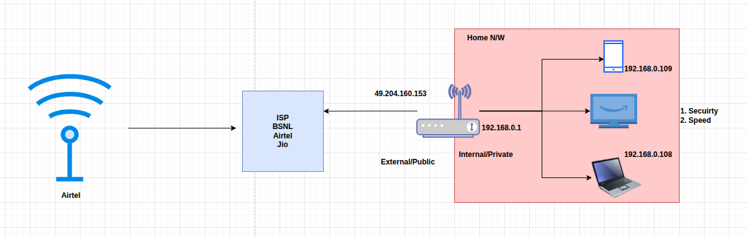

Wireless vs Wire
============
Wire is more speed

Chennai -> Guntur -> Vijayawada-> -> Vizag -> Kolkata

low speed and more time

non human user which will not have any password is called system/service user..

curl -o /tmp/backend.zip https://expense-builds.s3.us-east-1.amazonaws.com/expense-backend-v2.zip

dependencies or libraries
==================
nodejs -> package.json == build file --> here dependencies will be mentioned by developers, our application will work if we have these dependencies and project name, description, etc.
java -> pom.xml
python -> requirements.txt
.NET -> .sln
go -> build.go

npm install -> node package manager -> it expects package.json in the current folder.

dnf install nginx
systemctl start nginx

if custom application, then how to start/stop/restart

we can create systemctl services for custom applications

/etc/systemd/system/<preferred-name>.service

How to start the application, DB configuration details also will be provided

[Unit]
Description = Backend Service

[Service]
User=expense
Environment=DB_HOST="<MYSQL-SERVER-IPADDRESS>"
ExecStart=/bin/node /app/index.js
SyslogIdentifier=backend

[Install]
WantedBy=multi-user.target

/etc/systemd/system/<preferred-name>.service

/etc/systemd/system/backend.service

systemctl start backend
systemctl enable backend
systemctl status backend

systemctl daemon-reload

how much money?
why you spent?

mysql -h 172.31.30.95 -uroot -pExpenseApp@1 < /app/schema/backend.sql

backend applications mostly uses port no 8080

install programming language
created one directory
downloaded code
installed dependencies
created systemctl service to start/stop/restart
then make sure DB connections, schemas, tables exsits

backend -> Database

telnet <IP> <port>

login to backend server

telnet 172.31.30.95 3306

nginx -> famous webserver and reverse proxy
=================================

/usr/share/nginx/html -> default directory where you keep frontend code
/etc/nginx -> nginx configuration

systemctl start nginx

vim /etc/nginx/default.d/expense.conf

/etc/nginx

http://54.88.122.243/api/transaction

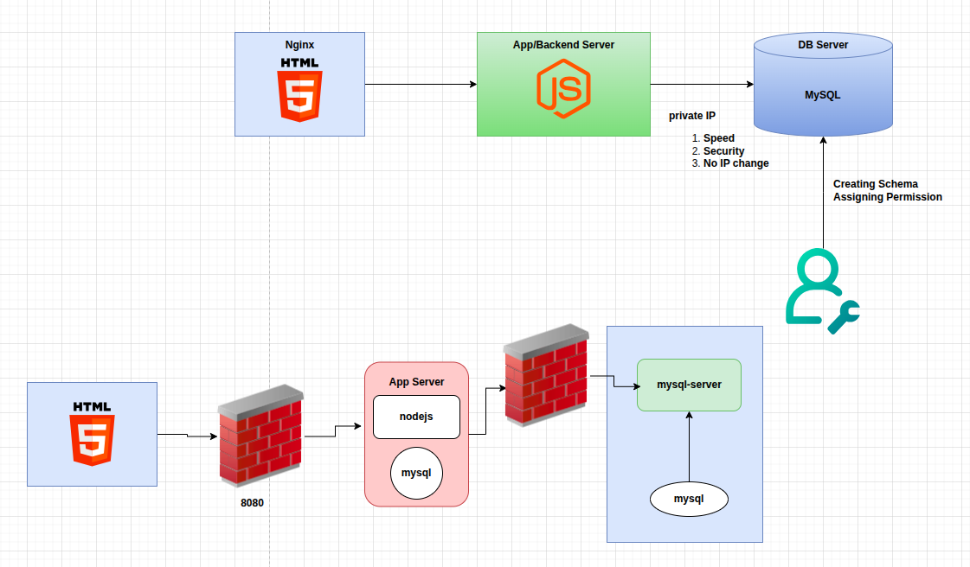
Session-09:
Database
=======
Installed database server
started
enabled
set the root password

mysql -> go to mysql cmd line
show databases;
use <database-name>;
show tables;
select * from <table-name>;

Backend
======
install programming run time -> nodejs/java/python

created one system user
create one directory
downloaded the code
installed dependencies
created systemctl service
make sure you provide dependencies like DB_URL
systemctl daemon-reload
systemctl started

connect to DB
run the scripts provided by developer
create a schema called transactions
use transactions
create table
create one user
provide access to that use to transactions schema

then restart backend

systemctl status
ps -ef | grep service name
netstat -lntp
telnet DB_IP <port-no>

frontend
===========
installed nginx as http/web server
started and enabled
/usr/share/nginx/html -> default location nginx search for HTML content
/etc/nginx

removed default website
downloaded our frontend website
configured a proxy to connect with backend
restarted

telnet backend_IP 8080

[Unit]
Description = Backend Service

[Service]
User=expense
Environment=DB_HOST="mysql.daws86s.fun"
ExecStart=/bin/node /app/index.js
SyslogIdentifier=backend

[Install]
WantedBy=multi-user.target

DNS -> domain name system

humans remember names, computer works on numbers

phonebook ->
name == number
telephone directory
name == number

DNS resolver -> a simple software running in ISP servers to fetch the IP address for a domain

English -> Oxford

ICANN -> Internet corporation for assigned names and numbers -> Non profit organisation

TLD -> Top level domain

.com .in .org .net .io .edu .us .uk .shop .ai

.in -> GOV of India
.us .uk
.ai
Tuvalu -> tv
.tv -> Gov of Tuvalu

What happens when you buy a domain?

daws86s.online
I will pay to godaddy/hostinger to purchase this domain
name, contact details, addres, etc.

.online -> Who owns it

domain registars == godaddy/hostinger
TLD pays commission to godaddy

if you want to keep that domain -> godaddy
temp purpose -> hostinger

Nameservers update to TLD

Domain ownership belongs .fun TLD
Domain manage/authorised person is hostinger

I want to shift domain authority to AWS. Why?

daws86s.fun -> frontend public IP

change in nameservers

update these to .fun TLD

Type of records
===============
A -> IpV4 address
CNAME --> Another domain
MX -> Mail servers
TXT -> Domain verrification purpose
AAAA -> IpV6
NS -> Nameservers, who is controlling the domain
SOA -> Who is controlling

mysql.daws86s.fun -> MySQL private IP

TTL -> Time to live (Controls how much your cache keeps this record, before issuing next request)

High TTL -> DNS overload decreases. stable websites will have high TTL
Low TTL -> migration activities. decrease TTL

daws86s.fun

Nginx
=======
1. http/web server
2. reverse proxy
3. load balancer

proxy == on behalf of someone

forward proxy
==============
on behalf of client

mobile -> Hotstar

Internet exchange points -> block the websites here

Mobile -> VPN(US) -> facebook.com and get the response to VPN --> Mobile

hiding the client identity
access restrictions
traffic filter

reverse proxy
=============
on behalf of server
hiding the server identity -> security

Perfect 👍 You’ve now outlined Database → Backend → Frontend → DNS → Nginx (forward & reverse proxy) in a structured way. Let me summarize and organize your notes into a clean learning flow (like a step-by-step DevOps practice project) so you can use it as a ready reference:

📌 Expense Project – 3 Tier Deployment (with DNS & Nginx)

1. Database (MySQL)
- Install and start MySQL server
dnf install mysql-server -y
systemctl enable mysqld
systemctl start mysqld
- Set root password
mysql_secure_installation --set-root-pass ExpenseApp@1
- Verify & operate inside MySQL
mysql;
show databases;
use <schema>;
show tables;
select * from <table>;
- Developer tasks (schema setup)
create database transactions;
use transactions;
create table ... ;
create user 'appuser'@'%' identified by 'password';
grant all privileges on transactions.* to 'appuser'@'%';
flush privileges;

2. Backend (NodeJS)
- Install Node.js runtime (as per developer version, e.g., v20)
dnf module disable nodejs -y
dnf module enable nodejs:20 -y
dnf install nodejs -y
- Create non-human service user
useradd expense
- Setup app directory and code
mkdir /app
curl -o /tmp/backend.zip https://expense-builds.s3.us-east-1.amazonaws.com/expense-backend-v2.zip
cd /app && unzip /tmp/backend.zip
npm install
- Systemd service for backend
[Unit]
Description=Backend Service

[Service]
User=expense
Environment=DB_HOST="mysql.daws86s.fun"
ExecStart=/bin/node /app/index.js
SyslogIdentifier=backend

[Install]
WantedBy=multi-user.target
systemctl daemon-reload
systemctl enable backend
systemctl start backend
systemctl status backend
- DB schema loading
mysql -h mysql.daws86s.fun -uroot -pExpenseApp@1 < /app/schema/backend.sql
systemctl restart backend
- Debugging tools:
ps -ef | grep backend
netstat -lntp
telnet DB_IP 3306

3. Frontend (Nginx)

- Install & start Nginx
dnf install nginx -y
systemctl enable nginx
systemctl start nginx
- Clean default HTML
rm -rf /usr/share/nginx/html/*
- Download & extract frontend
curl -o /tmp/frontend.zip https://expense-builds.s3.us-east-1.amazonaws.com/expense-frontend-v2.zip
cd /usr/share/nginx/html && unzip /tmp/frontend.zip
- Reverse proxy configuration
vim /etc/nginx/default.d/expense.conf
proxy_http_version 1.1;

location /api/ {
proxy_pass http://backend.daws86s.fun:8080/;
}

location /health {
stub_status on;
access_log off;
}
systemctl restart nginx
- Debugging:
telnet backend_IP 8080

4. DNS Concepts
- DNS = Phonebook of Internet
- Converts name → IP
- Managed by ICANN, delegated to TLDs (.com, .in, .fun, etc.)
- Domain purchase via registrars (GoDaddy, Hostinger, AWS Route53)
- DNS Records:
  - A → IPv4 address
  - AAAA → IPv6
  - CNAME → Alias
  - MX → Mail
  - TXT → Verification
  - NS → Nameservers
  - SOA → Authority
- TTL (Time To Live) → cache expiry time
Example:
daws86s.fun → frontend public IP
mysql.daws86s.fun → MySQL private IP
backend.daws86s.fun → Backend private IP

5. Nginx Roles
- Web Server – serve HTML, CSS, JS
- Reverse Proxy – hide backend identity, route API traffic
- Load Balancer – distribute load across multiple servers
- Forward Proxy – on behalf of client (VPN, bypass restrictions)

👉 With this, you’ve got a complete DevOps practice project:
- MySQL as DB
- NodeJS as Backend
- Nginx as Frontend & Reverse Proxy
- DNS setup for real domain routing

Would you like me to make a big architecture diagram (3-tier + DNS + Nginx roles) and add it into your PDF cheat sheet so you have a one-stop reference?

