NETFLIX
MOVIES & TV SHOWS DATA ANALYSIS
A Beginner-Friendly Exploratory Data Analysis (EDA) Project
________________________________________

Prepared By: [Your Name]
Organization / Institute: [Your College / Organization Name]
Date: 26 August 2026
Dataset: Netflix Movies and TV Shows (netflix_titles.csv)
Tools Used: Python, Pandas, NumPy, Matplotlib, Seaborn
Environment: Jupyter Notebook / VS Code / Google Colab

Table of Contents

1. Cover Page 1
2. Executive Summary 3
3. Introduction 4
4. Problem Statement 5
5. Project Objectives 6
6. Dataset Description 7
7. Business Questions 8
8. Tools and Technologies 9
9. Project Workflow 10
10. Data Loading 11
11. Data Exploration 12
12. Data Cleaning 13
13. Exploratory Data Analysis (EDA) 15
14. Bivariate Analysis 18
15. Multivariate Analysis 20
16. Feature Engineering 22
17. Data Visualization 23
18. Business Insights 25
19. Recommendations 26
20. Challenges Faced 27
21. Conclusion 28
22. Future Scope 29
23. References 30

2. Executive Summary
This project presents a complete beginner-friendly data analysis of the Netflix Movies and TV Shows dataset, which contains information about 8,807 titles available on the Netflix platform up to mid-2021. The purpose of this project is to explore, clean, and analyze the dataset using Python so that meaningful, real-world business insights can be drawn from it.

Project Objective
To understand what kind of content Netflix has built its catalogue around — by content type, country of production, genre, release trends, content ratings, and duration — and to convert those patterns into insights that a content or business team could act on.

Dataset Overview
The dataset has 8,807 rows and 12 original columns, covering both Movies and TV Shows, along with details such as director, cast, country, date added to Netflix, release year, content rating, duration, genre ("listed_in"), and a short description.

Analysis Performed
The analysis covered data cleaning (handling missing values, fixing a data-entry misalignment, and correcting data types), univariate analysis of individual columns, bivariate analysis comparing two variables at a time, multivariate analysis using pivot tables and cross-tabulations, and nine business-focused visualizations.

Major Findings
- Movies make up 69.6% of the Netflix catalogue, while TV Shows make up 30.4%.
- The United States (3,689 titles), India (1,046 titles) and the United Kingdom (804 titles) are the top three content-producing countries.
- "International Movies", "Dramas" and "Comedies" are the three most common genres on the platform.
- Content additions to Netflix grew sharply between 2016 and 2019, then slowed down in 2020–2021, most likely due to the COVID-19 pandemic's impact on production.
- The typical (median) movie runs for 98 minutes, and 67% of all TV Shows on the platform have only a single season.

Business Value
These insights help a streaming platform understand its own content mix, identify gaps (for example, under-represented countries or genres), plan future content investment, and benchmark how balanced its catalogue is between movies and series.

Final Outcome
A cleaned dataset, nine business-oriented visualizations, and a set of data-backed insights and recommendations were produced, all documented in this report in a format suitable for a college, internship, or portfolio submission.

3. Introduction
Netflix is one of the world's largest streaming platforms, offering thousands of Movies and TV Shows to subscribers across the globe. Behind every recommendation and every new season announcement lies data — data about what content exists, where it comes from, when it was added, and how it is categorized.
This project is about using that data to answer simple but important questions: What does Netflix's catalogue actually look like? Which countries and genres does it lean on the most? How has the catalogue grown over time? Answering these questions is a foundational data analysis skill that is used every day by analysts working with any kind of business or product data — not just streaming.

Why This Analysis Is Important
Understanding a content catalogue is directly useful for real business decisions: deciding which regions to invest in for local content, understanding audience-facing content rating balance, and tracking whether the platform is growing or slowing in terms of new additions.

Real-World Business Relevance
- Content strategy teams use this kind of analysis to decide where to commission new shows and movies.
- Marketing teams use genre and rating breakdowns to target the right audience segments.
- Operations teams track addition trends over time to measure catalogue growth and licensing activity.

Expected Outcome
By the end of this project, the dataset will be fully cleaned, explored, and visualized, and this document will present clear, data-backed business insights and recommendations.

4. Problem Statement
Streaming platforms host thousands of titles, and without structured analysis, it is difficult to know what the catalogue actually consists of. Simply browsing the platform does not reveal patterns such as which countries dominate content production, how the catalogue has grown year over year, or which genres are over- or under-represented.

Business Problem
The dataset helps solve the problem of understanding catalogue composition at scale — something that cannot be done by manually reviewing thousands of titles one by one.

Why Analyzing This Data Is Useful
- It reveals the balance between Movies and TV Shows, which affects subscriber engagement strategy.
- It identifies the leading content-producing countries, useful for regional expansion planning.
- It shows genre popularity, which helps guide content acquisition and recommendation algorithms.
- It tracks how content addition has changed year to year, reflecting platform growth or slowdown.

How Organizations Can Benefit
A streaming business (or any organization managing a large content or product catalogue) can use this kind of analysis to make informed, data-backed decisions about acquisition, regional investment, and catalogue balance rather than relying on guesswork.

5. Project Objectives
The following goals were set for this project:
- Understanding the dataset: Reviewing every column to understand what information is available and how it is structured.
- Cleaning the data: Identifying and fixing missing values, incorrect data types, and data-entry errors.
- Exploring patterns: Studying individual columns (univariate analysis) to understand their distribution.
- Performing EDA: Conducting bivariate and multivariate analysis to uncover relationships between columns.
- Creating visualizations: Building clear, purposeful charts that communicate findings at a glance.
- Generating business insights: Translating statistical findings into insights a business team could use.
- Making recommendations: Suggesting practical, data-backed next steps.

6. Dataset Description
Property | Value
Dataset Name | Netflix Movies and TV Shows
Dataset Source | Netflix content listing (netflix_titles.csv)
Number of Rows | 8,807
Number of Columns | 12 (original)
File Format | CSV (Comma-Separated Values)
Time Span Covered | Titles released from 1925 to 2021; added to Netflix mainly between 2008 and 2021

Column-by-Column Description
Column | Data Type | Description
show_id | Text | Unique identifier assigned to each title (e.g., s1, s2).
type | Categorical | Whether the title is a "Movie" or a "TV Show".
title | Text | The name of the movie or TV show.
director | Text | Name(s) of the director(s). Missing for many titles, especially TV Shows.
cast | Text | Names of the main cast members.
country | Categorical | Country or countries where the title was produced.
date_added | Date/Time | The date the title was added to the Netflix platform.
release_year | Numerical | The year the title was originally released.
rating | Categorical | The content/maturity rating (e.g., TV-MA, PG-13, TV-Y).
duration | Text | Movie length in minutes, or number of seasons for TV Shows.
listed_in | Categorical | Genre(s)/category tags assigned to the title.
description | Text | A short one- or two-line summary of the title's plot.

7. Business Questions
Based on the columns available in the dataset, the following business questions can be meaningfully answered:
- What is the split between Movies and TV Shows on the platform?
- Which countries contribute the most content to Netflix?
- Which genres/categories dominate the catalogue?
- How has the number of titles added to Netflix changed over the years?
- Which content ratings (maturity levels) are most common?
- What is the typical duration of a movie, and how many seasons do most TV Shows have?
- Has the release-year trend of content shifted over time, and does it differ between Movies and TV Shows?
- Which directors have the most titles listed on the platform?
Questions that cannot be answered from this dataset — such as actual viewership numbers, subscriber ratings, or revenue — were intentionally excluded, since no such columns exist in the data.

8. Tools and Technologies
Tool | Purpose | Real-World Use
Python | Core programming language used for the entire analysis. | Industry-standard language for data analysis, automation, and machine learning.
Pandas | Loading, cleaning, and manipulating tabular data. | Used by analysts everywhere to clean and reshape spreadsheet-style data.
NumPy | Numerical operations and array-based calculations. | Powers fast mathematical computation behind most data science tools.
Matplotlib | Creating static charts such as bar charts and line charts. | The foundation charting library used in most Python-based reports.
Seaborn | Creating statistical visualizations with cleaner default styling. | Used for quick, attractive exploratory charts in real analytics teams.
Jupyter Notebook / VS Code / Google Colab | Interactive coding environment for writing and running analysis step by step. | Standard environment for data analysts and data scientists to explore data.

9. Project Workflow
The analysis followed a structured, step-by-step workflow, shown below. Each step builds on the one before it, which is the standard approach used in real-world data analysis projects.
Step # | Stage | What Happens in This Stage
1 | Problem Statement | Define what business question the analysis will answer.
2 | Dataset Collection | Obtain the Netflix dataset in CSV format.
3 | Import Libraries | Load Pandas, NumPy, Matplotlib, and Seaborn into the working environment.
4 | Load Dataset | Read the CSV file into a Pandas DataFrame.
5 | Data Exploration | Use functions like head(), info(), and describe() to understand the data.
6 | Data Cleaning | Handle missing values, fix data-entry errors, and correct data types.
7 | Exploratory Data Analysis | Study the dataset in depth using statistics and grouping.
8 | Univariate Analysis | Examine one column at a time (e.g., how many Movies vs TV Shows).
9 | Bivariate Analysis | Compare two columns at a time (e.g., type vs country).
10 | Multivariate Analysis | Study three or more variables together using pivot tables.
11 | Feature Engineering | Create new, more useful columns from existing ones.
12 | Data Visualization | Build charts that communicate the findings clearly.
13 | Business Insights | Translate the numbers into plain-English takeaways.
14 | Recommendations | Suggest practical next steps based on the insights.
15 | Conclusion | Summarize what was learned from the entire project.

10. Data Loading

Importing Libraries
Before working with any data, the required Python libraries must be imported. This is done using the import keyword:
import pandas as pd
import numpy as np
import matplotlib.pyplot as plt
import seaborn as sns

Reading the Dataset
Pandas' read_csv() function is used to load the CSV file into a structured table called a DataFrame:
df = pd.read_csv("netflix_titles.csv")

What Is a DataFrame?
A DataFrame is simply a table — like a spreadsheet — made up of rows and columns, where each column can hold a different type of data (numbers, text, or dates). It is the core structure used throughout Pandas.

Displaying the Dataset
The df.head() function displays the first 5 rows of the dataset, which is a quick way to visually confirm the data loaded correctly:
df.head()

Verifying Successful Loading
The dataset loaded successfully with 8,807 rows and 12 columns, which was confirmed using df.shape. This immediately tells us the size of the dataset we are working with.

11. Data Exploration
Before cleaning or analyzing the data, it is important to explore its structure. The table below explains each exploration function used, in beginner-friendly terms.
Function | Purpose | Syntax | Output | Business Interpretation
df.head() | Shows the first 5 rows of the dataset. | df.head() | A preview table of the first 5 titles. | Confirms the data loaded correctly and shows what the raw data looks like.
df.tail() | Shows the last 5 rows of the dataset. | df.tail() | A preview table of the last 5 titles. | Useful to check if data was cut off or loaded incompletely.
df.shape | Returns the number of rows and columns. | df.shape | (8807, 12) | Tells us the dataset size: 8,807 titles across 12 attributes.
df.columns | Lists all column names. | df.columns | Index of 12 column names. | Confirms exactly what information is available for analysis.
df.dtypes | Shows the data type of every column. | df.dtypes | Mostly "object" (text) except release_year (integer). | Reveals that dates and durations are stored as text, not proper date/number types — a cleaning task.
df.info() | Summarizes column types and non-null counts in one view. | df.info() | A compact summary table. | Quickly reveals which columns have missing data (e.g., director, cast, country).
df.describe() | Generates summary statistics for numerical columns. | df.describe() | Count, mean, std, min, quartiles, max for release_year. | Shows that titles range from 1925 to 2021, with most content from recent years (median 2017).

12. Data Cleaning

Missing Values in director, cast, and country
- Why it is required: These columns had a large number of missing entries — director was missing in 29.9% of rows, cast in 9.4%, and country in 9.4%. Leaving these blank could cause errors in grouping and counting operations.
- Method used: Missing values in these three text columns were filled with the label "Not Specified" using df['director'].fillna('Not Specified'), instead of deleting the rows.
- Advantages: No data is lost — titles with missing director/cast/country information are still counted correctly in overall totals like content type and genre.
- Limitations: "Not Specified" entries are excluded from country- and director-specific breakdowns, since they don't represent a real value.
- Business impact: Preserves the full dataset of 8,807 titles for general analysis while keeping country/director-specific insights accurate.

Missing Values in rating and duration
- Why it is required: 4 rows had a missing rating and 3 rows had a missing duration. These are small numbers but still needed to be handled for clean analysis.
- Method used: The missing rating values were filled with the most frequently occurring rating (the mode, "TV-MA") using df['rating'].fillna(df['rating'].mode()[0]).
- Advantages: A simple, standard technique for a small number of missing categorical values that keeps all rows usable.
- Limitations: Assumes the missing rating is likely to be the most common one, which may not always be true for every individual title.
- Business impact: Ensures every title has a valid rating for rating-based analysis and charts.

Data-Entry Misalignment ("74 min", "84 min", "66 min" in the rating column)
- Why it is required: Three rows (all Louis C.K. comedy specials) had a duration value like "74 min" incorrectly stored in the rating column, while their actual duration column was empty. This is a genuine real-world data quality issue found during exploration.
- Method used: These misplaced values were detected and moved from the rating column into the duration column, and the rating column for those 3 rows was corrected using the mode value.
- Advantages: Fixes the root cause instead of just hiding the symptom, so both the rating and duration columns become reliable for those rows.
- Limitations: Required manual inspection to catch — this type of error would be missed by an automatic "fillna" alone.
- Business impact: Prevents "74 min" from being wrongly counted as a rating category, which would have distorted the rating distribution chart.

Incorrect Data Types (date_added and duration)
- Why it is required: The date_added column was stored as plain text, not as an actual date, which would make it impossible to analyze trends by year or month. Similarly, duration mixed numbers and units (e.g., "90 min", "2 Seasons") in a single text field.
- Method used: date_added was converted to a proper date type using pd.to_datetime(). The duration column was split into a numeric value (duration_num) and a unit (duration_unit, "min" or "Season(s)") using string extraction.
- Advantages: Enables time-based analysis (titles added per year) and numeric analysis (average movie length, average number of seasons).
- Limitations: 10 rows still had a missing or unparseable date_added value after conversion and were excluded from date-based trend charts only.
- Business impact: Makes year-over-year trend analysis and duration statistics possible, which are core business questions for this project.

Duplicate Rows
- Why it is required: Duplicate rows can inflate counts and distort every statistic in the analysis.
- Method used: df.duplicated().sum() was used to check for fully duplicated rows, and df.duplicated(subset=['title']) was used to check for duplicate titles.
- Advantages: A quick, reliable way to confirm data integrity before proceeding further.
- Limitations: Only catches exact duplicates; near-duplicates with slightly different spelling would not be caught.
- Business impact: Confirmed there were zero duplicate rows and zero duplicate titles, so no rows needed to be removed.

13. Exploratory Data Analysis (EDA)

Univariate Analysis
Univariate analysis looks at one column at a time to understand its individual distribution.

Numerical Column: release_year
Statistic | Value | Business Meaning
Mean | 2014.2 | On average, content on Netflix was originally released around 2014.
Median | 2017 | Half of all titles were released in 2017 or later — the catalogue leans recent.
Minimum | 1925 | The oldest title in the catalogue is nearly a century old.
Maximum | 2021 | The dataset's newest titles were released in 2021, the year the data was collected.
Standard Deviation | 8.8 years | Most titles are clustered fairly close to the median release year, with a smaller number of much older classics.
25th Percentile (Q1) | 2013 | 75% of titles were released in 2013 or later.
75th Percentile (Q3) | 2019 | 75% of titles were released in 2019 or earlier — content is heavily weighted toward the late 2010s.

Numerical Column: duration_num (Movies only, in minutes)
Statistic | Value | Business Meaning
Mean | 99.6 min | The average Netflix movie is just under 1 hour 40 minutes long.
Median | 98 min | Half of all movies are 98 minutes or shorter — close to a typical feature-film length.
Minimum | 3 min | The shortest "movie" entries are closer to short-film length.
Maximum | 312 min | The longest movie runs over 5 hours, an outlier compared to the rest of the catalogue.
Standard Deviation | 28.3 min | Movie lengths vary moderately, but most fall within roughly an hour of the average.

Categorical Column: type
Frequency, Value Counts, and Percentages:
Category | Count | Percentage
Movie | 6,131 | 69.6%
TV Show | 2,676 | 30.4%
Business meaning: Movies dominate the Netflix catalogue by more than a 2-to-1 ratio over TV Shows, showing the platform's historical emphasis on film content.
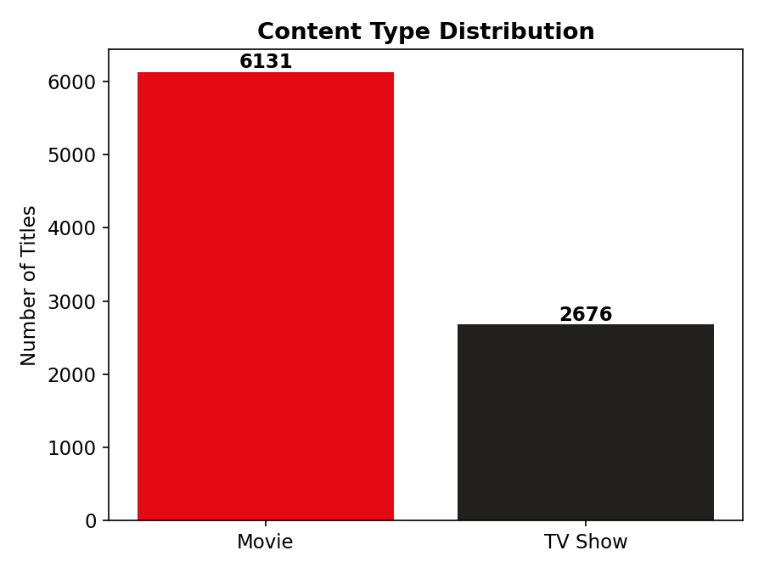
Chart 1: Content Type Distribution — Movies vs TV Shows

Categorical Column: rating
Top ratings by frequency and percentage:
Rating | Percentage | Meaning
TV-MA | 36.5% | Mature audiences — the single largest content-rating segment.
TV-14 | 24.5% | Content suitable for viewers aged 14 and up.
TV-PG | 9.8% | Parental guidance suggested.
R | 9.1% | Restricted movie rating (mature film content).
PG-13 | 5.6% | Movie rating suggesting caution for children under 13.
Business meaning: Over 60% of the catalogue is rated for mature or teen-plus audiences (TV-MA + TV-14 combined), showing that Netflix's content mix leans toward adult and young-adult viewers rather than young children.
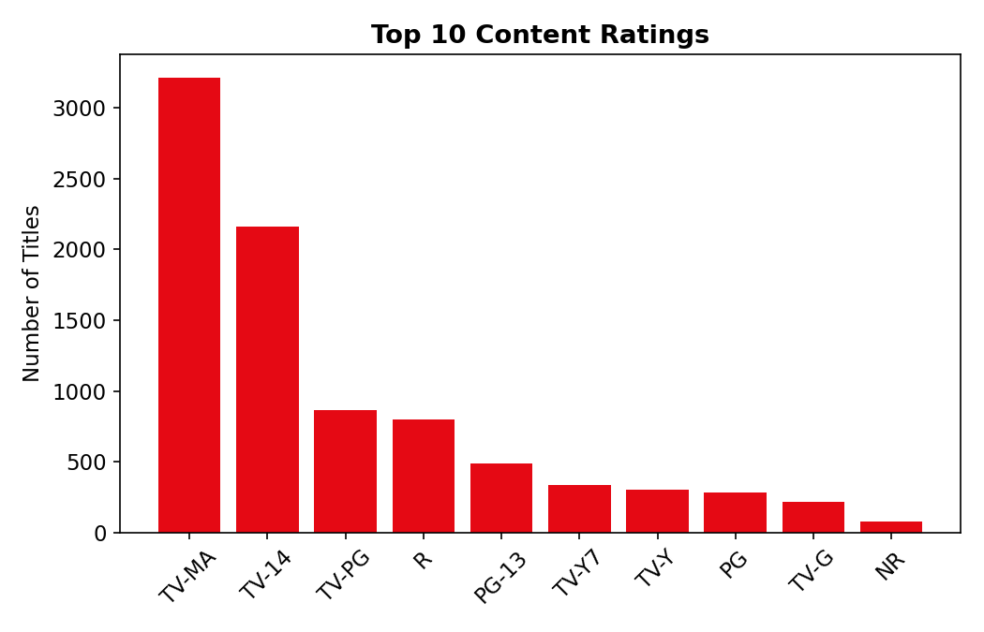
Chart 2: Top 10 Content Ratings on Netflix

14. Bivariate Analysis
Bivariate analysis compares two variables together to uncover relationships between them.

Country vs Number of Titles (Bar Chart)
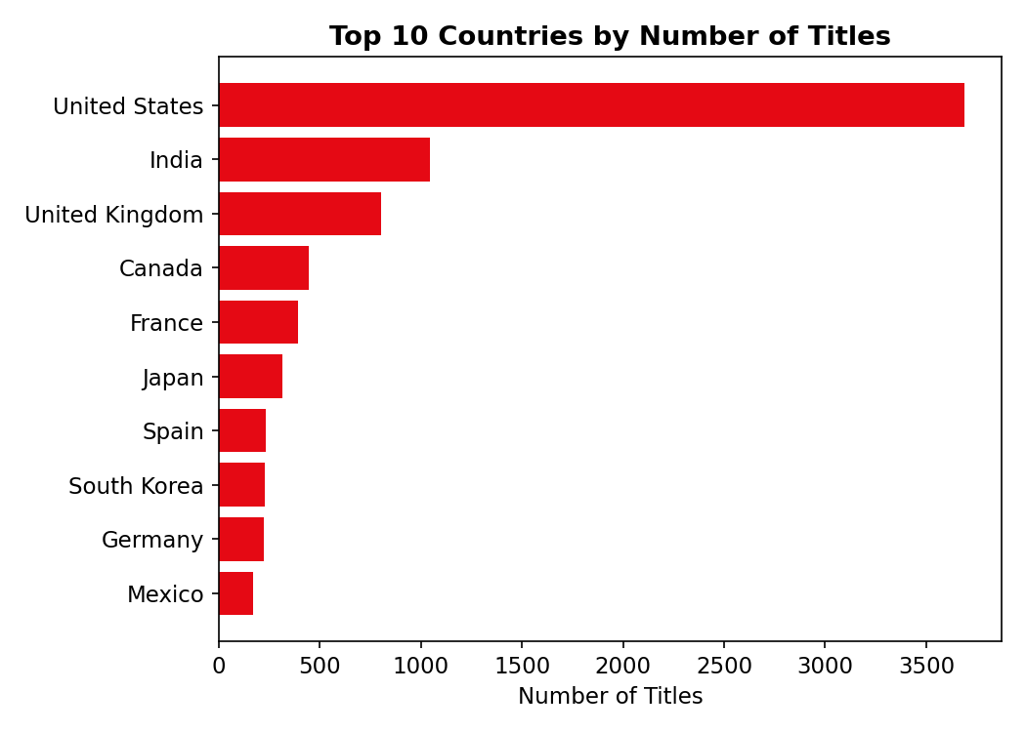
Chart 3: Top 10 Countries by Number of Titles
Relationship: There is a steep drop-off after the top 3 countries — the United States alone accounts for far more titles than any other single country.
Trend: Content production is heavily concentrated in a small number of countries, with the remaining 124 countries contributing far smaller shares each.
Business interpretation: The United States, India, and the United Kingdom together supply a large share of Netflix's catalogue, suggesting these three markets are Netflix's primary content-sourcing hubs.

Date Added vs Number of Titles (Line Chart)
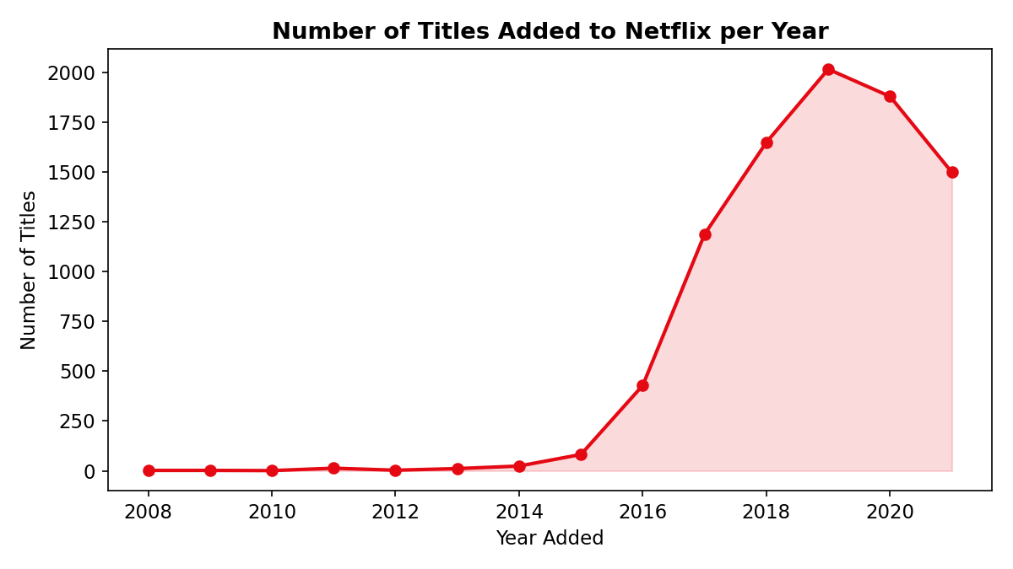
Chart 4: Number of Titles Added to Netflix per Year
Relationship: The number of titles added per year grew slowly until 2015, then rose sharply from 2016 to 2019, before declining in 2020 and 2021.
Trend: Content addition peaked in 2019 (2,016 titles) and dropped afterward, most likely linked to production slowdowns during the COVID-19 pandemic.
Business interpretation: Netflix's most aggressive catalogue expansion happened between 2016 and 2019; the recent slowdown is a useful signal for planning future content pipelines.

Type vs Duration (Box-style Distribution)
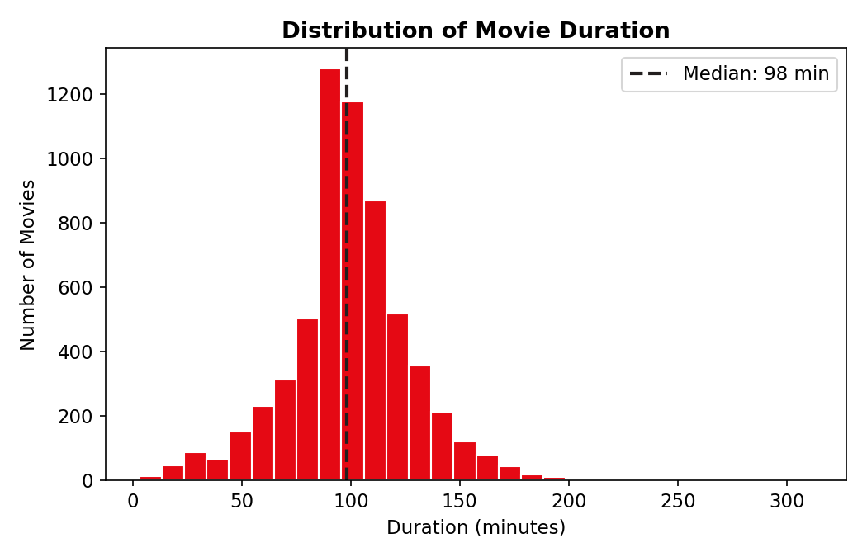
Chart 5: Distribution of Movie Duration (Minutes)
Relationship: Movie durations cluster tightly around the 85–115 minute range, with a long tail of longer movies extending toward 300 minutes.
Business interpretation: Netflix movies mostly follow standard feature-film runtimes, so major outliers (very long films) are the exception rather than the norm.

15. Multivariate Analysis

Pivot Table: Content Type by Top 5 Countries
Country | Movies | TV Shows
United States | 2,751 | 938
India | 962 | 84
United Kingdom | 532 | 272
Canada | 319 | 126
France | 303 | 90
Finding: India produces far more Movies than TV Shows (a ratio of roughly 11 to 1), while the United Kingdom has a much more balanced Movie-to-TV-Show ratio (about 2 to 1). This shows that content mix strategy differs meaningfully by country.

GroupBy Analysis: Release Year Trend by Content Type
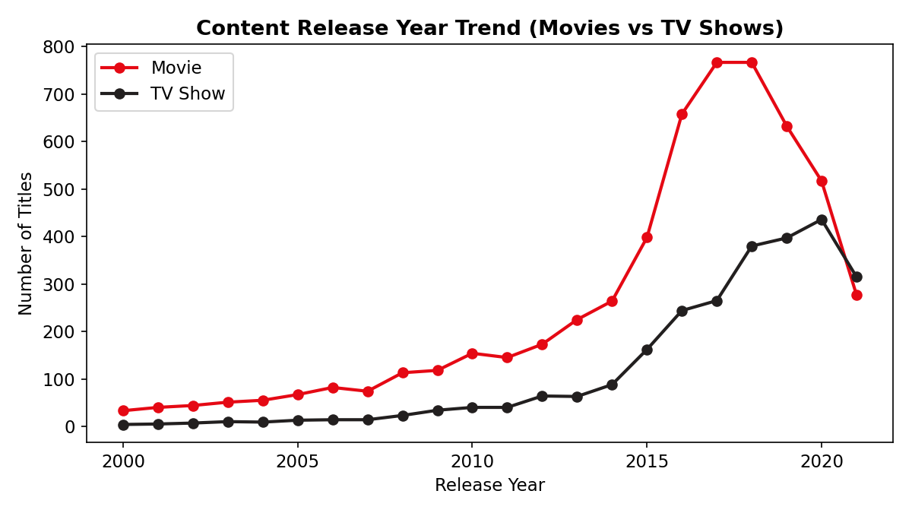
Chart 6: Content Release Year Trend — Movies vs TV Shows
Finding: Both Movies and TV Shows show rising release-year counts through the late 2010s, but TV Show releases grew at a faster relative pace after 2015, reflecting the broader industry shift toward prestige and binge-worthy streaming series.

Top Genres (Multi-label GroupBy)
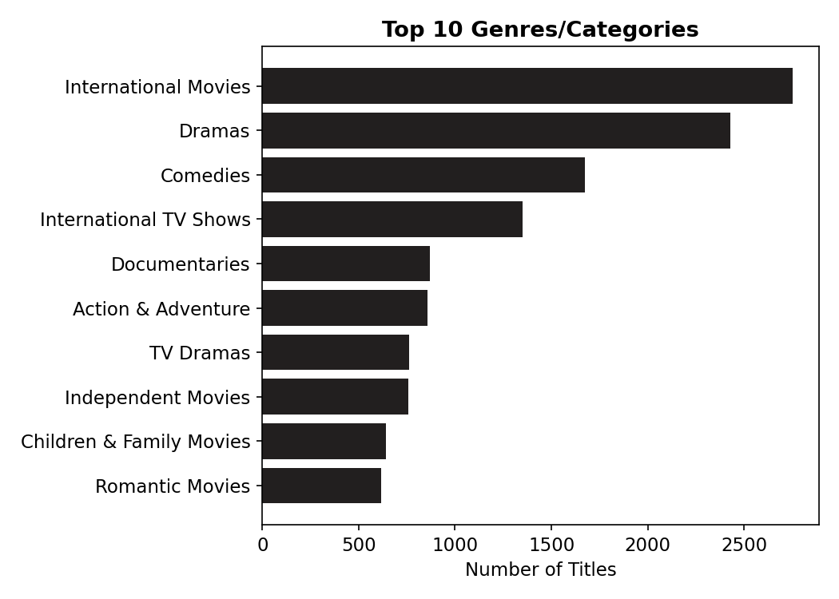
Chart 7: Top 10 Genres/Categories on Netflix
Finding: "International Movies" (2,752 tags), "Dramas" (2,427 tags) and "Comedies" (1,674 tags) are the three most frequently applied genre tags. Because a single title can belong to multiple genres, these counts reflect tag frequency, not unique title counts.

16. Feature Engineering
The following new features were created from existing columns to make analysis easier:

duration_num and duration_unit
- Why it was created: The original duration column mixed numbers and text (e.g., "90 min", "2 Seasons"), which cannot be used directly in numerical analysis or charts.
- Business benefit: Splitting it into a numeric value and a unit made it possible to calculate average movie length and average number of TV seasons, and to build the duration distribution charts.

date_added_parsed
- Why it was created: The original date_added column was stored as text, so trends over time could not be calculated.
- Business benefit: Converting it to a proper date type allowed titles to be grouped by year, revealing the catalogue growth trend shown in Chart 4.

Exploded Country and Genre Columns
- Why it was created: Many titles list multiple countries or genres in a single cell, separated by commas (e.g., "United States, India"), which would undercount each individual country or genre if left as-is.
- Business benefit: Splitting these into individual entries (one row per country/genre) allowed for an accurate count of each country's and genre's true contribution to the catalogue.

17. Data Visualization
All charts used in this report are summarized below, along with the reasoning behind each chart choice, the key observation, and its business interpretation. (Charts already shown earlier in this report are referenced again here for completeness; the TV Show Seasons and Missing Values charts are shown for the first time below.)
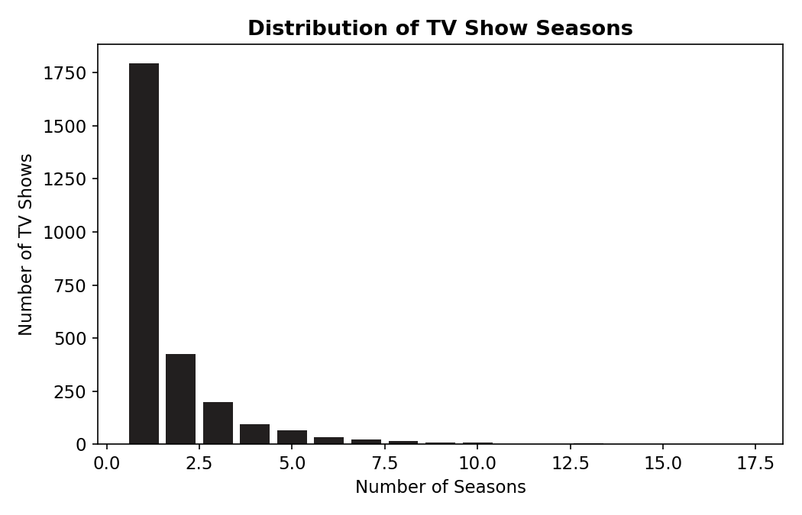
Chart 8: Distribution of TV Show Seasons
Observation: The vast majority of TV Shows have just 1 or 2 seasons, with very few extending beyond 5 seasons. Business interpretation: Netflix's TV strategy favors a large volume of shorter-run series over a small number of long-running ones.
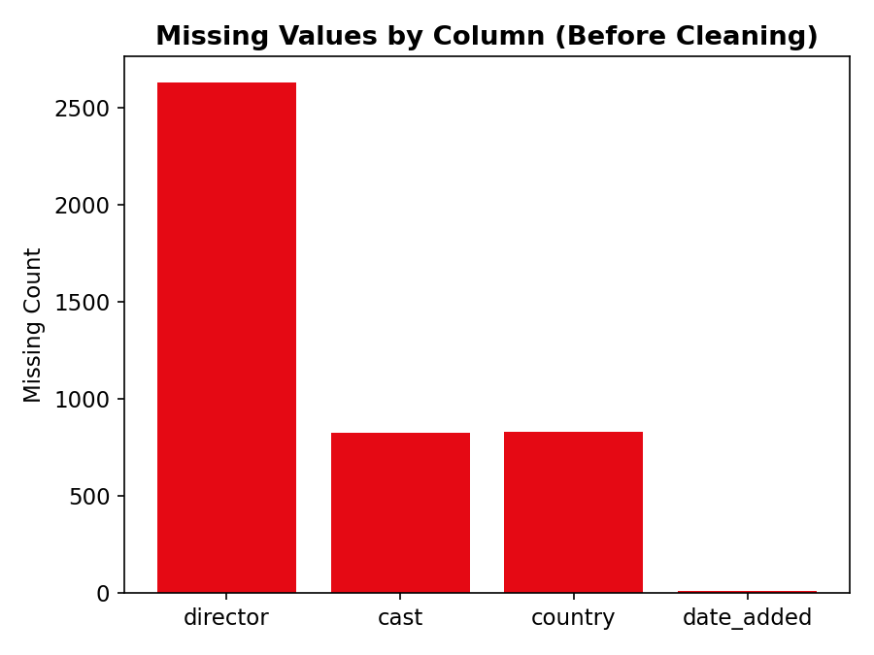
Chart 9: Missing Values by Column (Before Cleaning)
Observation: The director column had by far the most missing entries, followed by cast and country. Business interpretation: Director information is the least consistently available metadata field, which is worth noting for any future analysis relying on director-level data.

Chart Reference Summary
Chart | Objective | Type | Key Observation
Content Type Distribution | Show the split between Movies and TV Shows. | Bar Chart | Movies outnumber TV Shows by more than 2 to 1.
Top 10 Countries | Identify the leading content-producing countries. | Horizontal Bar Chart | The US, India, and UK lead by a wide margin.
Titles Added per Year | Track catalogue growth over time. | Line Chart | Sharp growth 2016–2019, decline in 2020–2021.
Top 10 Genres | Identify the most common content genres. | Horizontal Bar Chart | International Movies, Dramas, and Comedies lead.
Top 10 Content Ratings | Show the audience/maturity mix of the catalogue. | Bar Chart | TV-MA and TV-14 dominate.
Movie Duration Distribution | Show how long Netflix movies typically run. | Histogram | Most movies run 85–115 minutes.
TV Show Seasons Distribution | Show how many seasons TV Shows typically have. | Bar Chart | 67% of TV Shows have only 1 season.
Release Year Trend by Type | Compare Movie vs TV Show release trends. | Multi-Line Chart | TV Show releases grew faster after 2015.
Missing Values by Column | Visualize data-quality gaps before cleaning. | Bar Chart | Director had the most missing values.

18. Business Insights
- Movies remain the core of the catalogue: At 69.6% of all titles, Movies are still the backbone of Netflix's content library, even as streaming competitors invest heavily in original series.
- Content sourcing is geographically concentrated: Just three countries — the United States, India, and the United Kingdom — account for a disproportionately large share of the catalogue, with 124 other countries splitting the remainder.
- Catalogue growth peaked in 2019: Titles added per year rose nearly 100-fold between 2011 and 2019, then declined in 2020 and 2021, a pattern consistent with pandemic-related production disruptions.
- Drama and comedy are the safest genre bets: "Dramas" and "Comedies" rank among the top genres consistently, suggesting these categories have broad, dependable audience appeal.
- TV strategy favors short-run series: 67% of TV Shows have only one season, indicating Netflix commissions many shows on a trial basis rather than committing to long multi-season runs upfront.
- The catalogue skews toward mature audiences: TV-MA and TV-14 together make up 61% of all rated content, showing the platform's core content mix is not primarily aimed at young children.
- India shows a distinct content pattern: India's Movie-to-TV-Show ratio (about 11:1) is far more Movie-heavy than the US or UK, reflecting the historical dominance of the Indian film industry over episodic television in that market's Netflix offering.

19. Recommendations

1. Diversify content sourcing beyond the top 3 countries
Why suggested: With the US, India, and UK dominating the catalogue, there is a clear opportunity gap in other regions. Expected business benefit: Investing in under-represented regions (e.g., broader Latin American, African, or Southeast Asian content) could attract new subscriber segments and reduce over-reliance on a few markets.

2. Investigate the 2020–2021 content addition slowdown
Why suggested: The sharp drop in titles added after the 2019 peak stands out from the otherwise steady growth trend. Expected business benefit: Understanding whether this was purely pandemic-driven or reflects a strategic shift would help forecast and plan future content pipeline investment more accurately.

3. Continue investing in Drama and Comedy genres
Why suggested: These genres consistently rank at the top of the catalogue by volume, suggesting proven audience demand. Expected business benefit: Prioritizing acquisition and production budgets toward these dependable genres reduces content investment risk.

4. Track single-season show performance to inform renewal decisions
Why suggested: With 67% of TV Shows having just one season, understanding why (cancellation vs. planned limited series) would clarify content strategy. Expected business benefit: This distinction affects budget planning and helps set clearer expectations with content creators and audiences.

5. Improve metadata completeness for director and cast fields
Why suggested: With director missing in nearly 30% of records, this metadata gap limits any future director- or cast-based analysis (e.g., identifying top-performing directors). Expected business benefit: Better metadata collection at the content-acquisition stage would unlock more precise talent-based content analysis in the future.

20. Challenges Faced
- Missing values: Three columns (director, cast, country) had substantial missing data, requiring a thoughtful approach (labeling as "Not Specified") rather than simply deleting rows and losing data.
- Data quality issue in the rating column: Three rows had duration values ("74 min", "84 min", "66 min") incorrectly stored in the rating field, which required manual inspection to catch and correct — a good reminder that automated cleaning alone is not always enough.
- Inconsistent formatting in duration: The duration column combined two very different concepts (minutes for Movies, seasons for TV Shows) in a single text field, requiring careful splitting by content type.
- Multi-value fields: The country and listed_in columns often contained multiple comma-separated values per row, which required "exploding" the data into individual entries to get accurate counts per country or genre.
- Data limitations: The dataset does not include viewership numbers, subscriber ratings, or revenue data, which limited the business questions that could be answered to catalogue composition rather than content performance.

21. Conclusion
This project analyzed the Netflix Movies and TV Shows dataset from start to finish — starting with raw, unclean data and ending with a set of clear, data-backed business insights. The dataset was explored, cleaned (including catching and fixing a real data-entry error), and analyzed using univariate, bivariate, and multivariate techniques.
Major findings show that Netflix's catalogue is Movie-heavy but with a growing TV Show presence, concentrated in a small number of content-producing countries, weighted toward mature-audience ratings, and grew fastest between 2016 and 2019 before slowing in the most recent years covered by the data.
Business value: These insights could support real decisions around regional content investment, genre prioritization, and TV series commissioning strategy — the kind of analysis a content strategy or business intelligence team would perform routinely.
Final outcome: A cleaned dataset, nine business-focused visualizations, and a complete set of documented insights and recommendations were produced, fulfilling all the objectives set out at the start of this project.

22. Future Scope
- Dashboard creation: Build an interactive dashboard (e.g., using Power BI, Tableau, or Streamlit) so stakeholders can filter and explore the data themselves.
- Machine learning models: Build a genre or rating prediction model based on a title's description and metadata.
- Predictive analytics: If viewership data becomes available, build models to predict which upcoming titles are likely to perform well.
- Recommendation systems: Use genre, cast, and description data to build a simple content-based recommendation engine.
- Automation: Automate this entire analysis to refresh automatically whenever the Netflix catalogue dataset is updated.
- Real-time reporting: Connect this analysis pipeline to a live data source for continuously updated business reporting.

23. References
- Dataset Source: Netflix Movies and TV Shows dataset (netflix_titles.csv)
- Python Documentation — https://docs.python.org/3/
- Pandas Documentation — https://pandas.pydata.org/docs/
- NumPy Documentation — https://numpy.org/doc/
- Matplotlib Documentation — https://matplotlib.org/stable/index.html
- Seaborn Documentation — https://seaborn.pydata.org/

