DATA ANALYSIS PROJECT REPORT
Supermarket Sales Analysis
Analyzing Sales, Customer Behaviour, and Branch Performance Across Three Supermarket Branches
🛒
Prepared By | Data Analytics Project Team
Organization / Institute | Independent / Academic Data Analytics Project
Date | August 2026
Dataset | Supermarket Sales (1,000 transactions)
Tools Used | Python, Pandas, NumPy, Matplotlib, Seaborn
Technologies Used | Jupyter Notebook / VS Code, Microsoft Word

Table of Contents
1. Cover Page 1
2. Executive Summary 3
3. Introduction 5
4. Problem Statement 6
5. Project Objectives 7
6. Dataset Description 8
7. Business Questions 10
8. Tools and Technologies 11
9. Project Workflow 12
10. Data Loading 13
11. Data Exploration 14
12. Data Cleaning 16
13. Exploratory Data Analysis (EDA) — Univariate Analysis 18
14. Bivariate Analysis 22
15. Multivariate Analysis 25
16. Feature Engineering 27
17. Data Visualization 28
18. Business Insights 31
19. Recommendations 32
20. Challenges Faced 33
21. Conclusion 34
22. Future Scope 35
23. References 36

2. Executive Summary
This project analyzes 1,000 individual sales transactions from a supermarket chain operating three branches — Alex (Yangon), Cairo (Mandalay), and Giza (Naypyitaw) — over a three-month period from January to March 2019. The objective was to understand sales performance, product line profitability, customer behaviour, and timing patterns, and to translate these findings into practical business recommendations.

Project Objective
To clean, explore, and analyze the supermarket sales dataset in order to uncover branch performance differences, product line trends, customer purchasing behaviour, and peak sales timing, and to generate actionable recommendations for store operations and marketing.

Dataset Overview
The dataset contains 1,000 complete transaction records across 17 original columns, covering branch and city, customer type, gender, product line, pricing and quantity, tax and gross income, payment method, date and time, and customer satisfaction rating, spanning 1 January 2019 to 30 March 2019.

Analysis Performed
- Data cleaning and verification: confirmed the dataset had no missing values or duplicate rows, converted date and time fields, and verified the internal consistency of all financial columns.
- Univariate analysis of Branch, Product line, Customer type, Gender, Payment method, Sales, and Rating.
- Bivariate analysis of Sales against Quantity, Unit Price, and Product line/Branch combinations.
- Multivariate analysis using a correlation matrix and grouped pivot summaries across branches, product lines, and customer segments.
- Time-based analysis of sales by hour of day and day of week.

Major Findings
- The three branches perform very evenly, with total sales ranging narrowly from $106,198 (Cairo) to $110,569 (Giza) — no single branch dominates.
- Food and beverages is the top-selling product line by revenue ($56,145), while Health and beauty is the lowest ($49,194).
- Member customers generate 42% more total revenue than Normal customers ($189,695 vs $133,272), despite Members making up only 56.5% of transactions.
- Female customers account for 60% of total sales revenue ($194,672 of $322,967), outspending male customers by a wide margin.
- Sales are strongly driven by Quantity (0.71 correlation) and Unit Price (0.63 correlation), as expected for a per-item pricing model.
- The 7 PM hour is the single busiest hour for sales ($39,700), and Saturday is the busiest day of the week ($56,121).
- Customer satisfaction Rating shows essentially no relationship with Sales amount (correlation -0.04), meaning bigger purchases do not correspond to happier or unhappier customers.

Business Value
These findings help store operations, marketing, and merchandising teams understand which product lines and customer segments drive the most revenue, when staffing should peak, and where loyalty programs are already paying off — informing decisions on stocking, staffing, and targeted promotions.

Final Outcome
The analysis produced a clear, data-backed picture of supermarket performance over the three-month period, along with a set of prioritized, actionable recommendations to grow revenue and improve customer targeting — detailed in Sections 18–19 of this report.

3. Introduction
Retail and supermarket businesses generate a transaction record every time a customer checks out — what they bought, how much, at what price, when, and how they paid. This project uses one such dataset, covering 1,000 transactions across three supermarket branches, to demonstrate a complete, real-world data analysis workflow, from raw data to business recommendations.

What This Project Is About
This project takes a CSV file of individual point-of-sale transactions and turns it into a structured, professional analysis. It covers data cleaning, exploratory data analysis (EDA), visualization, and business insight generation — the same process a data analyst would follow inside a retail or supermarket chain.

Why This Analysis Is Important
Retail is a high-volume, competitive business where understanding which products sell, which customers spend the most, and when demand peaks directly shapes stocking, staffing, and promotional decisions. Small improvements in any of these areas compound across thousands of transactions.

Real-World Business Relevance
- Merchandising teams can use product-line performance data to guide shelf space and stocking priorities.
- Marketing teams can use customer-type and gender spending patterns to target loyalty programs and promotions more precisely.
- Operations teams can use hourly and daily demand patterns to plan staffing levels.
- Finance teams can use branch-level revenue and margin data to benchmark performance across locations.

Expected Outcome
A clear, evidence-based understanding of sales performance, customer behaviour, and timing patterns, presented through visualizations and summarized into practical recommendations that a supermarket chain could act on.

4. Problem Statement
A supermarket chain generates thousands of individual transactions across multiple branches and product lines, but without structured analysis, it is difficult to know which branches, products, and customer segments are actually driving revenue and profitability.

What Business Problem the Dataset Helps Solve
- Identifying which branches and product lines generate the most revenue and profit.
- Understanding how customer type (Member vs Normal) and gender relate to spending behaviour.
- Determining the busiest hours and days so staffing can be planned accordingly.
- Assessing whether customer satisfaction (Rating) relates to purchase size or product line.

Why Analyzing This Data Is Useful
Without structured analysis, a business only sees total revenue, not the underlying patterns driving it. Data analysis breaks 1,000 individual transactions down into patterns that are small enough in number to be understood and large enough in scale to be trusted.

How Organizations Can Benefit
- Focus marketing and loyalty efforts on the customer segments that already spend the most.
- Align staffing schedules with actual peak-hour and peak-day demand.
- Prioritize shelf space and promotions for the product lines that generate the most revenue.
- Benchmark branch performance to identify where operational practices could be shared or improved.

5. Project Objectives
- Understand the structure, size, and content of the supermarket sales dataset.
- Clean and verify the dataset, confirming data quality and internal consistency.
- Explore Branch, Product line, Customer type, Gender, and Payment method patterns.
- Perform univariate, bivariate, and multivariate exploratory data analysis (EDA).
- Create meaningful, business-relevant visualizations for every key variable.
- Generate insights that are fully supported by the data — no assumptions.
- Provide practical, actionable recommendations for sales, marketing, and staffing decisions.

6. Dataset Description
Field | Value
Dataset Name | Supermarket Sales
Dataset Source | User-provided CSV file ("SuperMarket_Analysis.csv") of point-of-sale transactions
Number of Rows | 1,000
Number of Columns (original) | 17
Number of Columns (after feature engineering) | 20 (3 date/time features added)
Time Period Covered | 1 January 2019 – 30 March 2019
Branches Covered | 3 (Alex/Yangon, Cairo/Mandalay, Giza/Naypyitaw)

Column-by-Column Description
Column | Description | Type
Invoice ID | Unique identifier for each transaction (e.g. 750-67-8428) | Text
Branch | Store branch code: Alex, Cairo, or Giza | Categorical
City | City where the branch is located: Yangon, Mandalay, or Naypyitaw | Categorical
Customer type | Whether the customer is a Member (loyalty program) or Normal (non-member) | Categorical
Gender | Customer's gender: Male or Female | Categorical
Product line | Category of product purchased (6 categories, e.g. Food and beverages) | Categorical
Unit price | Price per unit of the product, in US Dollars | Numerical
Quantity | Number of units purchased in the transaction | Numerical
Tax 5% | 5% sales tax applied to the transaction, in US Dollars | Numerical
Sales | Total transaction value including tax (Unit price × Quantity + Tax), in US Dollars | Numerical
Date | Date of the transaction (1 Jan – 30 Mar 2019) | Date/Time
Time | Time of day the transaction occurred | Date/Time
Payment | Payment method used: Cash, Credit card, or Ewallet | Categorical
cogs | Cost of goods sold, in US Dollars | Numerical
gross margin percentage | Gross margin percentage applied (constant at 4.76% for every transaction) | Numerical
gross income | Gross income earned on the transaction (equal to Tax 5%), in US Dollars | Numerical
Rating | Customer satisfaction rating for the transaction, on a scale of 4 to 10 | Numerical

7. Business Questions
The following business questions can be directly answered using the fields available in this dataset:
- Which branch generates the most total sales and gross income?
- Which product lines perform best and worst in terms of revenue?
- Do Member customers spend more than Normal customers?
- How does spending differ between male and female customers?
- Which payment method is most popular?
- What time of day and day of week see the highest sales?
- Is there a relationship between quantity purchased, unit price, and total sales?
- Does customer satisfaction (Rating) vary by product line or purchase size?
- Which product lines are most popular with each customer type?
Questions that cannot be reliably answered from this dataset — such as individual customer identity across visits, product-level (SKU) detail, competitor pricing, or profitability after fixed operating costs like rent and staffing — are intentionally excluded, since the data does not support them.

8. Tools and Technologies
Tool | Purpose | Real-World Use
Python | Core programming language for the entire analysis | Industry-standard language for data analytics and automation
Pandas | Loading, cleaning, and transforming tabular data | Used to filter, group, and summarize retail transaction data
NumPy | Numerical operations and array-based calculations | Powers fast statistical computation behind Pandas and ML libraries
Matplotlib | Creating static charts (bar, line, scatter, histogram) | Standard plotting library used in almost every Python data report
Seaborn | Statistical visualizations with cleaner default styling | Used for quick, presentation-ready charts like heatmaps and box plots
Jupyter Notebook / VS Code | Interactive coding environment for step-by-step analysis | Lets analysts write code, view results, and document findings together

9. Project Workflow
The analysis followed a standard, linear data-analysis workflow, shown below. Each stage builds on the previous one, ensuring that every conclusion is traceable back to the raw data.
Step | What Was Done
Problem Statement | Defined the business problem: understanding what drives sales across branches, products, and customer segments.
Dataset Collection | Received the Supermarket Sales CSV file containing 1,000 transaction records.
Import Libraries | Loaded Pandas, NumPy, Matplotlib, and Seaborn into the Python environment.
Load Dataset | Read the CSV file into a Pandas DataFrame for analysis.
Data Exploration | Checked shape, column names, data types, and summary statistics.
Data Cleaning | Verified no missing values or duplicates, converted date/time fields, checked financial-field consistency.
Exploratory Data Analysis | Examined every column's distribution and relationships.
Univariate Analysis | Studied each variable individually (Branch, Sales, Rating, etc.).
Bivariate Analysis | Compared two variables at a time, e.g. Sales vs Quantity.
Multivariate Analysis | Built a correlation matrix and grouped pivot summaries across several fields.
Feature Engineering | Created Hour, Day of Week, and Month columns from the raw date/time fields.
Data Visualization | Built 16 charts covering distributions, trends, and comparisons.
Business Insights | Converted statistical findings into plain-English business insights.
Recommendations | Proposed concrete actions the business could take based on the insights.
Conclusion | Summarized the overall findings and business value of the analysis.

10. Data Loading

Importing Libraries
Before working with any data, the required Python libraries were imported: Pandas (for tabular data), NumPy (for numerical operations), and Matplotlib/Seaborn (for charts).

Reading the Dataset
The CSV file was read into Python using pandas.read_csv(). The file contained a UTF-8 byte-order-mark character at the start of the first column name, which was handled automatically during loading to ensure the 'Invoice ID' column name was read correctly.

The DataFrame Concept
A DataFrame is Pandas' core data structure — think of it as a spreadsheet inside Python, made of rows and columns, where each column can hold a different type of data (numbers, text, or dates) and every row represents one sales transaction.

Displaying the Dataset
The first few rows were viewed using df.head() to visually confirm that the data loaded correctly and that column names and values looked as expected.

Verifying Successful Loading
The dataset's shape confirmed 1,000 rows and 17 original columns, matching the size of the raw CSV file, which verified that no rows were lost or corrupted during loading.

11. Data Exploration
Before cleaning or analyzing the data, it is important to understand its basic shape and structure. Each function below is documented with its purpose, syntax, output, and business interpretation, in beginner-friendly terms.

df.head()
Purpose: Shows the first 5 rows of the dataset
Syntax: df.head()
Output: A quick preview of 5 sample transactions with all 17 columns
Business Interpretation: Confirms the data loaded correctly and gives a first look at real transactions

df.tail()
Purpose: Shows the last 5 rows of the dataset
Syntax: df.tail()
Output: The final 5 transactions in the file (dated late March 2019)
Business Interpretation: Confirms the dataset is complete and not cut off

df.shape
Purpose: Returns (rows, columns) as a tuple
Syntax: df.shape
Output: (1000, 17)
Business Interpretation: Confirms the dataset scale — exactly 1,000 individual transactions to analyze

df.columns
Purpose: Lists all column names
Syntax: df.columns
Output: All 17 field names, e.g. Branch, Product line, Sales, Rating
Business Interpretation: Confirms which business fields are available for analysis

df.dtypes
Purpose: Shows the data type of every column
Syntax: df.dtypes
Output: Text columns for IDs/categories, float64/int64 for numeric fields
Business Interpretation: Flags which columns are ready for numeric analysis and which need date conversion

df.info()
Purpose: Summarizes columns, non-null counts, and memory usage
Syntax: df.info()
Output: Confirms all 1,000 entries are complete with zero missing values in any column
Business Interpretation: Immediately shows this is an unusually complete, well-maintained transaction log

df.describe()
Purpose: Generates summary statistics for numeric columns
Syntax: df.describe()
Output: Mean, min, max, quartiles for Sales, Unit price, Quantity, Rating, etc.
Business Interpretation: Gives a fast statistical snapshot of pricing, spending, and satisfaction ranges

12. Data Cleaning

Checking for Missing Values
Why it is required: Missing values in key fields like Sales, Quantity, or Rating could distort every downstream statistic.
Method used: Used df.isnull().sum() to check every column for missing values.
Advantage: Confirms whether the dataset needs any missing-value handling at all before proceeding.
Limitation: A missing-value check only catches truly empty cells, not values that are technically present but incorrect.
Business impact: Zero missing values were found in any of the 17 columns — this is an unusually complete dataset that required no filling, dropping, or imputation.

Checking for Duplicate Rows
Why it is required: Duplicate transactions would double-count sales and distort every revenue and quantity statistic.
Method used: Used df.duplicated().sum() to check for fully duplicated rows, and separately confirmed Invoice ID uniqueness.
Advantage: Confirms the dataset is safe to analyze as-is, with each row representing one genuine transaction.
Limitation: A row-level check cannot detect data-entry errors that still produce a technically unique row.
Business impact: Zero duplicate rows and zero duplicate Invoice IDs were found — every one of the 1,000 rows represents a distinct transaction.

Correcting Data Types
Why it is required: The Date and Time columns were stored as plain text, which prevents time-based sorting, filtering, and trend analysis.
Method used: Converted Date to a proper datetime type using pandas.to_datetime() with the correct month/day/year format, and parsed Time separately to extract the hour of day.
Advantage: Enables hour-of-day and day-of-week analysis (Sections 13 and 17).
Limitation: Relies on the original text format being consistent, which it was in this dataset.
Business impact: Made all time-based trend analysis in this report possible.

Verifying Internal Consistency of Financial Fields
Why it is required: With five related financial columns (Unit price, Quantity, Tax 5%, Sales, cogs, gross income), it is important to confirm they agree with each other before trusting any of them.
Method used: Checked that Sales = cogs + Tax 5% for every row, and that gross income = Tax 5% for every row, using direct numeric comparison.
Advantage: Confirms the financial data is internally consistent and mathematically sound, giving confidence in all revenue and profit calculations that follow.
Limitation: Internal consistency does not guarantee the original prices or costs themselves are accurate — only that the arithmetic between columns is correct.
Business impact: Both relationships held exactly for all 1,000 rows, confirming the financial columns can be trusted for analysis.

Flagging a Constant, Non-Informative Column
Why it is required: The 'gross margin percentage' column was found to be exactly 4.761904762 for every single row, meaning it carries no distinguishing information.
Method used: Verified using df['gross margin percentage'].unique(), which returned only one value across all 1,000 rows.
Advantage: Identifying constant columns early avoids wasting analysis effort on a field that cannot explain any variation in the data.
Limitation: A constant value in this sample does not guarantee it is fixed company-wide policy rather than a coincidence of this particular export.
Business impact: This column was excluded from correlation and comparison analysis, since a constant value cannot correlate meaningfully with anything.

Checking Categorical Values for Consistency
Why it is required: Inconsistent capitalization, spelling, or stray whitespace in columns like Branch, Product line, or Payment could split identical categories apart.
Method used: Reviewed unique values in every categorical column using .value_counts(); all values were clean, consistently formatted, and matched expectations (e.g. exactly 3 branches, 6 product lines, 3 payment methods).
Advantage: Confirms categorical counts and groupings used throughout this report are accurate.
Limitation: A review of unique values does not catch inconsistencies that happen to produce a valid-looking but incorrect category.
Business impact: No further text-cleaning steps were required for this dataset.

13. Exploratory Data Analysis (EDA) — Univariate Analysis

Numerical Columns
Statistic | Sales ($) | Unit Price ($) | Quantity | Rating
Mean | 322.97 | 55.67 | 5.51 | 6.97
Median | 253.85 | 55.23 | 5.00 | 7.00
Minimum | 10.68 | 10.08 | 1.00 | 4.00
Maximum | 1,042.65 | 99.96 | 10.00 | 10.00
Std. Deviation | 245.89 | 26.49 | 2.92 | 1.72
25th Percentile (Q1) | 124.42 | 32.88 | 3.00 | 5.50
75th Percentile (Q3) | 471.35 | 77.94 | 8.00 | 8.50

Business Meaning
- The median Sales value ($253.85) is well below the mean ($322.97), meaning a smaller number of large-basket transactions pull the average upward — most purchases are moderately sized.
- Quantity purchased ranges from 1 to 10 units per transaction, with a median of 5 — there is no single dominant basket size.
- Ratings cluster in a fairly narrow, healthy band between 4 and 10, with a mean of 6.97, suggesting generally positive but not extreme customer satisfaction.

Sales Distribution
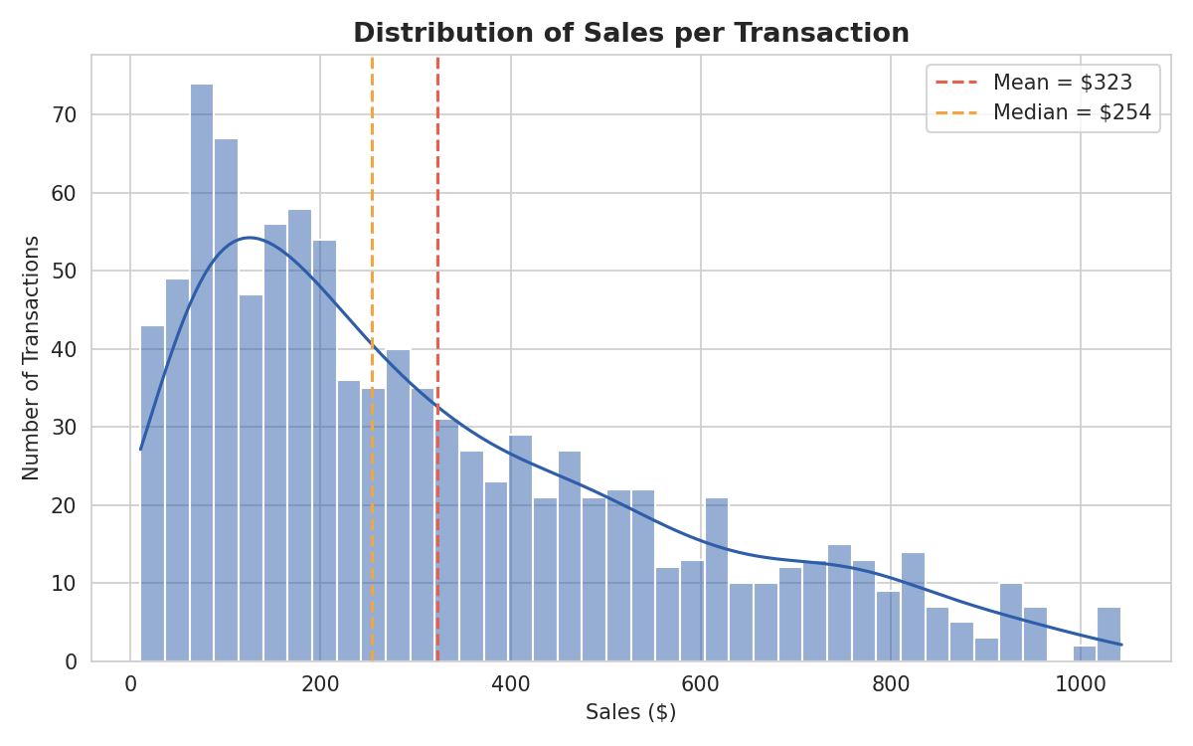
Figure 13.1 — Distribution of Sales per Transaction, showing a right-skewed pattern typical of retail spending.

Rating Distribution
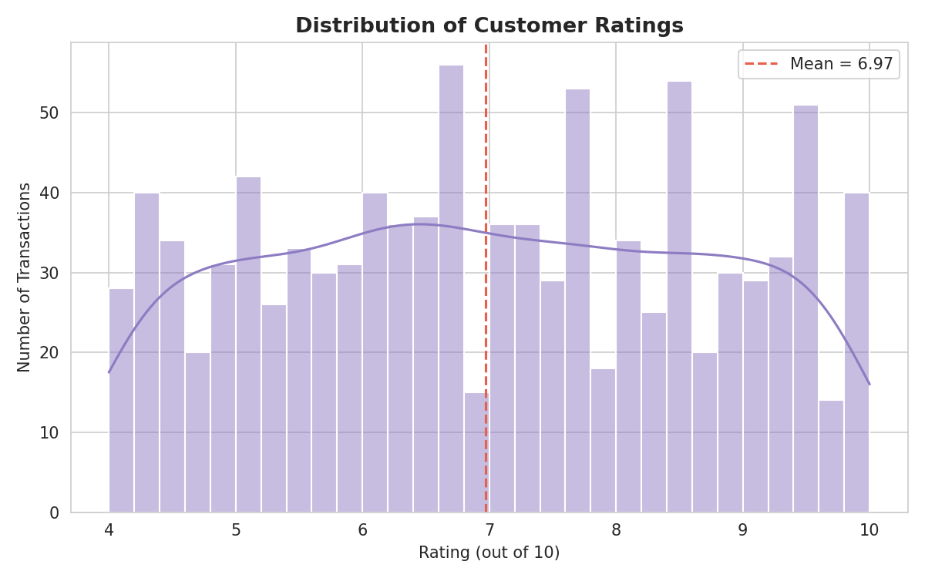
Figure 13.2 — Distribution of Customer Ratings across all transactions.

Categorical Columns — Frequency and Percentage

Branch
Branch | City | Count | Percentage
Alex | Yangon | 340 | 34.0%
Cairo | Mandalay | 332 | 33.2%
Giza | Naypyitaw | 328 | 32.8%
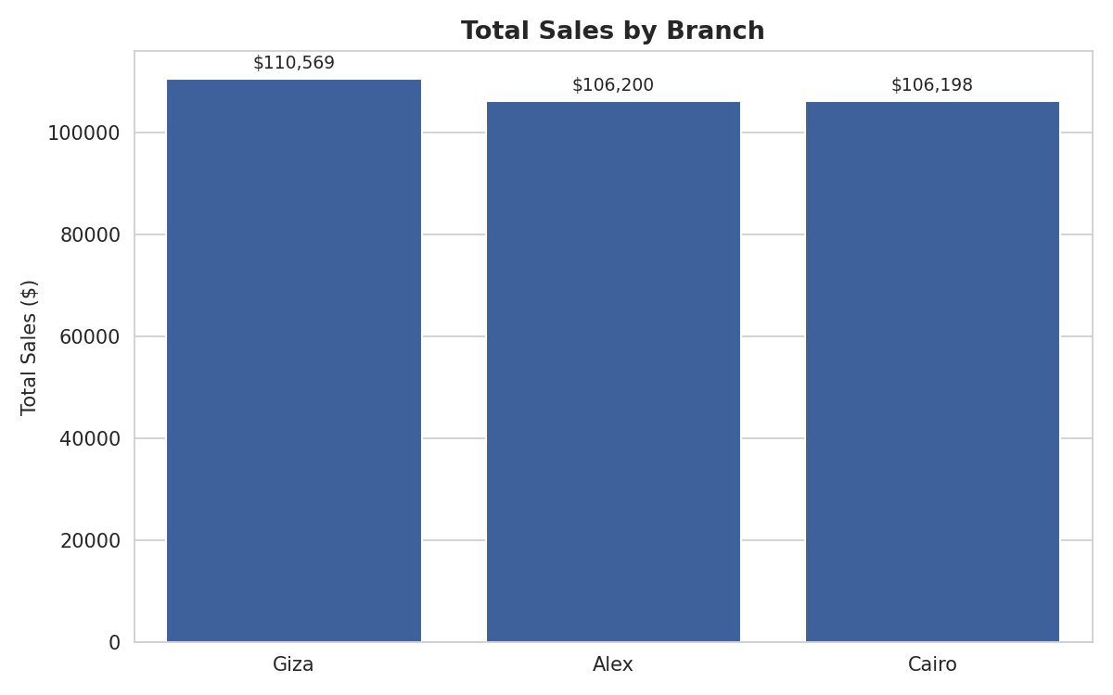
Figure 13.3 — Total Sales by Branch. Giza narrowly leads despite having the fewest transactions.

Product Line
Product Line | Count | Percentage
Fashion accessories | 178 | 17.8%
Food and beverages | 174 | 17.4%
Electronic accessories | 170 | 17.0%
Sports and travel | 166 | 16.6%
Home and lifestyle | 160 | 16.0%
Health and beauty | 152 | 15.2%
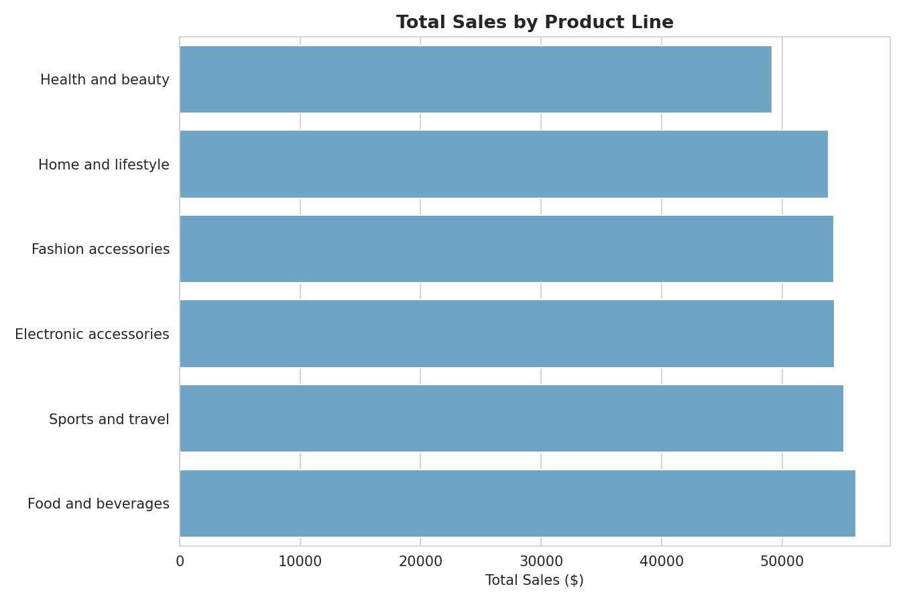
Figure 13.4 — Total Sales by Product Line. Food and beverages generates the most revenue despite not having the most transactions.

Customer Type and Gender
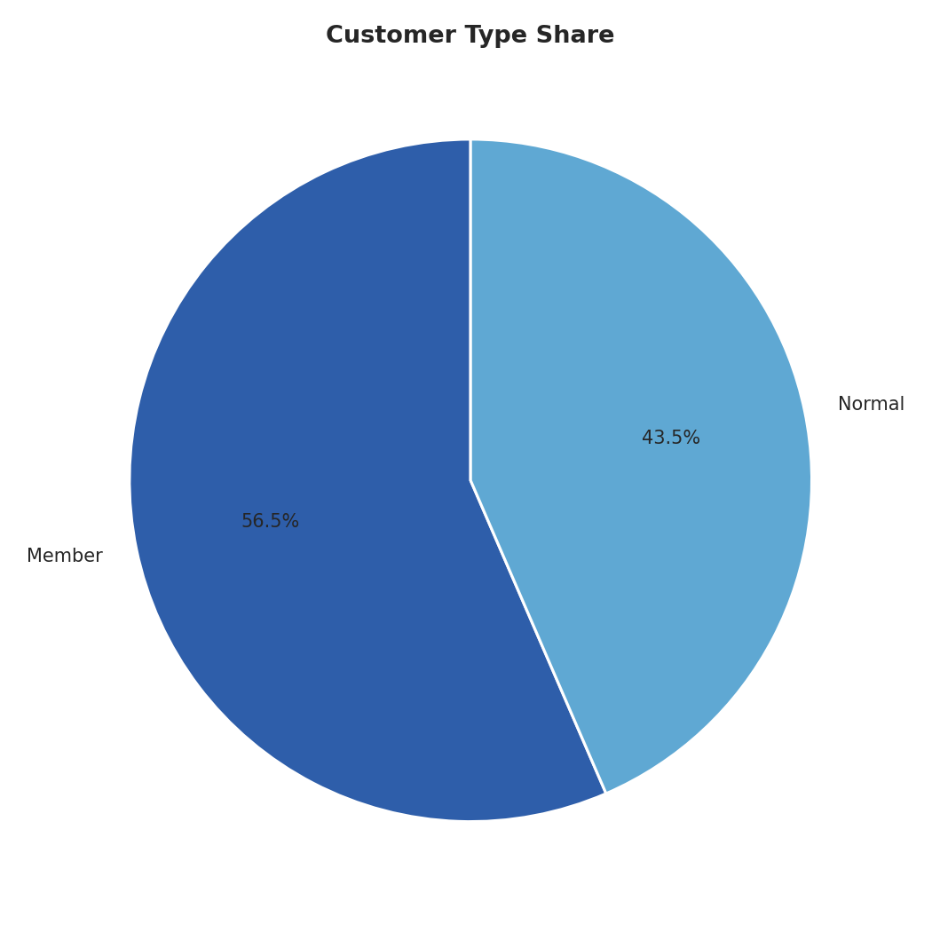
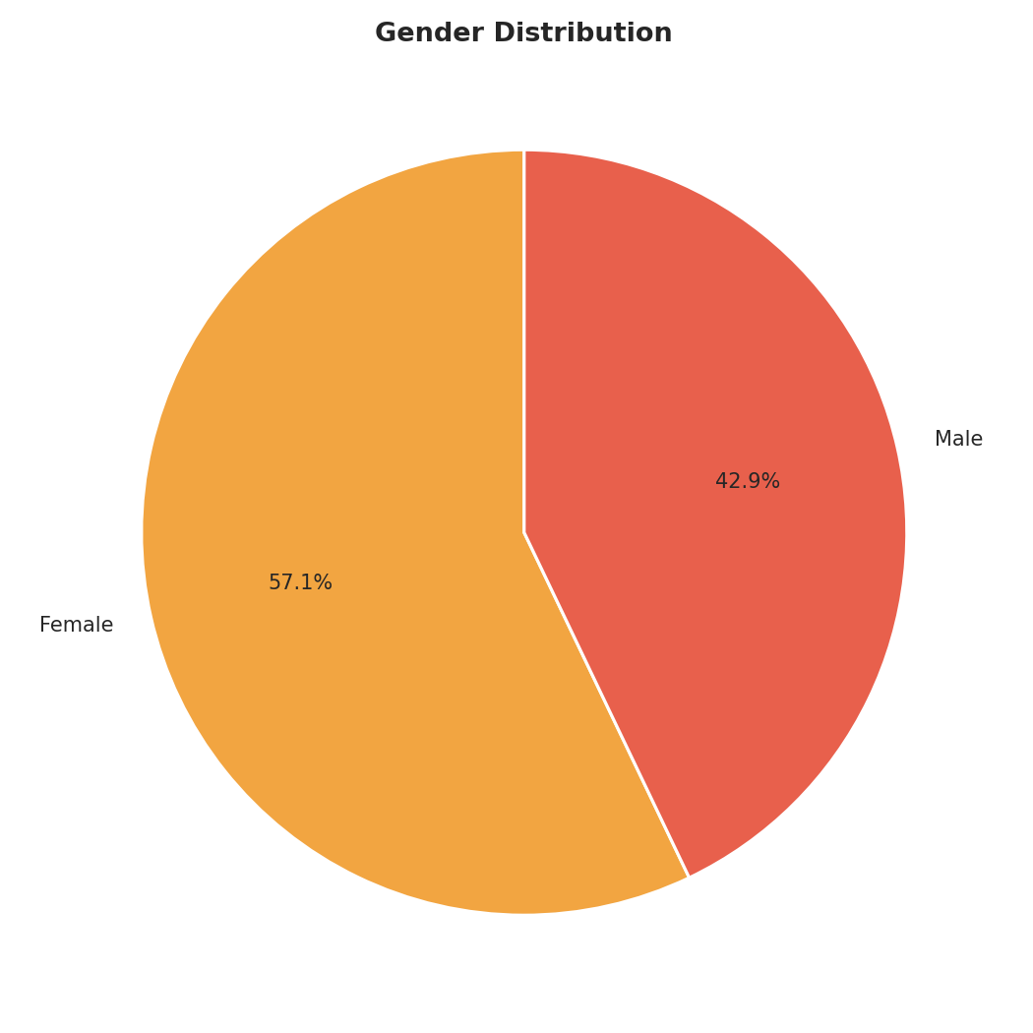
Figure 13.5 — Customer Type Share (left) and Gender Distribution (right).
Business meaning: Members make up 56.5% of transactions, while Female customers make up 57.1% — both are the majority groups, and both are explored further for spending differences in Section 14.

Payment Method
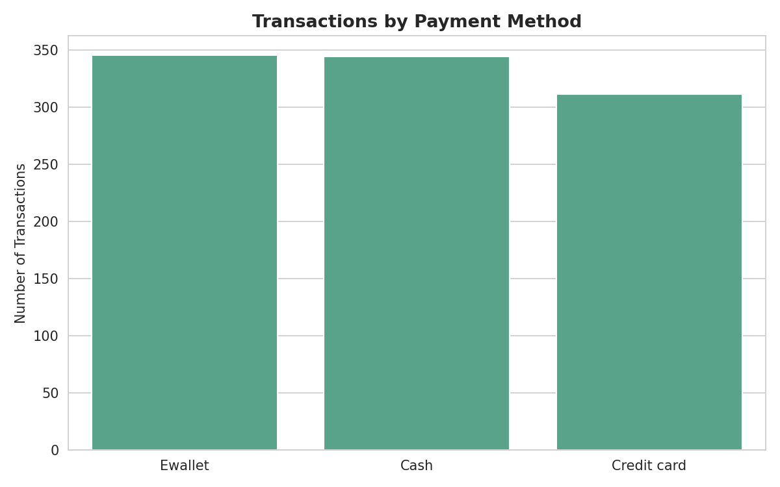
Figure 13.6 — Transactions by Payment Method.
Business meaning: The three payment methods are used in almost equal proportion (Ewallet 34.5%, Cash 34.4%, Credit card 31.1%), showing no single payment method dominates customer preference.

14. Bivariate Analysis

Quantity vs Sales
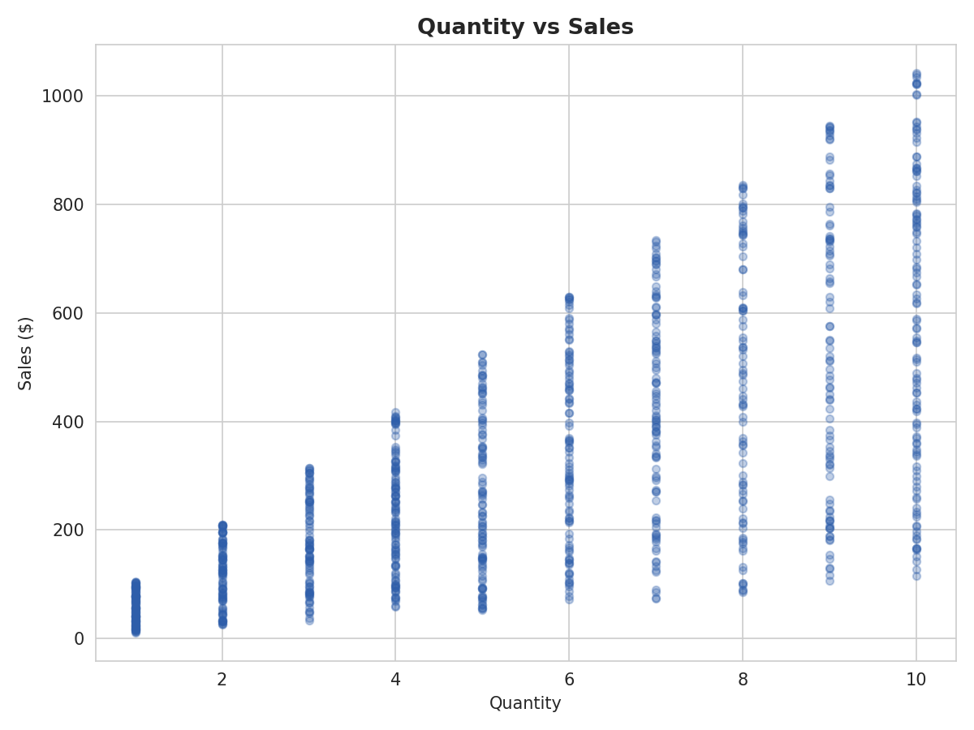
Figure 14.1 — Scatter plot of Quantity against Sales.
Relationship: There is a clear, fanning upward pattern — as Quantity increases, Sales increases, though with growing spread at higher quantities (since Sales also depends on unit price).
Trend: The correlation between Quantity and Sales is 0.71, the strongest relationship of any variable pair with Sales.
Business interpretation: Basket size (units purchased) is the single strongest lever on transaction value, making upselling and bundling strategies a logical focus for increasing average transaction size.

Unit Price vs Sales
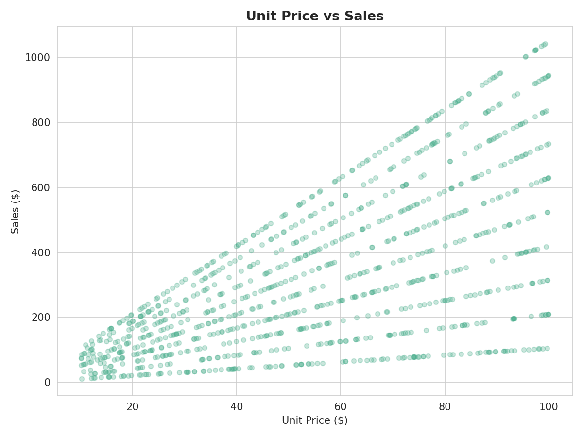
Figure 14.2 — Scatter plot of Unit Price against Sales.
Relationship: A similar fanning upward pattern appears, though slightly weaker and noisier than the Quantity relationship.
Trend: The correlation between Unit Price and Sales is 0.63.
Business interpretation: Both price and quantity contribute meaningfully to transaction value, confirming that no single lever alone explains total spend — product mix and basket size both matter.

Sales by Product Line and Branch
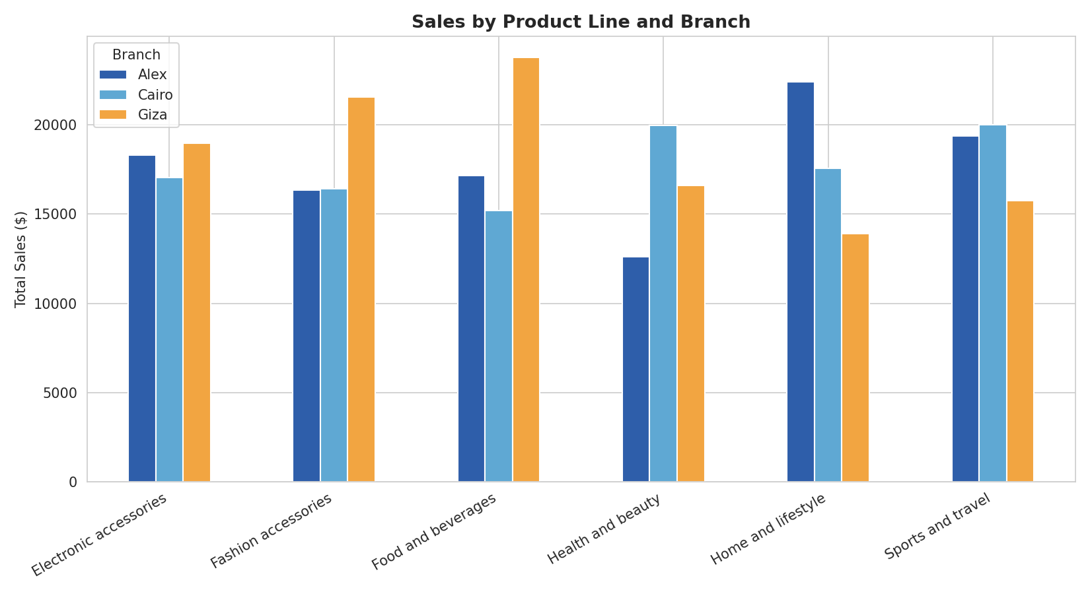
Figure 14.3 — Sales by Product Line, broken down by Branch.
Relationship: Product line performance varies meaningfully by branch — Giza leads in Food and beverages and Fashion accessories, while Alex leads in Home and lifestyle, and Cairo leads in Health and beauty.
Trend: No single branch dominates every product line; each branch has its own areas of relative strength.
Business interpretation: Branch-specific merchandising (stocking more of what already sells well locally) could outperform a one-size-fits-all approach across all three branches.

Product Line Preference by Customer Type
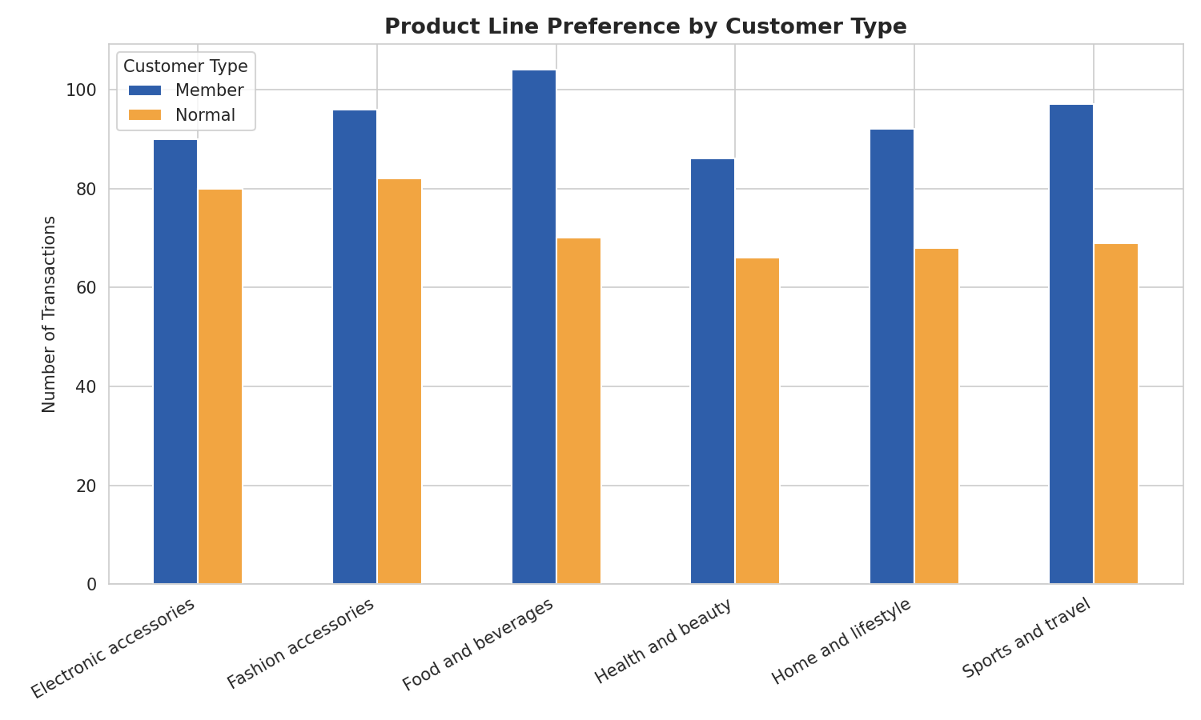
Figure 14.4 — Product Line transaction counts split by Customer Type.
Relationship: Member customers outnumber Normal customers across every single product line, consistent with Members' larger overall share of transactions.
Trend: No product line shows a reversed pattern where Normal customers outnumber Members, suggesting Member preference is broad rather than concentrated in specific categories.
Business interpretation: Loyalty-program marketing does not need to be product-line-specific, since Member engagement is consistently strong across the entire product range.

15. Multivariate Analysis

Correlation Matrix
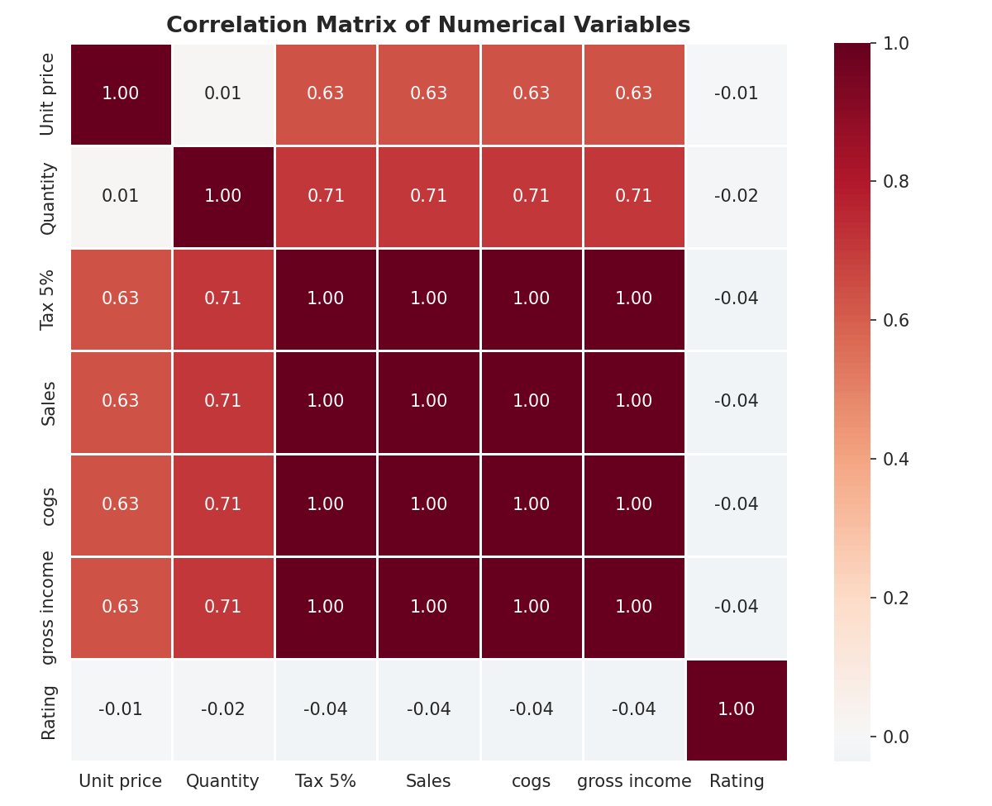
Figure 15.1 — Correlation matrix of key numerical variables.
Findings: Sales, Tax 5%, cogs, and gross income are all perfectly correlated (1.00) with each other. This is expected and mechanical rather than a genuine insight: since gross margin percentage is a fixed 4.76% for every transaction, these four fields are all directly calculated from one another by formula, not independently related. Quantity (0.71) and Unit price (0.63) are the two real, independent drivers of Sales. Rating shows almost no correlation with any financial variable (between -0.01 and -0.04), confirming customer satisfaction is unrelated to how much a customer spends.

Pivot Table — Total Sales and Gross Income by Branch
Branch | Total Sales | Average Sales per Transaction | Transaction Count
Giza | $110,569 | $337.10 | 328
Alex | $106,200 | $312.35 | 340
Cairo | $106,198 | $319.87 | 332
Findings: Giza has the highest total sales and the highest average sale per transaction, despite having the fewest transactions of the three branches — its customers tend to buy more per visit.

GroupBy Analysis — Sales by Customer Type
Customer Type | Total Sales | Average Sales | Transaction Count | Average Rating
Member | $189,695 | $335.74 | 565 | 6.92
Normal | $133,272 | $306.37 | 435 | 7.04
Findings: Member customers spend 9.6% more per transaction on average than Normal customers, and generate 42% more total revenue overall — but Normal customers report a marginally higher average satisfaction rating. This suggests the loyalty program is succeeding at driving spend without necessarily requiring higher satisfaction to do so.

GroupBy Analysis — Sales by Gender
Gender | Total Sales | Average Sales | Transaction Count
Female | $194,672 | $340.93 | 571
Male | $128,295 | $299.06 | 429
Findings: Female customers both transact more often (571 vs 429) and spend more per transaction ($340.93 vs $299.06) than male customers, making them the clearly dominant revenue segment in this dataset.

16. Feature Engineering
The raw dataset only provided separate Date and Time text columns. To enable time-based analysis, the following new columns were created:
New Feature | How It Was Created | Business Benefit
Hour | Extracted the hour (0–23) from the parsed Time column | Identifies peak and off-peak sales hours for staffing decisions (Section 17)
DayOfWeek | Extracted the day name (Monday–Sunday) from the parsed Date column | Reveals which days generate the most sales for scheduling and promotions
Month | Extracted the calendar month name from the parsed Date column | Enables month-over-month comparison within the three-month dataset window
No other derived fields were created, since the existing columns (Branch, Product line, Customer type, Payment, etc.) already provided clean, directly usable categories for analysis without needing further transformation.

17. Data Visualization

Sales by Hour of Day
Chart Title: Total Sales by Hour of Day
Objective: To identify peak and low-demand hours for staffing and promotional planning.
Why this chart was selected: A line chart clearly shows the shape of a trend across ordered hours of the day.
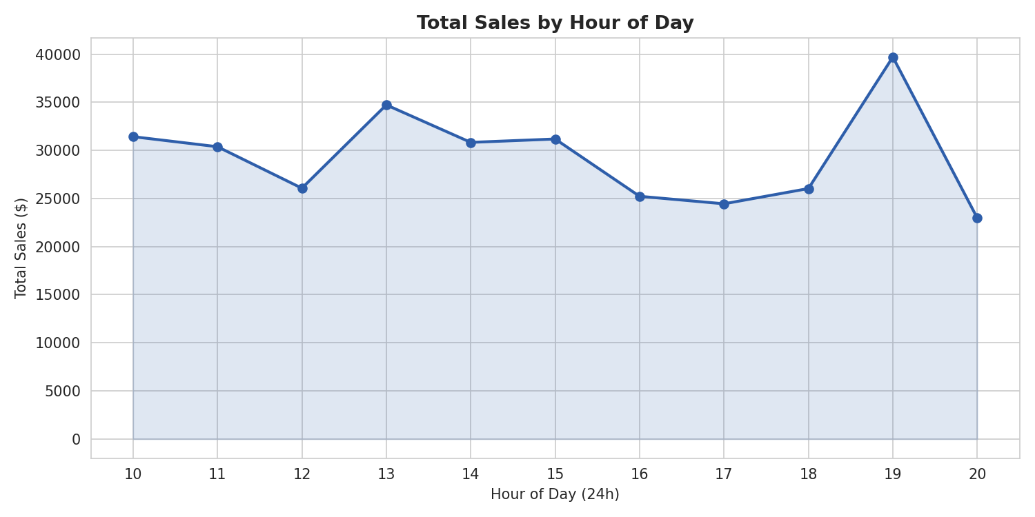
Figure 17.1 — Total sales by hour of day (store hours: 10 AM – 8 PM).
Observation: Sales rise and fall across the day with two visible peaks — around 1 PM (lunch hour, $34,723) and most strongly at 7 PM ($39,700, the single highest hour), with a dip in between during the mid-afternoon.
Business interpretation: Staffing and checkout capacity should be prioritized around the 7 PM closing-time rush, and secondarily around the 1 PM lunch peak, to avoid long queues during the busiest windows.

Sales by Day of Week
Chart Title: Total Sales by Day of Week
Objective: To see which days of the week drive the most revenue.
Why this chart was selected: A bar chart clearly compares seven ordered weekday categories.
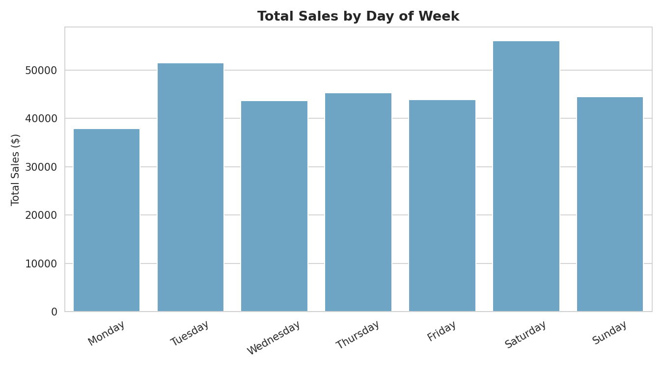
Figure 17.2 — Total sales by day of week.
Observation: Saturday is clearly the busiest day ($56,121), followed by Tuesday ($51,482); Monday is the quietest day ($37,899).
Business interpretation: Weekend staffing and stock levels should be higher, particularly on Saturdays, while Monday could be a lower-cost operating day.

Average Rating by Product Line
Chart Title: Average Customer Rating by Product Line
Objective: To see whether customer satisfaction varies by what they purchased.
Why this chart was selected: A horizontal bar chart ranks six categories clearly by a narrow numeric range.
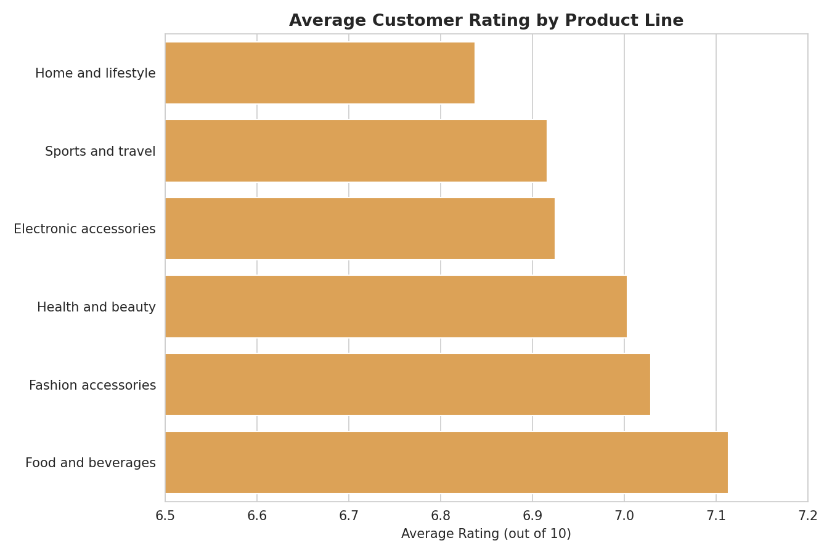
Figure 17.3 — Average customer rating by product line (note: axis starts at 6.5 to highlight small differences).
Observation: Ratings are tightly clustered between 6.84 (Home and lifestyle) and 7.11 (Food and beverages) — a narrow 0.27-point range.
Business interpretation: Customer satisfaction is fairly consistent across product lines, so there is no single product category driving unusually poor or excellent customer experience.

Gross Income Distribution by Branch
Chart Title: Gross Income Distribution by Branch
Objective: To compare the spread and consistency of profit-per-transaction across branches.
Why this chart was selected: A box plot shows the full distribution (median, spread, and outliers), not just the average.
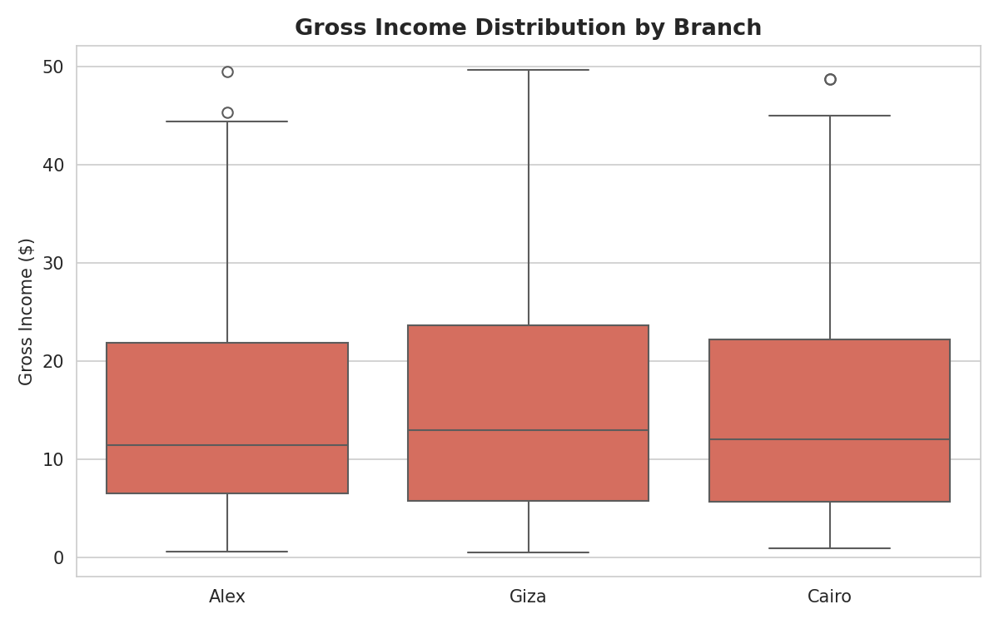
Figure 17.4 — Gross income per transaction, by branch.
Observation: All three branches show a similar spread and median gross income per transaction, with Giza's distribution shifted very slightly higher, consistent with its higher average sale value.
Business interpretation: Profitability per transaction is consistent across branches, meaning Giza's revenue lead (Section 15) comes from larger average transactions, not from a fundamentally different profit margin.

18. Business Insights
- The three branches perform very evenly (within 4% of each other in total sales), so no branch is currently underperforming badly enough to require urgent intervention — but Giza's higher average transaction value is worth understanding and replicating.
- Food and beverages is the top revenue-generating product line ($56,145), while Health and beauty is the lowest ($49,194), a $6,951 gap worth investigating for stocking or promotional reasons.
- Member customers drive 59% of total revenue ($189,695 of $322,967) from 56.5% of transactions, and spend 9.6% more per visit than Normal customers — the loyalty program is clearly associated with higher spending.
- Female customers generate 60% of total revenue despite being 57% of transactions, both transacting more often and spending more per visit than male customers.
- Quantity purchased (0.71 correlation) is a stronger driver of transaction value than unit price (0.63 correlation), suggesting basket-building strategies may have more revenue upside than pure pricing strategies.
- The 7 PM hour and Saturdays are the clear peak-demand windows, both requiring the strongest staffing and inventory readiness.
- Customer satisfaction (Rating) is unrelated to transaction size, branch, or product line in any meaningful way — ratings are consistently in the 6.8–7.1 range everywhere, suggesting satisfaction drivers lie outside what this dataset captures (e.g. service quality, wait times).
- Sales, tax, cost of goods sold, and gross income are all mechanically linked through a fixed 4.76% margin policy applied uniformly across every transaction — a useful confirmation of consistent pricing policy, though it limits how much these four fields can independently explain.

19. Recommendations

1. Investigate and replicate what drives Giza's higher average transaction value
Why suggested: Giza achieves the highest total sales and highest average sale per transaction ($337.10) with the fewest transactions of the three branches, suggesting a different customer mix, layout, or staff practice worth understanding.
Expected business benefit: If Giza's approach (e.g. product placement, upselling habits) can be identified and replicated at Alex and Cairo, overall chain revenue could rise without needing more foot traffic.

2. Prioritize staffing and inventory readiness around the 7 PM and Saturday peaks
Why suggested: The 7 PM hour and Saturdays are consistently the busiest windows for sales, and inadequate staffing during these peaks risks lost sales from checkout delays or stockouts.
Expected business benefit: Better peak-time coverage protects the chain's highest-value hours from operational bottlenecks.

3. Deepen engagement with the Member loyalty program
Why suggested: Members already spend 9.6% more per transaction and generate 59% of total revenue from 56.5% of transactions, showing the loyalty program is working.
Expected business benefit: Growing Member enrollment among the 43.5% of Normal customers, or increasing Member purchase frequency, could meaningfully grow total revenue given their proven higher spend.

4. Target promotions toward increasing basket size (Quantity) over pure discounting
Why suggested: Quantity purchased correlates more strongly with total Sales (0.71) than Unit Price does (0.63), suggesting 'buy more' incentives (bundles, multi-buy offers) may lift revenue more effectively than price cuts.
Expected business benefit: Bundle and multi-buy promotions could raise average transaction value without the margin erosion of straightforward discounting.

5. Investigate the revenue gap between Food & beverages and Health & beauty
Why suggested: Food and beverages outsells Health and beauty by $6,951 despite a similar number of transactions (174 vs 152), suggesting either lower average pricing, weaker placement, or lower customer interest in the Health and beauty line.
Expected business benefit: Identifying the cause (assortment, pricing, or placement) could unlock incremental revenue from the chain's lowest-performing product line.

6. Investigate satisfaction drivers beyond what this dataset captures
Why suggested: Rating shows no meaningful relationship with branch, product line, or spend amount, meaning satisfaction is being driven by something not captured here — likely service quality, wait times, or store experience.
Expected business benefit: Collecting additional data (e.g. service-time logs, staff-level feedback) could help identify actionable levers to raise the average rating from its current 6.97 baseline.

20. Challenges Faced
- Limited feature depth: The dataset does not include individual customer identity across visits, exact product SKUs, or store-level operating costs (rent, staffing), which constrained the analysis to transaction-level patterns rather than deeper customer-lifetime or profitability analysis.
- Redundant financial columns: Sales, Tax 5%, cogs, and gross income are all mathematically derived from one another via a fixed margin policy, which meant their perfect correlation had to be explained as a formula relationship rather than a genuine multivariate insight.
- Non-informative column: The 'gross margin percentage' column carried no analytical value since it was constant across all 1,000 rows, and had to be explicitly excluded from comparative analysis.
- Short time window: The dataset covers only three months (January–March 2019), which is not enough to draw conclusions about longer-term seasonality (e.g. holiday shopping patterns) beyond what is visible within this single quarter.
- Branch-city naming overlap: Branch codes (Alex, Cairo, Giza) and their corresponding cities (Yangon, Mandalay, Naypyitaw) do not match real-world geography (these are Myanmar cities paired with Egyptian branch names), which is a labelling quirk of the source dataset that does not affect the analysis but is worth noting for anyone using the city/branch fields together.

21. Conclusion
This project analyzed 1,000 sales transactions from a three-branch supermarket chain covering January to March 2019. The dataset required minimal cleaning — no missing values or duplicates were found — though several important data-quality characteristics (a fixed margin policy, mechanically linked financial columns, and a non-informative constant column) were identified and documented.
The clearest findings are that Member customers and Female customers are the strongest revenue segments, that Quantity purchased is a stronger sales driver than Unit Price, and that 7 PM and Saturdays are the clear peak-demand windows. Branch performance is closely matched overall, though Giza stands out for its higher average transaction value.
These findings carry clear business value for staffing, merchandising, and loyalty-program strategy. The final outcome of this project is a data-backed understanding of what drives supermarket sales in this dataset, paired with a prioritized set of recommendations to grow revenue and deepen customer engagement.

22. Future Scope
- Dashboard creation: Build a live dashboard (e.g. in Power BI or Tableau) so branch managers can monitor sales, product-line performance, and peak hours in real time.
- Machine learning models: Train a model to predict transaction value or customer rating based on branch, product line, and timing features.
- Predictive analytics: Forecast hourly and daily demand to guide dynamic staffing schedules ahead of peak periods.
- Recommendation systems: Suggest complementary products to customers based on product-line purchase patterns.
- Automation: Automatically flag branches or product lines whose sales or ratings fall outside their normal range for manager review.
- Real-time reporting: Extend this static, point-in-time analysis into a continuously updated reporting pipeline as new transaction data arrives, and expand the time window beyond the current three-month sample.

23. References
- Dataset Source: User-provided CSV file — Supermarket Sales, 1,000 records (Jan–Mar 2019).
- Python Documentation — https://docs.python.org/3/
- Pandas Documentation — https://pandas.pydata.org/docs/
- NumPy Documentation — https://numpy.org/doc/
- Matplotlib Documentation — https://matplotlib.org/stable/index.html
- Seaborn Documentation — https://seaborn.pydata.org/

