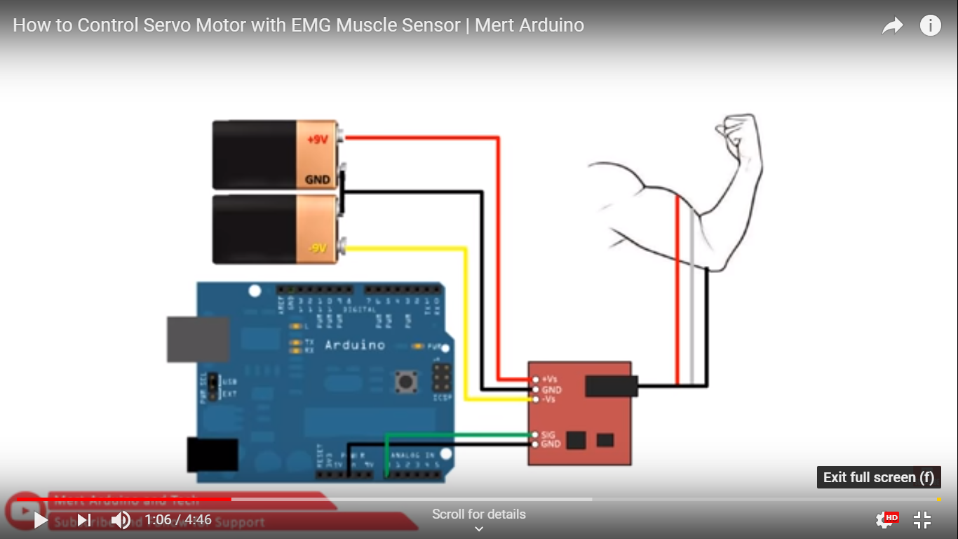

<https://www.youtube.com/watch?v=D-6GDlvAMCI&vl=en>