**Smart Plant**

**A PROJECT REPORT**

***Submitted by***

**Table of Contents**

1. Key Motivation for the project
2. Project Brief
3. Project circuit/Architecture
4. Code for the project
5. List of Components used in this Project
6. Future Enhancement
7. Appendix A-  
   Description about the components used in project

**Key Motivation for the project**

India’s major source of income is from agriculture sector and most of the irrigation systems are operated manually. The productivity in this sector is affected by decrease in availability of water for agriculture. These problems can be appropriately rectified if we use automated system for irrigation. Benefits are:

1.The farmers able to use right amount of water in right time.

2. They can save energy and water.

3. Overwatering of saturated soil can be avoided so that crop performance will improve.

4. Remotely monitor the moisture content of soil.

**Project Brief**

In this project, level of moisture content in soil is detected which would help the gardener in watering the plants. Moisture sensor detects the moisture in the soil and sends the information to the Arduino board. Depending on the moisture content red and green Led will glow for dry and wet condition accordingly. The Arduino also communicate to 1sheeld about the sensed data. The Bluetooth module in 1 shield connect with the app and send the notification, email and voice message to the gardener if watering of plant is required.

**Red Led Glowing as the soil is dry**

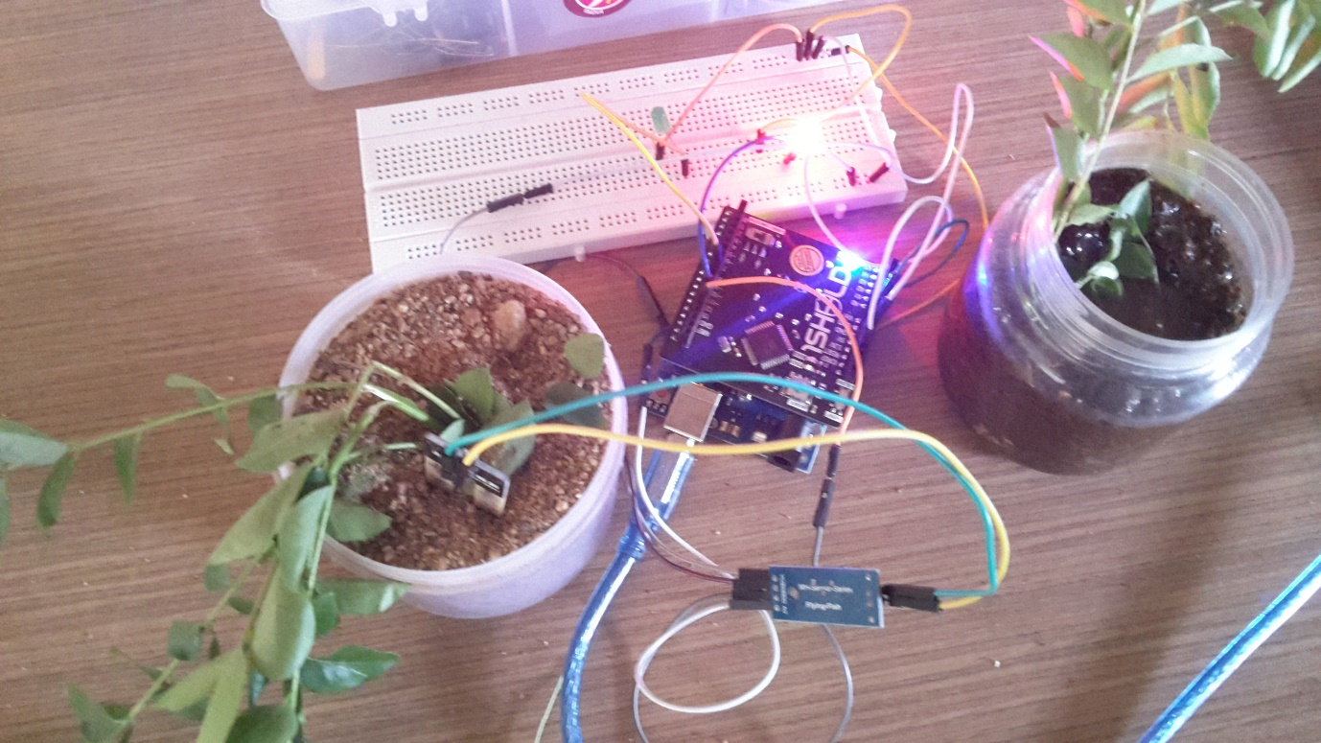

**Green Led Glowing as the soil is Moist**

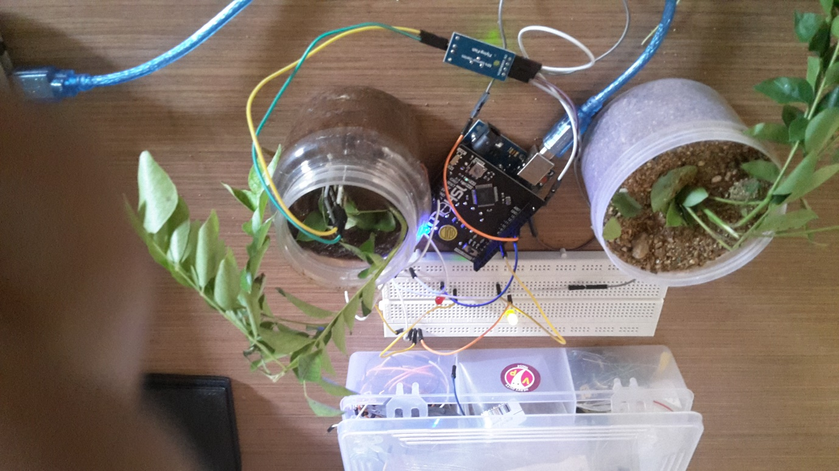

**Project Circuit / Architecture**

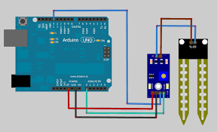

**Pin Wiring**

|  |  |
| --- | --- |
| Pin | Wiring to Arduino Uno |
| A0 | Analog Pins |
| D0 | Digital Pins |
| GND | GND |
| VCC | 5V |

**Code for the Project**

#define CUSTOM_SETTINGS

#define INCLUDE_SMS_SHIELD

#define INCLUDE_TEMPERATURE_SENSOR_SHIELD

#define INCLUDE_TEXT_TO_SPEECH_SHIELD

#define INCLUDE_TERMINAL_SHIELD //this Terminal shield is just to check if everything is going alright as planned

#define INCLUDE_EMAIL_SHIELD

#define INCLUDE_NOTIFICATION_SHIELD

/* Include 1Sheeld library. */

#include <OneSheeld.h>

inti= 1;

intsensorPin = 0; // select the input pin for the potentiometer

intsensorValue = 0; // variable to store the value coming from the sensor

intsensorVCC = 13;

int RED= 12; // Digital PIN 12

int GREEN= 8; // Digital PIN 8

void setup() {

pinMode(RED, OUTPUT);

pinMode(GREEN, OUTPUT);

//Serial.begin(9600);

OneSheeld.begin();

}

void loop() {

sensorValue = analogRead(sensorPin);

Terminal.println(sensorValue);

if(sensorValue>600)

{

// SMS.send("9884473440","Please Water me");

Terminal.println("water me");

TextToSpeech.say("Water me");

Email.send("sujaritha_b@hotmail.com","From Smart Plant","Hi, Pls water me ");

Notification.notifyPhone("Please Water ME");

digitalWrite(RED, HIGH);

}

else

{

digitalWrite(GREEN,HIGH);

}

delay(1000);

digitalWrite(GREEN,LOW);

digitalWrite(RED, LOW);

}

**List of Components used in this Project**

* Arduino UNO
* 1 Sheeld
* Soil Moisure Sensor
* A tiny breadboard.-To provide 5 volt source for the sensors.
* Red and Green Leds
* Arduino Battery Jack-Just to power the arduino
* Jumper wires.
* A 9volt Battery.
* A Plant

**The Future Enhancement**

1. Automatically power on or off motor for watering the crops depending on the soil moisture content so no labour is need to turn the motor on or off.
2. Solar power cell can be used to power the devices and motors.
3. Water level monitoring unit can be installed in tank from which watering of plant is done.

**Appendix A  
Description about the components used in project**

**Arduino UNO**

* **I have used Arduino Uno in my project.**
* **Arduino is an open-source electronics platform based on easy-to-use hardware and software**
* **Arduino boards are able to read inputs - light on a sensor, a finger on a button, or a Twitter message - and turn it into an output - activating a motor, turning on an LED, publishing something online.**
* **You can tell your board what to do by sending a set of instructions to the microcontroller on the board. To do so you use the Arduino programming language (based on Wiring), and the Arduino Software (IDE), based on Processing.**

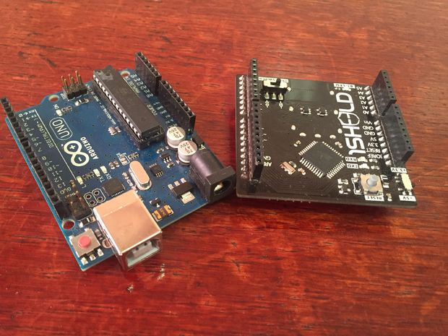

**1 Sheeld**

* **I used 1Sheeld board, the 1Sheeld mobile application and the Text To Speech functions.**
* **It's a board that gives your project the ability to communicate with your smart phone.**

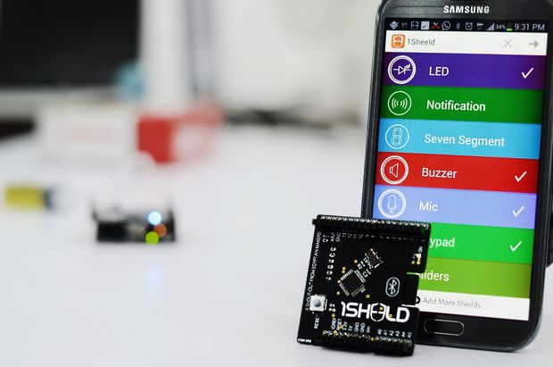

**Soil Moisture Sensor**

The soil moisture sensor or the hygrometer is usually used to detect the humidity of the soil. So, it is used to monitor the soil moisture of your plants.

The sensor is set up by two pieces: the electronic board (at the right), and the probe with two pads, that detects the water content (at the left).

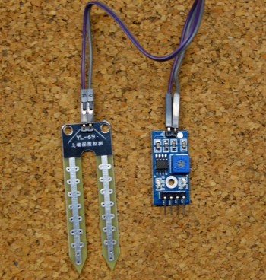

The sensor has a built-in potentiometer for sensitivity adjustment of the digital output (D0), a power LED and a digital output LED, as you can see in the following figure.

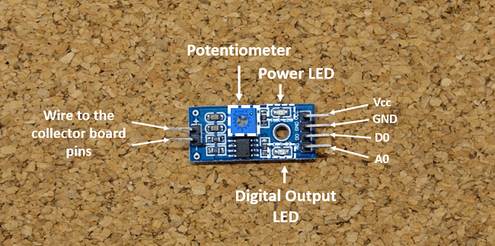

**How does it work?**

The voltage that the sensor outputs changes accordingly to the water content in the soil.

When the soil is:

* **Wet:**the output voltage decreases
* **Dry:**the output voltage increases

The output can be a digital signal (D0) LOW or HIGH, depending on the water content. If the soil humidity exceeds a certain predefined threshold value, the modules outputs LOW, otherwise it outputs HIGH. The threshold value for the digital signal can be adjusted using the potentiometer.The output can be ananalog signal and so you’ll get a value between 0 and 1023.