# WATER LEVEL INDICATOR USING ARDUINO-UNO,SERVO MOTOR AND ULTRASONIC SENSOR(HC-SR04).

# - By Darshan Shetter

# Table of content

1. ABOUT WATER LEVEL INDICATOR
   1. Abstarct
   2. Identifying features
   3. State of art/Research
   4. 5W’s & 1H and S.W.O.T analysis
2. Requirements
   1. High level requirements
   2. Low level requirements
3. Block Diagram and Blocks explanation
   1. Block Diagram
   2. Sensors
   3. Actuators
   4. Micro controller and memory
   5. Sub-system and others

1. Architecture
   1. Behavioral Diagram
      1. High Level Flow chart Behavioural Diagram
      2. Low Level Flow chart Behavioural Diagram
   2. Structural Diagram
      1. High Level UML Use Case Structural Diagram
      2. Low Level UML Use Case Structural Diagram
2. Test plan and output
   1. High level test plan
   2. Low level test plan
3. Output
4. Applications
5. Future Add on
6. References

# 1 ABOUT WATER LEVEL INDICATOR

## 1.1 ABSTRACT

* We live in a world which is moving at such a fast pace that everything if automated will help us to keep our lives going. The project on water level Indicator will help us to know when the water in our tanks is either full or empty and automatically switch on and off the pump as and when necessary. By using the basic principle of ultrasonic sensors, that is the ECHO method, we calculate the time of the ultrasonic waves travelling to and fro and after a few calculations the answer obtained will be the water level in the tank. By using this concept, the water pump is switched on or off automatically when the water level falls below a certain level.

## 1.2 Identifying features

* It should be power saver.
* Money saver.
* Automatic.
* Easy Installation.
* Should monitor the level of water in the tank and simultaneously switches on the water pump whenever the water level goes low in the water tank.
* By using the water level indicator we can overcome the overflow of water from the tankers.
* Time taken to produce output is less.
* LCD display always needs to give the current water level.

## 1.3 State of art/Research

* In relation with the current framework with so much work and too less time to spare, it is very difficult to keep in touch with the water level in the tanks. Water is essential in every hour of our lives. Hardly anyone keeps in track of the level of water in the overhead tanks. The objective of the project is to measure the level of water in the tank and notify the user about the water level through an SMS alert.
* This not only helps to keep the tank full but also making it more convenient for our day-to-day chores and also avoiding water wastage. In this project, the water is being measured by using ultrasonic sensors. Initially, the tank is
* considered to be empty. When the sound waves are transmitted in environment, they are reflected back as ECHO. This same concept is applied this project.
* Waves generated by the ultrasonic sensors is sent to the water tank and their time of travelling and coming back is noted and after few calculations we can estimate the level of water in the tank.

## 1.4 5W’s 1H

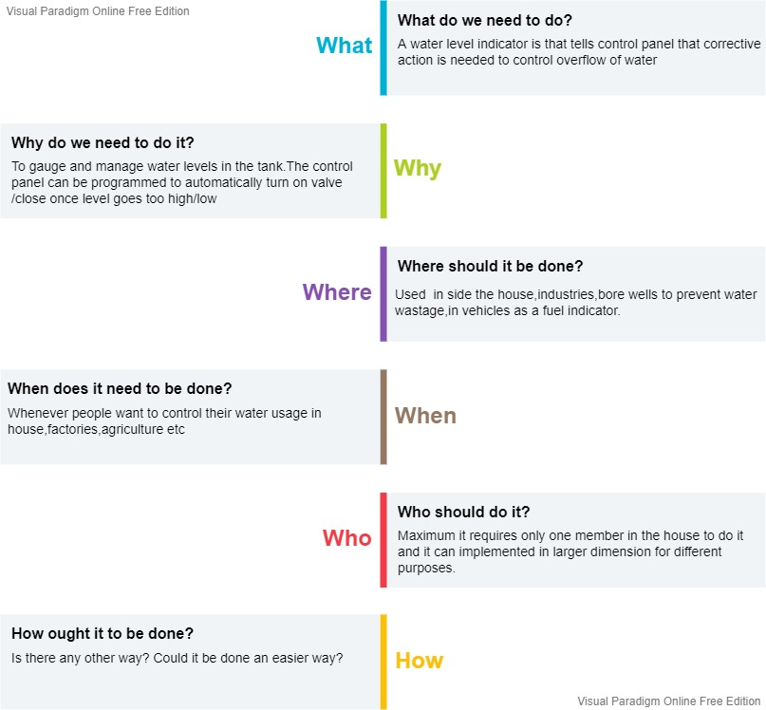

## 1.5 SWOT Analysis

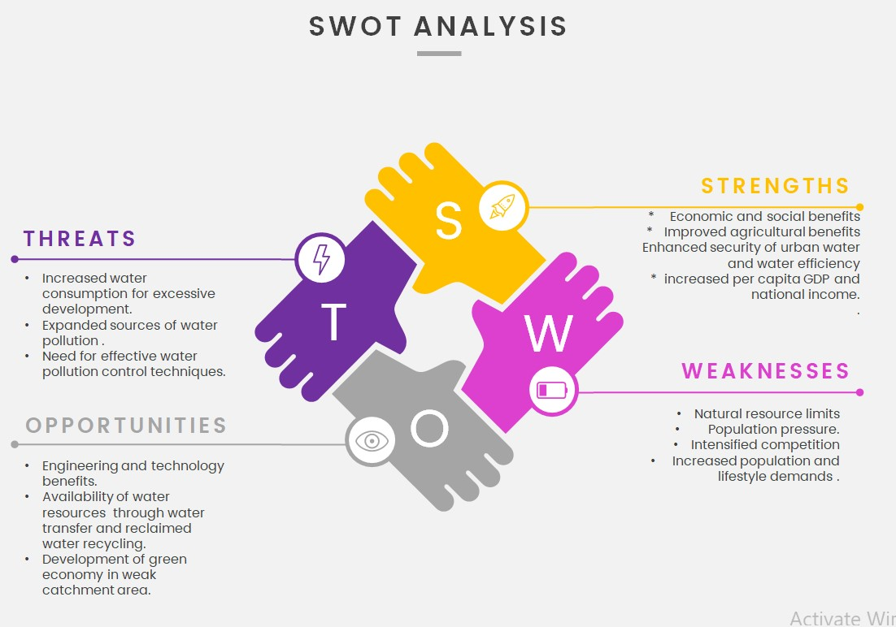

# 2 Requirements

## 2.1 High Level Requirements

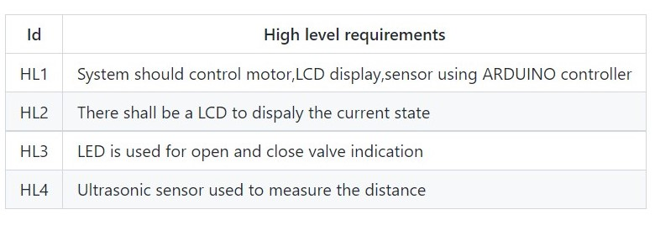

## 2.2 Low Level Requirements

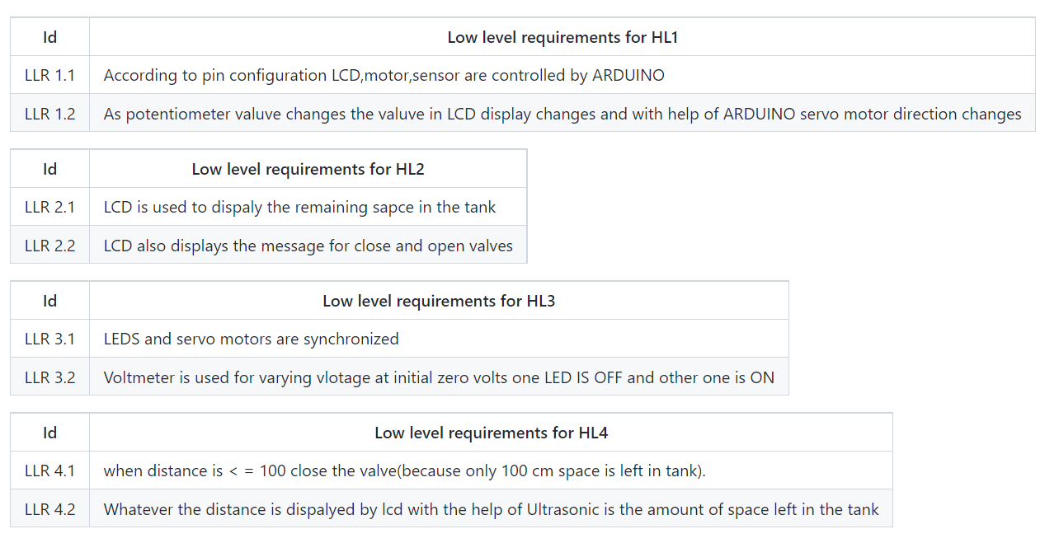

# 3 Block Diagram and Blocks explanation

## 3.1 BLOCK DIAGRAM

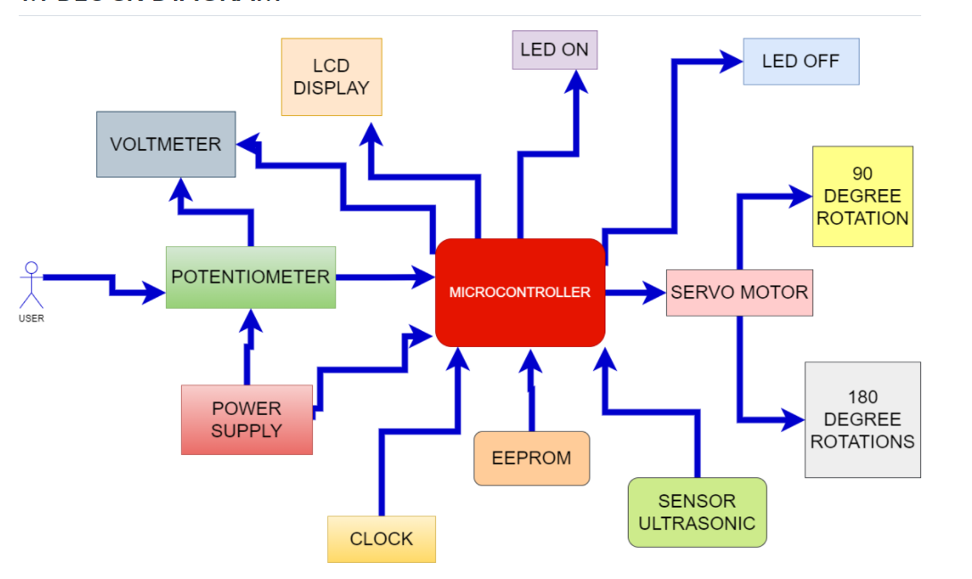

## 3.2 SENSORS

### Ultrasonic

Working :

* It is basically a distance sensor and is used for detecting the distance using SONAR method. It has two ultrasonic transmitters namely the receiver and the control circuit. The transmitter emits a high frequency ultrasonic sound wave which bounces off from any solid object and receiver receives it as an echo.
* The echo is then processed by the control circuit to calculate the time and the difference between the transmitter and receiver signal. This time can subsequently be used to measure the measure the distance between the sensor and the reflecting object. It has an ultrasonic frequency of 40 KHz and accuracy is nearest to 0.3 cm.

## 3.3 ACTUATORS

### 3.3.1 LCD display

* Based on the value taken by by sensor it displays the empty space in the tank and also indicates the necessary actions .LCDs allowed displays to be much thinner than cathode ray tube (CRT) technology. LCDs consume much less power than LED and gas-display displays because they work on the principle of blocking light rather than emitting it.

### 3.3.2 Servo motor

* Servo motors or “servos”, as they are known, are electronic devices and rotary or linear actuators that rotate and push parts of a machine with precision. Servos are mainly used on angular or linear position and for specific velocity, and acceleration. It is used to open and close the valves to control the wastage of water and based of distance value it rotates either 180 degree or 90.

### 3.3.3 Microcontroller and memory

* Arduino UNO has the micro-controller ATmega328 embedded in it. It has 14 digital I/O pins out of which 6 provide PWR output. It is an open-source and provides prototype platform. It also has a 16MHX crystal oscillator attached to it. In addition to the above features, it also has an USB connection, a power jack, an ICSP, header and reset button. It has everything to support a micro-controller. It can simply be connected to a computer using an USB cable power it with an AC or a DC adapter or a battery.

### 3.3.4 EEPROM

* + Here this is actually inside the microcontroller

### 3.3.5 Delay

These functions are used for smooth going of project helps every functions to perform their task.

### 3.3.6 Microcontroller

* This is the main component which controls all the above mentioned part or thins of our embedded system. This interfaces motor and LCD and controls the sensor, light and voltage depending on the value we pressed on potentiometer

## 3.5 SUBSYSTEM & OTHERS

### 3.5.1 LED

* Light-emitting diode (LED) is a widely used standard source of light in electrical equipment. It has a wide range of applications ranging from your mobile phone to large advertising billboards. They mostly find applications in devices that show the time and display different types of data. LEDs allow the current to flow in the forward direction and block the current in the reverse direction. Here, 2 leds are used for confirmation of opening and closing of valve.

### 3.5.2 Resistors

* A resistor is a passive two-terminal electrical component that implements electrical resistance as a circuit element. In electronic circuits, resistors are used to reduce current flow, adjust signal levels, divide voltages, bias active elements, and
* Terminate transmission lines, among other uses. Resistors are common elements of electrical networks and electronic circuits and are ubiquitous in electronic equipment.
* Practical resistors as discrete components can be composed of various compounds and forms Resistors are also implemented within integrated circuits. Here we used 100 ohm 2 resistors that connected to 2 leds.

### 3.5.3 Voltmeter

* voltmeter, instrument that measures voltages of either direct or alternating electric current on a scale usually graduated in volts, millivolts (0.001 volt), or kilovolts (1,000 volts). Many voltmeters are digital, giving readings as numerical displays. Here, voltmeter is used to change the voltage levels.

### 3.5.4 Potentiometer

* A potentiometer is a three-terminal resistor with a sliding or rotating contact that forms an adjustable voltage divider. If only two terminals are used, one end and the wiper, it acts as a variable resistor or rheostat. Here, they are used to measure displacement in any direction. Linear potentiometers linearly measure displacement and rotary potentiometers measure rotational displacement

# 4 Architecture

## 4.1 Behavioral Diagram

### 4.1.1 High Level Flow chart Behavioral Diagram

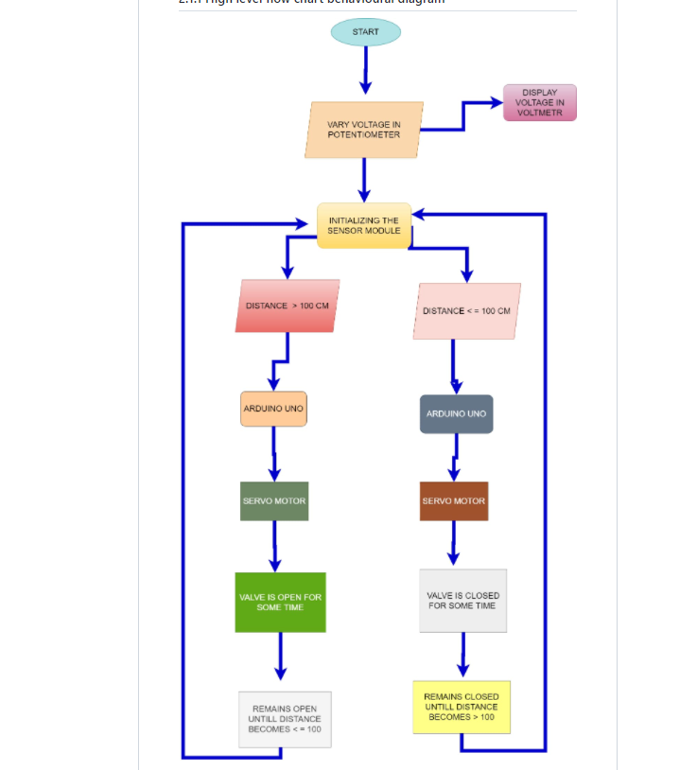

* + Diagram

    Description automatically generated

### 4.1.2 Low Level Flow chart Behavioural Diagram

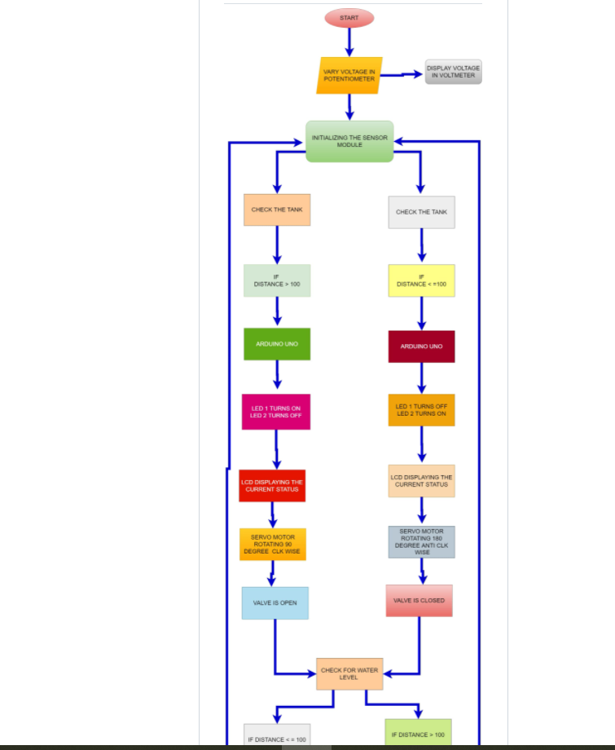

## 4.2 Structural Diagram

### 4.2.1 High Level UML Use Case Structural Diagram

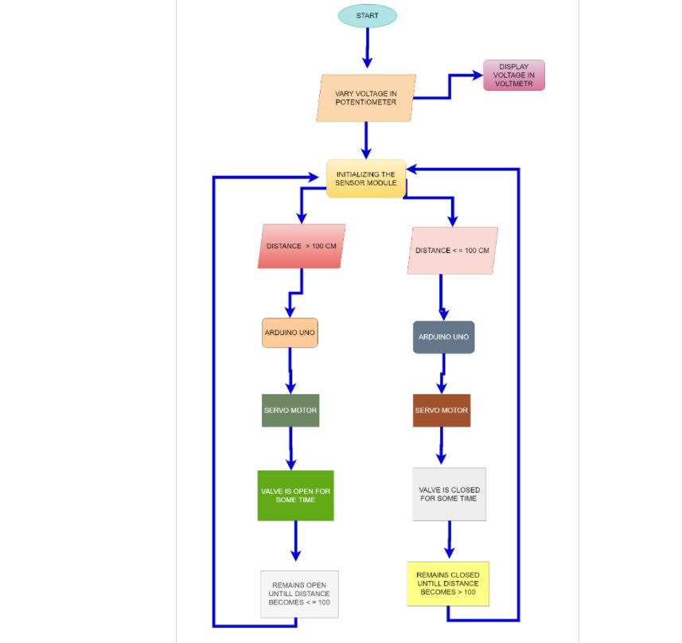

### 4.2.2 Low Level UML Use Case Structural Diagram

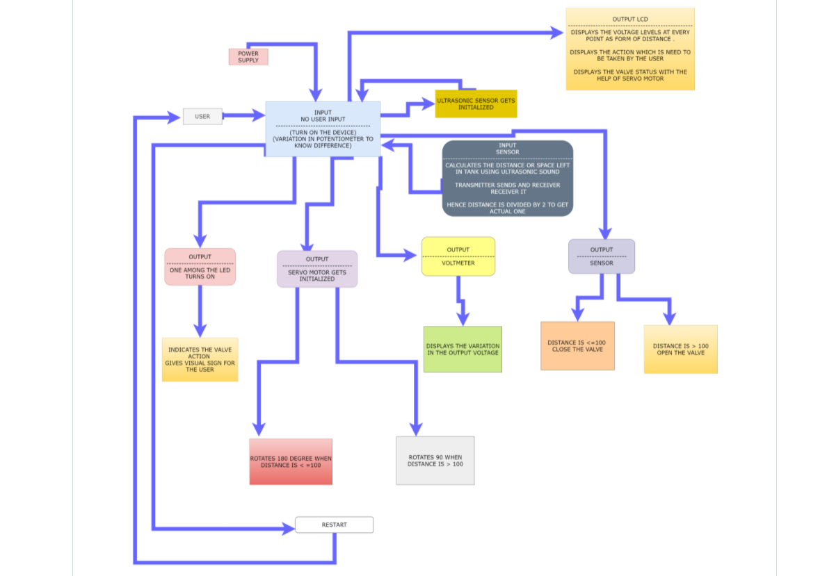

# 5 Test plan and output

# 5.1 HIGH LEVEL TEST PLAN

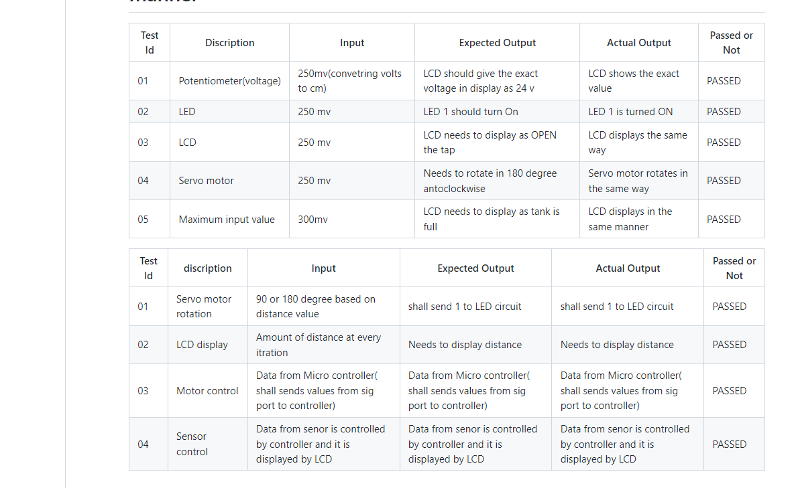

# 5.2 LOW LEVEL TEST PLAN

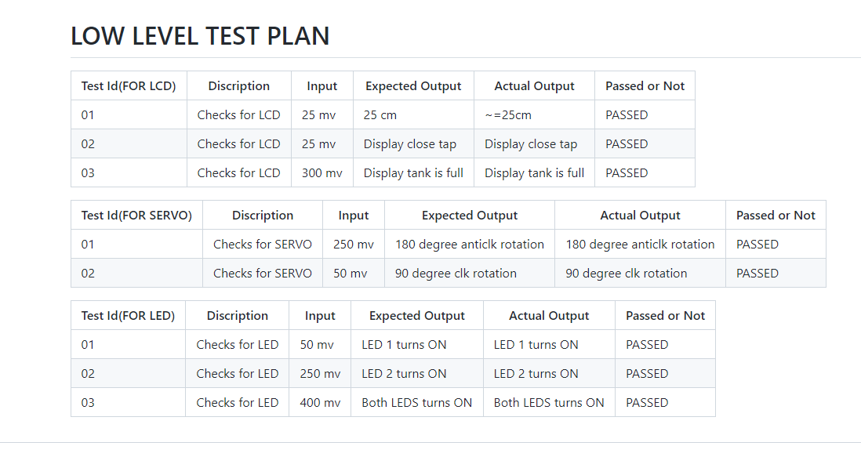

# 6 Images and videos(output)

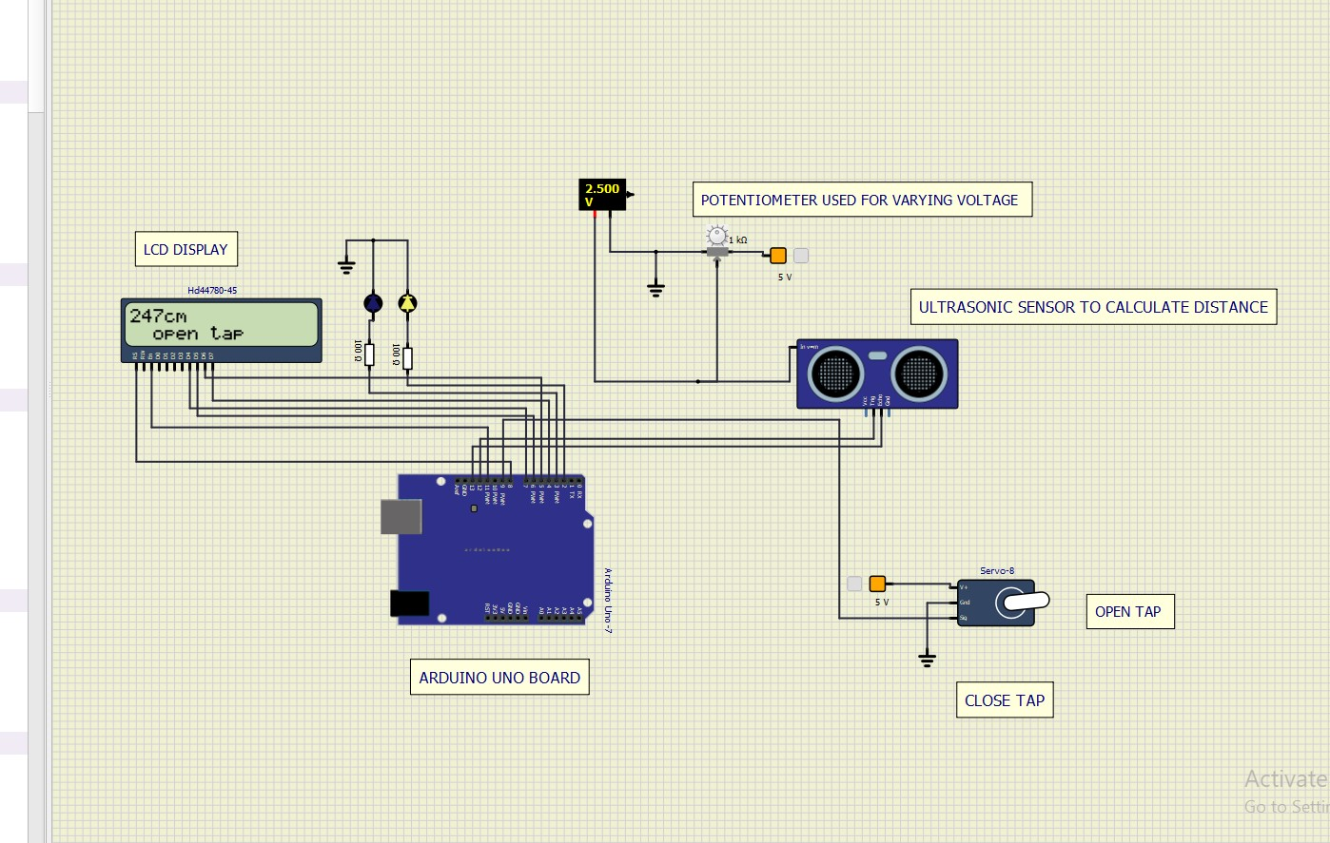

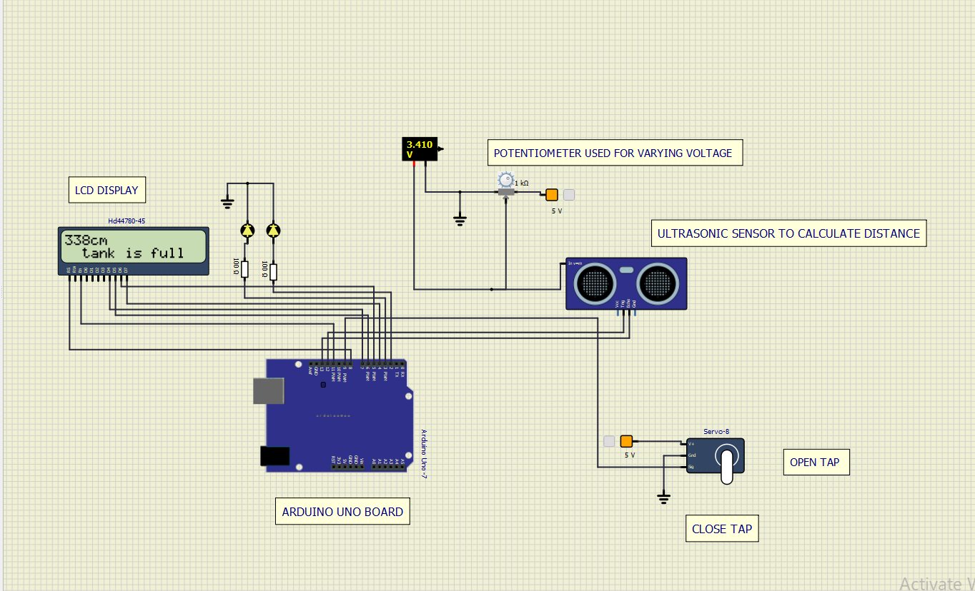

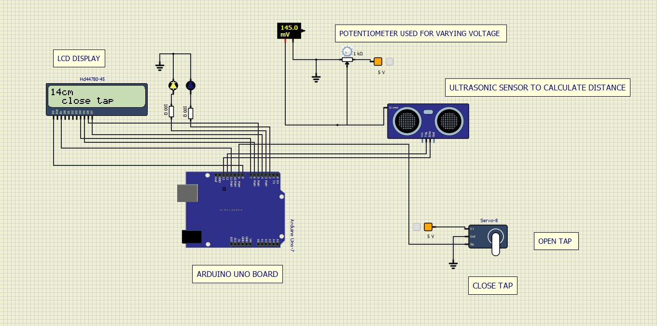

Simulation pic :

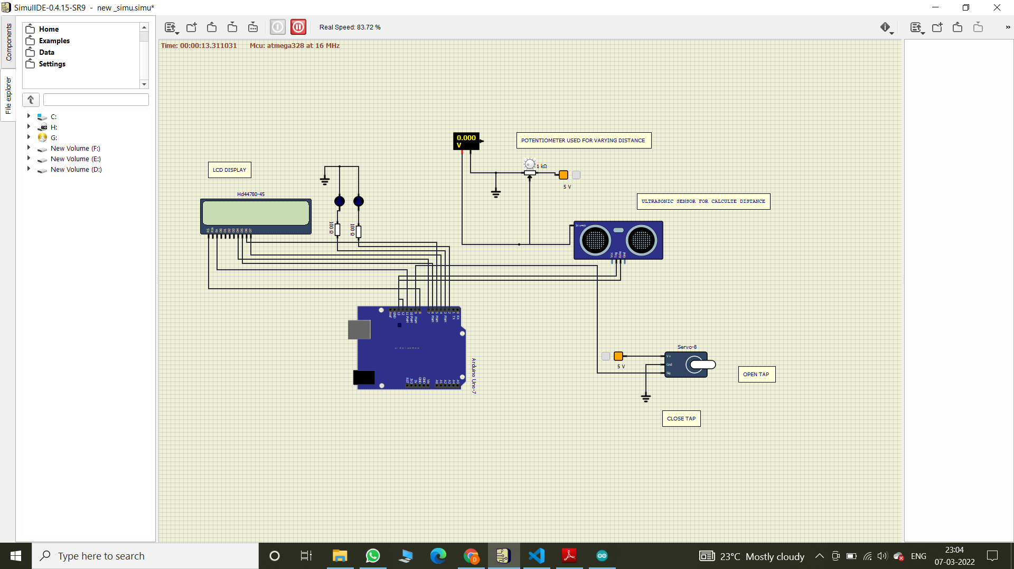

Git:

Project--- >Images and Videos or Output File

https://github.com/vsshetter/M2-EmbSys.git

# 7 Applications

* This system can be used in Light Control of Houses, Industries, Stadiums etc.…
* This system can be used in Fan Control of Houses, Industries, Stadiums etc.…
* This system can be used in Door Control of Houses, Industries, Stadiums etc.…
* This system can be used in Automatic Temperature Detector of Houses, Industries, Stadiums etc.…
* This system can be used to know number of appliances “On” status of Houses, Industries, Stadiums etc.…

# 8 Future Add On

* Automatic water level monitoring system has a good scope in future especially for agriculture sector. There are any areas where we need water level controller. It could be agricultural fields, overhead tanks. We can make this project wireless by using NRF transmitter and receiver. We can also add Ethernet shield so that we can get all the information using mobile phones and control it accordingly.

# 9 References

* https://circuitdigest.com/