CocoCare Stage 1 Scientific Methodology and Validation
End to end audit of the hybrid weather and water balance prototype
Audit date 18 October 2026 | Scope 2023 daily data | Pollachi Tamil Nadu
Conclusion. The audited frozen-weather run is complete and internally arithmetic-consistent after correction of software defects. It is not field-validated: weather is gridded, soil water and labels are modelled, and crop and soil parameters remain provisional.

1 Scope and inspected material
The audit inspected the Stage 1 generator, evaluator, both Stage 1 notebooks, original output CSV/JSON/plot reports, metadata and reference table. It preserved the original output directory, generated a separate audited run from the saved weather CSV, added a test, and performed exploratory one-at-a-time sensitivity scenarios.
Artifact | Role | Disposition
cococare_stage1_final_generator.py | Weather, ET, bucket and metadata | Corrected output/reuse controls and overflow drainage
evaluvation /cococare_stage1_evaluation.py | Quality, formulas and figures | Corrected source-column/missingness and correlation inputs
data/cococare_stage1_outputs | Original outputs | Preserved; original dataset SHA-256 4fb17c38db268f8b4d3e1476428e32d436adc0036af328c75434afc21c8ce7f6
audit_artifacts/audited_run | Corrected rerun | 365 rows, 30 source columns, all checks pass
audit_artifacts/sensitivity_analysis.csv | Exploratory scenarios | Not calibration or independent validation

2 Provenance schema and transformations
External values are NASA POWER daily point-request estimates: precipitation, maximum/minimum air temperature, all-sky surface shortwave radiation, relative humidity and wind. NASA describes its Daily API as analysis-ready solar and meteorological time series at the original source spatial resolution. It is not an on-farm weather-station record. The request did not set a time standard, so NASA POWER defaults to Local Solar Time.
Class | Fields | Status
External weather | rainfall, Tmax, Tmin, radiation, RH, wind | NASA POWER gridded estimates; not local observations
Calculated | ET0 | FAO-56-style calculation from supplied weather and fixed elevation
Modelled | ETc, effective rain, runoff, ETa, drainage, storage, depletion, VWC | Deterministic outputs of provisional rules
Rule labels | stress and simulated recommended action | Not ground truth or operational advice
Static metadata | location, variety, age and coordinates | Configuration assertions, not independent field records

The audited dataset has 365 days from 2023-01-01 to 2023-12-31, 30 source columns, no duplicate or invalid dates, no source missing cells, and exact agreement of source weather values with the frozen CSV. Broad range screens are plausibility checks only.

3 Formula by formula assessment
Component | Equation or rule | Scientific assessment
ET0 | FAO Penman Monteith daily form; G=0 | FAO-56 supports the general method. Mean RH is used to estimate actual vapour pressure; output remains an estimate.
Potential ETc | ETc = Kc ET0; Kc=0.70 | FAO-56 Eq 58 supports relationship, not this coconut-specific value.
Available water | TAW=1000(thetaFC-thetaWP)Zr=58.5 mm | Exactly FAO-56 Eq 82. FC=.23, WP=.10 and Zr=.45 m are unverified site assumptions.
Rain/runoff | effective rain=rain minus .05 rain | Arithmetic correct; no site/event/topography evidence for fixed 5 percent runoff.
Stress ET | ETa=ETc simplified storage Ks | Related to FAO-56 stress adjustment but not its complete crop-specific Ks method.
Drainage | max(0, pre-drainage minus TAW) | Corrected to report all overflow and close the bucket.
Labels | low D<.30; moderate D<.50; high otherwise | Rule-derived classes only, not observed water stress.

4 Evaluation anomalies and corrected results
The original evaluation JSON mixed the 30-column source CSV with 38 columns after temporary diagnostics were added. Its missing-value check falsely failed because first-row reconstructed storage is intentionally undefined. The evaluator now records source column count and source missingness before diagnostics, and excludes temporary/constant values from the exploratory correlation matrix.
The original drainage rule removed only half of above-capacity water before clipping storage. Clipping silently removed the remainder. Full-overflow drainage changes reported peak drainage from 18.0704 to 36.1408 mm; it does not change the storage state or rule-label counts because the previous clip forced the same storage state.
Daily-record investigation attributes the largest storage gain (15.67 mm on 2023-04-26) to 17.90 mm rain and 17.005 mm effective rainfall. The largest one-day decline (3.63 mm on 2023-05-16) follows 0.07 mm rain and 3.70 mm modelled actual ET. The 98 capacity days and 28 near-complete-depletion days are therefore consequences of the frozen weather sequence and the simplified 58.5 mm bucket, not soil-moisture observations.
Check | Audited result
Coverage and missingness | 365 expected days; no duplicates, invalid dates or source missing cells
Weather broad screens | rain 0 to 39.61 mm/day; Tmax 23.21 to 38.47 C; Tmin 13.69 to 23.96 C; all pass
ETc check | max reconstruction error 8.88e-16 mm/day
Water balance | 364 transitions; max absolute error 1.42e-14 mm
Storage and VWC | storage within 0 to 58.5 mm; derived variable errors below 7.11e-15 percentage points
Rule labels | low 197 days, moderate 43, high 125; action mapping exact

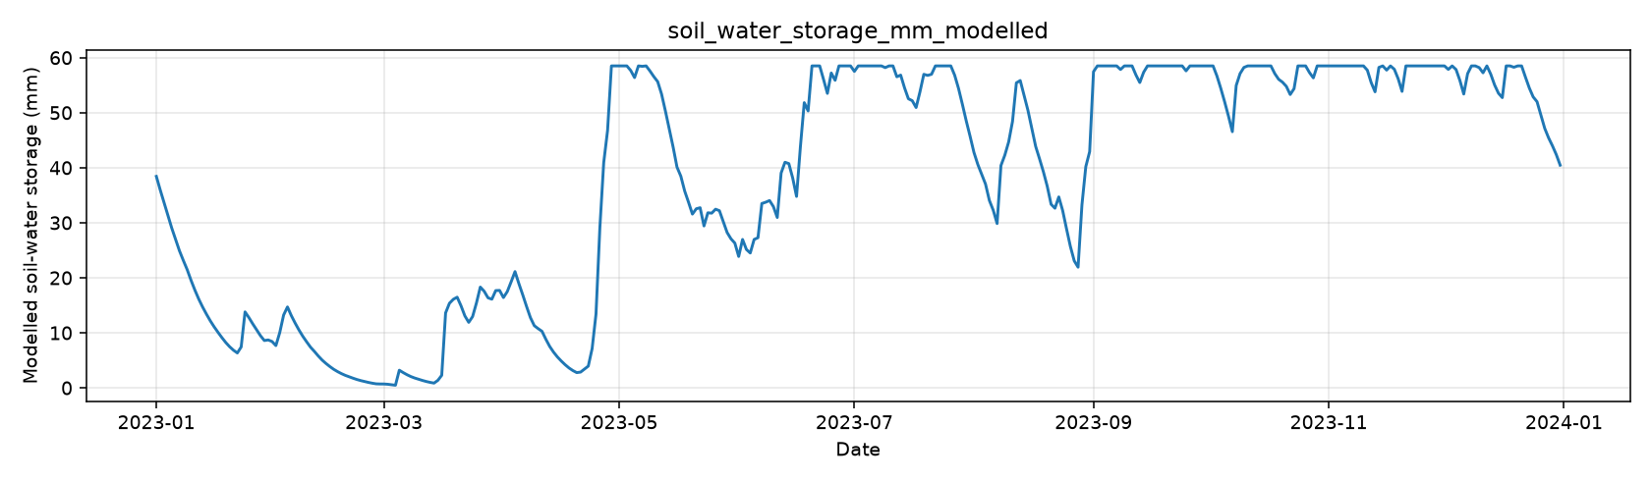
Figure 1. Modelled bucket storage; saturation at 58.5 mm is a capacity artefact, not a measured soil-water plateau.
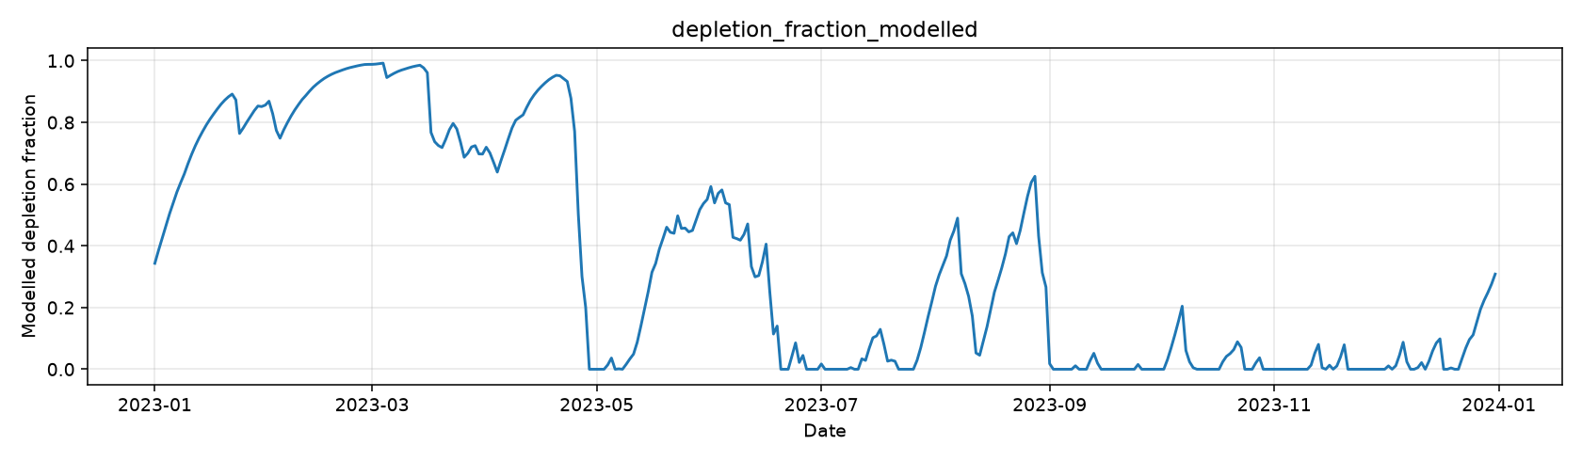
Figure 2. Modelled depletion; rapid shifts arise from the daily bucket rule and weather input.
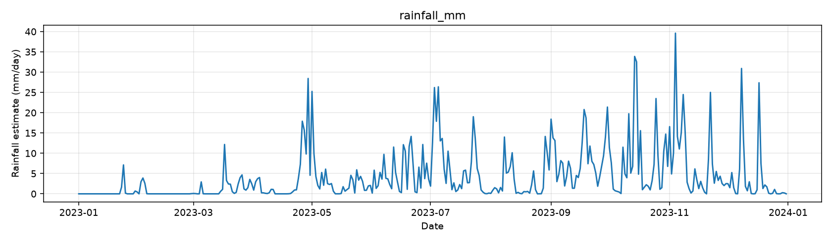
Figure 3. Frozen NASA POWER daily rainfall estimate used in the audited run.
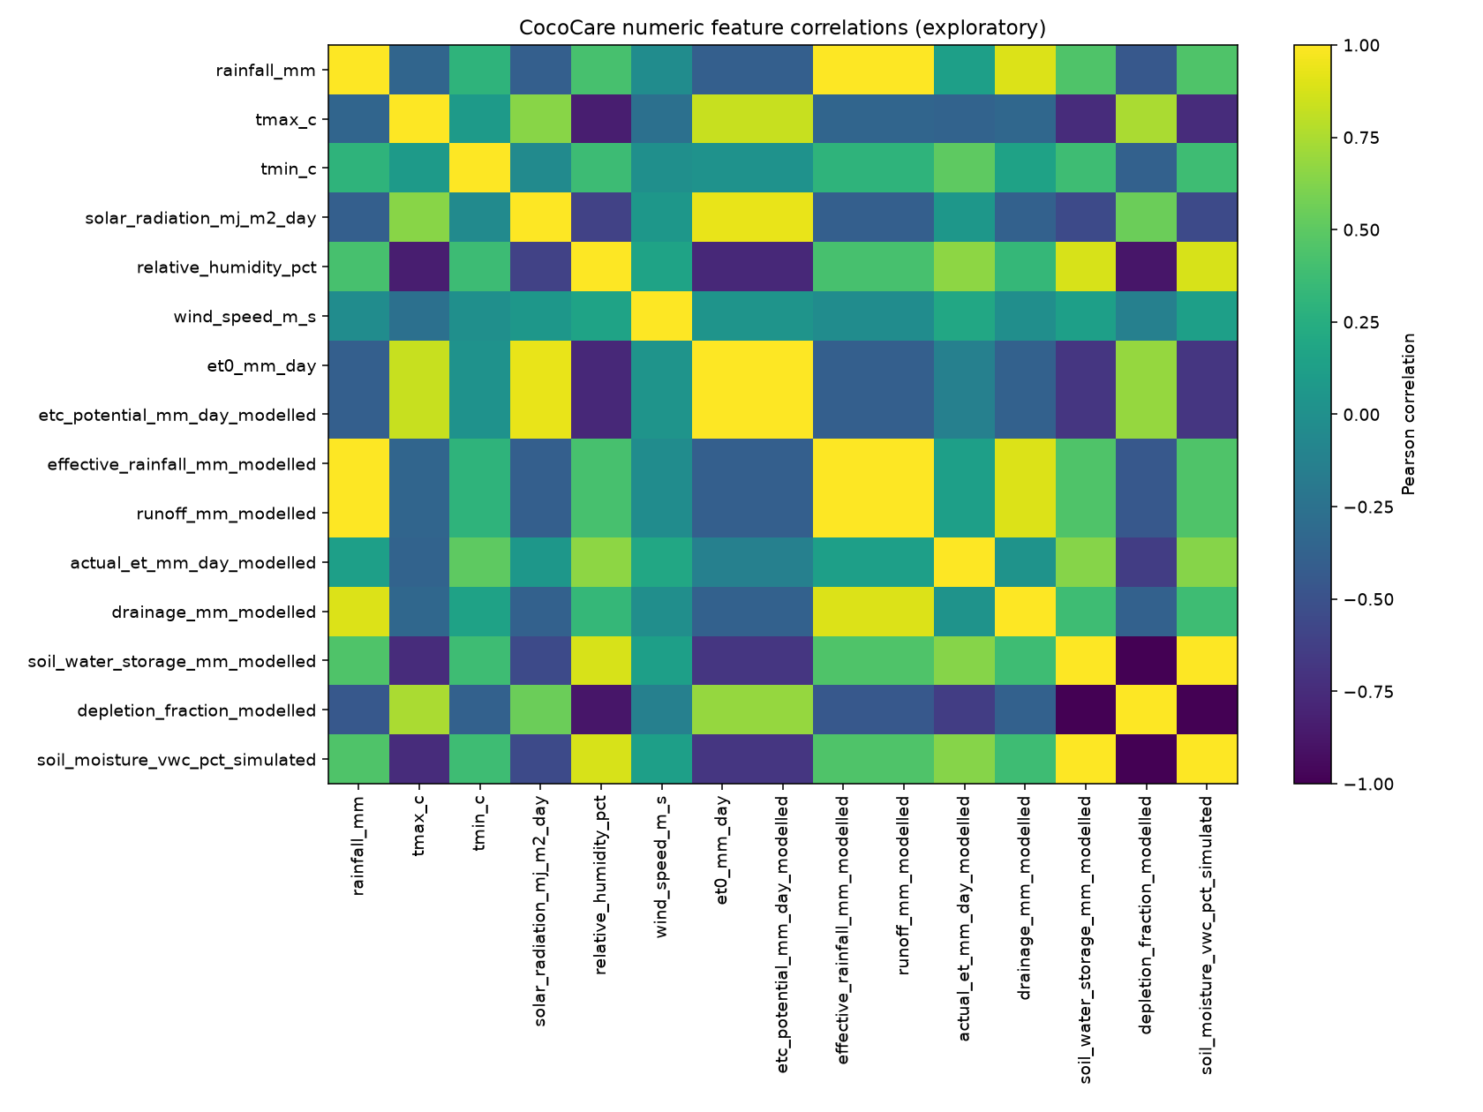
Figure 4. Exploratory source-field correlations; deterministic variables correlate by construction and do not prove causality.

5 Sources evidence and applicability
Source and access date | Support | Applicability boundary
NASA POWER Daily API documentation, NASA, accessed 2026-10-18, https://power.larc.nasa.gov/docs/services/api/temporal/daily/ | Daily data service, original source resolution and Local Solar Time default | Supports provenance/API use, not farm-level measurement accuracy.
Allen, Pereira, Raes and Smith, Crop Evapotranspiration, FAO 56, 1998, Ch 2 and 4, https://www.fao.org/4/x0490e/x0490e06.htm | FAO Penman Monteith reference ET and required inputs | Supports general ET0 equation, not local validation.
Allen et al, FAO 56, 1998, Ch 6 Eq 58, https://www.fao.org/4/X0490E/x0490e0b.htm | ETc=Kc ET0 and stage/condition adjustments | Does not establish Kc .70 for 18 month East Coast Tall at Pollachi.
Allen et al, FAO 56, 1998, Ch 8 Eq 82 to 83, https://www.fao.org/4/X0490E/x0490e0e.htm | TAW, RAW, field capacity, wilting point and stress concepts | Does not establish soil texture, retention curve or root depth for this site.
Jayakumar, Saseendran and Hemaprabha, Crop coefficient for coconut, Agricultural and Forest Meteorology, 1988, DOI 10.1016/0168-1923(88)90051-2 | A lysimeter study of 6-year coconut reported method-dependent Kc values including 0.73 for Blaney Criddle. | Useful contextual evidence only: different palm age, reference method, season and site; it does not validate Kc 0.70.
Miranda et al, Evapotranspiration and crop coefficients for green dwarf coconut, Revista Ciencia Agronomica, 2008, https://periodicos.ufc.br/revistacienciaagronomica/article/view/83857 | At 11 to 41 months, Kc increased from 0.63 to 1.00 under irrigated green dwarf conditions in coastal Ceara. | Age overlap is partial, but variety, climate, irrigation and country differ; not transferable without calibration.
Carvalho et al, Bragantia 83, 2024, DOI 10.1590/1678-4499.20230160 | A 5-year green dwarf coconut study found mean dry-season Kc 1.06 plus or minus 0.12 under its conditions. | Not applicable as a numerical value to an 18-month East Coast Tall palm at Pollachi; it demonstrates context dependence.
Rajagopal, Kasturi Bai and Voleti, Root activity and root-zone soil water dynamics of coconut palms, Agricultural Water Management 38, 1998, DOI 10.1016/S0378-3774(98)00064-X | An older-palm study in gravelly soil reported most roots between 20 and 100 cm depth. | Root architecture varies by age and soil. This is contextual evidence, not validation of the provisional 0.45 m root-zone depth.
TNAU Coconut nutrient management, accessed 2026-10-18, https://agritech.tnau.ac.in/expert_system/coconut/coconut/coconut_nutrient_management.html | Tamil Nadu table lists 20 kg compost/palm/year in second year | Age-aligned nutrient reference only; not a water-balance parameter source.
TNAU irrigation URL in project, accessed 2026-10-18, https://www.agritech.tnau.ac.in/expert_system/coconut/coconut/coconut_irrigation_management.html | Could not be reliably retrieved | Stored 45 L seedling summary remains unverified and is not an operational recommendation.

6 Parameter verification status
Parameter | Prototype value | Evidence and status
Kc | 0.70 dimensionless | Provisional. Coconut studies report context-specific values from 0.63 upward and historical method-dependent values; none matches the study palm/site.
Field capacity | 0.23 m3/m3 | Provisional. FAO-56 supports use in TAW but requires soil-specific retention information.
Wilting point | 0.10 m3/m3 | Provisional. Requires site texture/retention measurement.
Root-zone depth | 0.45 m | Provisional. Coconut root-distribution evidence is mainly for older palms and different soils; no age-matched root observations.
Initial available water | 0.70 fraction of TAW | Initial-condition assumption, not an observation. New sensitivity scenarios test 0.40 and 0.90.
Runoff | 0.05 of rainfall | Provisional fixed fraction; needs slope, surface, rainfall-intensity and infiltration evidence.
Drainage | all storage above TAW | Mathematically required for closure of this bucket; physical drainage rate is not calibrated.
Stress threshold p | 0.50 depletion fraction | FAO-56 notes p is crop and ETc dependent; 0.50 is a common generic default, not a validated coconut threshold.

7 Exploratory sensitivity analysis
One parameter was changed at a time with the 2023 frozen weather held fixed. Ranges are explicitly exploratory because no source matching 18-month East Coast Tall, Pollachi, the actual soil and management was established. This is not independent validation.
Scenario | Mean min max storage mm | Capacity days | Near depletion days | High-rule days
Baseline | 38.09 / 0.47 / 58.50 | 98 (26.8%) | 28 (7.7%) | 125 (34.2%)
Kc .55 / .85 | 41.23 / 1.13 / 58.50; 35.45 / .23 / 58.50 | 121 / 78 | 19 / 36 | 109 / 154
Available water low / high | 22.42 / .06 / 36.00; 68.67 / 2.80 / 99.00 | 104 / 95 | 42 / 15 | 150 / 109
Root depth .30 / .60 m | 24.46 / .10 / 39.00; 52.66 / 1.42 / 78.00 | 102 / 95 | 39 / 22 | 146 / 110
Initial storage .40 / .90 | 37.47 / .45 / 58.50; 38.68 / .50 / 58.50 | 98 / 98 | 29 / 28 | 129 / 119
Runoff 0 / 15 percent | 38.63 / .50 / 58.50; 36.98 / .43 / 58.50 | 102 / 85 | 27 / 31 | 122 / 139
Trigger .40 / .60 | 38.91 / .91 / 58.50; 37.44 / .21 / 58.50 | 99 / 97 | 22 / 38 | 144 / 112

Capacity uses storage at TAW within 1e-8 mm; near complete depletion means depletion at least 0.95. Baseline actions are 197 continue-monitoring, 43 recheck, and 125 consider-irrigation-if-field-conditions-confirm. For each scenario the action counts exactly equal low, moderate and high rule counts. Available-water capacity, root depth and Kc have the greatest simulated effect; initial storage chiefly affects early-season classification. Thus 125 high-rule days cannot be interpreted as observed stress frequency.

8 Reproducibility and remaining work
Run from repository root with pandas, numpy, matplotlib and requests installed: export COCOCARE_OUTPUT_DIR to ml/data/coconut_health/audit_artifacts/audited_run; export COCOCARE_WEATHER_CSV to ml/data/coconut_health/data/cococare_stage1_outputs/coimbatore_nasa_power_weather.csv; run the generator, evaluator, run_sensitivity_analysis.py, then python -m unittest discover -s ml/data/coconut_health/tests -v. Omit the weather CSV only to intentionally retrieve a fresh NASA POWER input, and retain the new snapshot/provenance.
Required next work. Field validation remains required. Collect site elevation and coordinates, measured rain/weather, soil texture and retention curves, effective root depth by age, irrigation dates/volumes, and repeated soil-water observations. Compare prospectively against independent withheld observations and revise parameters only under a documented calibration protocol. A zero arithmetic residual is not proof of physical accuracy.
Final audit area | Status
Original data preserved | Yes; original directory untouched and hash recorded
Generator and evaluator rerun | Yes; separate frozen-input audited output
Defects fixed | Drainage closure, output/reuse controls, source missingness/columns, correlation inputs
Automated test | Frozen-input end-to-end test passes
Independent field validation | Not available
Operational irrigation recommendations | Not justified by this prototype

