**SMART IRRIGATION SYSTEM USING IOT (AUDINO BASED)**

**INTRODUCTION:**

**Agriculture is the backbone of all developed countries. It uses 85% of available fresh water resources worldwide and this percentage continues to be dominant in water consumption because of population growth and increased food demand. Due to this, efficient water management is the major concern in many cropping system in arid and semi-arid areas. An automated irrigation system is needed to optimize water use for agricultural crops. The need of automated irrigation system is to overcome over irrigation and under irrigation.**

**HARDWARE AND SOFTWARE COMPONENTS:**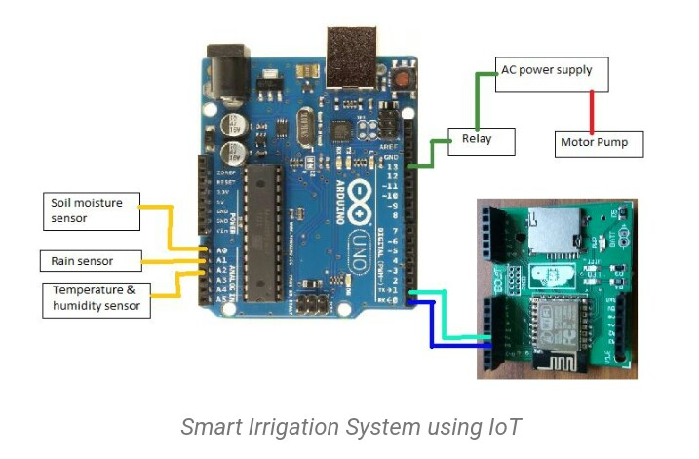

**The hardware and software requirements of this project include Arduino UNO, soil moisture sensor, Wi-Fi module ESP8266, Arduino CC(IDE), Android studio, and MySQL, etc.**

**ABSTRACT:**

**In India, agriculture in villages plays an essential role in developing the country. Basically, agriculture depends on the monsoons which have not enough water source. To overcome this problem, the irrigation system is employed in the field of agriculture. In this system, based on the soil type, the water will be provided to the agricultural field. In agriculture, there are two things, namely, the moisture content of the soil as well as the fertility of the soil. At the present time, there are several types of techniques available for irrigation to reduce the need for rain. This type of technique is driven by on/off schedule using electrical power. This article discusses the implementation of a smart irrigation system using IoT**

**The term “IoT” stands for the internet of things, can be defined as the interconnection between the individually identifiable embedded computing apparatus in the accessible internet infrastructure. The ‘IoT’ connects various devices and transportations with an help of internet as well as electronic sensors.**

**The Arduino UNO is one of the most used microcontrollers in the industry. It is very easy to handle, convenient, and use. The coding of this microcontroller is very simple. The program of this microcontroller is considered as unstable due to the flash memory technology. The applications of this microcontroller involve a wide range of applications like security, home appliances, remote sensors, and industrial automation. This microcontroller has the ability to be joined on the internet and perform as a server too.**

**Soil Moisture Sensor**

**Soil moisture sensor is one kind of sensor used to detect the soil moisture content. This sensor has two outputs like the analog output as well as the digital output.**

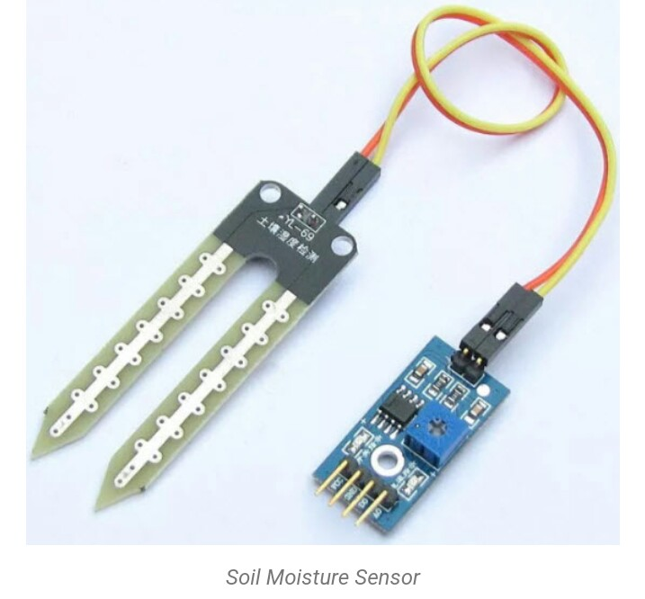 **The digital o/p is permanent and the analog o/p threshold can be changed. The working principle of soil moisture sensor is open & short circuit concept. Here the LED gives an indication when the output is high or low. When the condition of the soil is dried up, the flow of current will not flow through it. So it works like an open circuit. Therefore the o/p will be maximized. When the soil condition is soaked, the flow of current pass from one terminal to the other. So it works like a closed circuit. Therefore the o/p will be zero. Here sensor is coated with platinum, and anti-rust to make higher efficiency as well as long life. The sensing range is also high which will pay for the farmer at a minimum cost.**

**Wi-Fi Module ESP8266**

**The Wi-Fi module ESP8266 is a low-cost module, used to interface the microprocessors. It has a 96 KB of data RAM as well as a 64KB of instruction RAM.**

**In the agriculture field, sensors are used like soil moisture. The information received from the sensors is sent to the Database folder through the Android device. In the control section, the system is activated using the application, this is finished using the ON/OFF buttons in the application. Also, this system is automatically activated when the soil moisture is low, the pump is switched ON based on the moisture content.**

**The application has a feature like taking some time from the user and water the agriculture field when the time comes. In this system, there is a switch used to turn off the water supply if the system fails. Other parameters such as the moisture sensor demonstrate the threshold price and the level of water in**

**Further, this project can be enhanced by designing this system for large acres of soil. Also, this project can be incorporated to make sure the value of the soil and the expansion of harvest in each soil. The microcontroller and sensors are successfully interfaced and wireless communication is attained between a variety of nodes. Also, further this proposed system can be enhanced by adding up machine learning algorithms, which are capable to study and recognize the necessities of the crop, this would aid the agriculture field to be an automatic system. The inspections and outcomes tell us that this result can be executed for a lessening of water loss and decrease the manpower necessary for a field.**

**CONCLUSION:**

**From the above information, finally, we can conclude that the hardware components of this system interfaces with all the sensors. The system is powered by a power source, and the system has been checked for watering an agriculture field.**