Ex5
AIM
To understand and document the specific steps a user takes to complete main tasks within an online shopping application using Lucidchart.

PROCEDURE
- Requirement Analysis: Identify the core tasks of the shopping app, such as Browsing, Searching, Adding to Cart, and Checking Out.
- User Flow Documentation:
  - Login Flow: Map the steps from opening the app to reaching the home screen.
  - Search Flow: Document how a user navigates categories or uses the search bar to find products.
  - Add to Cart Flow: Detail the process of selecting product options (size/color) and adding them to the cart.
  - Checkout Flow: Map the steps for reviewing the cart, entering shipping/payment info, and placing the order.
- Diagram Creation: Use Lucidchart to create the flowcharts. Use Ovals for start/end points and Rectangles for general actions.
- Connecting Shapes: Use connectors and arrows to indicate the logical direction of the user journey.
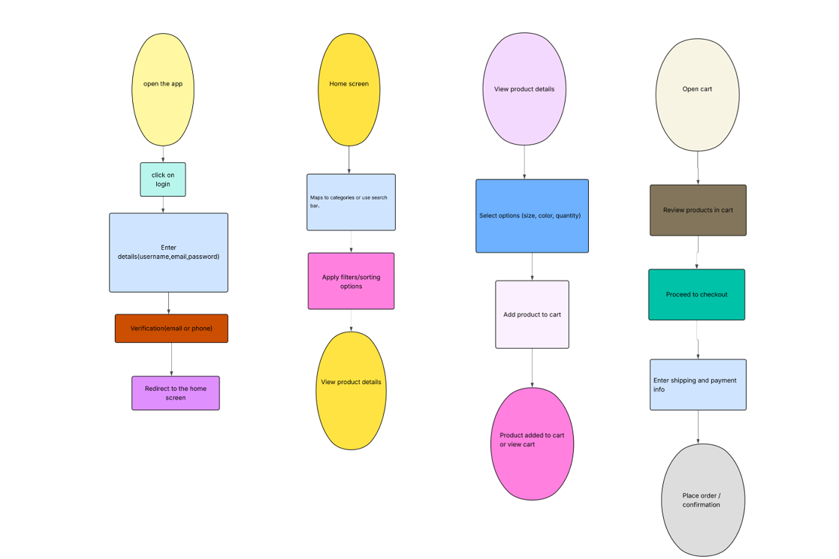

RESULTS
The user flows for the online shopping application were successfully analyzed and documented using Lucidchart. The resulting diagrams clearly illustrate the path a user takes from initial login to final order placement, ensuring a clear understanding of the app's navigation logic.

